# Homework 6 Boolean Algebra

1. Simplify the following Boolean expressions.

(a) [1]

(b) [1]

`

(c) (AAB + ABB) [1]

2. Simplify the following Boolean expressions, explaining each step.

(a) [3]

(b) AB + A (B+C) + B (B + C) [4]

3. (a) Write expressions for P, Q, R and S and T represented in the following logic circuit. [5]

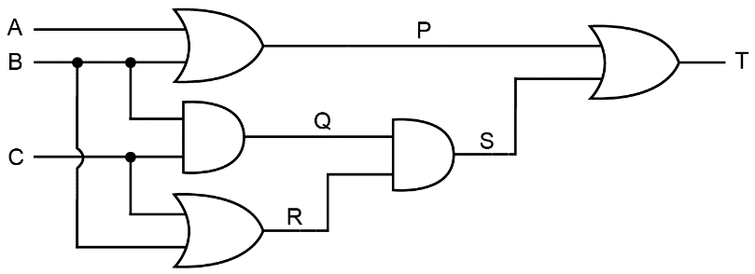

(b) Simplify the expression T. [5]

[Total 20 marks]