Machine Level Programming with TOM

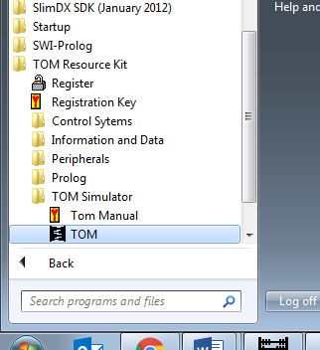
Getting started with TOM
- Open TOM Resource Kit: Registration Key
- Open TOM Resource Kit:TOM
- Copy and paste the key into the dialog box
- IGNORE THE ERROR MSG!

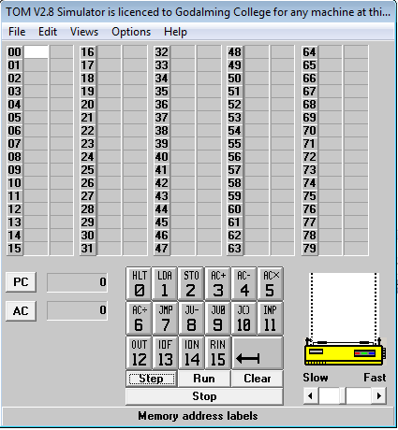
You should now see the following screen.

The help files are useless! BUT the TOM manual is a great overview and has 80’s retro graphics ☺

- Have a quick flick through the TOM manual, so you know what’s there
- Now go to the TOM simulator.
- Go to File: Demonstration
- Work through the steps doing EXACTLY what is asks
- note down below what the following are/do

PC Button and Label
AC Button and Label
High word
Low word
Option: Disassemble
Option: Hexadecimal
Step

Exercises using TOM

Write machine code programs that:

- Load the values held in two different locations, multiply them together and output the result.

- Count down and output the numbers 9 to 1 on TOM’s printer.

Hints: Load 9 into the accumulator and subtract 1 from it in a loop. Use an unconditional jump for the loop and a ‘jump if zero’ command to exit the loop.

- Allow the user to input a pair of values and output sum of the two values.

Hints: Store the first value in a location. Then input the second value. Then add to the accumulator from the stored location.

- Allow the user to input a pair of values and output the largest one.

Hints: Store each value in a different location after input. Use a subtract instruction followed by one of the jumps to perform the test.

- Allow the user to input a set of positive integers, terminated by zero, and output the arithmetic mean.

Hints: This is quite a complex problem even in a high level language. You should plan out your ALGORITHM before you start to write TOM instructions.

Extensions:
- Produce a times table (to 12) for a given inputted integer
- Returns the Largest number from a list of 10 number stored in memory
- Returns the number of times a given number appears in a list of numbers

