**Assembly language tracing questions**

All questions use the following instruction set, which is taken from the AQA specimen paper. Assume that all registers are 8 bit and that operand values are given in denary.

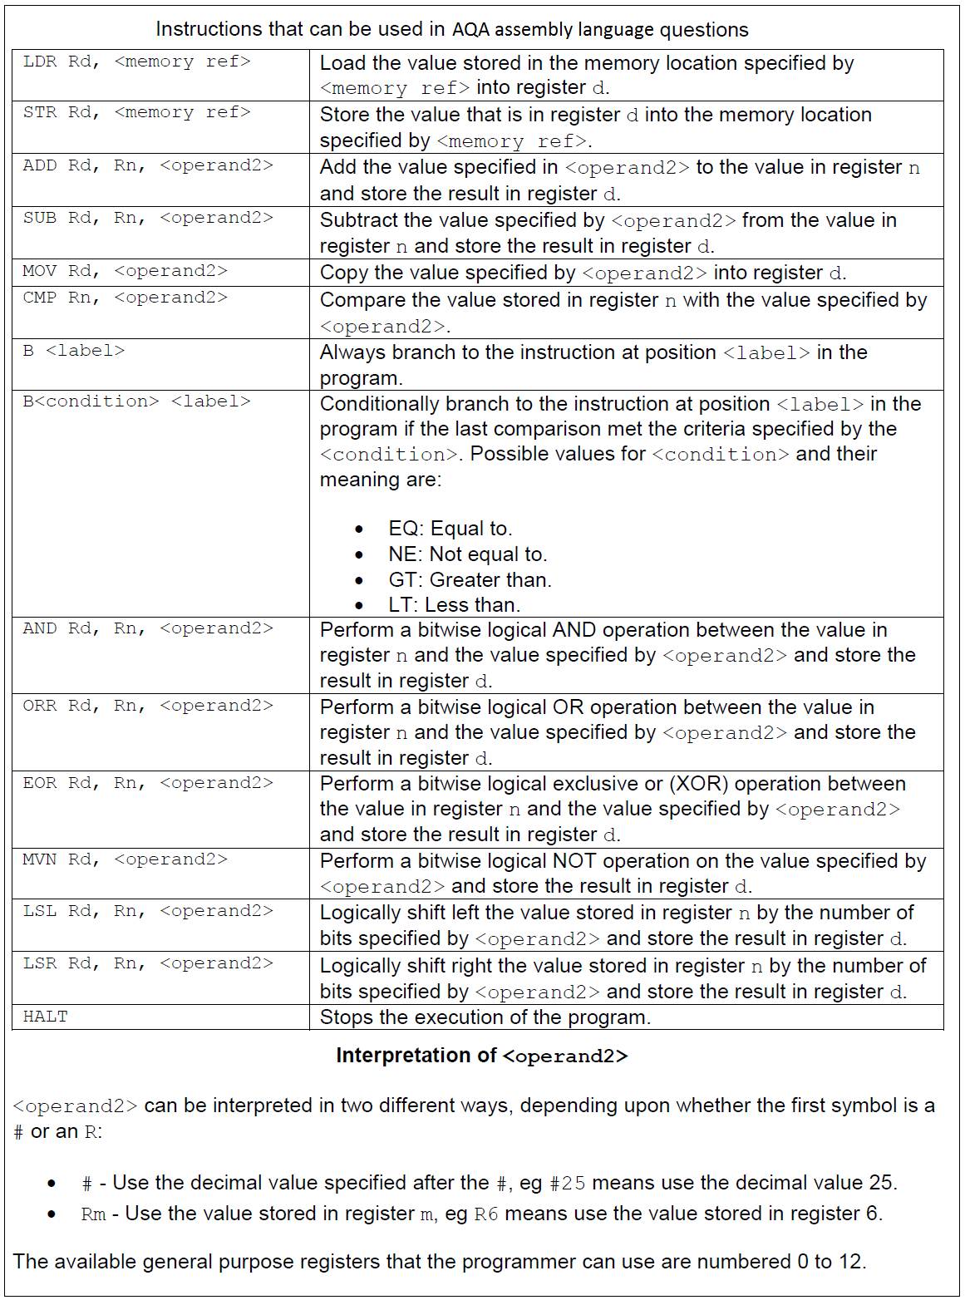

The following values have been loaded into an area of memory, and should be used in all questions.

|  |  |
| --- | --- |
| Address | Contents |
| 41 | 18 |
| 42 | 27 |
| 43 | 15 |
| 44 | 3 |
| 45 | 48 |

For each question, use the table provided to trace the program and complete the register values. Clearly you will not know the actual instruction addresses allocated by the assembler.

|  |  |  |
| --- | --- | --- |
| Instruction | R1 | R2 |
|  |  |  |
|  |  |  |
|  |  |  |
|  |  |  |

1. LDR R1, 42

MOV R2, #10

ADD R1, R1, R2

HALT

|  |  |  |  |
| --- | --- | --- | --- |
| Instruction | R1 | R2 | R3 |
|  |  |  |  |
|  |  |  |  |
|  |  |  |  |
|  |  |  |  |
|  |  |  |  |

1. LDR R1, 41

LDR R2, 43

CMP R1, R2

BNE label

MOV R3, #10

label:

MOV R3, #20

HALT

|  |  |  |  |
| --- | --- | --- | --- |
| Instruction | R1 | R2 | R3 |
|  |  |  |  |
|  |  |  |  |
|  |  |  |  |
|  |  |  |  |

1. LDR R1, 42

LDR R2, 43

AND R3, R1, R2

HALT

|  |  |  |  |  |
| --- | --- | --- | --- | --- |
| Instruction | R1 | R2 | R3 | R5 |
|  |  |  |  |  |
|  |  |  |  |  |
|  |  |  |  |  |
|  |  |  |  |  |
|  |  |  |  |  |
|  |  |  |  |  |
|  |  |  |  |  |
|  |  |  |  |  |
|  |  |  |  |  |
|  |  |  |  |  |
|  |  |  |  |  |
|  |  |  |  |  |
|  |  |  |  |  |
|  |  |  |  |  |

1. LDR R1, 43

LDR R2, 41

MOV R3, #0

MOV R5, #1

start:

ADD R1, R1, R5

ADD R3, R3, R5

CMP R1, R2

BEQ end

B start

end:

HALT

|  |  |  |
| --- | --- | --- |
| Instruction | R1 | R2 |
|  |  |  |
|  |  |  |
|  |  |  |
|  |  |  |

1. LDR R1, 43

MVN R2, R1

ORR R1, R1, R2

HALT

|  |  |  |  |
| --- | --- | --- | --- |
| Instruction | R1 | R2 | R5 |
|  |  |  |  |
|  |  |  |  |
|  |  |  |  |
|  |  |  |  |
|  |  |  |  |
|  |  |  |  |
|  |  |  |  |
|  |  |  |  |
|  |  |  |  |
|  |  |  |  |
|  |  |  |  |
|  |  |  |  |
|  |  |  |  |
|  |  |  |  |
|  |  |  |  |
|  |  |  |  |

1. MOV R1, #5

MOV R2, R1

MOV R5, #1

start:

SUB R1, R1, R5

ADD R2, R2, R1

CMP R1, R5

BEQ end

B start

end:

HALT

|  |  |  |  |  |
| --- | --- | --- | --- | --- |
| Instruction | R0 | R1 | R2 | R5 |
|  |  |  |  |  |
|  |  |  |  |  |
|  |  |  |  |  |
|  |  |  |  |  |
|  |  |  |  |  |
|  |  |  |  |  |
|  |  |  |  |  |
|  |  |  |  |  |
|  |  |  |  |  |
|  |  |  |  |  |
|  |  |  |  |  |
|  |  |  |  |  |
|  |  |  |  |  |
|  |  |  |  |  |
|  |  |  |  |  |
|  |  |  |  |  |

1. LDR R5, 44

LDR R2, 45

MOV R0, #1

MOV R1, #1

start:

ADD R0, R0, R1

LSL R5, R5, R1

CMP R2, R5

BEQ end

B start

end:

HALT