Big Block of text:

FBF MFK SFKDTOFEXB NI EJX CRFOK SZV EJX FOFRIETDFR XOYTOX, FOB NFNNFYX MFK DJFVGXB NI JXV TOEXRRXDE FOB FOFRIETDFR KLTRRK. FBF EVFOKRFEXB FO FVETDRX BXKDVTNTOY EJX FOFRIETDFR XOYTOX SVZG TEFRTFO EZ XOYRTKJ, F VFEJXV GWOBFOX EFKL, NWE FE EJX XOB ZS JXV EVFOKRFETZO KJX FCCXOBXB MJFE KJX GZBXKERI ETERXB OZEXK.

FBFK OZEXK TODRWBXB F DZGCRXEX FOB BXEFTRXB GXEJZB SZV JZM EZ CVZYVFG EJX FOFRIETDFR XOYTOX EZ DFRDWRFEX NXVOZWRRT OWGNXVK. EJZWYJ FBF OXPXV RTPXB EZ KXX EJX GFDJTOX NWTRE, RFEXV MJXO F GZBXR MFK DVXFEXB NFKXB ZO NFNNFYXK ZVTYTOFR BXKTYOK KZGXZOX EVTXB JXV CVZYVFG- FOB TE MZVLXB! EJXKX OZEXK FVX DZOKTBXVXB EJX STVKE XPXV DZGCWEXV CVZYVFG.

FBFK DZOEVTNWETZOK BZOE KEZC EJXVX. TO JXV OZEXK, FBF BTKDWKKXB EJX EVWX TGCZVEFODX ZS EJX FOFRIETDFR XOYTOX. KJX TGFYTOXB EJFE EJX FOFRIETDFR XOYTOX DZWRB NX FBFCEXB EZ BZ GZVX EJFO GXVX OWGNXV DVWODJTOY, NWE WRETGFEXRI EZ DFVVI ZWE FOI EICX ZS TOKEVWDETZOK BXRTPXVXB EJVZWYJ KIGNZRTD VXFKZOTOY, KZGXEJTOY MXRR NXIZOB MJFE NFNNFYX JFB XOPTKTZOXB. KJX MVZEX FNZWE EJX CFVEOXVKJTC NXEMXXO JWGFO DVXFETPTEI FOB GFDJTOX XQXDWETZO, EJFE GFDJTOXK DZWRB FTB JWGFO TOOZPFETZO OZE ZORI TO GFEJ, NWE TO FVE FOB BXKTYO FK MXRR. KJX BXPXRZCXB EJX STVKE XPXV EJXZVTXK ZO JZM FVETSTDTFR TOEXRRTYXODX MZWRB MZVL FRZOYKTBX JWGFO TOEXRRTYXODX, NWE OXPXV FK F VXCRFDXGXOE. F EJXZVI EJFE FRFO EWVTOY DJFRRXOYXB TO JTK MZVL, NWE TE TK FDEWFRRI FBFK GZBXR EJFE TK KETRR EVWX EZ EJTK BFI.

Secret Message

TS IZW BXDTCJXV EJTK IZW DFO YZ XFVRI

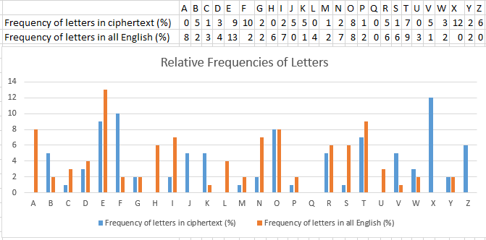

|  |  |  |  |  |  |  |  |  |  |  |  |  |  |  |  |  |  |  |  |  |  |  |  |  |  |  |  |  |  |  |  |  |  |  |  |  |  |  |  |  |  |  |  |  |  |  |  |  |  |  |  |
| --- | --- | --- | --- | --- | --- | --- | --- | --- | --- | --- | --- | --- | --- | --- | --- | --- | --- | --- | --- | --- | --- | --- | --- | --- | --- | --- | --- | --- | --- | --- | --- | --- | --- | --- | --- | --- | --- | --- | --- | --- | --- | --- | --- | --- | --- | --- | --- | --- | --- | --- | --- |
|  |  |  |  |  |  |  |  |  |  |  |  |  |  |  |  |  |  |  |  |  |  |  |  |  |  |  |  |  |  |  |  |  |  |  |  |  |  |  |  |  |  |  |  |  |  |  |  |  |  |  |  |

|  |  |  |  |  |
| --- | --- | --- | --- | --- |
| Letter | Guess |  | Letter | Guess |
| T |  |  | V |  |
| S |  |  | C |  |
| I |  |  | J |  |
| Z |  |  | K |  |
| W |  |  | F |  |
| B |  |  | O |  |
| X |  |  | Y |  |
| D |  |  | R |  |
| E |  |  |  |  |