# Revision paper

1. The symbol $Z$ is used to describe a set of integer numbers.  
   1. Complete the table below to identify which numbers are integers and which are not.

|  |  |  |
| --- | --- | --- |
| **Value** | **Is not an integer** | **Is an integer** |
| 3 |  |  |
| 1.2 |  |  |
| π |  |  |
| -7 |  |  |
| 3/2 |  |  |

[5]

b. $R$ is used to describe a set of **real numbers**. A real number is any number that also belongs to at least one of three other sets of numbers.   
  
Name the three sets of numbers.

Set 1:

Set 2:

Set 3:

[3]

1. Binary values are extensively used within computer systems.
   1. What is the binary equivalent of the decimal number 23110? Show your working. [2]

* 1. Hexadecimal values provide a summary of groups of binary digits. Convert the binary value 101011002 into hexadecimal. Show your working. [2]

* 1. Represent the decimal value 2.7510 as an unsigned binary fixed point number, with   
     the most significant 4 bits as the whole number part and the remaining 4 bits as the fractional part after the binary point. [2]

* 1. Two’s complement binary is used to represent negative values.  
       
     Represent -12110 as an 8-bit two’s complement binary value: [2]

* 1. Use two’s complement 8-bit binary to calculate the answer to 9810 – 2210. Show how you worked your answer. [4]

* 1. Binary multiplication is a common operation in computer systems.   
       
     Calculate 1012 x 10102. Show your working: [3]

1. The unit **byte** is used to represent 8 bits of data. Number prefixes can be used to summarise large amount of bytes. e.g. 1KB = 1000 bytes.
   1. How many bits are are represented by the value 65 MB? Show your working. [2]

* 1. How many gigabytes does this value represent? [1]

* 1. A KiB is a alternative byte prefix. How many bytes are in a KiB? [1]

1. ASCII is a system used to represent characters in a computer system using a predetermined character set.
   1. What is meant by a character set? [1]

* 1. The ASCII code for the letter b is 11000102. How would the word “at” be   
     represented in ASCII: [2]

a:

t:

* 1. **Unicode** character encoding is used as an alternative coding system due to its larger character set. Explain why the ASCII character set is unsuitable in the modern world. [2]

1. A digital picture frame is a low-powered computer that is able to display photos and play music. The image and sound files are stored on a 2GB memory card plugged into the back of the frame.

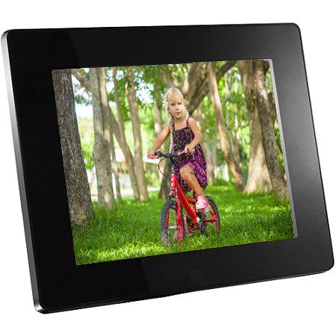

* 1. Photos are taken on an 8 Megapixel digital camera with a 24-bit colour depth. How many photos can be stored on the memory card? Show your working. [3]

* 1. All these photos do not fit on the memory card even though the full 2 GB is available, because **metadata** is stored with each image file. Give **two** examples of metadata. [2]

* 1. Photos are transferred onto the memory card leaving 72 MB of storage. A user wants to store 3600 seconds of audio to play on the frame. The device needs the audio to have a sampling resolution set to 16 bits.  
       
     What sampling rate should they set the sound files to so that they can get this amount of audio on the device? Show your working. [2]
  2. The instruction manual for the frame suggests that the sampling rate of audio files be no lower than 44,000 Hz.  
       
     What happens to the quality of audio as the sampling rate is reduced? Explain how the Nyquist theorem has been used to determine this lowest recommended sample rate. [2]

1. A photographer is uploading images across the Internet to his newspaper’s file repository in preparation for an exclusive front page story. There are several hundred high quality images that need to be uploaded.  
     
   The editor needs the photos urgently and needs them to be of a high quality. She suggests you compress the files before sending.
   1. Explain the differences between lossy and lossless compression and the effect that this might have on file transfer time. [5]

* 1. You feel that the files need to be encrypted when being sent across the Internet. Explain why this would be a good idea. [2]

1. The newspaper uses a Vernam cipher to allow all its employees to upload secure data to its servers. To do this they provide employees with a **one-time pad**.  
     
   Explain what the one-time pad is and how it should be used by employees. [2]

Total 50 marks