# Homework 5 Input and output devices

# For each of the situations below, state the most suitable input device. You may only use each device once.

|  |  |  |
| --- | --- | --- |
| **Digital camera** | **Barcode scanner** | **RFID** |

# (i) Anti-theft detection and identification of small, high-value items [1]

# (ii) Identification and recognition of vehicle number plates at a toll crossing [1]

# (iii) Validating tickets for admission to an event [1]

# Describe the principles of operation of a barcode scanner. [4]

# 

# A mail sorting office uses a camera-based scanner and specialist optical character recognition software in order to scan and recognise postcodes in typed addresses on envelopes.

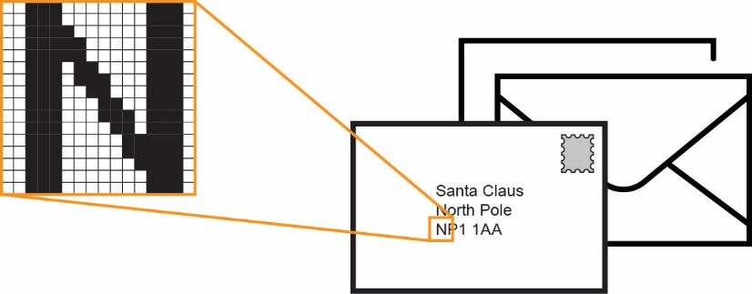

# Describe the principles of operation of a digital camera excluding its ability to determine a character from an image. [3]

# Explain how a digital camera image may be used to determine a character of text. [2]

3. A company uses a laser printer to print black and white invoices and customer orders. Describe the stages of operation of the laser printer as it produces an invoice. [6]

[Total 18 Marks]