1.1 Fundamentals of Problem Solving



1.1 Principles of computation
Focus on studying the processes of computation and understanding of Computation why and where they are important in Computing.

You should read pages 3 → 6 of AQA Computing AS (Bond and Langfield)

If you have access to it you should watch: “Inventions that changed the world: Computers” presented by Jeremy Clarkson.

This Pack is NOT about computers but how to “compute” and how to communicate computation.

Stages of Problem Solving
- Understand the problem.
- Define the problem.
- Define boundaries.
- Plan solution.
- Check solution.

You should read through the worked example on Pgs 8,9 of Bond and Langfield.

Now try and solve the following problem
- Four camels travelling on a very narrow ledge encounter four camels coming the other way.
- Camels never go backwards, especially when on a precarious ledge. The camels will climb over each other, but only if there is a camel sized space on the other side.
- The camels didn't see each other until there was only exactly one camel's width between the two groups.
- How can all camels pass, allowing both groups to go on their way, without any camel reversing?
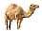 |  |  |  |  | 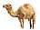

Define the problem
Initial Situation
Resources
Constraints

Goal
Ownership
If you want to…You should be able to solve the problem in 25 moves

Top-down Design
Read pgs 10&11 B&L and completed all the activities.

Here is a slightly trickier equation that finds the final velocity of an object that is accelerating (you don’t need to understand the equation to complete this task but will need to use your maths skills.
v= final velocity, u = initial velocity, a = acceleration, s = displacement
v²=u²+2as

Step-wise refinement consider sub-problems and the use of modules.

Structure table

Use the advice on pg 12 of B&L and the example below to help with the tasks
Here is the structure table for making a cup of tea
Level 0 | Make a cup of tea
Level 1 | - Tea bag in cup  - Add Boiling water  - Add Milk
Level 2 | - Get cup out of Cupboard  - Get teabag out of Cupboard  - Put teabag in cup  - Add water to kettle  - Turn kettle on  - Wait for it to boil and pour into cup  - Take milk out of fridge  - Pour milk into cup

Create a structure table for making Beans on Toast.
Level 0
Level 1
Level 2

Now create a structure table for your journey to college
Level 0
Level 1
Level 2

Here is a much trickier abstract problem
Five pirates have 100 gold coins. They have to divide up the loot. In order of seniority (suppose pirate 5 is most senior, pirate 1 is least senior), the most senior pirate proposes a distribution of the loot. They vote and if at least 50% accept the proposal, the loot is divided as proposed. Otherwise the most senior pirate is executed, and they start over again with the next senior pirate. What solution does the most senior pirate propose? Assume they are very intelligent and extremely greedy (and that they would prefer not to die).
This problem is very hard to solve just thinking as a whole. So lets make it simpler. (I’ll do the first couple for Ye!)
What is the solution for one pirate? He simply take all the Gold
What is the solution for two pirates? They vote the senior pirate forms at least 50% so he takes all the Gold
What is the solution for Three Pirates?

Think about what it would take for Pirate1 to vote for Pirate3
Now draw a hierarchy chart for the problem..

I have put the full solution on the AS computing Moodle site
Finite state machines with outputs
Draw and interpret simple state transition diagrams, transition tables.
• state transition diagrams
• state transition tables

Open Kara FSM Simulator from the Computing AS Moodle course site
Open and read the Kara Manual from the Computing AS Moodle course site (it isn’t long!)

Click on the Exercises and programming buttons and arrange the window so your screen looks like this:
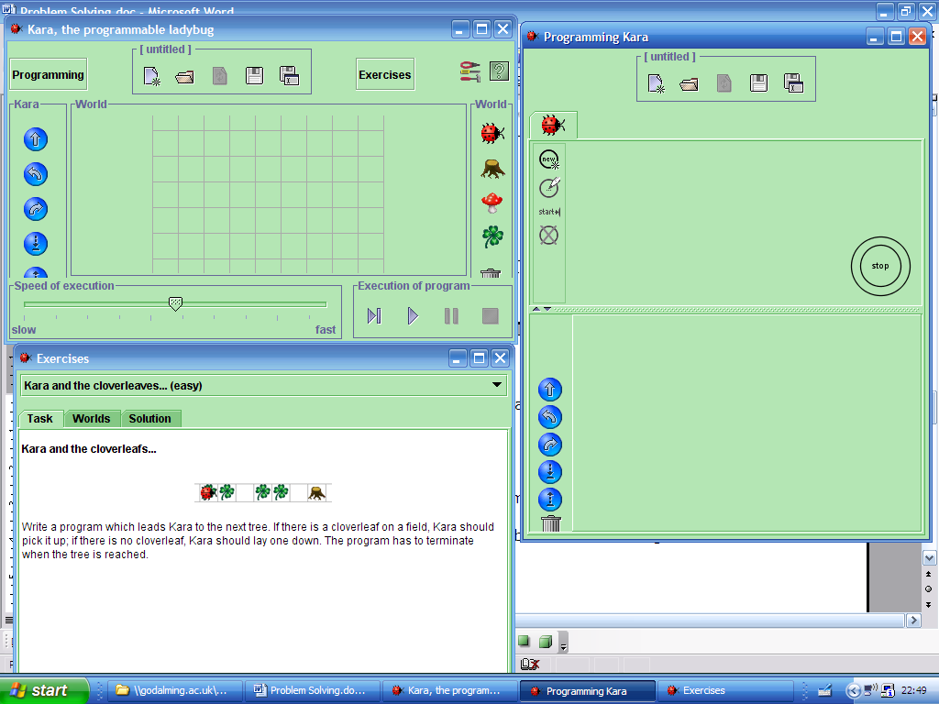

- Read the task in the exercises window
- Choose the first world
- Look at the first solution and Show Program
- You should see the solution appear in the programming window
- In the main window click the play button
- Now watch what kara does.
You can see an animation of the instructions on the Computing AS Moodle course site.

Spend some time looking at the other kara tasks and solutions. Take particular note at the FSM diagrams.
NOTE Kara doesn’t label the state transitions on the diagram, you have to look at the table below. When you draw a FSM Diagram you should always label the transitions

Read pgs 14 to 18 in B&L

Now Clear the Kara screens And have a go at task one (no cheeting!)

Test you solution against the three worlds.

FSM State Transition diagram problems
Door
Draw a state transition diagram for a door that opens when you push it and closes when you close it (i.e. a normal door with no locks or springs!)

- Draw a second diagram for a normal door with a mortice lock (requires a key to lock or unlock

- Draw a Third diagram for a normal door with a Yale lock (requires a key to lock but automatically lock whenever the door is closed

Chocolate Machine (that sells only one type of bar)

- Chocolate costs 20p (I wish!)
- The machine only accepts 20p coins, All other coins are rejected!
- There is just one button to drop the chocolate.
- The chocolate never runs out

- Add a transition that shows all other coins being rejected
- Add a state and transitions that show the machine running out of chocolate.
If you want a challenge then try to include one or more of these extensions:
- Accepts 10p or 20p
- Two different chocolate bars available

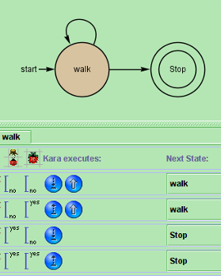
In Kara you saw how different inputs lead to different state transitions, and outputs
No Tree and Leaf, Pickup
No Tree and No Leaf, Drop

This is a form of State Transition Table , (state table) You can see the inputs (senses), Output (what kara executes), and the next state.
Tree and Leaf, Pickup
Tree and No Leaf, Drop
Pg 16&17 of B&L have more examples
Create a State Transition table for

Create a State Table for the normal door

Create a state table for the Mortice lock door

Create a table for the Chocolate machine

Decision tables Determine logical conditions and consequential actions.

Read pgs 17&18 in B&L
Complete the following decision table that describe the entry requirements to start AS computing
IF GCSE PASS >= 5 AND GCSE MATHS > C
THEN accept on to course
ELSE Advise on another course
conditions
Actions

Complete this decision table for a simplified common Central Heating/Hot Water system
IF HW timer = on AND HW thermostat <50 then
Boiler ON
Pump to HW tank
IF CH timer = ON and CH Thermostat <20 then
Boiler ON
Pump to Radiators

conditions | HW Timer ON
conditions | CH Timer ON
conditions | CH Thermostat <20
conditions | HW Thermostat <50
Actions | Boiler on
Actions | Pump to radiators
Actions | Pump to HW Tank

Algorithm Design Understand the term algorithm.
Express the solution to a simple problem as an algorithm using
flowcharts, pseudo-code or structured English and the standard
constructs:
• sequence
• assignment
• selection
• repetition.
Hand trace simple algorithms.
Convert a simple algorithm from
• structured English into pseudo-code,
• pseudo-code into high level program code.
Understand the standard algorithms: Bubble Sort, Linear Search.

Read pgs 1→6 B&L
Define the following terms:

Algorithm

Abstraction

Automation

Program

For the following exercises it is assumed that you have started working through the exercises in “Introduction to Programming in…”

Read chpt 1.4 pgs19→21 B&L Take Particular note of the section “Computer based Problem solving”
Structured English and Pseudocode example

SE | PC | VB
 | Input Name  Output ‘Hello’ Name | Dim name As String  console.writeline("enter your name")  name = console.readline()  console.writeline("hello ", name)

