|  |  |
| --- | --- |
|  | |
| **A-level Computer Science (7516/7517)**  Spring Programming Benchmark  Preditor Prey | Name:  Class: |

|  |  |
| --- | --- |
|  | |
| Time: | **1hr15mins** |
| Marks: | **75** |
| Comments: | **There is NO EAD!!! Most of the Paper is fill in the blanks.. For question 5 please paste into a word document with your name. Print and Staple Q5 to the back of this paper.** |
|  | |

|  |  |
| --- | --- |
| Q1 |  |
| Q2 |  |
| Q3 |  |
| Q4 |  |
| Q5 |  |
| Total |  |

# Section A

**Q1.**  Create a folder / directory for your new program.

One method for converting a decimal number into binary is to repeatedly divide by 2 using integer division. After each division is completed, the remainder is output and the integer result of the division is used as the input to the next iteration of the division process. The process repeats until the result of the division is 0.

Outputting the remainders in the sequence that they are calculated produces the binary digits of the equivalent binary number, but in reverse order.

For example, the decimal number 210 could be converted into binary as shown below.

|  |  |  |
| --- | --- | --- |
|  | 210 ÷ 2 =105 105 ÷ 2 =  52  52 ÷ 2 =  26 26 ÷ 2 = 13 13 ÷ 2 =  6 6 ÷ 2 =  3 3 ÷ 2 =  1 1 ÷ 2 =  0 | remainder 0 remainder 1 remainder 0 remainder 0 remainder 1 remainder 0 remainder 1 remainder 1 |

The sequence 0, 1, 0, 0, 1, 0, 1, 1 which would be output by this process is the reverse of the binary equivalent of 210 which is 11010010.

**What you need to do**

**Task 1**Write a program that will perform the conversion process described above. The program should display a suitable prompt asking the user to input a decimal number to convert and then output the bits of the binary equivalent of the decimal number in reverse order.

**Task 2**Improve the program so that the bits are output in the correct order, e.g. for 210 the output would be 11010010.

**Task 3**Test the program works by entering the value 210.

Save the program in your new folder / directory.

**Evidence that you need to provide**

(a)     Your PROGRAM SOURCE CODE after you have completed both **Task 1** and **Task 2**.

If you complete **Task 1** but do not attempt **Task 2** then a maximum of 9 marks will be awarded.

**(12)**

(b)     SCREEN CAPTURE(S) for the test showing the output of the program when 210 is entered.

The marks for this test will be awarded whether the binary digits are output in reverse order or in the correct order.

**(2)**

**(Total 14 marks)**

**Q2.**The figure below shows an incomplete diagram of a typical computer system architecture.

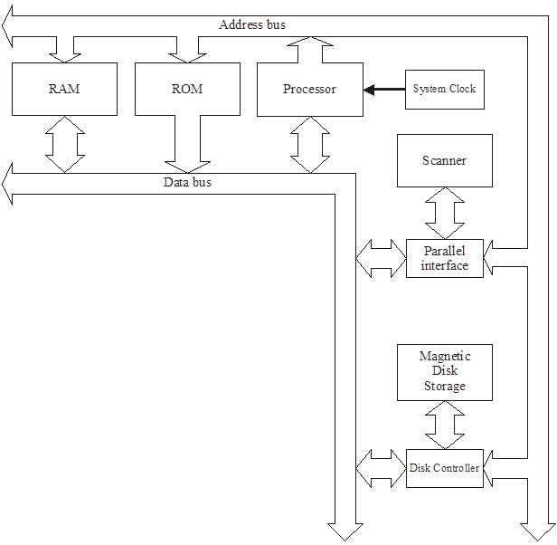

*(a)     {question removed}*

(b)     A third bus has been omitted from the diagram in the figure above.

Name this bus.

...........................................................................**(1)**

(c)     Explain why the data bus is bi-directional, but the address bus is one-way only.

……......................................................................

…………………………………………………………

………………………………………………………..

………………………………………………………...**(2)**

(d)     The processor performs different types of operations; for example, arithmetic operations.

Name **one** other type of operation. ................................................................

........................................................................................................................

**(1)**

(e)     Explain the **stored program concept**. ..........................................................

........................................................................................................................

........................................................................................................................

........................................................................................................................

**(3)**

**(Total 9 marks)**

**Q3.**

The diagram below shows some of the registers used in the fetch-execute cycle of a simple processor and the contents of a small section of main memory that it is connected to by the system bus ().

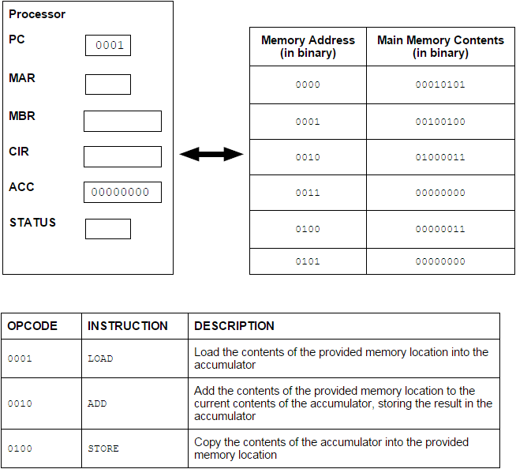

(a)     In the diagram above the first 4 bits of an instruction represent the opcode and give the type of instruction to be executed.

What name is given to the second 4 bits of an instruction?

........................................................................................................................

**(1)**

(b)     (i)      Currently the value in the Program Counter (PC) is example 0001.

Complete the table below by writing the values, expressed in binary, in the following registers after completing the fetch part of the fetch-execute cycle.

|  |  |  |
| --- | --- | --- |
|  | **Register** | **Value** |
|  | PC |  |
|  | MAR |  |
|  | MBR |  |

**(3)**

(ii)     Describe what will happen during the decode and execute part of the cycle.

...............................................................................................................

...............................................................................................................

...............................................................................................................

...............................................................................................................

...............................................................................................................

...............................................................................................................

...............................................................................................................

**(3)**

(c)     What would be the outcome of executing the instruction 01000011?

........................................................................................................................

........................................................................................................................

........................................................................................................................

........................................................................................................................

**(1)**

**(Total 8 marks)**

**Q4.**  The class diagram below is an attempt to represent the relationships between some of the classes in the Predator Prey Simulation. ALL of question 4 refers only to the correct 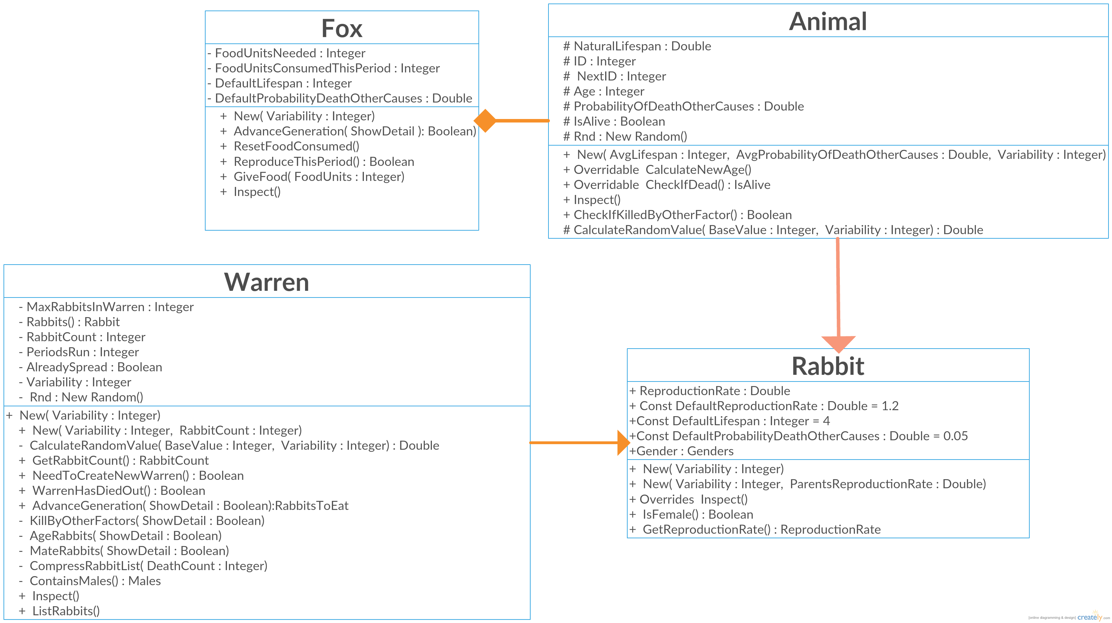classes from the **Skeleton Program** shown in the diagram.

(a)     Describe three errors that have been made in the class diagram.

**(3)**

(b)     Give an example of instantiation

**(1)**

(c)     State the name of an identifier for an array variable.

**(1)**

(d)     State the name of an identifier for a subclass.

**(1)**

(e)     State the name of an identifier for a variable that is used to store a whole number.

**(1)**

(f)     State the name of an identifier for a class that uses composition. **(1)**

(h)     Look at the Rabbit class in the **Skeleton Program**.

Why has a named constant DefaultLifeSpan been used instead of the numeric value 4? **(2)**

**(Total 10 marks)**

**Q5.**

(a)     This question refers to the Main Program

The **Skeleton Program** currently does not validate the user input for the number of foxes.

The subroutine Main needs to be adapted so that it displays an error message to the user if an illegal value is entered. A message should state "That is not a valid value".

**Evidence that you need to provide**

(i)      Your amended PROGRAM SOURCE CODE for the MAIN subroutine.

**(3)**

(ii)    SCREEN CAPTURE(S) for a test run showing a player trying to enter the string “wibble” in the number of foxes

**(1)**

(iii)    SCREEN CAPTURE(S) for a test run showing a player trying to enter more foxes than there are locations

**(1)**

(b) This question will require you to create a new class

You are required to create a new class called **Owl** that inherits **Animal**, The DefaultLifeSpan should be a constant and set to 5. No other changes need to be made

You should instantiate an object named “Barney” of type OWL in the Location Class   
**NB this is not a complete solution and will not run! You will need to comment out the instantiation if you need to go back to a previous question**

(i)      Your PROGRAM SOURCE CODE for the **OWL** Class.

**(3)**

(ii) Your PROGRAM SOURCE CODE for the **Location** Class. (3)