# Worksheet 6 Boolean Algebra Answers

**Task 1**

1. X, Y and Z are Boolean variables which can be either TRUE or FALSE, represented by 1 and 0.

Complete the following “rules” of Boolean algebra:

## **General rules**

1. X ⋅ 0 = 0
2. X ⋅ 1 = X
3. X ⋅ X = X
4. X + 0 = X
5. X + 1 = 1
6. X + X = X
7. = 1

## **Commutative rule**

1. X ⋅ Y = Y ⋅ X
2. X + Y = Y + X

## **Associative rule**

1. X ⋅ (Y ⋅ Z) = (X ⋅ Y) ⋅ Z
2. X + (Y + Z) = (X + Y) + Z

## **Distributive rule**

1. X ⋅ (Y + Z) = X ⋅ Y + X ⋅ Z
2. (X + Y) (W + Z) = X⋅W + X⋅Z + Y⋅W + Y⋅Z

**Absorption rules**

1. X + (X ⋅ Y) = X
2. X ⋅ (X + Y) = X

2. Write down de Morgan’s first and second laws:

3. Use de Morgan’s Laws and the rules of Boolean algebra to simplify the following expressions, stating which rule you use at each step.

(a) X Y + X (Y + Z)

= X Y + X Y + X Z Distributive Rule

= X Y + X Z Rule 7

(b)

= Distributive Rule

= Rule 4

= Rule 5

(c)

Using de Morgan’s Law,

Rule 8

= 1 Rule 6

(d)

Distributive Rule

Rule 3

Distributive rule

Rule 6

Absorption rule

Absorption rule

(e) (X + Y) (X + Z)

= XX + XZ + XY + YZ Rules 15, 10

= X + XZ + XY + YZ Rule 3

= X+ XY + YZ Absorption rule

= X + YZ Absorption rule

4. Complete the truth table to show that :

|  |  |  |  |  |  |
| --- | --- | --- | --- | --- | --- |
| **A** | **B** |  |  |  | **A + B** |
| 0 | 0 | 1 | 0 | 0 | 0 |
| 0 | 1 | 1 | 1 | 1 | 1 |
| 1 | 0 | 0 | 0 | 1 | 1 |
| 1 | 1 | 0 | 0 | 1 | 1 |

**Task 2**

1. Simplify the expression A ⋅ B + A ⋅ (B + C)

A B + AB + A C

= A B + AC

= A(B + C)

Draw a logic circuit representing the simplified expression, using only 2 gates.

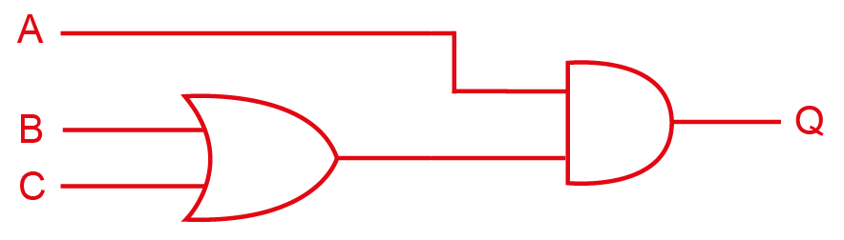

2. (a) Write the Boolean expression representing the logic circuit below.

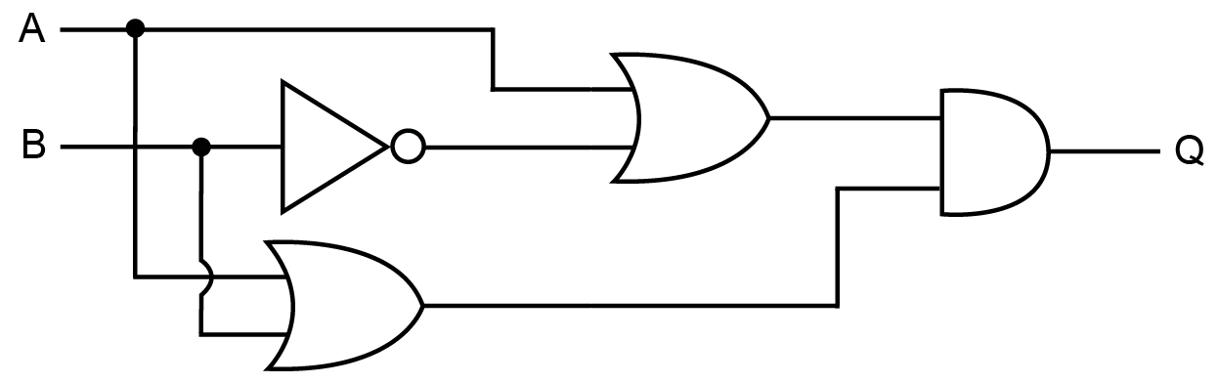

or alternatively, (A OR NOT B) AND (A OR B)

(b) Simplify the expression.

Rules 3 and 4 and distributive rule

= A + A Rules 8, 2

= A Rule 7

(c) With reference to the above example, explain why de Morgan’s Laws and the rules of Boolean algebra have a huge commercial significance in the manufacture of computers.

In the above example, the output Q has been reduced to a single input A, saving on the manufacture of four unnecessary logic gates. This saves both manufacturing costs and processing time.