Q1.
The algorithm below re-arranges numbers stored in a one-dimensional array called List. Ptr is an integer variable used as an index (subscript) which identifies elements within List. Temp is a variable, which is used as a temporary store for numbers from List.
Ptr ← I
While Ptr < 10 Do
If List [Ptr] > List [Ptr+ 1] Then
Temp ← List [Ptr]
List [Ptr] ← List [Ptr+l]
List [Ptr+l] ← Temp
Endif
Ptr ← Ptr+ 1
Endwhile
(a) Dry-run the algorithm by completing the table below,
It is only necessary to show those numbers which change at a particular step.

 |  | List
Ptr | Temp | [1] | [2] | [3] | [4] | [5] | [6] | [7] | [8] | [9] | [10]
 |  | 43 | 25 | 37 | 81 | 18 | 70 | 64 | 96 | 52 | 4
(7)
(b) What will happen when Ptr= 10?
___________________________________________________________________
(1)
(c) If the whole algorithm is now applied to this rearranged list, what will be the values of:
(i) List[1] _________________________________________________________
(ii) List[9] _________________________________________________________
(iii) List[10]? ______________________________________________________
(3)
(Total 11 marks)
Q2.
A routine for manipulating text strings uses the following pre-defined functions:
Len(q) returns the number of characters in the text string q;
Right$(q,p) returns a string consisting of the last (rightmost) p characters of the string q;
Left$(q,p) returns a string consisting of the first (leftmost) p characters of the string q.
The algorithm for this routine is shown below.
string: message, newstring
// main program
input message
newstring : = “”
output message
docharacter(message,newstring)
output newstring
// end of program
procedure docharacter(a,outstring) // both parameters passed by reference string: piece integer: x
x : = Len(a)
piece : = Right$(a,1)
outstring : = outstring + piece
x : = x – 1
if x > 0 then
a : = Left$(a,x)
docharacter(a,outstring)
endif
endproc
Trace the algorithm and show what is output if the word CAT is input.
_______________________________________________________________________
_______________________________________________________________________
_______________________________________________________________________
(Total 9 marks)
Q3.
The diagram below shows a partial solution to a logic puzzle. To complete the solution each of the letters A-I must appear exactly once in each row of nine cells, exactly once in each column of nine cells and exactly once in each of the collections of three-by-three cells shown with limits shown by a thicker border.
In the diagram the logic puzzle has been completed except for the collection of three-by-three cells in the top-right corner.
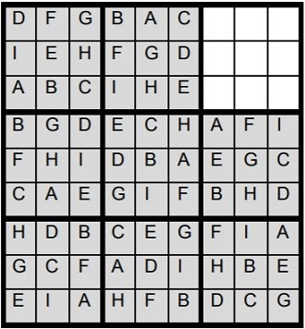
Complete the solution for the puzzle shown in the diagram above.
(Total 1 mark)
Q4.
Figure 1 shows a simpler example of a type of logic puzzle with fewer cells. In this simpler puzzle only the letters A-D are used.
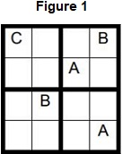
It is possible to represent this type of puzzle as a graph. To do this a unique number is given to each cell and a node containing this unique number is added to the graph. An edge between two nodes denotes a link between those two cells, meaning they cannot contain the same letter as each other.
Figure 2 shows how unique numbers have been allocated to each cell in the puzzle in Figure 1 and Figure 3 shows an adjacency matrix that represents this puzzle.
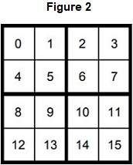
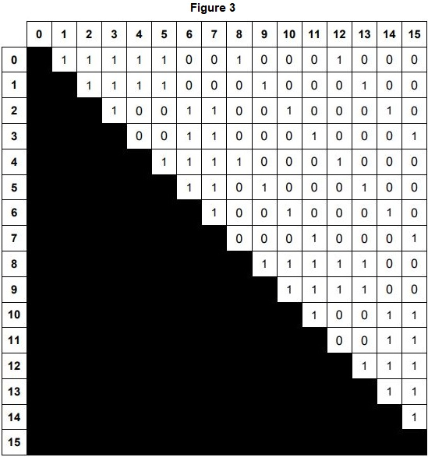
The graph in Figure 3 can be considered to be both a representational abstraction and an abstraction by generalisation of the puzzle from Figure 1.
What is representational abstraction?
_______________________________________________________________________
_______________________________________________________________________
(Total 1 mark)
Q9.
Explain the functionality of the * metacharacter when it is used in a regular expression.
_______________________________________________________________________
_______________________________________________________________________
(Total 1 mark)
Q10.
Explain the functionality of the ? metacharacter when it is used in a regular expression.
_______________________________________________________________________
_______________________________________________________________________
(Total 1 mark)
Q11.
Complete the below to show which of the strings belong to the language defined by the regular expression 1|01+.

String | Belongs to language (Y/N)?
1
11
01
0111
0101
111
0011
(Total 3 marks)

Q12.
The plan below shows the layout of the Mass Transit Railway (MTR) in Hong Kong. The maintenance depot is at Mong Kok.
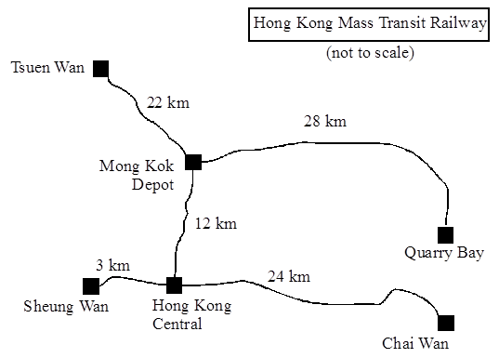
All the trains operate the same cycle (sequence) of journeys, given by the algorithm below. The algorithm is intended to ensure that:
1. trains are serviced as soon as possible after covering 135 km, and
2. each train will have travelled in both directions along each track at least once in the cycle.
The algorithm relates to three arrays called station, journey and km. The contents of these arrays are shown below.

Subscript | Station
0 | Mong Kok depot (MK)
1 | Tsuen Wan (TW)
2 | Quarry Bay (QB)
3 | Sheung Wan (SW)
4 | Chai Wan (CW)
5 | Hong Kong Central (HK)

Subscript | Journey
0 | 3
1 | 4
2 | 3
3 | 1
4 | 5
5 | 2
6 | 3
The 6 × 6 two-dimensional array km, representing the distance between stations (in kilometres), contains
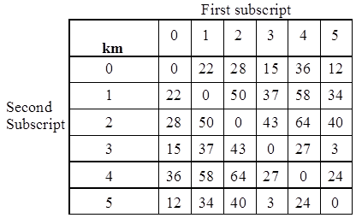
The proposed algorithm is:
org:=0
last := 1
dest:= 3
maintain := FALSE
start := station[org]
finish := station[dest]
totalkm := km [org, dest]
org := dest
while(TRUE)
n := 0
repeat
n := n + 1
if (maintain = TRUE) then
n := last
totalkm := 0
maintain := FALSE
endif
dest := journey [n]
if (totalkm > 135) then
dest := 0
last := n
maintain := TRUE
endif
start := station[org]
finish := station[dest]
totalkm := totalkm + km[org, dest]
org := dest
until n >= 6
endwhile
(a) What is the effect of the instructions while(TRUE) and endwhile?
___________________________________________________________________
___________________________________________________________________
(1)
(b) For each of the variables maintain and n, state with a reason what data type it should be.
___________________________________________________________________
___________________________________________________________________
___________________________________________________________________
___________________________________________________________________
___________________________________________________________________
___________________________________________________________________
___________________________________________________________________
___________________________________________________________________
(4)
(c) Copy and complete the trace table below, for one iteration of the outer (while .... endwhile) loop.
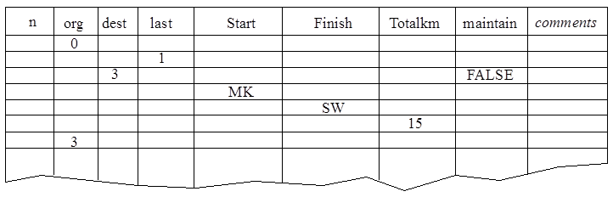

(8)
(d) An objective of the algorithm is that each train has travelled in both directions along every track at least once in the cycle. Using your trace table, state, with reasons, whether this objective has been achieved.
___________________________________________________________________
___________________________________________________________________
___________________________________________________________________
___________________________________________________________________
(2)
(Total 15 marks)
Q13.
The Cat transportation company (CTC) is a business that specialises in preparing cats for cat shows.
They need to take five cats to the AQA cat show. They will transport the cats in their van. CTC owns only one van.
They cannot put all the cats in their van at the same time because some of the cats get stressed when in the company of some of the other cats. The cats would not therefore arrive in top condition for the cat show if they were all in the van at the same time.
The graph in Figure 1 shows the relationships between the five cats (labelled 1 to 5). If there is an edge between two cats in the graph then they cannot travel in the van together at the same time.
Figure 1
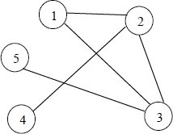
(a) Explain why the graph in Figure 1 is not a tree.
___________________________________________________________________
___________________________________________________________________
(1)
(b) Represent the graph shown in Figure 1 as an adjacency list by completing Table 1 .
Table 1

Vertex (in Figure 1) | Adjacent vertices
1
2
3
4
5
(2)
(c) Table 2 shows how the graph in Figure 1 can be represented as an adjacency matrix.
Table 2

Vertex (in Figure 1) | 1 | 2 | 3 | 4 | 5
1 | 0 | 1 | 1 | 0 | 0
2 | 1 | 0 | 1 | 1 | 0
3 | 1 | 1 | 0 | 0 | 1
4 | 0 | 1 | 0 | 0 | 0
5 | 0 | 0 | 1 | 0 | 0
Explain the circumstances in which it is more appropriate to represent a graph using an adjacency list instead of an adjacency matrix.
___________________________________________________________________
___________________________________________________________________
___________________________________________________________________
___________________________________________________________________
(2)
(d) Figure 2 shows an algorithm, written in pseudo-code, that CTC use.
Figure 2
NoOfCats ← 5
Cat[1] ← 1
FOR A ← 2 TO NoOfCats
B ← 1
C ← 1
WHILE B < A DO
IF M[A, B] = 1
THEN
IF Cat[B] = C
THEN
B ← 1
C ← C + 1
ELSE B ← B + 1
ENDIF
ELSE B ← B + 1
ENDIF
ENDWHILE
Cat[A] ← C
ENDFOR
The two-dimensional array, M, is used to store the adjacency matrix shown in Table 2.
Complete Table 3 to show the result of tracing the algorithm in Figure 2.
Table 3

 |  |  |  | Cat
NoOfCats | A | B | C | 1 | 2 | 3 | 4 | 5
(6)
(e) Explain the purpose of the algorithm in Figure 2.
___________________________________________________________________
___________________________________________________________________
(1)
(f) After a cat show, CTC needs to return the cats to their owners. They can have all the cats in the van at the same time because the show is now finished.
CTC likes to plan the return journey so that the shortest possible distance is travelled by the van. This is an example of an intractable problem.
What is meant by an intractable problem?
___________________________________________________________________
___________________________________________________________________
___________________________________________________________________
___________________________________________________________________
(2)
(g) What approach might a programmer take if asked to solve an intractable problem?
___________________________________________________________________
___________________________________________________________________
___________________________________________________________________
___________________________________________________________________
(2)
(Total 16 marks)
Mark schemes
Q1.
(a)
 |  | List
Ptr | Temp | [1] | [2] | [3] | [4] | [5] | [6] | [7] | [8] | [9] | [10]
 |  | 43 | 25 | 37 | 81 | 18 | 70 | 64 | 96 | 52 | 4
1 | 43 | 25 | 43
2 | 43 |  | 37 | 43
3
4 | 81 |  |  |  | 18 | 81
5 | 81 |  |  |  |  | 70 | 81
6 | 81 |  |  |  |  |  | 64 | 81
7
8 | 96 |  |  |  |  |  |  |  | 52 | 96
9 | 96 |  |  |  |  |  |  |  |  | 4 | 96
10
Ignore Ptr & Temp column
1 mark for each of rows 1, 2, 4, 5, 6, 8, 9
(Final list 25, 37, 43, 18, 70, 64, 81, 52, 4, 96)
7
(b) Control will pass to the instruction after Endwhile;
/the instruction/command/statement after Endwhile will be executed;
Program will exit while-block; loop stops;
A algorithim stops; R program stops;
Max 1
(c) (i) 25;
If part (a) not fully correct allow follow through: or lower of [1] & [2]
3
(ii) 81;
Only allow follow through mark if the list at the end of part(a) is still a partially sorted list
(iii) 96;
Must be 96 in all cases
[11]
Q2.
See trace table below. Sections corresponding to marks are shaded.
1 mark for newstring, message and procedure call correct. 1 mark for x and piece correct. 1 mark for outstring correct. 1 mark for changing x and a. 1 mark for tracing the second call to docharacter. 1 for section correct. 1 mark for third call correct. 1 mark for endprocs all correctly traced. 1 mark for outputs correct

 |  | ↓ |  |  |  |  |  | ↓ | Trace table |  |  |  | ↓
 | New string | message | a | Out string | x | piece | x>0? | a | Out string | x | piece | x>0? | a | Out string | x | piece | x>0? | output | marks
Input message |  | CAT
New string: = “” | ‘’’
Output message |  |  |  |  |  |  |  |  |  |  |  |  |  |  |  |  |  | CAT
Docharacter (message, new string) |  |  | CAT | ‘’’
x :=1en(a) |  |  |  |  | 3
Piece := Right$(a,1) |  |  |  |  |  | T
Outstring:=outstring+piece |  |  |  | T
x := x-1 |  |  |  |  | 2
If x>0 then |  |  |  |  |  |  | true
a= Left$(a,x) |  |  | CA
Docharacter (message, new string) |  |  |  |  |  |  |  | CA | T
x :=1en(a) |  |  |  |  |  |  |  |  |  | 2
Piece :=Right$(a, 1) |  |  |  |  |  |  |  |  |  |  | A
Outstring: = outstring+piece |  |  |  |  |  |  |  |  | TA
x :=x-1 |  |  |  |  |  |  |  |  |  | 1
If x>0 then |  |  |  |  |  |  |  |  |  |  |  | true
a= Left$ (a, x) |  |  |  |  |  |  |  | C
Docharacter (message, new string) |  |  |  |  |  |  |  |  |  |  |  |  | C | TA
x :=1en(a) |  |  |  |  |  |  |  |  |  |  |  |  |  |  | 1
Piece :=Right$(a, l) |  |  |  |  |  |  |  |  |  |  |  |  |  |  |  | C
Outstring: = outstring+piece |  |  |  |  |  |  |  |  |  |  |  |  |  | TAC
x :=x-1 |  |  |  |  |  |  |  |  |  |  |  |  |  |  | 0
If x>0 then |  |  |  |  |  |  |  |  |  |  |  |  |  |  |  |  | false
Endif
endproc |  |  |  |  |  |  |  | C | TAC
Endif
endproc |  |  | C | TAC
Endif
endproc | TAC | C
Output new string |  |  |  |  |  |  |  |  |  |  |  |  |  |  |  |  |  | TAC
Note that there is no need to trace a and outstring separately in each cell as there are parameters passed by reference. If they are included in the trace then recursive calls must be shown. X and piece must be shown as additional columns for each cell.
[9]
Q3.
Mark is for AO2 (analyse)

I | E | H
C | A | B
G | D | F
[1]
Q4.
Mark is for AO1 (knowledge)
Removing (unnecessary) details;
[1]
Q5.
Mark is for AO1 (knowledge)
Grouping by common characteristics // a hierarchical / ‘kind-of’ relationship;
[1]
Q6.
Mark is for AO2 (analyse)
(If there is a relationship between two cells is still represented but) if the relationship is because two cells are in the same row/column/two-by-two block is no longer represented // the nature of the link between the two cells is not represented; A. the location of a cell is not represented
[1]
Q7.
All marks for AO1 (understanding)
Adjacency matrix appropriate when there are many edges between vertices // when graph/matrix is not sparse; when edges frequently changed; when presence/absence of specific edges needs to be tested frequently;
Max 2 marks
A. Alternative words which describe edge, eg connection, line
[2]
Q8.
Mark is for AO1 (understanding)
Directed (graph) // digraph;
[1]
Q9.
Mark for AO1 (knowledge)
Zero or more (of the preceding element/character/value);
A. any number of the preceding element/character/value
[1]
Q10.
Mark for AO1 (knowledge)
Zero or one (of the preceding element/character/value) // (the preceding element/character/value is) optional;
[1]
Q11.
All marks AO2 (apply)

String | Belongs to language (Y/N)?
1 | Y
11 | N
01 | Y
0111 | Y
0101 | N
111 | N
0011 | N
Mark as follows:
1 mark: four rows correct
2 marks: five rows correct
3 marks: all seven rows correct
[3]
Q12.

(a) Causes process to repeat indefinitely
NOT repeats until maintain is TRUE
1
(b) Maintain has two values, TRUE / FALSE (1), => must be Boolean (1) n is used as an array subscript (1) => must be integer (1) or n is used as a loop control and can never be non-integer within the algorithm (1) => integer (1)
NOT numeric - too vague
4
(c) See table for model solution 1 mark each indicated section completed correctly, including follow–through (7x1); additional 1 mark for correctly modifying n downwards in penultimate section If candidates go completely wrong but clearly deserve some credit marks can be awarded on the following criteria, up to a maximum of 2 marks for correct sequence of loop repetitions, including the change from 6 to 5 then 6 - i.e. the column for n, including correct exit 2 marks for correct completion of the sequence of stations, ie the org, dest, start, finish columns
2 marks for correct completion of totalkm column, i.e. correct lookups and totalling 2 marks for correctly executing inner if branches, i.e. setting maintain and resetting totalkm in correct places. Total 8 marks for all-correct trace follow-through marks should be awarded where appropriate
8
(d) 2 marks for diagram, or explanation, showing that the journeys indicated above cover all routes in both directions marks can be awarded for any reasoned answer (indicating achievement or not) providing it is consistent with the candidate’s trace table Note: the sequence is MK -> SW -> CW -> SW -> TW -> HK -> MK -> QB -> SW etc., which does cover all lines in both directions. Strictly speaking, whether the objective is achieved depends whether journeys to/from MK depot are passenger-carrying / revenue-earning or not. Either interpretation is acceptable - the marks are awarded for the explanation.

n | org | dest | last | start | finish | totalkm | maintain | Remarks
 | 0 | 3 | 1
 |  |  |  |  |  |  | FALSE
 |  |  |  | MK
 |  |  |  |  | SW
 |  |  |  |  |  | 15
 | 3
0
Given

1
 |  | 4 |  |  |  |  |  | if ignored
 |  |  |  | SW |  |  |  | if ignored
 |  |  |  |  | CW
 |  |  |  |  |  | +27 = 42
 | 4 |  |  |  |  |  |  | N<6 so rpt
1 mark

2
 |  | 3 |  |  |  |  |  | if ignored
 |  |  |  | CW |  |  |  | if ignored
 |  |  |  |  | SW
 |  |  |  |  |  | +27 = 69
 | 3 |  |  |  |  |  |  | N<6 so rpt
1 mark

3
 |  | 1 |  |  |  |  |  | if ignored
 |  |  |  | SW |  |  |  | if ignored
 |  |  |  |  | TW
 |  |  |  |  |  | +37=106
 | 1 |  |  |  |  |  |  | N<6 so rpt
1 mark

4
 |  | 5 |  |  |  |  |  | if ignored
 |  |  |  | TW |  |  |  | if ignored
 |  |  |  |  | HK
 |  |  |  |  |  | +34=140
 | 5 |  |  |  |  |  |  | N<6 so rpt
5
1 mark

 |  | 2 |  |  |  |  |  | if ignored
 |  | 0 |  |  |  |  |  | >140 so if  executed
 |  |  | 5
 |  |  |  |  |  |  | True
 |  |  |  | HK
 |  |  |  |  | MK
 |  |  |  |  |  | +12=152
 | 0 |  |  |  |  |  |  | N<6 so rpt
1 mark

6 |  |  |  |  |  |  |  | TRUE so if executed
5
 |  |  |  |  |  | 0
 |  |  |  |  |  |  | False
 |  | 2
 |  |  |  |  |  |  |  | if ignored
 |  |  |  | MK
 |  |  |  |  | QB
 |  |  |  |  |  | +28 = 28
 | 2 |  |  |  |  |  |  | N<6 so rpt
1 mark

6
 |  | 3 |  |  |  |  |  | if ignored
 |  |  |  | QB |  |  |  | if ignored
 |  |  |  |  | SW
 |  |  |  |  |  | +43 = 71
 | 3
 |  |  |  |  |  |  |  | N = 6 so stop repeat loop
 |  |  |  |  |  |  |  | end while
1 mark
2
[15]
Q13.

(a) Mark is for AO1 (understanding)
It contains a cycle / cycles;
1
(b) All marks AO2 (apply)

Vertex (in  Figure 1 | Adjacent  vertices
1 | 2,3
2 | 1,3,4
3 | 1,2,5
4 | 2
5 | 3
Mark as follows:
1 mark: Three correct rows;
1 mark: All rows correct;
I Order of items within each list / row.
2
(c) All marks AO1 (understanding)
Adjacency list appropriate when there are few edges between
vertices / / when graph / matrix is sparse;
when edges rarely changed;
when presence / absence of specific edges does not need to be
tested (frequently);
Max 2
A Alternative words which describe edge, eg connection, line.
2
(d) All marks AO2 (apply)

 |  |  |  | Cat
NoOfCats | A | B | C | 1 | 2 | 3 | 4 | 5
5 |  |  |  | 1
 | 2 | 1 | 1
 |  | 1 | 2
 |  | 2 |  |  | 2
 | 3 | 1 | 1
 |  | 1 | 2
 |  | 2
 |  | 1 | 3
 |  | 2
 |  | 3 |  |  |  | 3
 | 4 | 1 | 1
 |  | 2
 |  | 3
 |  | 4 |  |  |  |  | 1
 | 5 | 1 | 1
 |  | 2
 |  | 3
 |  | 4
 |  | 5 |  |  |  |  |  | 1
Mark as follows:
1 mark: A is set the sequence indicated in the table;
1 mark: B is set the sequence indicated in the table;
1 mark: C is set the sequence indicated in the table;
1 mark: NoOfCats is set to 5, Cat[1] is set to 1;
1 mark: Cat[2] is set to 2 and Cat[3] is set to 3;
1 mark: Cat[4] is set to 1 and Cat[5] is set to 1;
Info for examiner: Ignore the empty cells in the sequences - values do not need to be set in the rows indicated in the table.
6
(e) Mark is for AO2 (analyse)
To work out which cats will travel together to the show / /
To plan which cats will be in the van on which journey to the cat show / /
To colour the vertices of a graph / /
To create a decomposition of a graph;
Max 1
1
(f) All marks AO1 (knowledge)
1 mark (1 from): The problem can be solved / / algorithm exists for problem;
But it cannot be solved in polynomial time / / but not quickly
enough to be useful;
Max 2
1 mark: It takes an unreasonable amount of time; to solve;
A Too long time but R Long time
2
(g) All marks AO1 (understanding)
1 mark: Use of heuristic; algorithm that makes a guess based on experience;
That provides a close-to-optimal solution / approximation; that only works in some cases; A non-optimal
Example of heuristic method eg hill-climbing / stochastic / local improvement / greedy algorithms / simulated annealing / trial and error / any reasonable example;
1 mark: Relax some of the constraints on the solution; A Solve simpler version of problem
2
[16]

