# Homework 4 TCP/IP

# A file is being transferred between two computers across a network.

1. Identify a protocol that could be used to transfer this file [1]
2. The network uses TCP/IP as shown below

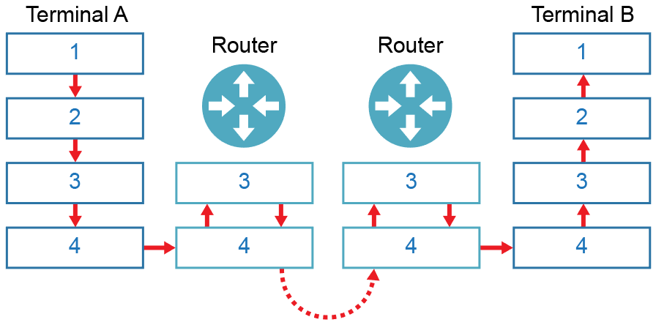

The numbers represent the layers of the TCP/IP stack. Name the layers   
in the table below: [4]

|  |  |
| --- | --- |
| **Label** | **Layer** |
| 1 |  |
| 2 |  |
| 3 |  |
| 4 |  |

1. Data packets travel from router to router on layers 3 and 4. As this happens, their headers change. Explain the changes with reference to IP and MAC addresses. [5]

# A self-employed accountant runs his own business from a small office. He has an email server that he uses to communicate with his clients. A firewall is also used.

1. Identify **one** protocol and its associated port that he can use to read email   
   held on this server. [2]
2. The accountant also uses his smartphone to access emails. He finds that emails he reads in the office do not appear on his phone. Explain why this is. [2]
3. A section of the company firewall log is displayed on the accountant’s computer.

Firewall blocked access to resource at 84.134.4.128:80

Firewall granted access to resource at 84.134.4.128:22

From the log above, give an example of the following:

1. Port number [1]
2. IP Address [1]
3. Socket [1]
4. Firewall settings currently restrict access to HTTP. Describe how Secure Shell could be used to circumvent this restriction and provide additional security.   
   Your answer should include what makes SSH a secure connection. [3]

[Total 20 Marks]