# Worksheet 5 IP addresses Answers

### Task 1

**Note:** Exercise 2 asks students to develop the spreadsheet formulae using logical functions. This is not a requirement of the specification, but if time allows, may help understanding of bitwise manipulation in the context of IP address masks. Otherwise, a completed spreadsheet is available enabling students to advance to Exercise 3.

1. Open up the spreadsheet **IP Addresses Blank.xlsx**
2. Use an appropriate formula that can be used to automatically determine the network and host IDs of a given IP address  
     
   *Hint: Use the AND, OR or NOT spreadsheet functions to replicate a bitwise operation to evaluate the each bit of the network and host IDs.*

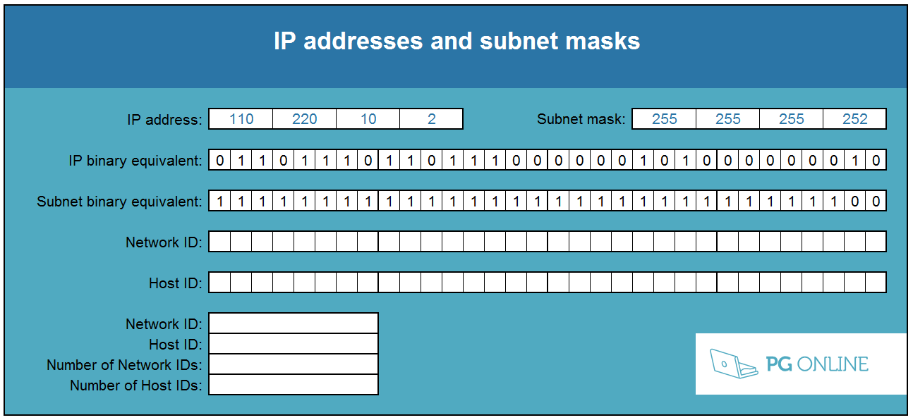

For the Network ID performs an AND operation on the IP address and the subnet mask. This evaluates to TRUE or FALSE which can be converted to a 1 or 0 by multiplying by 1 since TRUE * 1 is always 1 and FALSE * 1 is always 0.  
  
e.g. =AND(D8,D10)*1  
  
For the Host ID perform a NOT operation on the subnet mask and AND this with the IP address.  
  
e.g. =AND(D8,NOT(D10))*1

1. Use the spreadsheet to complete the following table: (A complete spreadsheet is available called **IP Addresses Complete.xlsx**.)

|  |  |  |  |  |  |
| --- | --- | --- | --- | --- | --- |
| **IP Address** | **Subnet mask** | **Network ID** | **Host ID** | **Number of network IDs for this subnet mask** | **Number of host IDs for this subnet mask** |
| 110.220.10.2 | 255.255.255.252 | 110.220.10.0 | 0.0.0.2 | 1,073,741,824  (1 gibinetwork) | 2 |
| 10.2.5.19 | 255.0.0.0 | 10.0.0.0 | 0.2.5.19 | 256 | 16,777,214  (16 mebihosts) |
| 253.63.48.99 | 255.255.0.0 | 253.63.0.0 | 0.0.48.99 | 65,536 | 65,534 |
| 33.66.99.11 | 255.255.255.128 | 33.66.99.0 | 0.0.0.11 | 33,554,432 | 126 |
| 33.66.99.240 | 255.255.255.128 | 33.66.99.128 | 0.0.0.112 | 33,554,432 | 126 |
| 48.65.195.253 | 255.192.0.0 | 48.64.0.0 | 0.1.195.253 | 1,024 | 4,194,302 |

1. What is the relationship between the number of network IDs and the number of   
   host IDs?

As the number of network IDs increases so must the number of bits that the Network ID uses.

Consequently, the remaining number bits for the Host ID decreases and the number of host IDs also decreases.

### Task 2

1. Design the IP address scheme for a private network for a university campus that has five different buildings. Each building needs its own subnet with at least 1000 IP addresses available.

The network manager has decided that subnet IDs should be within the range 192.168.0.0 to 192.168.19.254.

|  |  |  |  |  |
| --- | --- | --- | --- | --- |
| C:\Users\Rob\AppData\Roaming\PixelMetrics\CaptureWiz\Temp\41.png | | | | |
| **Network ID:**  192.168.0.0 | **Network ID:**  192.168.4.0 | **Network ID:**  192.168.8.0 | **Network ID:**  192.168.12.0 | **Network ID:**  192.168.16.0 |
| **Subnet mask:** 255.255.252.0 | **Subnet mask:** 255.255.252.0 | **Subnet mask:** 255.255.252.0 | **Subnet mask:** 255.255.252.0 | **Subnet mask:** 255.255.252.0 |

1. What are the advantages of subnetting a network like this?

The broadcast range for a subnetwork is greatly reduced from the whole. This increases security, speed and reliability.

A bus network configuration will allow for two computers on different subnets to communicate at the same time without colissions.

### Task 3

1. The subnets in Task 2 are connected via a network of routers. What additional network setting will be needed on each host so that machines in one building can communicate with another?  
     
   Default gateway in its own subnet (IP address of nearest router).
2. Explain why this is needed within the context of subnets.  
     
   The IP addresses in different buildings are all on different subnets. If a host on one subnet needs to communicate with a host on another it will need to know where to direct traffic if it is not on its immediate network.
3. The first two octets of the IP range used are 192.168. Explain why this is.  
     
   This is a private IP address. It is not routable on the Internet but it can be used however the user sees fit. There is no need for these addresses to be registered with an Internet registrar or to be unique.
4. The network of routers also includes a connection to the Internet. Explain, giving examples, how NAT will allow hosts on the network to access websites on the Internet.  
     
   The device running NAT will sit on the edge of the network connected to the Internet. As the hosts have private IP addresses they will be directed to the device running the NAT service when they want to communicate via the Internet. NAT will accept a request on a host’s behalf for a resource and will record the internal IP address and the source port number. It will replace this with its own public values. When data is returned, the NAT service will reverse the process substituting its own port and IP values with those it stored when the previous request was sent out.