# Assessment test

1. A website is hosted in the USA.
2. Explain how the structure of the Internet allows users in other countries access

to the website. [2]

(b) The website is accessed via the domain name starsnstripes.com.   
What is the name of the top-level domain used in this address? [1]

(c) The IP address assigned to starsnstripes.com is 132.154.3.78.   
  
(i) Explain the relationship between the domain name and the IP address. [2]

(ii) Why are websites not addressed purely by their IP address? [1]

(d) The Indian company, Reliance Jio Infocomm Limited, is the current owner of the IP address block 132.154.0.0 to 132.154.255.255, located in the USA. Suppose that this ISP wants to separate the block into 50 separate different subnets. Calculate the maximum number of hosts possible per network if they make a minimum of 50 different subnets (show your working). [4]

1. Two Government offices are connected across the Internet as follows:

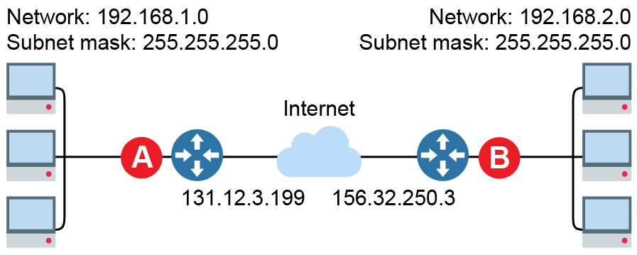

(a) Suggest a suitable IP address for the router interfaces labelled A and B. [2]

(b) Outline how hosts with private IP addresses on each subnet are able to   
communicate via the Internet. [2]

(c) State a security feature that should be present on each router. [1]

(d) To maximise security of data transmitted across the Internet, asymmetric encryption is used. Explain how hosts in the different subnets can send and receive encrypted data that only they can decrypt. [4]

(e) Explain how a digital signature is produced and verifies that the message has not been tampered with. [4]

(f) The use of a digital certificate could also enhance the security of the data being transferred. Explain how this can be used to authenticate the sender of the data. [3]

1. The TCP/IP protocol stack is used extensively in many computer networks including the Internet.

(a) Describe the role of each of the four layers of the stack. [6]

1. Firewalls are designed to block traffic that should not be allowed through.

Explain how allowing SSH might allow other blocked traffic through. [2]

(c) Data from a private local network can be forwarded across the Internet using packet switching. Describe how this is achieved. Make reference in your answer to the use of routers, packets and the IP protocol on the Network layer. [6]

1. The Domain Name System (DNS) is a method for assigning alphanumeric addresses to hosts on a network.

(a) DNS is used extensively on the Internet. Explain how the assignment of IP addresses to domain names is managed. [2]

(b) Explain how a client uses DNS to determine the IP address of the webserver www.google.co.uk for the first time. [4]

1. Attacks on systems are frequently identified and blocked using various techniques.

(a) Describe the role of a firewall in blocking unauthorised access. [2]

(b) Describe how stateful inspection provides additional security against malicious data. [2]

[Total 50 Marks]