|  |  |  |  |  |  |  |  |  |  |  |  |  |  |
| --- | --- | --- | --- | --- | --- | --- | --- | --- | --- | --- | --- | --- | --- |
| 001 | | | | | | | | |  |  |  |  |  |
|  | | | |  | **IP** | | | | | |  |  |  |
| 1 1 1 | | | |  | 101 | | | | | |  |  |  |
| 10011000 | |  |  |  |  |  |  |  |  |  |  |  |  |
|  | 11111 | | |  |  |  |  |  |  |  |  |  |  |
|  | 1 1 | | |  |  |  |  |  |  |  |  |  |  |
|  |  | 111 | |  |  |  |  |  |  |  |  |  |  |
|  | 1 | | 1 1 |  |  |  |  |  |  |  |  |  |  |
|  | 1 11 | | |  |  |  |  |  |  |  |  |  |  |
| 1111 1 1 1 | | | |  |  |  |  |  |  |  |  |  |  |
| 11 1 | 11 1 | | |  |  |  |  |  |  |  |  |  |  |
| 1 1 |  | 1 1 | |  |  |  |  |  |  |  |  |  |  |
| 1 1 1 1 | |  | 1 |  |  |  |  |  |  |  |  |  |  |
| 1 1 1 | |  | 1 1 |  |  |  |  |  |  |  |  |  |  |
| 11 1 11 | | | 1 |  |  |  |  |  |  |  |  |  |  |
| 11 1 1 | |  |  |  |  |  |  |  |  |  |  |  |  |
| 1 1 1 | | | |  |  |  |  |  |  |  |  |  |  |
| 1 | 1 1 | | |  |  |  |  |  |  |  |  |  |  |
|  |  |  |  |  |  | **Addressing** | | | | |  |  |  |
|  |  |  |  |  |  |  |  | **and** | | |  |  |  |
|  |  |  |  |  |  | **Subnetting** | | | | |  |  |  |
|  |  |  |  |  |  |  |  | **Workbook** | | |  |  |  |
|  |  |  |  |  |  |  |  | **Version 1.5** | | |  |  |  |
|  |  | | |  |  | |  |  |  |  |  |  |  |
|  |  | | |  | | |  |  |  |  |  |  |  |
|  | 10010101 | | | | | |  |  |  |  |  |  |  |
| 00011011 | | | | | |  |  | 10000110 | | | | |  |
| 11010011 | | | | | | |  | Student Name: |  |  |  |  |  |
|  |  |  |  |  |  |  |  |  |  |  | | |  |
|  |  |  |  |  |  |  |  |  |  |  |  |  |  |
|  |  |  |  |  |  |  |  |  |  |  |  |  |  |

**IP Address Classes**

|  |  |  |  |  |  |  |  |
| --- | --- | --- | --- | --- | --- | --- | --- |
| Class A | 1 – 127 | (Network 127 is reserved for loopback and internal testing) | | | | | |
|  |  | Leading bit pattern | 0 | 00000000.00000000.00000000.00000000 | | | |
|  |  |  |  | **Network .** | **Host .** | **Host .** | **Host** |
| Class B | 128 – 191 | Leading bit pattern | 10 | 10000000.00000000.00000000.00000000 | | | |
|  |  |  |  | **Network .** | **Network .** | **Host.** | **Host** |
| Class C | 192 – 223 | Leading bit pattern | 110 | 11000000.00000000.00000000.00000000 | | | |
|  |  |  |  | **Network .** | **Network .** | **Network .** | **Host** |
| Class D | 224 – 239 | (Reserved for multicast) | |  |  |  |  |
| Class E | 240 – 255 | (Reserved for experimental, used for research) | | | | |  |

**Private Address Space**

Class A 10.0.0.0 to 10.255.255.255

Class B 172.16.0.0 to 172.31.255.255

Class C 192.168.0.0 to 192.168.255.255

**Default Subnet Masks**

|  |  |
| --- | --- |
| Class A | 255.0.0.0 |
| Class B | 255.255.0.0 |
| Class C | 255.255.255.0 |

Produced by: Robb Jones jonesr@careertech.net

Frederick County Career & Technology Center

Cisco Networking Academy

Frederick County Public Schools

Frederick, Maryland, USA

Special Thanks to Melvin Baker and Jim Dorsch for taking the time to check this workbook for errors,

and to everyone who has sent in suggestions to improve the series.

**Workbooks included in the series:**

IP Addressing and Subnetting Workbooks

ACLs - Access Lists Workbooks

VLSM Variable-Length Subnet Mask IWorkbooks

Inside Cover

**Binary To Decimal Conversion**

|  |  |  |  |  |  |  |  |  |  |  |  |  |  |  |
| --- | --- | --- | --- | --- | --- | --- | --- | --- | --- | --- | --- | --- | --- | --- |
| **128** | **64** | **32** | **16** | **8** | **4** | **2** | **1** | **Answers** |  | **Scratch Area** | | | |  |
| 1 | 0 | 0 | 1 | 0 | 0 | 1 | 0 | *146* | *128* | | *64* | |  |  |
|  |  |  |  |  |  |  |  |  | *16* | | *32* | |  |  |
|  |  |  |  |  |  |  |  |  |  |
| 0 | 1 | 1 | 1 | 0 | 1 | 1 | 1 | *119* |  | *2* | *16* | |  |  |
| *146* | |  |
|  |  |  |  |  |  |  |  |  | *4* | |  |  |
|  |  |  |  |  |  |  |  |  |  |
| 1 | 1 | 1 | 1 | 1 | 1 | 1 | 1 |  |  |  | *2* | |  |  |
|  |  |  |  |  |  |  |  |  |  |  | *1* | |  |  |
|  |  |  |  |  |  |  |  |  |  |  |  |
| 1 | 1 | 0 | 0 | 0 | 1 | 0 | 1 |  |  |  |  | *119* |  |  |
| 1 | 1 | 1 | 1 | 0 | 1 | 1 | 0 |  |  |  |  |  |  |  |
| 0 | 0 | 0 | 1 | 0 | 0 | 1 | 1 |  |  |  |  |  |  |  |
| 1 | 0 | 0 | 0 | 0 | 0 | 0 | 1 |  |  |  |  |  |  |  |
| 0 | 0 | 1 | 1 | 0 | 0 | 0 | 1 |  |  |  |  |  |  |  |
| 0 | 1 | 1 | 1 | 1 | 0 | 0 | 0 |  |  |  |  |  |  |  |
|  |  |  |  |  |  |  |
| 1 | 1 | 1 | 1 | 0 | 0 | 0 | 0 |  |  |  |  |  |  |  |
| 0 | 0 | 1 | 1 | 1 | 0 | 1 | 1 |  |  |  |  |  |  |  |
| 0 | 0 | 0 | 0 | 0 | 1 | 1 | 1 |  |  |  |  |  |  |  |

00011011

10101010

01101111

11111000

00100000

01010101

00111110

00000011

11101101

11000000

1

**Decimal To Binary Conversion**

Use all 8 bits for each problem

|  |  |  |  |  |  |  |  |  |  |  |  |  |  |  |  |
| --- | --- | --- | --- | --- | --- | --- | --- | --- | --- | --- | --- | --- | --- | --- | --- |
| **128** | **64** | **32** | **16** | **8** | **4** | **2** | **1 = 255** | |  |  | **Scratch Area** | | | |  |
| *1* | *1* | *1* | *0* | *1* | *1* | *1* | *0* | 238 | *238* | | | *34* | |  |  |
| _________________________________________ | | | | | | | |  | *-128* | | |  | |  |  |
| *0* | *0* | *1* | *0* | *0* | *0* | *1* | *0* |  |  | | | *-32* | |  |  |
|  |  |  |  |  |  |  |  | 34 | *110* | | | *2* | |  |  |
| _________________________________________ | | | | | | | |  |  | *-64* | |  | |  |  |
|  |  |  |  |  |  |  |  |  |  |  | | *-2* | |  |  |
|  |  |  |  |  |  |  |  |  | *46* | | |  | |  |  |
| _________________________________________ | | | | | | | | 123 |  | | |  | *0* |  |  |
|  |  |  |  |  |  |  |  |  | *-32* | | |  |  |  |  |
| _________________________________________ | | | | | | | | 50 | *14* | | |  |  |  |  |
|  |  |  |  |  |  |  |  |  | *-8* | | |  |  |  |  |
| _________________________________________ | | | | | | | | 255 |  | | *6* |  |  |  |  |
|  |  |  |  |  |  |  |  |  | *-4* | | |  |  |  |  |
| _________________________________________ | | | | | | | | 200 | *2* | | |  |  |  |  |
|  |  |  |  |  |  |  |  |  | *-2* | | |  |  |  |  |
| _________________________________________ | | | | | | | | 10 | *0* | | |  |  |  |  |
| _________________________________________ | | | | | | | | 138 |  |  |  |  |  |  |  |
| _________________________________________ | | | | | | | | 1 |  |  |  |  |  |  |  |
| _________________________________________ | | | | | | | | 13 |  |  |  |  |  |  |  |
| _________________________________________ | | | | | | | | 250 |  |  |  |  |  |  |  |
| _________________________________________ | | | | | | | | 107 |  |  |  |  |  |  |  |
| _________________________________________ | | | | | | | | 224 |  |  |  |  |  |  |  |
| _________________________________________ | | | | | | | | 114 |  |  |  |  |  |  |  |
| _________________________________________ | | | | | | | | 192 |  |  |  |  |  |  |  |
| _________________________________________ | | | | | | | | 172 |  |  |  |  |  |  |  |
| _________________________________________ | | | | | | | | 100 |  |  |  |  |  |  |  |
| _________________________________________ | | | | | | | | 119 |  |  |  |  |  |  |  |
| _________________________________________ | | | | | | | | 57 |  |  |  |  |  |  |  |
| _________________________________________ | | | | | | | | 98 |  |  |  |  |  |  |  |
| _________________________________________ | | | | | | | | 179 |  |  |  |  |  |  |  |
| _________________________________________ | | | | | | | | 2 |  |  |  |  |  |  |  |
| 2 |  |  |  |  |  |  |  |  |  |  |  |  |  |  |  |

|  |  |  |  |
| --- | --- | --- | --- |
|  | **Address Class Identification** |  |  |
| **Address** | **Class** |  |  |
| 10.250.1.1 | _____ |  |  |
|  | *A* |  |  |
| 150.10.15.0 | _____ |  |  |
|  | *B* |  |  |
| 192.14.2.0 | _____ |  |  |
| 148.17.9.1 | _____ |  |  |
| 193.42.1.1 | _____ |  |  |
| 126.8.156.0 | _____ |  |  |
| 220.200.23.1 | _____ |  |  |
| 230.230.45.58 | _____ |  |  |
| 177.100.18.4 | _____ |  |  |
| 119.18.45.0 | _____ |  |  |
| 249.240.80.78 | _____ |  |  |
| 199.155.77.56 | _____ |  |  |
| 117.89.56.45 | _____ |  |  |
| 215.45.45.0 | _____ |  |  |
| 199.200.15.0 | _____ |  |  |
| 95.0.21.90 | _____ |  |  |
| 33.0.0.0 | _____ |  |  |
| 158.98.80.0 | _____ |  |  |
| 219.21.56.0 | _____ | 3 |  |
|  |  |  |  |

**Network & Host Identification**

|  |  |
| --- | --- |
| Circle the network portion | Circle the host portion of |
| of these addresses: | these addresses: |
| 177.100.18.4 | 10.15.123.50 |
| 119.18.45.0 | 171.2.199.31 |
| 209.240.80.78 | 198.125.87.177 |
| 199.155.77.56 | 223.250.200.222 |
| 117.89.56.45 | 17.45.222.45 |
| 215.45.45.0 | 126.201.54.231 |
| 192.200.15.0 | 191.41.35.112 |
| 95.0.21.90 | 155.25.169.227 |
| 33.0.0.0 | 192.15.155.2 |
| 158.98.80.0 | 123.102.45.254 |
| 217.21.56.0 | 148.17.9.155 |
| 10.250.1.1 | 100.25.1.1 |
| 150.10.15.0 | 195.0.21.98 |
| 192.14.2.0 | 25.250.135.46 |
| 148.17.9.1 | 171.102.77.77 |
| 193.42.1.1 | 55.250.5.5 |
| 126.8.156.0 | 218.155.230.14 |
| 220.200.23.1 | 10.250.1.1 |

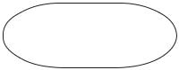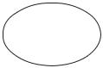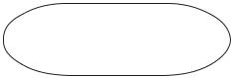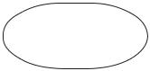

4

**Network Addresses**

Using the IP address and subnet mask shown write out the network address:

*188 . 10 . 0 . 0*

188.10.18.2 _____________________________

255.255.0.0

*10 . 10 . 48 . 0*

10.10.48.80 _____________________________

255.255.255.0

192.149.24.191 _____________________________

255.255.255.0

150.203.23.19 _____________________________

255.255.0.0

10.10.10.10 _____________________________

255.0.0.0

186.13.23.110 _____________________________

255.255.255.0

223.69.230.250 _____________________________

255.255.0.0

200.120.135.15 _____________________________

255.255.255.0

27.125.200.151 _____________________________

255.0.0.0

199.20.150.35 _____________________________

255.255.255.0

191.55.165.135 _____________________________

255.255.255.0

28.212.250.254 _____________________________

255.255.0.0

5

**Host Addresses**

Using the IP address and subnet mask shown write out the host address:

*0 . 0 . 18 . 2*

188.10.18.2 _____________________________

255.255.0.0

*0 . 0 . 0 . 80*

10.10.48.80 _____________________________

255.255.255.0

222.49.49.11 _____________________________

255.255.255.0

128.23.230.19 _____________________________

255.255.0.0

10.10.10.10 _____________________________

255.0.0.0

200.113.123.11 _____________________________

255.255.255.0

223.169.23.20 _____________________________

255.255.0.0

203.20.35.215 _____________________________

255.255.255.0

117.15.2.51 _____________________________

255.0.0.0

199.120.15.135 _____________________________

255.255.255.0

191.55.165.135 _____________________________

255.255.255.0

48.21.25.54 _____________________________

255.255.0.0

6

**Default Subnet Masks**

Write the correct default subnet mask for each of the following addresses:

*255 . 255 . 0 . 0*

177.100.18.4 _____________________________

*255 . 0 . 0 . 0*

119.18.45.0 _____________________________

191.249.234.191 _____________________________

223.23.223.109 _____________________________

10.10.250.1 _____________________________

126.123.23.1 _____________________________

223.69.230.250 _____________________________

192.12.35.105 _____________________________

77.251.200.51 _____________________________

189.210.50.1 _____________________________

88.45.65.35 _____________________________

128.212.250.254 _____________________________

193.100.77.83 _____________________________

125.125.250.1 _____________________________

1.1.10.50 _____________________________

220.90.130.45 _____________________________

134.125.34.9 _____________________________

95.250.91.99 _____________________________

7

**ANDING With**

**Default subnet masks**

Every IP address must be accompanied by a subnet mask. By now you should be able to look at an IP address and tell what class it is. Unfortunately your computer doesn’t think that way.

For your computer to determine the network and subnet portion of an IP address it must

“AND” the IP address with the subnet mask.

**Default Subnet Masks:**

|  |  |
| --- | --- |
| Class A | 255.0.0.0 |
| Class B | 255.255.0.0 |
| Class C | 255.255.255.0 |

**ANDING Equations:**

1 AND 1 = 1

1 AND 0 = 0

0 AND 1 = 0

0 AND 0 = 0

**Sample:**

What you see...

|  |  |
| --- | --- |
| IP Address: | 192 . 100 . 10 . 33 |

What you can figure out in your head...

|  |  |
| --- | --- |
| Address Class: | C |
| Network Portion: | **192 . 100 . 10** . 33 |
| Host Portion: | 192 . 100 . 10 . **33** |

In order for you computer to get the same information it must AND the IP address with the subnet mask in binary.

**Network** **Host**

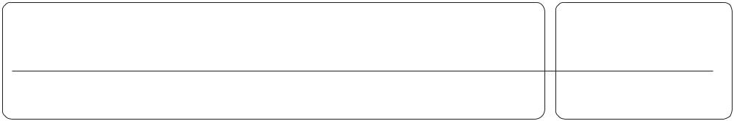

IP Address: 1 1 0 0 0 0 0 0 . 0 1 1 0 0 1 0 0 . 0 0 0 0 1 0 1 0 . 0 0 1 0 0 0 0 1 Default Subnet Mask: 1 1 1 1 1 1 1 1 . 0 1 1 1 1 1 1 1 . 1 1 1 1 1 1 1 1 . 0 0 0 0 0 0 0 0

AND: 1 1 0 0 0 0 0 0 . 0 1 1 0 0 1 0 0 . 0 0 0 0 1 0 1 0 . 0 0 0 0 0 0 0 0

(192 . 100 . 10 . 33)

(255 . 255 . 255 . 0)

(192 . 100 . 10 . 0)

ANDING with the default subnet mask allows your computer to figure out the network portion of the address.

8

**ANDING With**

**Custom subnet masks**

When you take a single network such as 192.100.10.0 and divide it into five smaller networks

(192.100.10.16, 192.100.10.32, 192.100.10.48, 192.100.10.64, 192.100.10.80) the outside world still sees the network as 192.100.10.0, but the internal computers and routers see five smaller subnetworks. Each independent of the other. This can only be accomplished by using a custom subnet mask. A custom subnet mask borrows bits from the host portion of the address to create a subnetwork address between the network and host portions of an IP address. In this example each range has 14 usable addresses in it. The computer must still

AND the IP address against the custom subnet mask to see what the network portion is and which subnetwork it belongs to.

|  |  |
| --- | --- |
| IP Address: | 192 . 100 . 10 . 0 |
| Custom Subnet Mask: | 255.255.255.240 |

Address Ranges: 192.10.10.0 to 192.100.10.15 192.100.10.16 to 192.100.10.31

192.100.10.32 to 192.100.10.47 (Range in the sample below) 192.100.10.48 to 192.100.10.63

192.100.10.64 to 192.100.10.79 192.100.10.80 to 192.100.10.95 192.100.10.96 to 192.100.10.111 192.100.10.112 to 192.100.10.127 192.100.10.128 to 192.100.10.143 192.100.10.144 to 192.100.10.159 192.100.10.160 to 192.100.10.175 192.100.10.176 to 192.100.10.191 192.100.10.192 to 192.100.10.207 192.100.10.208 to 192.100.10.223 192.100.10.224 to 192.100.10.239 192.100.10.240 to 192.100.10.255

|  |  |
| --- | --- |
|  | **Sub** |
| **Network** | **Network Host** |

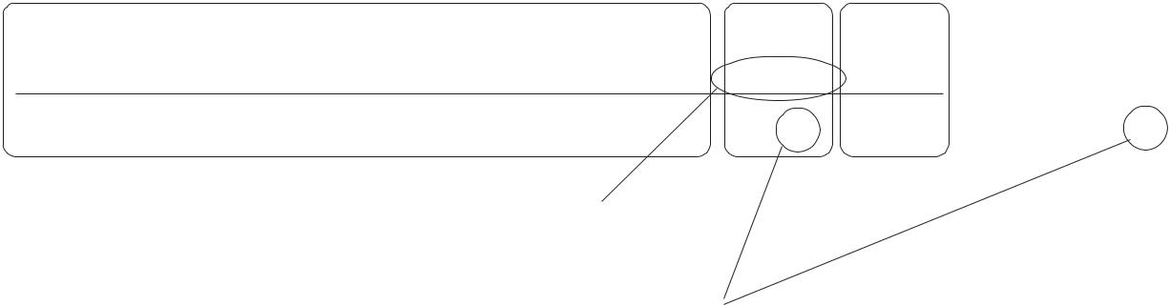

IP Address: 1 1 0 0 0 0 0 0 . 0 1 1 0 0 1 0 0 . 0 0 0 0 1 0 1 0 . 0 0 1 0 0 0 0 1 (192 . 100 . 10 . 33) Custom Subnet Mask: 1 1 1 1 1 1 1 1 . 0 1 1 1 1 1 1 1 . 1 1 1 1 1 1 1 1 . 1 1 1 1 0 0 0 0 (255 . 255 . 255 . 240)

AND: 1 1 0 0 0 0 0 0 . 0 1 1 0 0 1 0 0 . 0 0 0 0 1 0 1 0 . 0 0 1 0 0 0 0 0 (192 . 100 . 10 . 32)

Four bits borrowed from the host portion of the address for the custom subnet mask.

The ANDING process of the four borrowed bits shows which range of IP addresses this particular address will fall into.

In the next set of problems you will determine the necessary information to determine the correct subnet mask for a variety of IP addresses.

9

**How to determine the number of subnets and the number of hosts per subnet**

Two formulas can provide this basic information:

**Number of subnets = 2 s** (Second subnet formula: **Number of subnets = 2s** **- 2**)

**Number of hosts per subnet = 2h - 2**

Both formulas calculate the number of hosts or subnets based on the number of binary bits used. For example if you borrow three bits from the host portion of the address use the *number of subnets* formula to determine the total number of subnets gained by borrowing thethree bits. This would be 23 or 2 x 2 x 2 = 8 subnets

To determine the number of hosts per subnet you would take the number of binary bits used in the host portion and apply this to the *number of hosts per subnet* formula If five bits are in the host portion of the address this would be 25 or 2 x 2 x 2 x 2 x 2 = 32 hosts.

When dealing with the *number of hosts per subnet* you have to subtract two addresses from the range. The first address in every range is the subnet number. The last address in every range is the broadcast address. These two addresses cannot be assigned to any device in the network which is why you have to subtract two addresses to find the number of usable addresses in each range.

For example if two bits are borrowed for the network portion of the address you can easily determine the number of subnets and hosts per subnets using the two formulas.

|  |  |  |  |  |  |  |  |
| --- | --- | --- | --- | --- | --- | --- | --- |
| ***195. 223 . 50 . 0 0*** | | |  | ***0 0 0 0 0 0*** | |  |  |
|  |  |  |
|  |  |  |  |  |  |  |  |
|  | The number of subnets |  |  |  | The number of hosts created by |  |  |
|  | created by borrowing 2 |  |  |  | leaving 6 bits is 26 - 2 or |  |  |
|  | bits is 22 or 2 x 2 = 4 |  |  |  | 2 x 2 x 2 x 2 x 2 x 2 = 64 - 2 = 62 |  |  |
|  | subnets. |  |  |  | usable hosts per subnet. |  |  |
|  |  |  |  |  |  |  |  |
|  |  |  |  |  |  |  |  |



**What about that second subnet formula:**

**Number of subnets = 2 s - 2**

In some instances the first and last subnet range of addresses are reserved. This is similar to the first and last host addresses in each range of addreses.

The first range of addresses is the ***zero subnet***. The subnet number for the *zero subnet* is also the subnet number for the classful subnet address.

The last range of addresses is the ***broadcast subnet***. The broadcast address for the last subnet in *the broadcast subnet* is the same as the classful broadcast address.

10

**Class C Address unsubnetted:**

***195. 223 . 50 . 0***

|  |  |  |  |  |  |  |  |  |
| --- | --- | --- | --- | --- | --- | --- | --- | --- |
| *195.223.50.0 to* | *195.223.50.255* | | |  |  |  |  |  |
|  |  |  |  |  |  | Notice that the subnet and |  |  |
| **Class C Address subnetted** (2 bits borrowed): | | | |  |  | broadcast addresses match. |  |  |
|  |  |  |  |  |
| ***195. 223 . 50 . 0 0*** | |  | ***0 0 0 0 0 0*** | | | |  |  |
|  |  |  |
| *(Invalid range) (0)* |  |  |  | *to* | | *195.223.50.63* |  |  |
| *195.223.50.0* | | |  |  |
| *(1)* | *195.223.50.64* | | | *to* | | *195.223.50.127* | |  |
| *(2)* | *195.223.50.128* | | | *to* | | *195.223.50.191* | |  |
| *(Invalid range) (3)* | *195.223.50.192* | | | *to* | | *195.223.50.255* | |  |

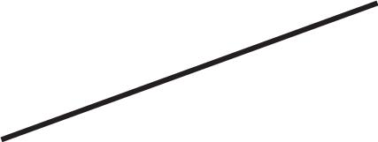

The primary reason the the zero and broadcast subnets were not used had to do pirmarily with the broadcast addresses. If you send a broadcast to 195.223.255 are you sending it to all 255 addresses in the classful C address or just the 62 usable addresses in the broadcast range?

The **CCNA** and **CCENT** certification exams may have questions which will require you to determine which formula to use, and whehter or not you can use the first and last subnets. Use the chart below to help decide.

**When to use which formula to determine the number of subnets**

|  |  |
| --- | --- |
| Use the **2s** **- 2** formula and **don’t use** the | Use the **2s** formula and **use** the zero and |
| zero and broadcast ranges if... | broadcast ranges if... |
|  |  |
| Classful routing is used | Classless routing or VLSM is used |
|  |  |
| RIP version 1 is used | RIP version 2, EIGRP, or OSPF is used |
|  |  |
| The ***no ip subnet zero*** command is | The ***ip subnet zero*** command is |
| configured on your router | configured on your router (default setting) |
|  |  |
|  | No other clues are given |
|  |  |

Bottom line for the CCNA exams; if a question does not give you any clues as to whether or not to allow these two subnets, assume you can use them.

This workbook has you use the number of subnets = 2**s** formula.

11

**Custom Subnet Masks**

**Problem 1**

Number of needed subnets **14**

Number of needed usable hosts **14**

Network Address **192.10.10.0**

Address class __________*C*

Default subnet mask _______________________________*255.255.255.0*

Custom subnet mask _______________________________*255.255.255.240*

Total number of subnets ___________________*16*

Total number of host addresses ___________________*16*

Number of usable addresses ___________________*14*

Number of bits borrowed ___________________*4*

**Show your work for Problem 1 in the space below.**

|  |  |  |  |  |  |  |  |  |  |  |  |
| --- | --- | --- | --- | --- | --- | --- | --- | --- | --- | --- | --- |
|  | *256 128 64* | | | *32* | *16* | *8* | *4* | *2* | *-* | *Number of* |  |
| *Number of* | *Hosts* |  |
|  | *4* | *8* | *16* | *32* | *64 128* | | *256* | |  |  |
| *Subnets - 2* | |  |  |
|  | *128* | *64* | *32* | *16* | *8* | *4* | *2* | *1* | *-* | *Binary values* |  |

***192 . 10 . 10 . 0 0 0 0 0 0 0 0***

Add the binary value numbers to the left of the line to create the custom subnet mask.

*128*

*64*

*32*

*+16*

*240*

*16 -2 ~~14~~*

Observe the total number of hosts.

Subtract 2 for the number of usable hosts.

12

**Custom Subnet Masks**

**Problem 2**

Number of needed subnets **1000**

Number of needed usable hosts **60**

Network Address **165.100.0.0**

Address class __________*B*

Default subnet mask _______________________________*255.255.0.0*

Custom subnet mask _______________________________*255.255.255.192*

Total number of subnets ___________________*1,024*

Total number of host addresses ___________________*64*

Number of usable addresses ___________________*62*

Number of bits borrowed ___________________*10*

**Show your work for Problem 2 in the space below.**

*Number of*

*Hosts*

*65,53632,76816,3848,1924,0962,0481,024512 -* 

|  |  |  |  |  |  |
| --- | --- | --- | --- | --- | --- |
| *. 256 128* | *64 32* | *16* | *8* | *4* | *2* |

|  |  |  |  |  |  |  |  |  |  |  |  |  |  |  |  |  |
| --- | --- | --- | --- | --- | --- | --- | --- | --- | --- | --- | --- | --- | --- | --- | --- | --- |
| *Number of* |  |  |  |  |  |  |  |  |  |  |  |  |  |  |  |  |
|  |  |  |  |  |  |  |  |  |  |  |  |  |  |
|  |  |  |  |  |  |  |  |  |  |  |  |  |  |  |  |
|  |  |  |  | *8* | | *16* | | *32* | | *64* | | *128 256.* | | |  |
| *Subnets - 2 4* | | | | |  |
| *Binary values - 128 64* | | | | | *32* | | *16* | | *8* | | *4* | | *2 1* ***.*** | | |  |

|  |  |  |  |  |  |  |  |
| --- | --- | --- | --- | --- | --- | --- | --- |
|  |  |  |  | *16,38432,76865,536* | | | |
| *512102420484,0968,192* | | | | |  |  |  |
| *128* | *64* | *32* | *16* | *8* | *4* | *2* | *1* |

***165 . 100 . 0 0 0***

|  |  |  |
| --- | --- | --- |
|  | *128* |  |
|  | *64* |  |
|  | *32* |  |
| Add the binary value | *16* |  |
| numbers to the left of the line to | *8* |  |
| *4* |  |
| create the custom subnet mask. |  |

*2*

*+1*

*255*

***0 0 0 0 0 . 0***

*128*

*+64*

*192* *64 -2 62*

***0 0 0 0 0 0 0***

Observe the total number of hosts.

Subtract 2 for the number of usable hosts.

13

|  |  |  |  |
| --- | --- | --- | --- |
| **Custom Subnet Masks** | |  |  |
| **Problem 3** |  | bits used for the network and |  |
|  |  | **/26** indicates the total number of |  |
| Network Address **148.75.0.0 /26** address. All bits remaining belong | | |  |
|  |  | subnetwork portion of the |  |
|  | *B* | to the host portion of the address. |  |
| Address class |  |  |
| Default subnet mask | *255 . 255 . 0 . 0* | |  |
| Custom subnet mask | *255 . 255 . 255 . 192* | |  |
| Total number of subnets | *1,024* |  |  |
| Total number of host addresses | *64* |  |  |
| Number of usable addresses | *62* |  |  |
| Number of bits borrowed | *10* |  |  |



**Show your work for Problem 3 in the space below.**

*Number of*

*Hosts*

*65,53632,76816,3848,1924,0962,0481,024512 -* 

|  |  |  |  |  |  |
| --- | --- | --- | --- | --- | --- |
| *. 256 128* | *64 32* | *16* | *8* | *4* | *2* |

|  |  |  |  |  |  |  |  |  |  |  |  |  |  |  |  |  |
| --- | --- | --- | --- | --- | --- | --- | --- | --- | --- | --- | --- | --- | --- | --- | --- | --- |
| *Number of* |  |  |  |  |  |  |  |  |  |  |  |  |  |  |  |  |
|  |  |  |  |  |  |  |  |  |  |  |  |  |  |
|  |  |  |  |  |  |  |  |  |  |  |  |  |  |  |  |
|  |  |  |  | *8* | | *16* | | *32* | | *64* | | *128 256.* | | |  |
| *Subnets - 2 4* | | | | |  |
| *Binary values - 128 64* | | | | | *32* | | *16* | | *8* | | *4* | | *2 1* ***.*** | | |  |

|  |  |  |  |  |  |  |  |
| --- | --- | --- | --- | --- | --- | --- | --- |
|  |  |  |  | *16,38432,76865,536* | | | |
| *512102420484,0968,192* | | | | |  |  |  |
| *128* | *64* | *32* | *16* | *8* | *4* | *2* | *1* |

***148 . 75 . 0 0 0***

|  |  |  |
| --- | --- | --- |
|  | *128* |  |
|  | *64* |  |
|  | *32* |  |
| Add the binary value | *16* |  |
| numbers to the left of the line to | *8* |  |
| *4* |  |
| create the custom subnet mask. |  |

*2*

*+1*

*255*

***0 0 0***

*128*

*+64*

*192*

*1024 -2 1,022*

***0 0 . 0 0 0 0 0 0 0 0***

|  |  |  |
| --- | --- | --- |
| *64* | hosts.Observe the total number of |  |
| *-2* | Subtract 2 for the number of |  |
| *62* |  |
| usable hosts. |  |

Subtract 2 for the total number of subnets to get the usable number of subnets.

14

**Custom Subnet Masks**

**Problem 4**

Number of needed subnets **6**

Number of needed usable hosts **30**

Network Address **210.100.56.0**

Address class _______

Default subnet mask _______________________________

Custom subnet mask _______________________________

Total number of subnets ___________________

Total number of host addresses ___________________

Number of usable addresses ___________________

Number of bits borrowed ___________________

**Show your work for Problem 4 in the space below.**

|  |  |  |  |  |  |  |  |  |  |  |  |  |
| --- | --- | --- | --- | --- | --- | --- | --- | --- | --- | --- | --- | --- |
|  | *256 128 64* | | |  | *32* | *16* | *8* | *4* | *2* | *-* | *Number of* |  |
|  |  | | |  |  |  |  |  |  |  |  |  |
| *Number of* |  | | |  |  |  |  |  |  |  | *Hosts* |  |
|  |  | *4* | *8* |  | *16* | *32* | *64 128* | | *256* | |  |  |
| *Subnets - 2* | |  |  |  |  |  |  | |  | |  |  |
|  | *128* | *64* | *32* |  | *16* | *8* | *4* | *2* | *1* | *-* | *Binary values* |  |
| ***210 . 100 . 56 . 0*** | | ***0*** | ***0*** |  | ***0*** | ***0*** | ***0*** | ***0*** | ***0*** |  |  |  |

15

**Custom Subnet Masks**

**Problem 5**

Number of needed subnets **6**

Number of needed usable hosts **30**

Network Address **195.85.8.0**

Address class _______

Default subnet mask _______________________________

Custom subnet mask _______________________________

Total number of subnets ___________________

Total number of host addresses ___________________

Number of usable addresses ___________________

Number of bits borrowed ___________________

**Show your work for Problem 5 in the space below.**

|  |  |  |  |  |  |  |  |  |  |  |  |  |
| --- | --- | --- | --- | --- | --- | --- | --- | --- | --- | --- | --- | --- |
|  | *256 128 64* | | |  | *32* | *16* | *8* | *4* | *2* | *-* | *Number of* |  |
|  |  | | |  |  |  |  |  |  |  |  |  |
| *Number of* |  | | |  |  |  |  |  |  |  | *Hosts* |  |
|  |  | *4* | *8* |  | *16* | *32* | *64 128* | | *256* | |  |  |
| *Subnets - 2* | |  |  |  |  |  |  | |  | |  |  |
|  | *128* | *64* | *32* |  | *16* | *8* | *4* | *2* | *1* | *-* | *Binary values* |  |
| ***195 . 85 . 8 . 0*** | | ***0*** | ***0*** |  | ***0*** | ***0*** | ***0*** | ***0*** | ***0*** |  |  |  |

16

**Custom Subnet Masks**

**Problem 6**

Number of needed subnets **126**

Number of needed usable hosts **131,070**

Network Address **118.0.0.0**

Address class _______

Default subnet mask _______________________________

Custom subnet mask _______________________________

Total number of subnets ___________________

Total number of host addresses ___________________

Number of usable addresses ___________________

Number of bits borrowed ___________________

**Show your work for Problem 6 in the space below.**

*Number of*

*Hosts -*

*4,194,3042,097,1521,048,576524,288262,144131,07265,536* *32,76816,3848,1924,0962,0481,024512*

|  |  |  |  |  |  |  |  |
| --- | --- | --- | --- | --- | --- | --- | --- |
| *.* | *256 128* | *64* | *32* | *16* | *8* | *4* | *2* |

|  |  |  |  |  |  |  |  |  |  |  |  |  |
| --- | --- | --- | --- | --- | --- | --- | --- | --- | --- | --- | --- | --- |
| *Number of* |  |  |  |  |  |  |  |  |  |  |  |  |
| *- 2* | *4* | *8* | | *16 32* | | | *64 128 256* | | | |  |
| *Subnets* |  |
| *Binary values* | *-128* | *64* | *32* | | *16 8* | | | *4 2 1* | | | |  |

|  |  |  |  |  |  |  |  |  |  |  |  |  |  |
| --- | --- | --- | --- | --- | --- | --- | --- | --- | --- | --- | --- | --- | --- |
|  |  | | |  |  |  |  |  |  |  | *65,536* | *131,072262,144524,2881,048,5762,097,1524,194,304* |  |
|  |  |  |  |  |  |  |  |  |  |  |  |  |  |
|  |  |  |  |  |  |  |  |  |  |  |  |  |  |
| *.* | *5121,0242,0484,0968,19216,38432,768* | | | | | | | | | | | *.* |  |
|  |  |  |  |  |  |  |  |  |  |  |  |  |  |
| ***.*** *128 64 32 16 8 4 2 1* | | | | | | | | | | | | ***.*** *128 64 32 16 8 4 2 1* |  |

***118. 0 0 0 0 0 0 0 0 . 0 0 0 0 0 0 0 0 . 0 0 0 0 0 0 0 0***

17

**Custom** **Subnet** **Masks**

**Problem** **7**

Number of needed subnets **2000**

Number of needed usable hosts **15**

Network Address **178.100.0.0**

Address class __________

Default subnet mask _______________________________

Custom subnet mask _______________________________

Total number of subnets ___________________

Total number of host addresses ___________________

Number of usable addresses ___________________

Number of bits borrowed ___________________

**Show** **your** **work** **for** **Problem** **7** **in** **the** **space** **below.**

*Number of*

*Hosts*

*65,53632,76816,3848,1924,0962,0481,024512 -* 

*.* *256* *128* *64* *32* *16* *8* *4* *2*

|  |  |  |  |  |  |  |
| --- | --- | --- | --- | --- | --- | --- |
| *Number of* | *8* | *16* | *32* | *64* | *128 256.* |  |
| *Subnets - 2 4* |  |
| *Binary values - 128 64* | *32* | *16* | *8* | *4* | *2 1* ***.*** |  |

|  |  |  |  |  |  |  |  |
| --- | --- | --- | --- | --- | --- | --- | --- |
|  |  |  |  | *16,38432,76865,536* | | | |
| *512102420484,0968,192* | | | | |  |  |  |
| *128* | *64* | *32* | *16* | *8* | *4* | *2* | *1* |

***178*** ***.*** ***100*** ***.*** ***0*** ***0*** ***0*** ***0*** ***0*** ***0*** ***0*** ***0*** ***.*** ***0*** ***0*** ***0*** ***0*** ***0*** ***0*** ***0*** ***0***

18

**Custom Subnet Masks**

**Problem 8**

Number of needed subnets **3**

Number of needed usable hosts **45**

Network Address **200.175.14.0**

Address class _______

Default subnet mask _______________________________

Custom subnet mask _______________________________

Total number of subnets ___________________

Total number of host addresses ___________________

Number of usable addresses ___________________

Number of bits borrowed ___________________

**Show your work for Problem 8 in the space below.**

19

**Custom Subnet Masks**

**Problem 9**

Number of needed subnets **60**

Number of needed usable hosts **1,000**

Network Address **128.77.0.0**

Address class _______

Default subnet mask _______________________________

Custom subnet mask _______________________________

Total number of subnets ___________________

Total number of host addresses ___________________

Number of usable addresses ___________________

Number of bits borrowed ___________________

**Show your work for Problem 9 in the space below.**

20

**Custom Subnet Masks**

**Problem 10**

Number of needed usable hosts **60**

Network Address **198.100.10.0**

Address class _______

Default subnet mask _______________________________

Custom subnet mask _______________________________

Total number of subnets ___________________

Total number of host addresses ___________________

Number of usable addresses ___________________

Number of bits borrowed ___________________

**Show your work for Problem 10 in the space below.**

21

**Custom Subnet Masks**

**Problem 11**

Number of needed subnets **250** Network Address **101.0.0.0**

Address class _______

Default subnet mask _______________________________

Custom subnet mask _______________________________

Total number of subnets ___________________

Total number of host addresses ___________________

Number of usable addresses ___________________

Number of bits borrowed ___________________

**Show your work for Problem 11 in the space below.**

22

**Custom Subnet Masks**

**Problem 12**

Number of needed subnets **5**

Network Address **218.35.50.0**

Address class _______

Default subnet mask _______________________________

Custom subnet mask _______________________________

Total number of subnets ___________________

Total number of host addresses ___________________

Number of usable addresses ___________________

Number of bits borrowed ___________________

**Show your work for Problem 12 in the space below.**

23

**Custom Subnet Masks**

**Problem 13**

Number of needed usable hosts **25**

Network Address **218.35.50.0**

Address class _______

Default subnet mask _______________________________

Custom subnet mask _______________________________

Total number of subnets ___________________

Total number of host addresses ___________________

Number of usable addresses ___________________

Number of bits borrowed ___________________

**Show your work for Problem 13 in the space below.**

24

**Custom Subnet Masks**

**Problem 14**

Number of needed subnets **10** Network Address **172.59.0.0**

Address class _______

Default subnet mask _______________________________

Custom subnet mask _______________________________

Total number of subnets ___________________

Total number of host addresses ___________________

Number of usable addresses ___________________

Number of bits borrowed ___________________

**Show your work for Problem 14 in the space below.**

25

**Custom Subnet Masks**

**Problem 15**

Number of needed usable hosts **50** Network Address **172.59.0.0**

Address class _______

Default subnet mask _______________________________

Custom subnet mask _______________________________

Total number of subnets ___________________

Total number of host addresses ___________________

Number of usable addresses ___________________

Number of bits borrowed ___________________

**Show your work for Problem 15 in the space below.**

26

**Custom Subnet Masks**

**Problem 16**

Number of needed usable hosts **29** Network Address **23.0.0.0**

Address class _______

Default subnet mask _______________________________

Custom subnet mask _______________________________

Total number of subnets ___________________

Total number of host addresses ___________________

Number of usable addresses ___________________

Number of bits borrowed ___________________

**Show your work for Problem 16 in the space below.**

27

**Subnetting**

**Problem 1**

Number of needed subnets **14**

Number of needed usable hosts **14**

Network Address **192.10.10.0**

Address class __________*C*

Default subnet mask _______________________________*255.255.255.0*

Custom subnet mask _______________________________*255.255.255.240*

Total number of subnets ___________________*16*

Total number of host addresses ___________________*16*

Number of usable addresses ___________________*14*

Number of bits borrowed ___________________*4*

What is the 4th

subnet range? _______________________________________________*192.10.10.48to192.10.10.63*

What is the subnet number

for the 8th subnet? ________________________*192.10.10.112*

What is the subnet broadcast address for

the 13th subnet? ________________________*192.10.10.207*

What are the assignable

addresses for the 9th

subnet? ______________________________________*192.10.10.129to192.10.10.142*

28

**Show your work for Problem 1 in the space below.**

|  |  |  |  |  |  |  |  |  |  |  |  |  |  |  |  |
| --- | --- | --- | --- | --- | --- | --- | --- | --- | --- | --- | --- | --- | --- | --- | --- |
|  |  | *256 128 64* | | | *32* |  | *16* | *8* | *4* | *2 -* | *Number of* | | | |  |
|  |  |  | | |  |  |  |  |  |  |  | | | |  |
|  | *Number of* |  | | |  |  |  |  |  |  | *Hosts* | |  |  |  |
|  |  | ***2*** | ***4*** | ***8*** | ***16*** |  | *32* | *64 128* | | *256* |  |  |  |  |  |
|  | *Subnets -* |  |  |  |  |  |  |  | |  |  |  |  |  |  |
|  |  | *128* | *64* | *32* | *16* |  | *8* | *4* | *2* | *1 -* | *Binary values* | | | |  |
| ***192. 10 . 10 . 0 0 0 0*** | | | | | |  | ***0*** | ***0*** | ***0*** | ***0*** |  |  |  |  |  |
|  |  |  |  |  |  |  |  | | | |  |  |  |  |  |
| *(0)* | | *0* | *0* | *0* | *0* |  | *192.10.10.0* | | | |  | *to* | *192.10.10.15* | |  |
| *(1)* | | *0* | *0* | *0* | *1* |  | *192.10.10.16* | | | |  | *to* | *192.10.10.31* | |  |
| *(2)* | | *0* | *0* | *1* | *0* |  | *192.10.10.32* | | | |  | *to* | *192.10.10.47* | |  |
| *(3)* | | *0* | *0* | *1* | *1* |  | *192.10.10.48* | | | |  | *to* | *192.10.10.63* | |  |
| *(4)* | | *0* | *1* | *0* | *0* |  | *192.10.10.64* | | | |  | *to* | *192.10.10.79* | |  |
| *(5)* | | *0* | *1* | *0* | *1* |  | *192.10.10.80* | | | |  | *to* | *192.10.10.95* | |  |
| *(6)* | | *0* | *1* | *1* | *0* |  | *192.10.10.96* | | | |  | *to* | *192.10.10.111* | |  |
| *(7)* | | *0* | *1* | *1* | *1* |  | *192.10.10.112* | | | | | *to* | *192.10.10.127* | |  |
| *(8)* | | *1* | *0* | *0* | *0* |  | *192.10.10.128* | | | | | *to* | *192.10.10.143* | |  |
| *(9)* | | *1* | *0* | *0* | *1* |  | *192.10.10.144* | | | | | *to* | *192.10.10.159* | |  |
| *(10)* | | *1* | *0* | *1* | *0* |  | *192.10.10.160* | | | | | *to* | *192.10.10.175* | |  |
| *(11)* | | *1* | *0* | *1* | *1* |  | *192.10.10.176* | | | | | *to* | *192.10.10.191* | |  |
| *(12)* | | *1* | *1* | *0* | *0* |  | *192.10.10.192* | | | | | *to* | *192.10.10.207* | |  |
| *(13)* | | *1* | *1* | *0* | *1* |  | *192.10.10.208* | | | | | *to* | *192.10.10.223* | |  |
| *(14)* | | *1* | *1* | *1* | *0* |  | *192.10.10.224* | | | | | *to* | *192.10.10.239* | |  |
| *(15)* | | *1* | *1* | *1* | *1* |  | *192.10.10.240* | | | | | *to* | *192.10.10.255* | |  |
|  |  |  |  |  |  |  |  |  |  |  |  |  |  |  |  |

|  |  |  |  |  |
| --- | --- | --- | --- | --- |
|  | *128* |  |  |  |
|  | *64* |  | *16* |  |
|  | *32* |  |  |
| Custom subnet | *+16* | Usable subnets | *-2* |  |
| *14* |  |
| mask | *240* |  |  |
|  |  |  |  |

The binary value of the last bit borrowed is the range. In this problem the range is 16.

The first address in each subnet range is the subnet number.

The last address in each subnet range is the subnet broadcast address.

*16 -2*

Usable hosts *14*

29

**Subnetting**

**Problem 2**

Number of needed subnets **1000**

Number of needed usable hosts **60**

Network Address **165.100.0.0**

Address class __________*B*

Default subnet mask _______________________________*255.255.0.0*

Custom subnet mask _______________________________*255.255.255.192*

Total number of subnets ___________________*1,024*

Total number of host addresses ___________________*64*

Number of usable addresses ___________________*62*

Number of bits borrowed ___________________*10*

What is the 15th

subnet range? _______________________________________________*165.100.3.128to165.100.3.191*

What is the subnet number

for the 6th subnet? ________________________*165.100.1.64*

What is the subnet broadcast address for

the 6th subnet? ________________________*165.100.1.127*

What are the assignable

addresses for the 9th

subnet? ______________________________________*165.100.2.1to165.100.0.62*

30

|  |  |  |  |  |  |  |  |  |  |  |  |  |  |  |  |  |  |  |  |  |  |  |  |  |
| --- | --- | --- | --- | --- | --- | --- | --- | --- | --- | --- | --- | --- | --- | --- | --- | --- | --- | --- | --- | --- | --- | --- | --- | --- |
| *Number of* |  | *65,536* |  | *32,768* |  |  | *16,384* |  |  | *8,192* |  | *4,096* | |  | *2,048* | | *1,024* |  | *512* | | *. 256 128* | | |  |
| *Hosts* | *-* |  |  |  |  |  |  |  |  |  |  |  |  |  |  |  |  |  |  |  |  |
|  |  |  |  |  |  |  |  |  |  |  |  |  |  |  |  |  |  |  |  |  | *1024* |  |
| *Number of* |  |  |  |  |  |  |  |  |  |  |  |  |  |  |  |  |  |  |  |  |  | *512* |  |
|  |  |  |  |  |  |  |  |  |  |  |  |  |  |  |  |  |  |  |  |  |  |
|  |  |  |  |  |  |  |  |  |  |  |  |  |  |  |  |  |  |  |  |  |  |
|  |  |  |  |  |  |  |  |  |  |  |  |  |  |  |  |  |  |  |  |  |  |
|  |  |  |  |  |  |  |  |  |  |  |  |  |  |  |  |  |  |  |  |  |  |  |  |
|  |  |  |  |  |  |  |  |  |  |  |  |  |  |  |  |  |  |  |  |  |  |  |  |
| *- 2* | | | *4* | |  | *8* | |  | *16* | | *32* | | | *64* | | *128 256.* | | | | |  |  |  |
| *Subnets* |  |  |  |  |  |
| *Binary values - 128 64* | | | | | | | *32* | |  | *16* | | *8* | | | *4* | | *2* | | *1* ***.*** | |  | *128* | *64* |  |
| ***165 . 100 . 0*** | | |  | ***0*** | |  | ***0*** | |  | ***0*** | | ***0 0*** | | | | | ***0*** | | ***0 .*** | |  | ***0*** | ***0*** |  |
|  |  |  |  |  |  |  |  |  |  |  |  |  |  |  | *(0)* | |  |  | *.* | |  |  | *0* |  |
|  |  |  |  |  |  | *64* | |  |  | *128* | | | |  | *(1)* | |  |  |  |  |  | *1* | *1* |  |
|  |  |  |  |  |  |  |  |  |  |  |  |  |  | *0* |  |
|  |  | Usable | | | | *-2* | |  |  |  | *64* | | |  | *(2)* | |  |  |  |  |  | *1* | *1* |  |
|  |  | hosts | | | | *62* | |  |  |  | *32* | | |  | *(3)* | |  |  | *1 .* | |  | *0* | *0* |  |
|  |  |  |  |  |  |  |  |  |  |  | *16* | | |  | *(4)* | |  |  |  |  |
|  |  |  |  |  |  |  | *128* | | | |  | *8* |  |  | *(5)* | |  |  | *1 .* | |  | *0* | *1* |  |
|  |  |  |  |  |  |  |  |  |  | *(6)* | |  |  | *1 .* | |  | *1* | *0* |  |
|  |  | Custom | | | | | *+64* | | | |  | *4* | |  | *(7)* | |  |  | *1 .* | |  | *1* | *1* |  |
|  | subnet mask | | | | | | *192* | | | |  | *2* |  |  | *(8)* | | *1* | | *0 .* | |  | *0* | *0* |  |
| The binary value of the last bit borrowed is | | | | | | | | |  |  | *+1* | | |  | *(9)* | | *1* | | *0 .* | |  | *0* | *1* |  |
|  | *255* | | | |  |  |  |
| the range. In this problem the range is 64. | | | | | | | | | |  | *(10)* | | *1* | | *0 .* | |  | *1* | *0* |  |
|  | *(11)* | | *1* | | *0 .* | |  | *1* | *1* |  |
| The first address in each subnet range is the | | | | | | | | | |  |  |  |  |  |  |  |
| subnet number. |  |  |  |  |  |  |  |  |  |  |  |  |  |  | *(12)* | | *1* | | *1 .* | |  | *0* | *0* |  |
| The last address in each subnet range is the | | | | | | | | | |  |  |  |  |  |  |  |
| subnet broadcast address. | | | |  |  |  |  |  |  |  |  |  |  |  | *(13)* | | *1* | | *1 .* | |  | *0* | *1* |  |
|  |  |  |  |  |  |  |  |  |  |  |  |  |  |  | *(14)* | | *1* | | *1 .* | |  | *1* | *0* |  |
|  |  |  |  |  |  |  |  |  |  |  |  |  |  |  | *(15)* | | *1* | | *1 .* | |  | *1* | *1* |  |

|  |  |  |  |  |  |  |  |  |  |  |
| --- | --- | --- | --- | --- | --- | --- | --- | --- | --- | --- |
| *(1022)* | *1* | *1* | *1* | *1* | *1* | *1* | *1* | *1 .* | *1* | *0* |
| *(1023)* | *1* | *1* | *1* | *1* | *1* | *1* | *1* | *1 .* | *1* | *1* |

|  |  |  |  |  |  |  |  |  |  |  |
| --- | --- | --- | --- | --- | --- | --- | --- | --- | --- | --- |
| *64 32* | | *16* | *8* | *4* |  | *2* |  |  |  |  |
| *2048* | *4,096* | *8,192* | *16,384* | *32,768* | *65,536* | |  |  | **Show** |  |
| *32* | *16* | *8* | *4* | *2* |  | *1* |  |  |  |
| ***0*** | ***0*** | ***0*** | ***0*** | ***0*** |  | ***0*** |  |  | **your** |  |
| *165.100.0.0* | | | | |  | *to* | *165.100.0.63* |  |  |
|  |  |  |  |
| *165.100.0.64* | | | | |  | *to* | *165.100.0.127* |  | **work** |  |
| *165.100.0.128* | | | | | | *to* | *165.100.0.191* |  |  |
| *165.100.0.192* | | | | | | *to* | *165.100.0.255* |  | **for** |  |
| *165.100.1.0* | | | | |  | *to* | *165.100.1.63* |  |  |
|  |  | **2Problem** |  |
|  |  |  |
| *165.100.1.64* | | | | |  | *to* | *165.100.1.127* |  |  |
| *165.100.1.128* | | | | | | *to* | *165.100.1.191* |  |  |  |
| *165.100.1.192* | | | | | | *to* | *165.100.1.255* |  |  |  |
| *165.100.2.0* | | | | |  | *to* | *165.100.0.63* |  | **in** |  |
|  |  |  |
| *165.100.2.64* | | | | |  | *to* | *165.100.0.127* |  |  |
|  |  |  |  |
| *165.100.2.128* | | | | | | *to* | *165.100.0.191* |  | **the** |  |
| *165.100.2.192* | | | | | | *to* | *165.100.0.255* |  |  |
|  | **space** |  |
| *165.100.3.0* | | | | |  | *to* | *165.100.3.63* |  |  |
| *165.100.3.64* | | | | |  | *to* | *165.100.3.127* |  |  |  |
| *165.100.3.128* | | | | | | *to* | *165.100.3.191* |  | **.below** |  |
| *165.100.3.192* | | | | | | *to* | *165.100.3.255* |  |  |
|  |  |  |

*Down to*

*165.100.255.128 to 165.100.255.191 165.100.255.192 to 165.100.255.255*

|  |
| --- |
| 31 |

**Subnetting**

**Problem 3**

Number of needed subnets **2**

Network Address **195.223.50.0**

Address class __________

Default subnet mask _______________________________

Custom subnet mask _______________________________

Total number of subnets ___________________

Total number of host addresses ___________________

Number of usable addresses ___________________

Number of bits borrowed ___________________

What is the 3rd

subnet range? _______________________________________________

What is the subnet number

for the 2nd subnet? ________________________

What is the subnet broadcast address for

the 1st subnet? ________________________

What are the assignable addresses for the 3rd

subnet? ______________________________________

32

**Show your work for Problem 3 in the space below.**

|  |  |  |  |  |  |  |  |  |  |  |  |  |  |
| --- | --- | --- | --- | --- | --- | --- | --- | --- | --- | --- | --- | --- | --- |
|  |  | *256 128* | |  | *64* | *32* | *16* | *8* | *4* | *2* | *-* | *Number of* |  |
|  |  |  | |  |  |  |  |  |  |  |  |  |  |
|  | *Number of* |  | |  |  |  |  |  |  |  |  | *Hosts* |  |
|  |  | ***2*** | ***4*** |  | ***8*** | ***16*** | *32* | *64 128* | | *256* | |  |  |
|  | *Subnets -* |  |  |  |  |  |  |  | |  | |  |  |
|  |  | *128* | *64* |  | *32* | *16* | *8* | *4* | *2* | *1* | *-* | *Binary values* |  |
| ***195. 223 . 50 . 0*** | | | ***0*** |  | ***0*** | ***0*** | ***0*** | ***0*** | ***0*** | ***0*** |  |  |  |
|  |  |  |  |  |  |  |  |  |  |  |  |  |  |

33

**Subnetting**

**Problem 4**

Number of needed subnets **750**

Network Address **190.35.0.0**

Address class __________

Default subnet mask _______________________________

Custom subnet mask _______________________________

Total number of subnets ___________________

Total number of host addresses ___________________

Number of usable addresses ___________________

Number of bits borrowed ___________________

What is the 15th

subnet range? _______________________________________________

What is the subnet number for the 13th subnet?

________________________

What is the subnet broadcast address for the 10th subnet?

________________________

What are the assignable addresses for the 6th subnet?

______________________________________

34

**Show your work for Problem 4 in the space below.**

35

**Subnetting**

**Problem 5**

Number of needed usable hosts **6**

Network Address **126.0.0.0**

Address class __________

Default subnet mask _______________________________

Custom subnet mask _______________________________

Total number of subnets ___________________

Total number of host addresses ________________

Number of usable addresses ___________________

Number of bits borrowed ___________________

What is the 2nd

subnet range? _______________________________________________

What is the subnet number

for the 5th subnet? ________________________

What is the subnet broadcast address for

the 7th subnet? ________________________

What are the assignable addresses for the 10th

subnet? ______________________________________

36

**Show your work for Problem 5 in the space below.**

37

**Subnetting**

**Problem 6**

Number of needed subnets **10**

Network Address **192.70.10.0**

Address class __________

Default subnet mask _______________________________

Custom subnet mask _______________________________

Total number of subnets ___________________

Total number of host addresses ___________________

Number of usable addresses ___________________

Number of bits borrowed ___________________

What is the 9th

subnet range? _______________________________________________

What is the subnet number

for the 4th subnet? ________________________

What is the subnet broadcast address for

the 12th subnet? ________________________

What are the assignable addresses for the 10th

subnet? ______________________________________

38

**Show your work for Problem 6 in the space below.**

39

**Subnetting**

**Problem 7**

Network Address **10.0.0.0 /16**

Address class __________

Default subnet mask _______________________________

Custom subnet mask _______________________________

Total number of subnets ___________________

Total number of host addresses ___________________

Number of usable addresses ___________________

Number of bits borrowed ___________________

What is the 11th

subnet range? _______________________________________________

What is the subnet number

for the 6th subnet? ________________________

What is the subnet broadcast address for

the 2nd subnet? ________________________

What are the assignable addresses for the 9th

subnet? ______________________________________

40

**Show your work for Problem 7 in the space below.**

41

**Subnetting**

**Problem 8**

Number of needed subnets **5**

Network Address **172.50.0.0**

Address class __________

Default subnet mask _______________________________

Custom subnet mask _______________________________

Total number of subnets ___________________

Total number of host addresses ___________________

Number of usable addresses ___________________

Number of bits borrowed ___________________

What is the 4th

subnet range? _______________________________________________

What is the subnet number

for the 5th subnet? ________________________

What is the subnet broadcast address for

the 6th subnet? ________________________

What are the assignable addresses for the 3rd

subnet? ______________________________________

42

**Show your work for Problem 8 in the space below.**

43

**Subnetting**

**Problem 9**

Number of needed usable hosts **28**

Network Address **172.50.0.0**

Address class __________

Default subnet mask _______________________________

Custom subnet mask _______________________________

Total number of subnets ___________________

Total number of host addresses ___________________

Number of usable addresses ___________________

Number of bits borrowed ___________________

What is the 2nd

subnet range? _______________________________________________

What is the subnet number

for the 10th subnet? ________________________

What is the subnet broadcast address for

the 4th subnet? ________________________

What are the assignable addresses for the 6th

subnet? ______________________________________

44

**Show your work for Problem 9 in the space below.**

45

**Subnetting**

**Problem 10**

Number of needed subnets **45**

Network Address **220.100.100.0**

Address class __________

Default subnet mask _______________________________

Custom subnet mask _______________________________

Total number of subnets ___________________

Total number of host addresses ___________________

Number of usable addresses ___________________

Number of bits borrowed ___________________

What is the 5th

subnet range? _______________________________________________

What is the subnet number

for the 4th subnet? ________________________

What is the subnet broadcast address for

the 13th subnet? ________________________

What are the assignable addresses for the 12th

subnet? ______________________________________

46

**Show your work for Problem 10 in the space below.**

47

**Subnetting**

**Problem 11**

Number of needed usable hosts **8,000**

Network Address **135.70.0.0**

Address class __________

Default subnet mask _______________________________

Custom subnet mask _______________________________

Total number of subnets ___________________

Total number of host addresses ___________________

Number of usable addresses ___________________

Number of bits borrowed ___________________

What is the 6th

subnet range? _______________________________________________

What is the subnet number

for the 7th subnet? ________________________

What is the subnet broadcast address for

the 3rd subnet? ________________________

What are the assignable addresses for the 5th

subnet? ______________________________________

48

**Show your work for Problem 11 in the space below.**

49

**Subnetting**

**Problem 12**

Number of needed usable hosts **45**

Network Address **198.125.50.0**

Address class __________

Default subnet mask _______________________________

Custom subnet mask _______________________________

Total number of subnets ___________________

Total number of host addresses ___________________

Number of usable addresses ___________________

Number of bits borrowed ___________________

What is the 2nd

subnet range? _______________________________________________

What is the subnet number

for the 2nd subnet? ________________________

What is the subnet broadcast address for

the 4th subnet? ________________________

What are the assignable addresses for the 3rd

subnet? ______________________________________

50

**Show your work for Problem 12 in the space below.**

51

**Subnetting**

**Problem 13**

Network Address **165.200.0.0 /26**

Address class __________

Default subnet mask _______________________________

Custom subnet mask _______________________________

Total number of subnets ___________________

Total number of host addresses ___________________

Number of usable addresses ___________________

Number of bits borrowed ___________________

What is the 10th

subnet range? _______________________________________________

What is the subnet number

for the 11th subnet? ________________________

What is the subnet broadcast address for

the 1023rd subnet? ________________________

What are the assignable addresses for the 1022nd

subnet? ______________________________________

52

**Show your work for Problem 13 in the space below.**

53

**Subnetting**

**Problem 14**

Number of needed usable hosts **16**

Network Address **200.10.10.0**

Address class __________

Default subnet mask _______________________________

Custom subnet mask _______________________________

Total number of subnets ___________________

Total number of host addresses ___________________

Number of usable addresses ___________________

Number of bits borrowed ___________________

What is the 7th

subnet range? _______________________________________________

What is the subnet number

for the 5th subnet? ________________________

What is the subnet broadcast address for

the 4th subnet? ________________________

What are the assignable addresses for the 6th

subnet? ______________________________________

54

**Show your work for Problem 14 in the space below.**

55

**Subnetting**

**Problem 15**

Network Address **93.0.0.0 \19**

Address class __________

Default subnet mask _______________________________

Custom subnet mask _______________________________

Total number of subnets ___________________

Total number of host addresses ___________________

Number of usable addresses ___________________

Number of bits borrowed ___________________

What is the 15th

subnet range? _______________________________________________

What is the subnet number

for the 9th subnet? ________________________

What is the subnet broadcast address for

the 7th subnet? ________________________

What are the assignable addresses for the 12th

subnet? ______________________________________

56

**Show your work for Problem 15 in the space below.**

57

**Practical Subnetting 1**

Based on the information in the graphic shown, design a network addressing scheme that will supply the **minimum number of subnets**, and allow enough extra subnets and hosts for

100% growth in both areas. Circle each subnet on the graphic and answer the questions below.

**IP Address 172.16.0.0**

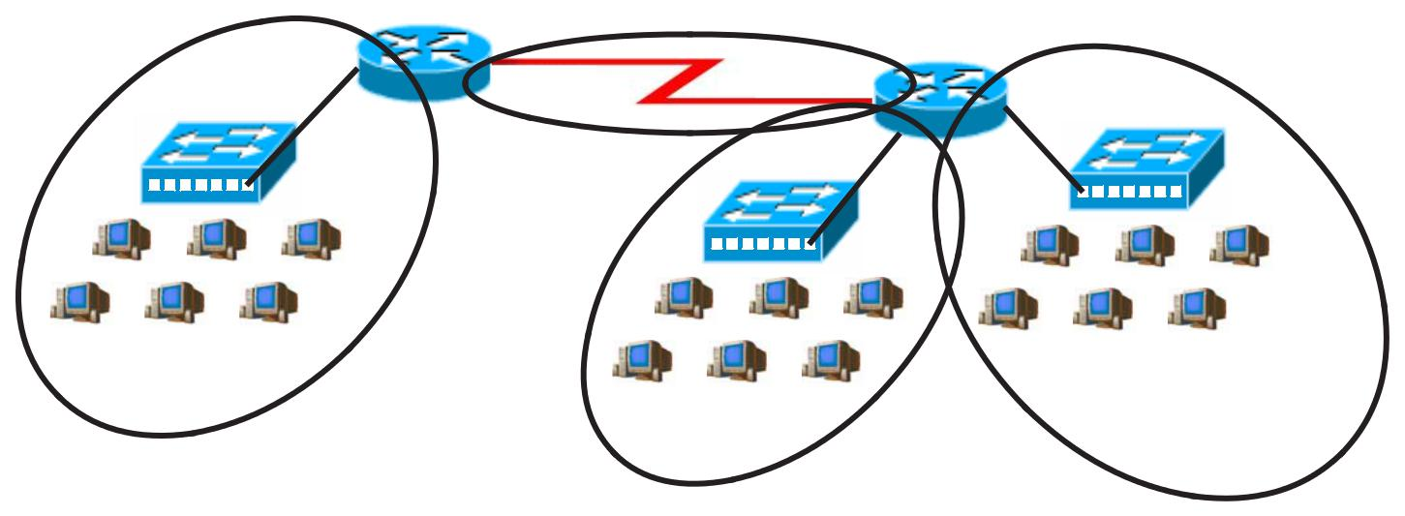

**F0/0**

|  |  |  |
| --- | --- | --- |
| Router A**S0/0/0** | **S0/0/1** | **F0/1** |

**F0/0** Router B

|  |  |  |  |  |  |  |  |  |  |  |  |  |  |  |  |  |  |  |  |  |  |  |  |  |  |  |  |  |  |  |  |  |  |  |  |  |  |  |  |  |  |  |  |  |  |  |  |  |  |  |  |  |  |  |  |  |  |  |  |  |  |  |  |  |  |
| --- | --- | --- | --- | --- | --- | --- | --- | --- | --- | --- | --- | --- | --- | --- | --- | --- | --- | --- | --- | --- | --- | --- | --- | --- | --- | --- | --- | --- | --- | --- | --- | --- | --- | --- | --- | --- | --- | --- | --- | --- | --- | --- | --- | --- | --- | --- | --- | --- | --- | --- | --- | --- | --- | --- | --- | --- | --- | --- | --- | --- | --- | --- | --- | --- | --- |
|  | | |  | | | |  | |  | |  |  | | | | | | | |  | | | | | | | | | | | | | | | | | | | | | | | | | |  | | | |  | | |  | |  |  | | | | | | | |  |  |
|  | | | | | | | |  |  | | | | | | | | |  | | | | | | | | | | | | | | | | | | | | | | | | | | | | | | | | | |  |  | | | | | | | | |  | | |  |
|  |  | | | | | | |  |  | | | | | | | | |  | | | | | |  | | | |  | | |  | |  |  | | | | | | | |  | |  | | | | | | | |  |  | | | | | | | | |  | | |  |
|  |  | Marketing | | | | | | | | | | | | | | | | | | |  |  |  |  |  |  |  |  |  |  |  |  |  |  |  |  |  |  |  |  |  |  | Management | | | | | | | | | | | | | | | | | | | | | |  |
|  |  |  |  |  |  |  |  |  |  |  |  |  |  |  |  |  |  |  |  |  |  |  |  |  |
|  |  | 24 Hosts | | | | | | | | | | | | | | | | | | | | | Reasearch | | | | | | | | | | | | | | | | | | | |  |  | 15 Hosts | | | | | | | | | | | | | | | | | | | |  |
|  |  |  |  |  |  |  |  |  |  |  |  |  |  |  |  |  |  |  |  |  |  |  | 60 Hosts | | | | | | | | | | | | | | | | | | | |  |  |  |  |  |  |  |  |  |  |  |  |  |  |  |  |  |  |  |  |  |  |  |
|  |  |  |  |  |  |  |  |  |  |  |  |  |  |  |  |  |  |  |  | Address class | | |  |  |  |  |  |  |  |  |  |  |  |  |  |  |  |  |  |  |  |  | *B* | | | | | | | | | | | | | | | | | | | | | |  |
|  |  |  |  |  |  |  |  |  |  |  |  |  |  |  |  |  |  |  |  | _____________________________ | | | | | | | | | | | | | | | | | | | | | | | | | | | | | | | | | | | | | | | | | |  |
|  |  |  |  |  |  |  |  |  |  |  |  |  |  |  |  |  | Custom subnet mask | | | | | |  |  |  | *255.255.224.0* | | | | | | | | | | | | | | | | | | | | | | | | | | | | | | | | | | | |  |  |  |  |
|  |  |  |  |  |  |  |  |  |  |  |  |  |  |  |  |  | _____________________________ | | | | | | | | | | | | | | | | | | | | | | | | | | | | | | | | | | | | | | | | | |  |
| Minimum number of subnets needed | | | | | | | | | | | | | | | | | | | | | | |  |  |  | *4* | | | | | | | | | | | | |  |  |  |  |  |  |  |  |  |  |  |  |  |  |  |  |  |  |  |  |  |  |  |  |  |  |  |
| _________ | | | | | | | | | | | | | | | | | | | |  |  |  |  |  |  |  |  |  |  |  |  |  |  |  |  |  |  |  |  |  |  |  |
| Extra subnets required for 100% growth | | | | | | | | | | | | | | | | | | | | | | | + | | | *4* | | | | | | | | | | | | |  |  |  |  |  |  |  |  |  |  |  |  |  |  |  |  |  |  |  |  |  |  |  |  |  |  |  |
| (Round up to the next whole number) | | | | | | | | | | | | | | | | | | | | | | | | | | | | | | | | | | | | | | | | | | | | | | | | | | | | | | | | | | | | | | | | |  |
| Total number of subnets needed | | | | | | | | | | | | | | | | | | | | | | | = | | | *8* | | | | | | | | | | | |  |  |  |  |  |  |  |  |  |  |  |  |  |  |  |  |  |  |  |  |  |  |  |  |  |  |  |  |
|  |  |  |  |  |  | Number of host addresses | | | | | | | | | | | | | | | | |  |  |  | *60* | | | | | | | | | | | | | |  |  |  |  |  |  |  |  |  |  |  |  |  |  |  |  |  |  |  |  |  |  |  |  |  |  |
|  |  |  |  |  |  |  | in the largest subnet group | | | | | | | | | | | | | | | | _________ | | | | | | | | | | | | | | | | | | | |  |  |  |  |  |  |  |  |  |  |  |  |  |  |  |  |  |  |  |  |  |  |  |
| Number of addresses needed for | | | | | | | | | | | | | | | | | | | | | | | + *60* | | | | | | | | | | | | | | | | |  |  |  |  |  |  |  |  |  |  |  |  |  |  |  |  |  |  |  |  |  |  |  |  |  |  |
| 100% growth in the largest subnet | | | | | | | | | | | | | | | | | | | | | | |  |  |  |  |  |  |  |  |  |  |  |  |  |  |  |  |  |  |  |  |  |  |  |  |  |  |
| (Round up to the next whole number) | | | | | | | | | | | | | | | | | | | | | | | | | | | | | | | | | | | | | | | | | | | | | | | | | | | | | | | | | | | | | | | | |  |
|  |  |  |  |  |  |  |  |  |  |  |  |  | Total number of address | | | | | | | | | | = *120* | | | | | | | | | | | | | | | | |  |  |  |  |  |  |  |  |  |  |  |  |  |  |  |  |  |  |  |  |  |  |  |  |  |  |
|  |  | needed for the largest subnet | | | | | | | | | | | | | | | | | | | | |  |  |  |  |  |  |  |  |  |  |  |  |  |  |  |  |  |  |  |  |  |  |  |  |  |  |

Start with the first subnet and arrange your sub-networks from the largest group to the smallest.

|  |  |  |
| --- | --- | --- |
| IP address range for Research | _____________________________*172.16.0.0to172.31.255* |  |
| IP address range for Marketing | _____________________________*172.16.32.0to172.63.255* |  |
| IP address range for Management | _____________________________*172.16.64.0to172.95.255* |  |
| IP address range for Router A | _____________________________*172.16.96.0to172.127.255* |  |
| to Router B serial connection |  |  |

58

|  |  |  |  |  |  |  |  |  |  |  |  |  |  |  |  |  |  |  |  |  |  |  |  |  |  |  |  |  |  |  |
| --- | --- | --- | --- | --- | --- | --- | --- | --- | --- | --- | --- | --- | --- | --- | --- | --- | --- | --- | --- | --- | --- | --- | --- | --- | --- | --- | --- | --- | --- | --- |
|  |  |  | *Number of* |  | *65,536* | *32,768* | |  | *16,384* |  | *8,192* |  | *4,096* | | *2,048* | | *1,024* |  | *512* | | *. 256 128* | | | *64 32* | | *16* | *8* | *4* | *2* |  |
|  |  |  | *Hosts -* | |  |  |  |  |  |  |  |  |  |  |  |  |  |  |  |  |  |
|  |  |  |  |  |  |  |  |  |  |  |  |  |  |  |  |  |  |  |  | *1024* | *2048* | *4,096* | *8,192* | *16,384* | *32,768* | *65,536* |  |
|  |  |  | *Number of* |  |  |  |  |  |  |  |  |  |  |  |  |  |  |  |  |  |  | *512* |  |
|  |  |  |  |  |  |  |  |  |  |  |  |  |  |  |  |  |  |  |  |  |  |
|  |  |  |  |  |  |  |  |  |  |  |  |  |  |  |  |  |  |  |  |  |  |
|  |  |  |  |  |  |  |  |  |  |  |  |  |  |  |  |  |  |  |  |  |  |
|  |  |  |  |  |  |  |  |  |  |  |  |  |  |  |  |  |  |  |  |  |  |  |  |  |  |  |  |  |  |
|  |  |  |  |  |  |  |  |  |  |  |  |  |  |  |  |  |  |  |  |  |  |  |  |  |  |  |  |  |
|  |  | *-* | | *2 4* | | | *8* | | *16* | | *32* | | *64* | | *128 256.* | | | | |  |  |  |  |  |  |  |  |  |
|  |  |  | *Subnets* |  |  |  |  |  |  |  |  |  |
|  |  | *Binary values - 128 64* | | | | | | | *32* | | *16* | | *8* | | *4* | | *2* | | *1* ***.*** | |  | *128* | *64* | *32* | *16* | *8* | *4* | *2* | *1* |  |
|  |  | ***172 . 16 . 0 0 0*** | | | | | | | |  | ***0 0 0 0 0 . 0 0 0 0 0 0 0 0*** | | | | | | | | | | | | | | | | | | |  |
|  |  |  |  |  |  |  |  |  |  |  |  | | | | | | | |  |  |  |  |  | | | | | |  |  |
|  |  | *(0)* | |  |  |  |  |  | *0* |  | *172.16.0.0* | | | | | | | |  |  |  | *to* | *172.16.31.255* | | | | | |  |  |
|  |  | *(1)* | |  |  | *1* | |  | *1* |  | *172.16.32.0* | | | | | | | |  |  |  | *to* | *172.16.63.255* | | | | | |  |  |
|  |  | *(2)* | |  |  |  | *0* |  | *172.16.64.0* | | | | | | | |  |  |  | *to* | *172.16.95.255* | | | | | |  |  |
|  |  | *(3)* | |  | *1* | *1* | |  | *1* |  | *172.16.96.0* | | | | | | | |  |  |  | *to* | *172.16.127.255* | | | | | |  |  |
|  |  | *(4)* | |  | *0* | |  | *0* |  | *172.16.128.0* | | | | | | | | |  |  | *to* | *172.16.159.255* | | | | | |  |  |
|  |  | *(5)* | |  | *1* | *0* | |  | *1* |  | *172.16.160.0* | | | | | | | | |  |  | *to* | *172.16.191.255* | | | | | |  |  |
| *4* |  | *(6)* | |  | *1* | *1* | |  | *0* |  | *172.16.192.0* | | | | | | | | |  |  | *to* | *172.16.223.255* | | | | | |  |  |
|  | *(7)* | |  | *1* | *1* | |  | *1* |  | *172.16.224.0* | | | | | | | | | |  | *to* | *172.16.255.255* | | | | | | |  |
| *x1.0* | |  |  |  |  |  |
| *4* |  |  |  |  |  |  |  |  |  |  |  |  |  |  |  |  |  |  |  |  |  |  |  |  |  |  |  |  |  |  |
| *60* | |  |  |  |  |  |  |  |  |  |  |  |  |  |  |  |  |  |  |  |  |  |  |  |  |  |  |  |  |  |
| *x1.0* | |  |  |  |  |  |  |  |  |  |  |  |  |  |  |  |  |  |  |  |  |  |  |  |  |  |  |  |  |  |
| *60* | |  |  |  |  |  |  |  |  |  |  |  |  |  |  |  |  |  |  |  |  |  |  |  |  |  |  |  |  |  |

|  |
| --- |
| 59 |

|  |
| --- |
| **Show your work for Practical Subnetting 1 in the space below.** |

**Practical Subnetting 2**

Based on the information in the graphic shown, design a network addressing scheme that will supply the **minimum number of hosts per subne**t, and allow enough extra subnets and hosts for 30% growth in all areas. Circle each subnet on the graphic and answer the questions below.

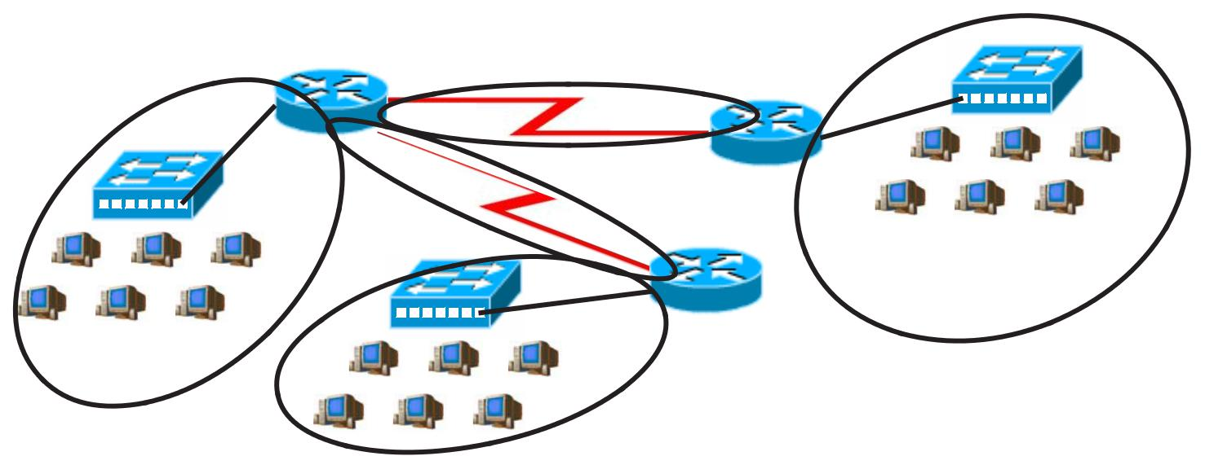

|  |  |  |  |  |  |  |  |  |  |  |  |  |  |  |  |  |  |  |  |  |  |  |  |  |  |  |  |  |  |  |  |  |  |  |  |  |  |  |  |  |  |  |  |  |  |  |  |  |  |  |  |  |  |  |  |  |  |  |  |  |  |  |  |  |  |  |  |
| --- | --- | --- | --- | --- | --- | --- | --- | --- | --- | --- | --- | --- | --- | --- | --- | --- | --- | --- | --- | --- | --- | --- | --- | --- | --- | --- | --- | --- | --- | --- | --- | --- | --- | --- | --- | --- | --- | --- | --- | --- | --- | --- | --- | --- | --- | --- | --- | --- | --- | --- | --- | --- | --- | --- | --- | --- | --- | --- | --- | --- | --- | --- | --- | --- | --- | --- | --- |
|  |  |  |  |  |  |  |  |  |  |  |  |  |  |  |  |  |  |  |  |  |  |  | **IP Address 135.126.0.0** | | | | | | | | | | | | | | | | | | | | | | |  |  |  |  |  |  |  |  |  |  |  |  |  |  |  |  |  |  |  |  |  |  |
|  |  |  |  |  |  |  |  |  |  |  |  |  |  |  |  |  |  | **F0/0** | | |  |  |  |  | **S0/0/0** | | | | | | | | | | | | | | | |  |  |  | **S0/0/1** | |  |  |  |  |  |  |  |  |  |  |  |  |  |  |  |  |  |  |  |  |  |  |
|  |  |  |  |  |  |  |  |  |  |  |  |  |  |  |  |  |  | Router A | | | | | | | | | | | | | | | | | | | |  |  |  |  |  |  |  |  |  |  |  |  |  |  |  |  |  |  |  |  |  |  |  |  |  |
|  |  |  |  |  |  |  |  |  |  |  |  |  |  |  |  |  |  |  |  |  | **S0/0/1** | | | | | | | | | | | | | | | | | | | |  |  |  | **F0/0** | | Router B | **F0/1** | | | | | | | |  |  |  |  |  |  |  |  |  |  |  |  |  |
|  |  |  |  |  |  |  |  |  |  |  |  |  |  |  |  |  |  |  |  |  |  |  |  |  |  |  |  |  |  |  |  |  |  |  |  |  |  |  |  |  |  |  |  |  |
|  |  |  |  |  |  |  |  |  |  |  |  |  |  |  |  |  |  |  |  |  |  |  |  |  |  |  |  |  |  |  |  |  |  |  |  |  |  |  |  |  |  |  |  |  |  |
|  |  |  |  |  |  |  |  |  |  |  |  |  |  |  |  |  |  |  |  |  |  |  |  |  |  |  |  |  |  |  |  |  |  |  |  |  |  |  |  |  |  |  |  | **S0/0/0** |  |  |  |  | Tech Ed Lab | | | | | | | | | | | | | | | | | |  |
|  |  |  |  |  |  |  |  |  |  |  |  |  |  |  |  |  |  |  |  |  |  |  |  |  |  |  |  |  |  |  |  |  |  |  |  |  |  |  |  |  |  |  |  |  |  |  |  |  |
|  |  |  |  |  |  |  |  |  |  |  |  |  |  |  |  |  |  |  |  |  |  |  |  |  |  |  |  |  |  |  |  |  |  |  |  |  |  |  |  |  |  |  |  |  |  |  |  |  |
|  |  |  |  |  |  |  |  |  |  |  |  |  |  |  |  |  |  |  |  |  |  |  |  |  |  |  |  |  |  |  |  |  |  |  |  |  |  |  |  |  |  |  |  | **F0/1** | Router C |  |  |  |  | 20 Hosts | | | | | | | | | | | | | | | | |  |
|  | | | | | | | | | | | | | | | | | | | | | | | | | | | | | | | | | | | | | | | | | | | |  | | | | | | | | | | | | | | | | | | | | |  |
|  | Science Lab | | | | | | | | | | | | | | | | | | | |  |  |  |  |  |  |  |  |  |  |  |  |  |  |  |  |  |  |  |  |  |  |  |  |  |  |  |  |  |  |  |  |  |  |  |  |  |  |  |  |  |  |  |  |  |  |
|  |  |  |  |  |  |  |  |  |  |  |  |  |  |  |  |  |  |  |  |  |  |  |  |  |  |  |  |  |  |  |  |  |  |  |  |  |  |  |  |  |  |  |  |  |  |  |  |
|  |  | 10 Hosts | | | | | | | | | | | | | | | | | | |  |  |  |  |  |  |  |  |  |  |  |  |  |  |  |  |  |  |  |  |  |  | English Department | | | |  |  |  |  |  |  |  |  |  |  |  |  |  |  |  |  |  |  |  |  |  |
|  | | | | | | | | | | | | | | | | | | | | | | | | | | | | | | | | | | | | | | | | | | |  | | | | | | | | | | | | | | | | | | | |  |
|  |  |  |  |  |  |  |  |  |  |  |  |  |  |  |  |  |  |  |  |  |  |  |  |  |  |  |  |  |  |  |  |  |  |  |  |  |  |  |  |  |  |  | 15 Hosts | |  |  | *B* | | | | | | | | | | | | | | | | | | | |  |
|  |  |  |  |  |  |  |  |  |  |  |  |  |  |  |  |  |  |  |  |  | Address class | | | | | | | | | | | | | | | | | | | |  |  |  |  |  |  |  |
|  |  |  |  |  |  |  |  |  |  |  |  |  |  |  |  |  | Custom subnet mask | | | | | | | | | | | | | | | | | | | | | | | |  |  |  | *255.255.255.224* | | | | | | | | | | | | | | | | |  |  |  |  |  |  |  |
| *5* | | | | | | | | | | | | | | | | | | | | | | | | | | | | | | | | | | | | | | | | | | | | | | | | | | | | | | | | | | | | | | | | | | |  |
| Minimum number of subnets needed _________ | | | | | | | | | | | | | | | | | | | | | | | | | | | | | | | | | | | | | | | | | | | | | |  |  |  |  |  |  |  |  |  |  |  |  |  |  |  |  |  |  |  |  |  |  |
| Extra subnets required for 30% growth | | | | | | | | | | | | | | | | | | | | | | | | | | | | | | | | | | | | | | | | | + | | | *2* |  |  |  |  |  |  |  |  |  |  |  |  |  |  |  |  |  |  |  |  |  |  |  |
|  |  |  |  |  |  |  |  |  |  |  |  |  |  |  |  |  |  |  |  |  |  |  |  |
|  |  |  |  |  |  |  |  |  |  |  |  |  |  |  |  |  | (Round up to the next whole number) | | | | | | | | | | | | | | | | | | | | | | | |  |  |  |  |  |  |  |  |  |  |  |  |  |  |  |  |  |  |  |  |  |  |  |  |  |  |  |
| Total number of subnets needed | | | | | | | | | | | | | | | | | | | | | | | | | | | | | | | | | | | | | | | | | = | | | *7* |  |  |  |  |  |  |  |  |  |  |  |  |  |  |  |  |  |  |  |  |  |  |  |
|  |  |  |  |  |  |  |  |  |  |  |  |  |  |  |  |  |  |  |  |  |  |  |  |
|  |  |  |  |  |  | Number of host addresses | | | | | | | | | | | | | | | | | | | | | | | | | | | | | | | | | | | _________ | | | | |  |  |  |  |  |  |  |  |  |  |  |  |  |  |  |  |  |  |  |  |  |  |
|  |  |  |  |  |  |  | in the largest subnet group | | | | | | | | | | | | | | | | | | | | | | | | | | | | | | | | | |  |  |  | *20* |  |  |  |  |  |  |  |  |  |  |  |  |  |  |  |  |  |  |  |  |  |  |  |
| Number of addresses needed for | | | | | | | | | | | | | | | | | | | | | | | | | | | | | | | | | | | | | | | | | + | | | *6* |  |  |  |  |  |  |  |  |  |  |  |  |  |  |  |  |  |  |  |  |  |  |  |
| 30% growth in the largest subnet | | | | | | | | | | | | | | | | | | | | | | | | | | | | | | | | | | | | | | | | |  |  |  |  |  |  |  |  |  |  |  |  |  |  |  |  |  |  |  |  |  |  |  |
|  |  |  |  |  |  |  |  |  |  |  |  |  |  |  |  |  | (Round up to the next whole number) | | | | | | | | | | | | | | | | | | | | | | | |  |  |  |  |  |  |  |  |  |  |  |  |  |  |  |  |  |  |  |  |  |  |  |  |  |  |  |
|  |  |  |  |  |  |  |  |  |  |  |  |  | Total number of address | | | | | | | | | | | | | | | | | | | | | | | | | | | | = | | | *26* |  |  |  |  |  |  |  |  |  |  |  |  |  |  |  |  |  |  |  |  |  |  |  |
|  |  | needed for the largest subnet | | | | | | | | | | | | | | | | | | | | | | | | | | | | | | | | | | | | | | |  |  |  |  |  |  |  |  |  |  |  |  |  |  |  |  |  |  |  |  |  |  |  |

Start with the first subnet and arrange your sub-networks from the largest group to the smallest.

IP address range for Tech Ed _____________________________*135.126.0.0to135.126.0.31* IP address range for English _____________________________*135.126.0.32to135.126.0.63* IP address range for Science _____________________________*135.126.0.64to135.126.0.95*

IP address range for Router A

to Router B serial connection *135*_____________________________*.126.0.96to135.126.0.127*

IP address range for Router A

to Router B serial connection*135*_____________________________*.126.0.128to135.126.0.159*

60

|  |  |  |  |  |  |  |  |  |
| --- | --- | --- | --- | --- | --- | --- | --- | --- |
| *Number of* |  | *65,536* |  | *32,768* |  | *16,384* |  |  |
| *Hosts* | *-* |  |  |  |  |  |  |  |
|  |  |  |  |  |  |  |
| *Number of* |  |  |  |  |  |  |  |  |
|  |  |  |  |  |  |  |  |
|  |  |  |  |  |  |  |  |
|  |  |  |  |  |  |  |  |
|  |  |  |  |  |  |  |  |
|  |  |  |  |  |  |  |  |
| *- 2* | | | *4* | | *8* | |  |
| *Subnets* |  |
| *Binary values - 128 64* | | | | | | *32* | |  |
| ***135. 126 . 0*** | | | | ***0*** | | ***0*** | |  |

*5*

*x.3*

*1.5*

*(Round up to 2)*

*20*

*x.3*

*6*

|  |
| --- |
| 61 |

|  |  |  |  |  |  |  |  |  |  |  |  |  |  |  |  |  |  |  |  |  |  |
| --- | --- | --- | --- | --- | --- | --- | --- | --- | --- | --- | --- | --- | --- | --- | --- | --- | --- | --- | --- | --- | --- |
| *8,192* |  | *4,096* | | *2,048* | | *1,024* |  | *512* | | *. 256 128* | | | *64* | *32* | *16* | *8* | *4* |  | *2* |  |  |
|  |  |  |  |  |  |  |  |  |  |  | *512* | *1024* | *2048* | *4,096* | *8,192* | *16,384* | *32,768* | *65,536* | |  |  |
|  |  |  |  |  |  |  |  |  |  |  |  |  |
|  |  |  |  |  |  |  |  |  |  |  |  |  |
|  |  |  |  |  |  |  |  |  |  |  |  |  |
|  |  |  |  |  |  |  |  |  |  |  |  |  |
|  |  |  |  |  |  |  |  |  |  |  |  |  |
|  |  |  |  |  |  |  |  |  |  |  |  |  |
| *16 32 64* | | | | | | *128 256.* | | | | |  |  |
| *16* | | *8* | | *4* | | *2* | | *1* ***.*** | |  | *128* | *64* | *32* | *16* | *8* | *4* | *2* |  | *1* |  |  |
| ***0 0 0 0 0 . 0 0 0*** | | | | | | | | | | | | | | ***0 0 0 0 0*** | | | | | |  |  |
|  |  |  |  |  |  | *(0)* | | *.* | |  |  |  | *0* | *135.126.0.0* | | | |  | *to* | *135.126.0.31* |  |
|  |  |  |  |  |  | *(1)* | |  |  |  |  | *1* | *1* | *135.126.0.32* | | | |  | *to* | *135.126.0.63* |  |
|  |  |  |  |  |  | *(2)* | |  |  |  |  | *0* | *135.126.0.64* | | | |  | *to* | *135.126.0.95* |  |
|  |  |  |  |  |  | *(3)* | |  |  |  | *1* | *1* | *1* | *135.126.0.96* | | | |  | *to* | *135.126.0.127* |  |
|  |  |  |  |  |  | *(4)* | |  |  |  | *0* | *0* | *135.126.0.128* | | | | | *to* | *135.126.0.159* |  |
|  |  |  |  |  |  | *(5)* | |  |  |  | *1* | *0* | *1* | *135.126.0.160* | | | | | *to* | *135.126.0.191* |  |
|  |  |  |  |  |  | *(6)* | |  |  |  | *1* | *1* | *0* | *135.126.0.192* | | | | | *to* | *135.126.0.223* |  |
|  |  |  |  |  |  | *(7)* | | *1 .* | |  | *1* | *1* | *1* | *135.126.0.224* | | | | | *to* | *135.126.0.255* |  |
|  |  |  |  |  |  | *(8)* | |  | *0* | *0* | *0* | *135.126.1.0* | | | |  | *to* | *135.126.1.31* |  |
|  |  |  |  |  |  | *(9)* | | *1 .* | |  | *0* | *0* | *1* | *135.126.1.32* | | | |  | *to* | *135.126.1.63* |  |
|  |  |  |  |  |  | *(10)* | | *1 .* | |  | *0* | *1* | *0* | *135.126.1.64* | | | |  | *to* | *135.126.1.95* |  |
|  |  |  |  |  |  | *(11)* | | *1 .* | |  | *0* | *1* | *1* | *135.126.1.96* | | | |  | *to* | *135.126.1.127* |  |
|  |  |  |  |  |  | *(12)* | | *1 .* | |  | *1* | *0* | *0* | *135.126.1.128* | | | |  | *to* | *135.126.1.159* |  |
|  |  |  |  |  |  | *(13)* | | *1 .* | |  | *1* | *0* | *1* | *135.126.1.160* | | | | | *to* | *135.126.1.191* |  |
|  |  |  |  |  |  | *(14)* | | *1 .* | |  | *1* | *1* | *0* | *135.126.1.192* | | | | | *to* | *135.126.1.223* |  |
|  |  |  |  |  |  | *(15)* | | *1 .* | |  | *1* | *1* | *1* | *135.1261.224* | | | | | *to* | *135.126.1.255* |  |
|  |  |  |  |  |  |  |  |  |  |  |  |  |  |  |  |  |  |  |  |  |  |

|  |
| --- |
| **Show your work for Problem 2 in the space below.** |

**Practical Subnetting 3**

Based on the information in the graphic shown, design a classfull network addressing scheme that will supply the **minimum number of hosts per subne**t, and allow enough extra subnets and hosts for 25% growth in all areas. Circle each subnet on the graphic and answer the questions below.

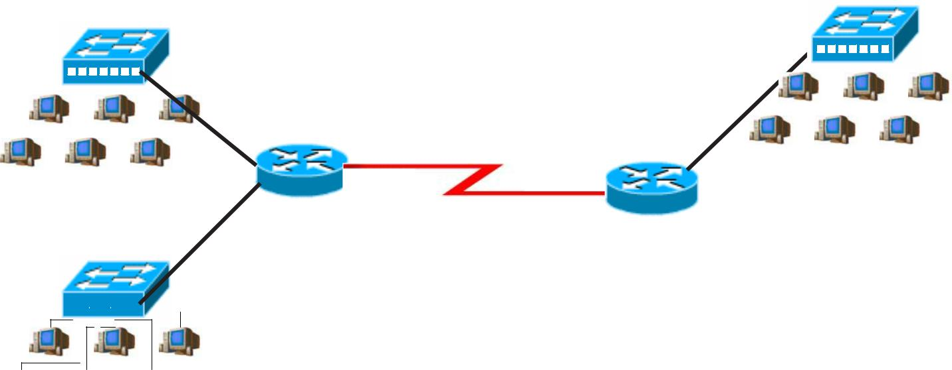

|  |  |  |  |  |  |  |  |  |  |  |  |  |  |  |  |  |  |  |  |  |  |  |  |  |  |  |  |  |  |  |  |  |  |  |  |  |  |  |  |  |  |  |  |
| --- | --- | --- | --- | --- | --- | --- | --- | --- | --- | --- | --- | --- | --- | --- | --- | --- | --- | --- | --- | --- | --- | --- | --- | --- | --- | --- | --- | --- | --- | --- | --- | --- | --- | --- | --- | --- | --- | --- | --- | --- | --- | --- | --- |
|  |  |  |  |  |  |  |  |  |  |  |  |  |  |  |  |  |  |  |  |  | **F0/0** | **IP Address 172.16.0.0** |  |  |  |  |  |  |  |  |  |  |  |  |  |  |  |  |  |  |  |  |  |
|  |  |  |  |  |  |  |  |  |  |  |  |  |  |  |  |  |  |  |  |  |  |  |  |  |  |  |  |  |  |  |  |  |  |  |  |  |  |  |  |  |  |
|  |  |  |  |  |  |  |  |  |  |  |  |  |  |  |  |  |  |  |  |  | **S0/0/1** |  |  |  |  |  |  |  |  |  |  |  |  |  |  |  |  |  |  |  |  |  |
|  |  |  |  |  |  |  |  |  |  |  |  |  |  |  |  |  |  |  |  |  | **F0/0** |  |  |  | Sales | | | | | | | | | | | | | |  |  |  |
| Administrative | | | | | | | | | | | | | | | | | | | | | Router A |  |  |  |  |  |  |
|  |  |  |  |  |  |  |
|  | Router B |  | 185 Hosts | | | | | | | | | | | | | | | |  |  |  |
|  |  |  |  |  |  |  |  |  |  |  |  |  |  |  |  |  |  |  |  |  |  |  |  |  |  |  |  |  |  |  |  |  |  |  |  |  |  |  |  |  |  |  |
|  |  | 30 Hosts | | | | | | | | | | | | | | | | | | | **F0/1** | **S0/0/0** |  |  |  |  |  |  |  |  |  |  |  |  |  |  |  |  |  |  |  |  |  |
|  |  |  |  |  |  |  |  |  |  |  |  |  |  |  |  |  |  |  |  |  |  |  |  |

Marketing

 50 Hosts



Address class _____________________________

Custom subnet mask _____________________________

Minimum number of subnets needed _________

Extra subnets required for 25% growth _________+

(Round up to the next whole number)

Total number of subnets needed _________=

Number of host addresses

in the largest subnet group _________

Number of addresses needed for 25% growth in the largest subnet +

(Round up to the next whole number)

Total number of address needed for the largest subnet =

Start with the first subnet and arrange your sub-networks from the largest group to the smallest.

IP address range for Sales _____________________________

IP address range for Marketing _____________________________

IP address range for Administrative _____________________________

IP address range for Router A

to Router B serial connection _____________________________

62

**Show your work for Problem 3 in the space below.**

63

**Practical Subnetting 4**

Based on the information in the graphic shown, design a network addressing scheme that will supply the **minimum number of subnets**, and allow enough extra subnets and hosts for 70% growth in all areas. Circle each subnet on the graphic and answer the questions below.

|  |  |  |  |  |  |  |  |  |  |  |  |  |  |  |  |  |  |  |  |  |  |  |  |  |  |  |  |  |  |  |  |  |  |  |  |  |  |  |  |  |  |  |  |  |  |  |  |  |  |  |  |  |  |  |  |  |  |  |  |  |  |  |  |  |  |  |  |
| --- | --- | --- | --- | --- | --- | --- | --- | --- | --- | --- | --- | --- | --- | --- | --- | --- | --- | --- | --- | --- | --- | --- | --- | --- | --- | --- | --- | --- | --- | --- | --- | --- | --- | --- | --- | --- | --- | --- | --- | --- | --- | --- | --- | --- | --- | --- | --- | --- | --- | --- | --- | --- | --- | --- | --- | --- | --- | --- | --- | --- | --- | --- | --- | --- | --- | --- | --- |
|  |  |  |  |  |  |  |  |  |  |  |  |  |  |  |  |  |  |  |  |  |  |  |  |  |  |  |  |  |  |  |  |  |  | **IP Address 135.126.0.0** | | | | | | | | | | | | |  |  |  |  |  |  |  |  |  |  |  |  |  |  |  |  |  |  |  |  |  |
|  |  |  |  |  |  |  |  |  |  |  |  |  |  |  |  |  |  |  |  |  | **F0/0** | | |  |  |  |  | **S0/0/0** | | | | | | | | | | | | | | | | | |  |  |  |  |  |  |  |  |  |  |  |  |  |  |  |  |  |  |  |  |  |  |
| Router A | | | | | | | | | | | | | | | | | | | | | | | | | | | | | | | | | | | | | | | | | | | | | **S0/0/1** | | | | | | | | | | | | | | | | | | | | | |  |
|  |  |  |  |  |  |  |  |  |  |  |  |  |  |  |  |  |  |  |  |  |  |  |  | **S0/0/1** | | | | | | | |  |  |  |  |  |  |  |  |  |  |  |  |  | **F0/0**Router B | | | | | | | | | | | | | | | | | | | |  |  |  |
|  | | | | | | | | |  |  | | |  |  | | | | | | | | | **S0/0/0** | | | | | | | | | | | | | | | | | | | | | | | | | | |  | | | | |  |  | |  |  | | | | | | | |  |
|  | | | | | | | | | | | | | | | | | | | | | | | | | | |  | | | |  | | | |  |  |  |  |  | | | | | | **F0/1** | Router C | **F0/0** |  | | | | | | |  |  | | | | | | | | |  | |  |
|  |  |  | Dallas | | | | | | | | | | | | | | | | | | | | |  |  |  |  |  |  |  |  |  |  |  |  |  |  |  |  |  |  |  |  |  |  |  |  |  | New York | | | | | | | | | | | | | | | |  |  |  |
|  | 150 Hosts | | | | | | | | | | | | | | | | | | | | | | |  |  |  |  |  |  |  |  |  |  |  |  |  |  |  |  |  |  |  |  |  |  |  |  |  |  |  |  |
|  |  |  |  |  |  |  |  |  |  |  |  |  |  |  |  |  |  |  |  |  |  |  |  |  |  |  |  |  |  |  |  |  |  |  |  |  |  |  |  |  |  |  |  |  | Washington D.C. | |  |  | 325 Hosts | | | | | | | | | | | | | | | |  |  |  |
| 220 Hosts | | | | | | | | | | | | | | | | | | | | | | | | | | | | | | | | | | | | | | | | | | | | | | | | | | | | | | | | | | | | | | | | | | |  |

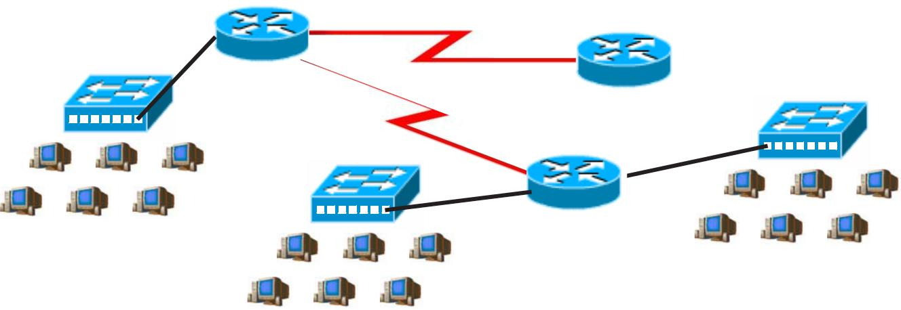

Address class _____________________________

Custom subnet mask _____________________________

Minimum number of subnets needed _________

Extra subnets required for 70% growth _________+

(Round up to the next whole number)

Total number of subnets needed _________=

Number of host addresses

in the largest subnet group _________

Number of addresses needed for 70% growth in the largest subnet +

(Round up to the next whole number)

Total number of address needed for the largest subnet =

Start with the first subnet and arrange your sub-networks from the largest group to the smallest.

IP address range for New York _____________________________

IP address range for Washington D. C. _____________________________

IP address range for Dallas _____________________________

IP address range for Router A

to Router B serial connection _____________________________

IP address range for Router A

to Router C serial connection _____________________________

64

**Show your work for Problem 4 in the space below.**

65

**Practical Subnetting 5**

Based on the information in the graphic shown, design a network addressing scheme that will supply the **minimum number of hosts per subnet**, and allow enough extra subnets and hosts for 100% growth in all areas. Circle each subnet on the graphic and answer the questions below.

|  |  |  |  |  |  |  |  |  |  |  |  |  |  |  |  |  |  |  |  |  |  |  |  |  |  |  |  |  |  |  |  |  |  |  |  |  |  |  |  |  |  |  |  |  |  |  |  |  |  |  |  |  |  |  |  |  |  |  |  |  |  |  |  |  |
| --- | --- | --- | --- | --- | --- | --- | --- | --- | --- | --- | --- | --- | --- | --- | --- | --- | --- | --- | --- | --- | --- | --- | --- | --- | --- | --- | --- | --- | --- | --- | --- | --- | --- | --- | --- | --- | --- | --- | --- | --- | --- | --- | --- | --- | --- | --- | --- | --- | --- | --- | --- | --- | --- | --- | --- | --- | --- | --- | --- | --- | --- | --- | --- | --- |
|  |  |  |  |  |  |  |  |  |  |  |  |  |  |  |  |  |  |  |  |  |  |  |  |  |  |  |  |  |  |  |  |  |  |  |  |  | **IP Address 210.15.10.0** | | | | | | | | | | | | | | | | | | |  |  |  |  |  |  |  |  |  |
|  | | | | | | | | | | | | | | | | | | | | | | | | | | | | | | | | | | | | | | | | **F0/1** | | |  | |  | |  |  |  |  |  |  |  |  |  |  | | | | | | | |  |
|  | | | | | | | | | | | | | | | | | | | | | | | | | | | | | | | | | | | | | | | |  | |  | | | | | | | |  |
|  | |  | | | |  | |  | |  |  | | | | | | | |  | | | | | | | | | | | | | | | | | | | | |  |  | |  |  |  |  |  | | |  |  | | | | | | | |  |
|  | | | | | | |  |  | | | | | | | | | **F0/0** | | | | | | | | | | | | | | | | | | | | | | | | | | | | | | |  |  | | | | | |  | | | | | | | | |  |
|  |  | | | | | |  |  | | | | | | | | |  | | | | | | | | | | | | | | | | | | | | | | | |  | | | | | | |  |  | | | | | |  | | | | | | | | |  |
|  |  |  |  | | | | |  |  |  |  |  |  |  |  |  |  |  |  | | | | |  |  |  |  |  |  |  |  |  |  |  |  |  |  |  |  |  |  | Tech Ed Lab | | | | | | | | | | | | | |  |  |  |  |  |  |  |  |  |
| Science Room | | | | | | | | | | | | | | | | | | | | | | | |  |  |  |  |  |  |  |  |  |  |  |  |  |  |  |  |  |  |  |  |  |  |  |  |  |  |  |
|  | 10 Hosts | | | | | | | | | | | | | | | | | | | | |  |  |  |  |  |  |  |  |  |  |  |  |  |  |  |  |  |  |  |  | 18 Hosts | | | | | | | | | | | | | |  |  |  |  |  |  |  |  |  |
|  |  |  |  |  |  |  |  |  |  |  |  |  |  |  |  |  |  |  |  |  |  |  |  |  |  |  |  |  |  |
|  | | | | | | | | | | | | | | | | | | | | | | | | | | |  |  | | | | | | | | | |  | | | | | | | | | | | | | | | | | | | | |  | | |  | |  |
|  | | | | | | | | | | | | | | | | | | | |  | | | | | | |  |  | | | | | | | | | |  | | | | | | | | | | | | | | | | | | | | | | | | | |  |
|  | | | | | | | | | | | | | | | | | | | | | | | | | | | | | | | | | | | | | | | | | | | | | | | | | | | | | | | | |  | | | | | | |  |

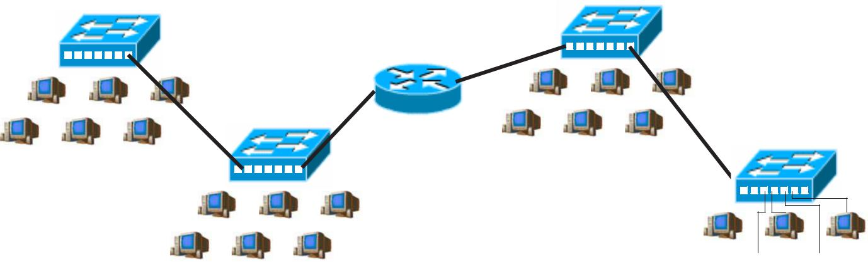English classroom  15 Hosts Art Classroom

12 Hosts

Address class _____________________________

Custom subnet mask _____________________________

Minimum number of subnets needed _________

Extra subnets required for 100% growth _________+

(Round up to the next whole number)

Total number of subnets needed _________=

Number of host addresses

in the largest subnet group _________

Number of addresses needed for 100% growth in the largest subnet +

(Round up to the next whole number)

Total number of address needed for the largest subnet =

Start with the first subnet and arrange your sub-networks from the largest group to the smallest.

IP address range for Router F0/0 Port _____________________________

IP address range for Router F0/1 Port _____________________________

66

**Show your work for Problem 5 in the space below.**

67

**Practical Subnetting 6**

Based on the information in the graphic shown, design a network addressing scheme that will supply the **minimum number of subnets**, and allow enough extra subnets and hosts for 20% growth in all areas. Circle each subnet on the graphic and answer the questions below.

|  |  |  |  |  |  |  |  |  |  |  |  |  |  |  |  |  |  |  |  |  |  |  |  |  |  |  |  |  |  |  |  |  |  |  |  |  |  |  |  |  |  |  |  |  |  |  |  |  |  |  |  |  |  |  |  |  |  |  |  |  |  |  |  |  |  |  |  |  |  |  |  |  |  |  |  |  |  |  |  |  |  |  |  |  |  |  |
| --- | --- | --- | --- | --- | --- | --- | --- | --- | --- | --- | --- | --- | --- | --- | --- | --- | --- | --- | --- | --- | --- | --- | --- | --- | --- | --- | --- | --- | --- | --- | --- | --- | --- | --- | --- | --- | --- | --- | --- | --- | --- | --- | --- | --- | --- | --- | --- | --- | --- | --- | --- | --- | --- | --- | --- | --- | --- | --- | --- | --- | --- | --- | --- | --- | --- | --- | --- | --- | --- | --- | --- | --- | --- | --- | --- | --- | --- | --- | --- | --- | --- | --- | --- | --- | --- | --- |
|  | | | | | | | | | | | | | | | | | | | | **S0/0/0** | | | **IP Address 10.0.0.0** | | | | | | | | | | | | | | | | | | | | | | | | | | | | | | | | | | | | | | | | | | | | | | | | | | | | | | | | | | | | | | |  |
|  | | | | | | | | | | | | | | | | | | | |  | | | | | | | | | | | | | | | | | | | | | | | | | | | | | | | | | | | | | | | | | **S0/0/1** |  | | | | | | | | | Technology | | | | | | | | | | | |  |
| Router A | | | | | | | | | | | | | | | | | | | | | | | | | | | | | | | | | | | | | | | | | | | | | | | | | | | | | | | | | | | | | | | |  | | | | | | | | |  |
|  |  |  |  | **F0/0** | | | | | | | | | | | | | | | **S0/0/1** | | | |  |  |  |  |  |  |  |  |  |  |  |  |  |  |  |  |  |  |  |  |  |  |  |  |  |  |  |  |  |  |  |  |  |  |  |  |  |  |  | **S0/0/0** | | | Router B | | | | |  |  |  |  | Building | | | | | | | | | | | |  |
|  |  |  |  |  |  |  |  |  |  |  |  |  |  |  |  |  |  |  |  |  |  |  |  |  |  |  |  |  |  |  |  |  |  |  |  |  |  |  |  |  |  |  | **F0/1** | | | | |  |  |  |  | 320 Hosts | | | | | | | | | | | |  |
|  | | | | | | | | | | | | | | | | | | | | | | | | | | | | | | | | | | | | | | | | | | | **S0/0/1** | | | | | | | |  | | | | | | | | | | | | | |  | | | |  |
|  | | | | | | | | | | | | | | | | | | | | | | | | | | | | | | | | | | | | | | | | **S0/0/0** | | |  | | | | | | | | | | | | | |  | | | | | | | | | | | | | | | |  |
|  | | | | | | | | | | | | | | | | | | | | | | | | | | | | | | | | | | | | | | | |  | | | | | | | | | | | | | | | | | | | | | | | | | | | | | | | | | | |  |
|  |  |  |  |  |  |  |  |  |  |  |  |  |  |  |  |  |  |  |  |  |  |  |  | Art & Drama | | | | | | | | | | | | | | | | | | Router C | | | | | | | | |  | Administration | | | | | | | | | | | | |  |  |  |  |  |  |  |  |  |  |  |  |  |  |  |  |  |  |  |  |  |  |
|  |  |  |  |  |  |  |  |  |  |  |  |  |  |  |  |  |  |  |  |  |  |  |  |  |  |  |  |  |  |  |  |  |  |  |  |  |  |  |  |  |  |  |  |  |
|  |  |  |  |  |  |  |  |  |  |  |  |  |  |  |  |  |  |  |  |  |  |  |  |  |  |  |  |  | 75 Hosts | | | | | | | | | | | | | **F0/0** | **F0/1** | | | | | | | |  | 35 Hosts | | | | | | | | | | | | |  |  |  |  |  |  |  |  |  |  |  |  |  |  |  |  |  |  |  |  |  |  |
|  | | | | | | | | |  |  | | | | | | | | | |  | | | | | | | | | | | | | | | | | | | | | |  | | | | | | | | | | | | | | |  | | | | | | |  |  | | | | | | | | |  | | |  |
|  |  | | | | | | | |  |  | | | | | | | | | |  | | | | | | | | | | | | | | | | | | | | | | | | | | | | | | | | | | | | | | | | | | | | | | | | | | | | | | | | | | | | | | | | | |  |
| Science Building | | | | | | | | | | | | | | | | | | | | | | |  | | | | | | | | | | | | | | | | | | | | | | | | | | | | | | | | | | | | | | | | | | | | | | | | | | | | | | | | | | | | | | |  |
|  | |  | | | |  | |  | |  |  | | | | | | | |  | | | |  | | | |  | | |  | |  |  | | | | | | | |  | | | | | | | | | | | | | | | | | | | | | |  |
|  | | | | | | |  |  | | | | | | | | |  | | | |  | | | | | | | |  |  | | | | | | | | |  | | | | | | | | | | | | | | | | | | | | | | | |  |
| 225 Hosts | | | | | | | | | | | | | | | | | | | | | | | | | | | | | | | | | | | | | | | | | | | | | | | | | | | | | | | | | | | | | | | | | | | | | | | | | | | | | | | | | | | | | |  |

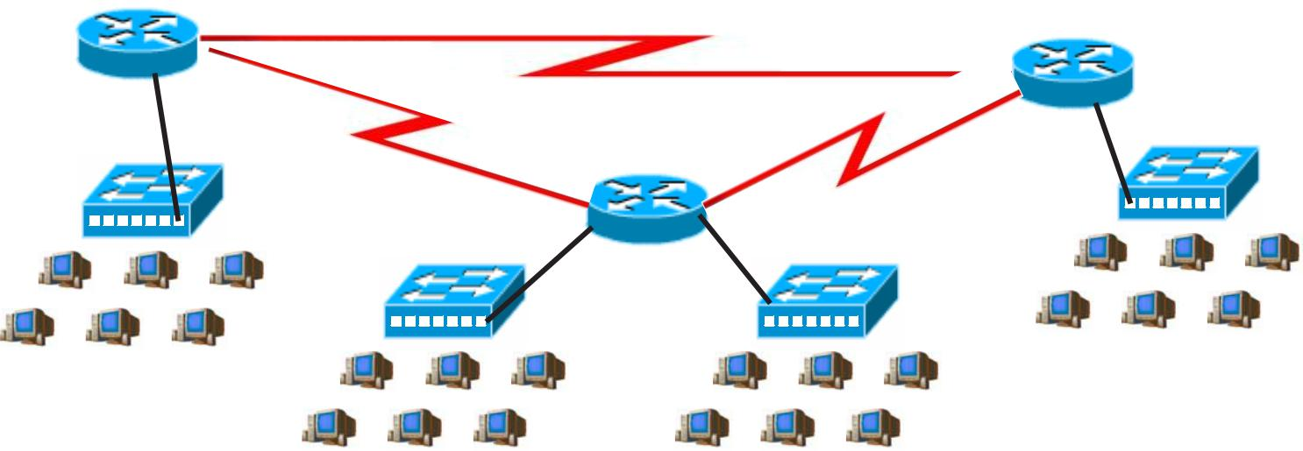

Address class _____________________________

Custom subnet mask _____________________________

Minimum number of subnets needed _________

Extra subnets required for 20% growth _________+

(Round up to the next whole number)

Total number of subnets needed _________=

Start with the first subnet and arrange your sub-networks from the largest group to the smallest.

IP address range for Technology _____________________________

IP address range for Science _____________________________

IP address range for Arts & Drama _____________________________

IP Address range Administration _____________________________

IP address range for Router A

to Router B serial connection _____________________________

IP address range for Router A

to Router C serial connection _____________________________

IP address range for Router B

to Router C serial connection _____________________________

68

**Show your work for Problem 6 in the space below.**

69

**Practical Subnetting 7**

Based on the information in the graphic shown, design a network addressing scheme that will supply the **minimum number of hosts per subne**t, and allow enough extra subnets and hosts for 125% growth in all areas. Circle each subnet on the graphic and answer the questions below.

|  |  |  |  |
| --- | --- | --- | --- |
|  | **IP Address 177.135.0.0** | **S0/0/0** |  |
|  | **S0/0/0** |  |
| Router A | **F0/0** |  |
|  |  |  |

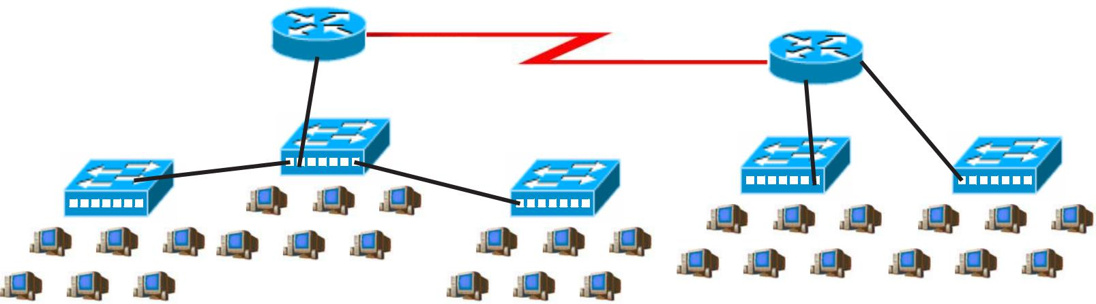

|  |  |  |
| --- | --- | --- |
| **F0/0** | Router B |  |
|  |  |
|  | **F0/1** |  |

|  |  |  |  |  |  |  |  |  |  |  |  |  |  |  |  |  |  |  |  |  |  |  |  |  |  |  |  |  |  |  |  |  |  |  |  |  |  |  |  |  |  |  |  |  |  |  |  |  |  |  |  |  |  |  |  |  |  |  |  |  |  |  |  |  |  |  |  |  |  |  |  |  |  |  |  |  |  |  |  |  |  |  |  |  |  |  |  |  |  |  |  |  |  |  |  |  |  |  |  |  |  |  |  |  |  |
| --- | --- | --- | --- | --- | --- | --- | --- | --- | --- | --- | --- | --- | --- | --- | --- | --- | --- | --- | --- | --- | --- | --- | --- | --- | --- | --- | --- | --- | --- | --- | --- | --- | --- | --- | --- | --- | --- | --- | --- | --- | --- | --- | --- | --- | --- | --- | --- | --- | --- | --- | --- | --- | --- | --- | --- | --- | --- | --- | --- | --- | --- | --- | --- | --- | --- | --- | --- | --- | --- | --- | --- | --- | --- | --- | --- | --- | --- | --- | --- | --- | --- | --- | --- | --- | --- | --- | --- | --- | --- | --- | --- | --- | --- | --- | --- | --- | --- | --- | --- | --- | --- | --- | --- | --- | --- |
|  | |  | | | |  | | |  | |  |  | | | | | | | |  |  | | | | | | | | |  |  | | |  |  | | | | | | | | |  | | |  | | | |  | |  | |  |  | | | | | | | |  | | |  | | | |  | | |  | |  |  | | | | | | | |  | | |  | | | |  | |  | |  |  | | | | | | | |  |
|  | | | | | | | |  |  | | | | | | | | |  | | Administration | | | | | | | | | | | | | | | | | | | | | | | | |  | | | | | | |  |  | | | | | | | | |  | | |  | | | | | | | |  |  | | | | | | | | |  | | |  | | | | | | |  |  | | | | | | | | |  | |  |
|  |  |  |  |  |  |  |  |  |  |  |  |  |  |  |  |  |  |  |  |  |  |  |  |  |  |  |  |  |  |  |  |  |  |  |  |  |  |  |  |  |  |  | Research | | | | | | | | | | | | | | | | |  |  | Deployment | | | | | | | | | | | | | | | | | |  |
|  |  |  |  |  |  |  |  |  |  |  |  |  |  |  |  |  |  |  |  |  |  |  |  |  |  |  |  |  |  |  |  |  |  |  |  |  |  |  |  |  |  |  |  |  |  |
|  | Marketing | | | | | | | | | | | | | | | | |  |  |  |  | 33 Hosts | | | | | | | | | | | | | | | | | | | | | | |  |  |  | Sales | | | | | | | | | | | | | |  |  |  |  |  |  |  |  |  |
|  |  |  |  |  |  |  |  |  |  |  |  | 135 Hosts | | | | | | | | | | | | | | | | | | |  |  | 63 Hosts | | | | | | | | | | | | | | | | | |  |
| 75 Hosts | | | | | | | | | | | | | | | | | | | | | | | | | | | | | | | | | | | | | | | | | | | | | | 255 Hosts | | | | | | | | | | | | | | | | | | | | | | | | | | | | | | | | | | | | | | | | | | | | | | | | | | | | | | | | | | |  |

Address class _____________________________

Custom subnet mask _____________________________

Minimum number of subnets needed _________

Extra subnets required for 125% growth _________+

(Round up to the next whole number)

Total number of subnets needed _________=

Number of host addresses

in the largest subnet group _________

Number of addresses needed for 125% growth in the largest subnet +

(Round up to the next whole number)

Total number of address needed for the largest subnet =

Start with the first subnet and arrange your sub-networks from the largest group to the smallest.

IP address range for Router A Port F0/0 _____________________________

IP address range for Research _____________________________

IP address range for Deployment _____________________________

IP address range for Router A

to Router B serial connection _____________________________

70

**Show your work for Problem 7 in the space below.**

71

**Practical Subnetting 8**

Based on the information in the graphic shown, design a network addressing scheme that will supply the **minimum number subnets**, and allow enough extra subnets and hosts for 85% growth in all areas. Circle each subnet on the graphic and answer the questions below.

|  |  |  |  |  |  |  |
| --- | --- | --- | --- | --- | --- | --- |
|  | **IP Address 192.168.1.0** |  |  |  |  |  |
| **F0/0** | **S0/0/0** | **F0/1** | | |  |  |
|  |  |
| Router A | **S0/0/1** |  |  |
|  |  |  |  |  |

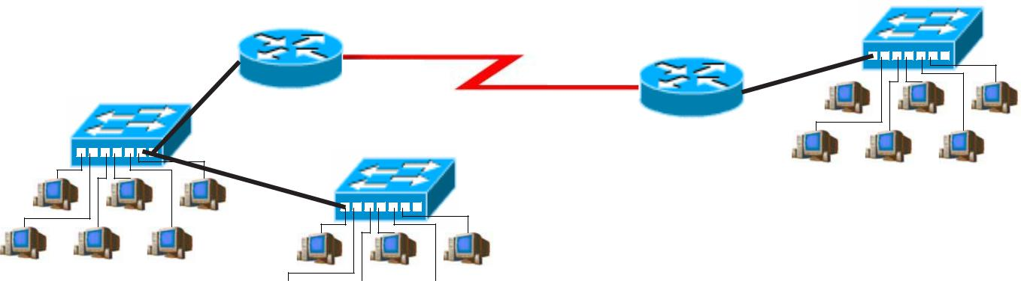

Boston

5 Hosts

**F0/0** Router B

New York

8 Hosts



Research & Development

8 Hosts

Address class _____________________________

Custom subnet mask _____________________________

Minimum number of subnets needed _________

Extra subnets required for 85% growth _________+

(Round up to the next whole number)

Total number of subnets needed _________=

Number of host addresses

in the largest subnet group _________

Number of addresses needed for 85% growth in the largest subnet +

(Round up to the next whole number)

Total number of address needed for the largest subnet =

Start with the first subnet and arrange your sub-networks from the largest group to the smallest.

IP address range for Router A F0/0 _____________________________

IP address range for New York _____________________________

IP address range for Router A

to Router B serial connection _____________________________

72

**Show your work for Problem 8 in the space below.**

73

**Practical Subnetting 9**

Based on the information in the graphic shown, design a network addressing scheme that will supply the **minimum number of hosts per subne**t, and allow enough extra subnets and hosts for 15% growth in all areas. Circle each subnet on the graphic and answer the questions below.

**IP Address 148.55.0.0**

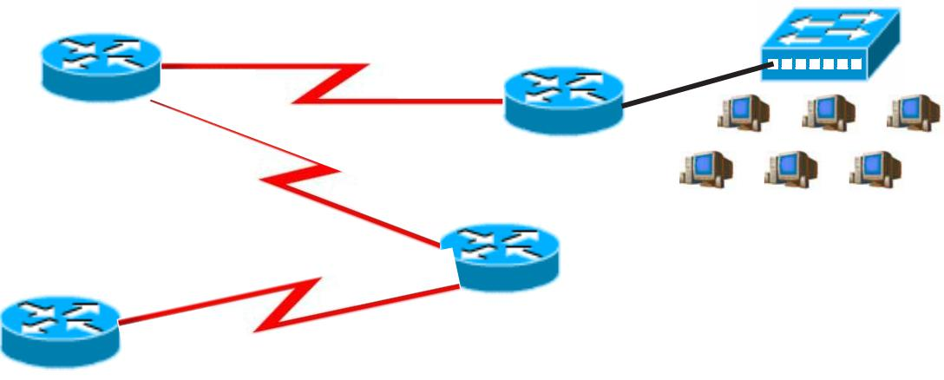

|  |  |  |  |  |  |  |  |  |  |  |  |  |  |  |  |  |  |  |  |  |  |  |
| --- | --- | --- | --- | --- | --- | --- | --- | --- | --- | --- | --- | --- | --- | --- | --- | --- | --- | --- | --- | --- | --- | --- |
| **S0/0/0** | **S0/0/1** | **F0/1** | | |  | |  |  |  |  |  |  |  |  |  |  |  |  |  |  |  |  |
| Router A |  |  |  |  |  |  |  |  |  |  |  |  |  |  |  |  |
| **S0/0/1** | **F0/0** | Router B |  | | | | | | |  |  |  |  |  |  |  |  |  |  |  |  |  |
|  | **S0/0/0** |  |  |  |  | Dallas | | | | | | | | | | | | | |  |  |  |

1500 Hosts

Router C

|  |  |  |  |  |  |  |  |  |  |  |  |  |  |  |  |  |  |  |
| --- | --- | --- | --- | --- | --- | --- | --- | --- | --- | --- | --- | --- | --- | --- | --- | --- | --- | --- |
|  |  |  |  |  |  |  |  |  |  |  |  |  |  |  |  | **F0/0** | **S0/0/1** |  |
|  |  |  |  |  |  |  |  |  |  |  |  |  |  |  |  |  |  |
|  |  |  |  |  |  |  |  |  |  |  |  |  |  |  |  |  | Router D **S0/0/0** |  |
|  |  |  |  |  |  |  |  |  |  |  |  |  |  |  |  |  |  |  |



Ft. Worth

2300 Hosts Address class _____________________________

Custom subnet mask _____________________________

Minimum number of subnets needed _________

Extra subnets required for 15% growth _________+

(Round up to the next whole number)

Total number of subnets needed _________=

Number of host addresses

in the largest subnet group _________

Number of addresses needed for 15% growth in the largest subnet +

(Round up to the next whole number)

Total number of address needed for the largest subnet =

Start with the first subnet and arrange your sub-networks from the largest group to the smallest.

IP address range for Ft. Worth _____________________________

IP address range for Dallas _____________________________

IP address range for Router A _____________________________

to Router B serial connection

IP address range for Router A _____________________________

to Router C serial connection

IP address range for Router C _____________________________

74 to Router D serial connection

**Show your work for Problem 9 in the space below.**

75

**Practical Subnetting 10**

Based on the information in the graphic shown, design a network addressing scheme that will supply the **minimum number of subnets**, and allow enough extra subnets and hosts for 110% growth in all areas. Circle each subnet on the graphic and answer the questions below.

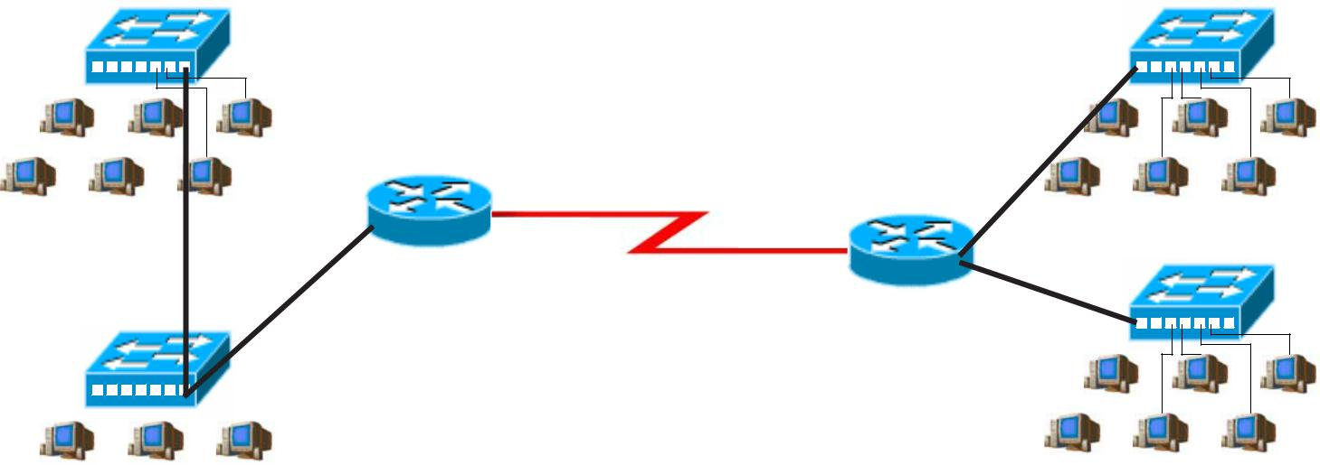

**IP Address 172.16.0.0**

|  |  |  |  |  |  |  |  |  |  |  |  |  |  |  |  |  |  |  |  |  |
| --- | --- | --- | --- | --- | --- | --- | --- | --- | --- | --- | --- | --- | --- | --- | --- | --- | --- | --- | --- | --- |
|  |  |  |  |  |  |  |  |  |  |  | Sales |  | Marketing | | |  | |  |  |  |
|  |  |  |  |  |  |  |  |  |  |  |  |  |  |  |
|  |  |  |  |  |  |  |  |  |  |  |  |  |  |  |
|  |  |  |  |  |  |  |  |  |  |  | 115 Hosts | | 56 Hosts | | | | |  |  |  |
|  |  |  |  |  |  |  |  |  |  |  |  |  |  |  |  |  |  |  |
|  |  |  |  |  |  |  |  |  |  |  | **F0/0** | **S0/0/0** | **F0/0** | | | | |  |  |  |
|  |  |  |  |  |  |  |  |  |  |  | Router A | **S0/0/1** | | | | |  |  |  |
|  |  |  |  |  |  |  |  |  |  |  |  |  |  |  |  |

|  |  |  |  |  |  |  |  |  |  |  |  |  |  |  |  |  |  |  |  |  |  |  |  |  |  |  |  |  |
| --- | --- | --- | --- | --- | --- | --- | --- | --- | --- | --- | --- | --- | --- | --- | --- | --- | --- | --- | --- | --- | --- | --- | --- | --- | --- | --- | --- | --- |
|  |  |  |  |  |  |  |  |  |  |  |  |  |  |  |  |  |  |  |  |  | Router B | | | | |  |  |  |
|  |  |  |  |  |  |  |  |  |  |  |  |  |  |  |  |  |  |  |  |  | **F0/1** | | | | |  |  |  |
|  |  |  |  |  |  |  |  |  |  |  |  |  |  |  |  |  |  |  |  | Management | Research | | |  |  |  |  |  |
|  |  |  |  |  |  |  |  |  |  |  |  |  |  |  |  |  |  |  |  |  |  |  |  |  |
|  |  |  |  |  |  |  |  |  |  |  |  |  |  |  |  |  |  |  |  |  |  |  |  |  |
|  |  |  |  |  |  |  |  |  |  |  |  |  |  |  |  |  |  |  |  | 35 Hosts | | | | |  |  |  |
|  |  |  |  |  |  |  |  |  |  |  |  |  |  |  |  |  |  |  |  | 25 Hosts |  |  |  |
|  |  |  |  |  |  |  |  |  |  |  |  |  |  |  |  |  |  |  |  |  |  |  |
|  |  |  |  |  |  |  |  |  |  |  |  |  |  |  |  |  |  |  |  |  |  |  |  |  |  |  |  |  |



Address class _____________________________

Custom subnet mask _____________________________

Minimum number of subnets needed _________

Extra subnets required for 110% growth _________+

(Round up to the next whole number)

Total number of subnets needed _________=

Number of host addresses

in the largest subnet group _________

Number of addresses needed for 110% growth in the largest subnet +

(Round up to the next whole number)

Total number of address needed for the largest subnet =

Start with the first subnet and arrange your sub-networks from the largest group to the smallest.

IP address range for Sales/Managemnt _____________________________

IP address range for Marketing _____________________________

IP address range for Research _____________________________

IP address range for Router A

to Router B serial connection _____________________________

76

**Show your work for Problem 10 in the space below.**

77

**Valid and Non-Valid IP Addresses**

Using the material in this workbook identify which of the addresses below are correct and usable. If they are not usable addresses explain why.

|  |  |  |
| --- | --- | --- |
| IP Address: 0.230.190.192 | ________________________________*ThenetworkIDcannotbe0.* |  |
| Subnet Mask: 255.0.0.0 | ________________________________ |  |
| *Reference Page Inside Front Cover* |  |  |
| IP Address: 192.10.10.1 | ________________________________*OK* |  |
| Subnet Mask: 255.255.255.0 | ________________________________ |  |
| *Reference Pages 28-29* |  |  |
| IP Address: 245.150.190.10 | ________________________________ |  |
| Subnet Mask: 255.255.255.0 | ________________________________ |  |
| *Reference Page Inside Front Cover* |  |  |
| IP Address: 135.70.191.255 | ________________________________ |  |
| Subnet Mask: 255.255.254.0 | ________________________________ |  |
| *Reference Pages 48-49* |  |  |
| IP Address: 127.100.100.10 | ________________________________ |  |
| Subnet Mask: 255.0.0.0 | ________________________________ |  |
| *Reference Pages Inside Front Cover* |  |  |
| IP Address: 93.0.128.1 | ________________________________ |  |
| Subnet Mask: 255.255.224.0 | ________________________________ |  |
| *Reference Pages 56-57* |  |  |
| IP Address: 200.10.10.128 | ________________________________ |  |
| Subnet Mask: 255.255.255.224 | ________________________________ |  |
| *Reference Pages 54-55* |  |  |
| IP Address: 165.100.255.189 | ________________________________ |  |
| Subnet Mask: 255.255.255.192 | ________________________________ |  |
| *Reference Pages 30-31* |  |  |
| IP Address: 190.35.0.10 | ________________________________ |  |
| Subnet Mask: 255.255.255.192 | ________________________________ |  |
| *Reference Pages 34-35* |  |  |
| IP Address: 218.35.50.195 | ________________________________ |  |
| Subnet Mask: 255.255.0.0 | ________________________________ |  |
| *Reference Page Inside Front Cover* |  |  |
| IP Address: 200.10.10.175 /22 | ________________________________ |  |
| *Reference Pages 54-55 and/or Inside Front Cover* | ________________________________ |  |
|  |  |  |
| IP Address: 135.70.255.255 | ________________________________ |  |
| Subnet Mask: 255.255.224.0 | ________________________________ |  |
| *Reference Pages 48-49* |  |  |

78

**IP Address Breakdown**

|  |  |  |  |  |  |  |  |  |
| --- | --- | --- | --- | --- | --- | --- | --- | --- |
| **/24** | **/25** | **/26** | **/27** | **/28** |  | **/29** | **/30** |  |
| 8+8+8 | 8+8+8+1 | 8+8+8+2 | 8+8+8+3 | 8+8+8+4 |  | 8+8+8+5 | 8+8+8+6 |  |
| 255.255.255.0 | 255.255.255.128 | 255.255.255.192 | 255.255.255.224 | 255.255.255.240 |  | 255.255.255.248 | 255.255.255.252 |  |
| 256 Hosts | 128 Hosts | 64 Hosts | 32 Hosts | 16 Hosts | | 8 Hosts | 4 Hosts |  |
|  |  |  |  |  |  | 0-7 | 0-3 |  |
|  |  |  |  | 0-15 |  |  | 4-7 |  |
|  |  |  |  |  |  |  |  |  |
|  |  |  |  |  |  | 8-15 | 8-11 |  |
|  |  |  |  |  |  |  |  |  |
|  |  |  |  |  |  |  | 12-15 |  |
|  |  |  |  |  |  |  |  |  |
|  |  |  |  |  |  | 16-23 | 16-19 |  |
|  |  |  |  | 16-31 |  |  | 20-23 |  |
|  |  |  |  |  |  |  |  |  |
|  |  |  |  |  |  | 24-31 | 24-27 |  |
|  |  |  |  |  |  |  |  |  |
|  |  | 0-63 |  |  |  |  | 28-31 |  |
|  |  |  |  |  |  |  |  |  |
|  |  |  |  |  |  | 32-39 | 32-35 |  |
|  |  |  |  |  |  |  |  |  |
|  |  |  |  | 32-47 |  |  | 36-39 |  |
|  |  |  |  |  |  |  |  |  |
|  |  |  |  |  |  | 40-47 | 40-43 |  |
|  |  |  |  |  |  |  |  |  |
|  |  |  |  |  |  |  | 44-47 |  |
|  |  |  |  |  |  |  |  |  |
|  |  |  |  |  |  | 48-55 | 48-51 |  |
|  |  |  |  | 48-63 |  |  | 52-55 |  |
|  |  |  |  |  |  |  |  |  |
|  |  |  |  |  |  | 56-63 | 56-59 |  |
|  |  |  |  |  |  |  |  |  |
|  | 0-127 |  |  |  |  |  | 60-63 |  |
|  |  |  |  |  |  |  |  |  |
|  |  |  |  |  |  | 64-71 | 64-67 |  |
|  |  |  |  |  |  |  |  |  |
|  |  |  |  | 64-79 |  |  | 68-71 |  |
|  |  |  |  |  |  |  |  |  |
|  |  |  |  |  |  | 72-79 | 72-75 |  |
|  |  |  |  |  |  |  |  |  |
|  |  |  |  |  |  |  | 76-79 |  |
|  |  |  |  |  |  |  |  |  |
|  |  |  |  |  |  | 80-87 | 80-83 |  |
|  |  |  |  | 80-95 |  |  | 84-87 |  |
|  |  |  |  |  |  |  |  |  |
|  |  |  |  |  |  | 88-95 | 88-91 |  |
|  |  |  |  |  |  |  |  |  |
|  |  | 64-127 |  |  |  |  | 92-95 |  |
|  |  |  |  |  |  |  |  |  |
|  |  |  |  |  |  | 96-103 | 96-99 |  |
|  |  |  |  |  |  |  |  |  |
|  |  |  |  | 96-111 |  |  | 100-103 |  |
|  |  |  |  |  |  |  |  |  |
|  |  |  |  |  |  | 104-111 | 104-107 |  |
|  |  |  |  |  |  |  |  |  |
|  |  |  |  |  |  |  | 108-111 |  |
|  |  |  |  |  |  |  |  |  |
|  |  |  |  |  |  | 112-119 | 112-115 |  |
|  |  |  |  | 112-127 |  |  | 116-119 |  |
|  |  |  |  |  |  |  |  |  |
|  |  |  |  |  |  | 120-127 | 120-123 |  |
|  |  |  |  |  |  |  |  |  |
| 0-255 |  |  |  |  |  |  | 124-127 |  |
|  |  |  |  |  |  |  |  |  |
|  |  |  |  |  |  | 128-135 | 128-131 |  |
|  |  |  |  |  |  |  |  |  |
|  |  |  |  | 128-143 |  |  | 132-135 |  |
|  |  |  |  |  |  |  |  |  |
|  |  |  |  |  |  | 136-143 | 136-139 |  |
|  |  |  |  |  |  |  |  |  |
|  |  |  |  |  |  |  | 140-143 |  |
|  |  |  |  |  |  |  |  |  |
|  |  |  |  |  |  | 144-151 | 144-147 |  |
|  |  |  |  | 144-159 |  |  | 148-151 |  |
|  |  |  |  |  |  |  |  |  |
|  |  |  |  |  |  | 152-159 | 152-155 |  |
|  |  |  |  |  |  |  |  |  |
|  |  | 128-191 |  |  |  |  | 156-159 |  |
|  |  |  |  |  |  |  |  |  |
|  |  |  |  |  |  | 16-167 | 160-163 |  |
|  |  |  |  |  |  |  |  |  |
|  |  |  |  | 160-175 |  |  | 164-167 |  |
|  |  |  |  |  |  |  |  |  |
|  |  |  |  |  |  | 168-175 | 168-171 |  |
|  |  |  |  |  |  |  |  |  |
|  |  |  |  |  |  |  | 172-175 |  |
|  |  |  |  |  |  |  |  |  |
|  |  |  |  |  |  | 176-183 | 176-179 |  |
|  |  |  |  | 176-191 |  |  | 180-183 |  |
|  |  |  |  |  |  |  |  |  |
|  |  |  |  |  |  | 184-191 | 184-187 |  |
|  |  |  |  |  |  |  |  |  |
|  | 128-255 |  |  |  |  |  | 188-191 |  |
|  |  |  |  |  |  |  |  |  |
|  |  |  |  |  |  | 192-199 | 192-195 |  |
|  |  |  |  |  |  |  |  |  |
|  |  |  |  | 192-207 |  |  | 196-199 |  |
|  |  |  |  |  |  |  |  |  |
|  |  |  |  |  |  | 200-207 | 200-203 |  |
|  |  |  |  |  |  |  |  |  |
|  |  |  |  |  |  |  | 204-207 |  |
|  |  |  |  |  |  |  |  |  |
|  |  |  |  |  |  | 208-215 | 208-211 |  |
|  |  |  |  | 208-223 |  |  | 212-215 |  |
|  |  |  |  |  |  |  |  |  |
|  |  |  |  |  |  | 216-223 | 216-219 |  |
|  |  |  |  |  |  |  |  |  |
|  |  | 192-255 |  |  |  |  | 220-223 |  |
|  |  |  |  |  |  |  |  |  |
|  |  |  |  |  |  | 224-231 | 224-227 |  |
|  |  |  |  |  |  |  |  |  |
|  |  |  |  | 224-239 |  |  | 228-231 |  |
|  |  |  |  |  |  |  |  |  |
|  |  |  |  |  |  | 232-239 | 232-235 |  |
|  |  |  |  |  |  |  |  |  |
|  |  |  |  |  |  |  | 236-239 |  |
|  |  |  |  |  |  |  |  |  |
|  |  |  |  |  |  | 240-247 | 240-243 |  |
|  |  |  |  | 240-255 |  |  | 244-247 |  |
|  |  |  |  |  |  |  |  |  |
|  |  |  |  |  |  | 248-255 | 248-251 |  |
|  |  |  |  |  |  |  |  |  |
|  |  |  |  |  |  |  | 252-255 |  |
|  |  |  |  |  |  |  |  |  |

79

**Visualizing Subnets Using**

**The Box Method**

The box method is the simplest way to visualize the breakdown of subnets and addresses into smaller sizes.

Start with a square. The whole square is a single subnet comprised of 256 addresses.

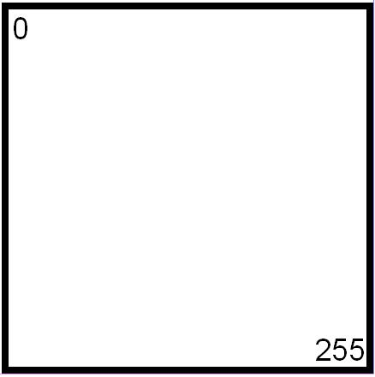

/24

255.255.255.0 256 Hosts 1 Subnet

Split the box in half and you get two subnets with 128 addresses,

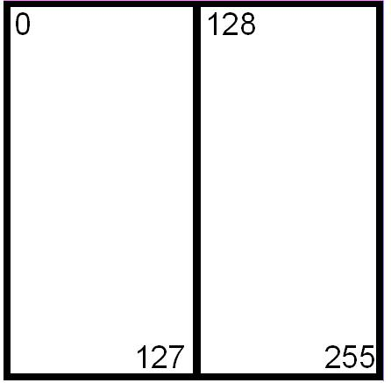

/25

255.255.255.128 128 Hosts 2 Subnets

Divide the box into quarters and you get four subnets with 64 addresses,

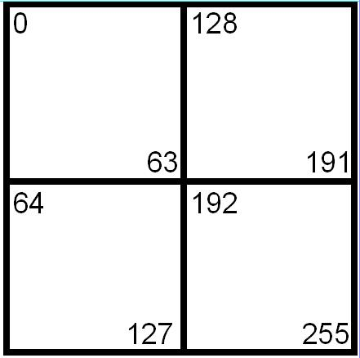

/26

255.255.255.192 64 Hosts 4 Subnets

80

Split each individual square and you get eight subnets with 32 addresses,

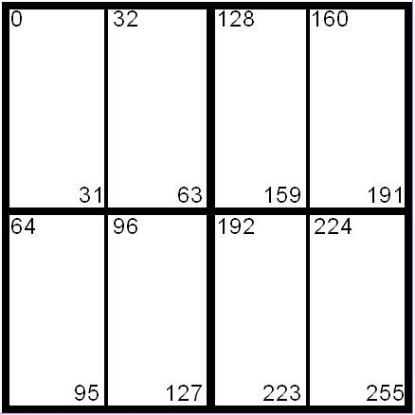

/27

255.255.255.224 32 Hosts 8 Subnets

Split the boxes in half again and you get sixteen subnets with sixteen addresses,

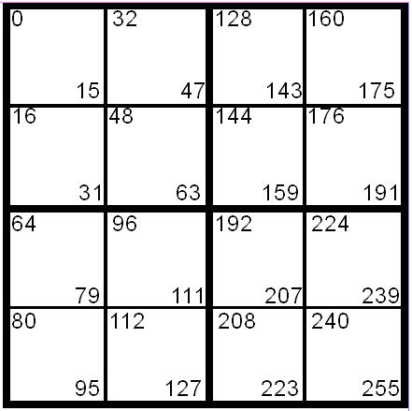

/28

255.255.255.240 16 Hosts 16 Subnets

The next split gives you thirty two subnets with eight addresses,

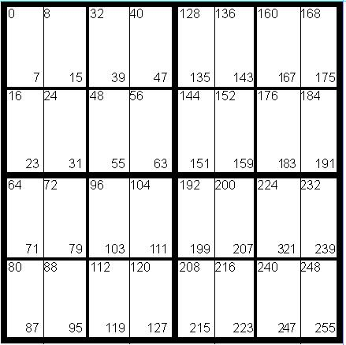

/29

255.255.255.248 8 Hosts 32 Subnets

The last split gives sixty four subnets with four addresses each,

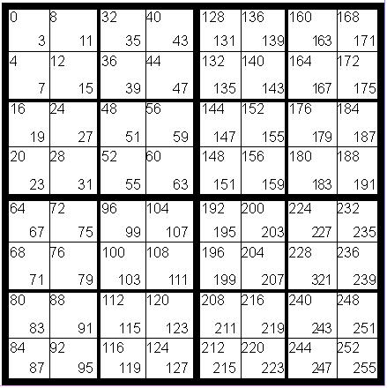

/30

255.255.255.252 4 Hosts 64 Subnets

81

|  |  |  |  |  |  |  |  |  |  |
| --- | --- | --- | --- | --- | --- | --- | --- | --- | --- |
|  |  |  | **Class A Addressing Guide** | | | |  |  |  |
|  |  | **# of Bits** | **Subnet** | **Total # of** |  |  | **Total # of** | **Usable # of** |  |
|  |  |  |  |
| ______________________________________________________________________________________________ | **CIDR** | **Borrowed** | **Mask** | **Subnets** |  |  | **Hosts** | **Hosts** |  |
|  | /8 | 0 | 255.0.0.0 | 1 |  |  | 16,777,216 | 16,777,214 |  |
|  | /9 | 1 | 255.128.0.0 | 2 |  |  | 8,388,608 | 8,388,606 |  |
|  | /10 | 2 | 255.192.0.0 | 4 |  |  | 4,194,304 | 4,194,302 |  |
|  | /11 | 3 | 255.224.0.0 | 8 |  |  | 2,097,152 | 2,097,150 |  |
|  | /12 | 4 | 255.240.0.0 | 16 |  |  | 1,048,576 | 1,048,574 |  |
|  | /13 | 5 | 255.248.0.0 | 32 |  |  | 524,288 | 524,286 |  |
|  | /14 | 6 | 255.252.0.0 | 64 |  |  | 262,144 | 262,142 |  |
|  | /15 | 7 | 255.254.0.0 | 128 |  |  | 131,072 | 131,070 |  |
|  | /16 | 8 | 255.255.0.0 | 256 |  |  | 65,536 | 65,534 |  |
|  | /17 | 9 | 255.255.128.0 | 512 |  |  | 32,768 | 32,766 |  |
|  | /18 | 10 | 255.255.192.0 | 1,024 |  |  | 16,384 | 16,382 |  |
|  | /19 | 11 | 255.255.224.0 | 2,048 |  |  | 8,192 | 8,190 |  |
|  | /20 | 12 | 255.255.240.0 | 4,096 |  |  | 4,096 | 4,094 |  |
|  | /21 | 13 | 255.255.248.0 | 8,192 |  |  | 2,048 | 2,046 |  |
|  | /22 | 14 | 255.255.252.0 | 16,384 |  |  | 1,024 | 1,022 |  |
|  | /23 | 15 | 255.255.254.0 | 32,768 |  |  | 512 | 510 |  |
|  | /24 | 16 | 255.255.255.0 | 65,536 |  |  | 256 | 254 |  |
|  | /25 | 17 | 255.255.255.128 | 131,072 |  |  | 128 | 126 |  |
|  | /26 | 18 | 255.255.255.192 | 262,144 |  |  | 64 | 62 |  |
|  | /27 | 19 | 255.255.255.224 | 524,288 |  |  | 32 | 30 |  |
|  | /28 | 20 | 255.255.255.240 | 1,048,576 |  |  | 16 | 14 |  |
|  | /29 | 21 | 255.255.255.248 | 2,097,152 |  |  | 8 | 6 |  |
|  | /30 | 22 | 255.255.255.252 | 4,194,304 |  |  | 4 | 2 |  |
|  |  |  |  |  |  |  |  |  |  |

|  |  |  |  |  |  |  |  |
| --- | --- | --- | --- | --- | --- | --- | --- |
|  |  |  | **Class B Addressing Guide** | | |  |  |
|  |  | **# of Bits** | **Subnet** | **Total # of** |  | **Total # of** | **Usable # of** |
| ______________________________________________________________________________________________ | **CIDR** | **Borrowed** | **Mask** | **Subnets** |  | **Hosts** | **Hosts** |
|  | /16 | 0 | 255.255.0.0 | 1 |  | 65,536 | 65,534 |
|  | /17 | 1 | 255.255.128.0 | 2 |  | 32,768 | 32,766 |
|  | /18 | 2 | 255.255.192.0 | 4 |  | 16,384 | 16,382 |
|  | /19 | 3 | 255.255.224.0 | 8 |  | 8,192 | 8,190 |
|  | /20 | 4 | 255.255.240.0 | 16 |  | 4,096 | 4,094 |
|  | /21 | 5 | 255.255.248.0 | 32 |  | 2,048 | 2,046 |
|  | /22 | 6 | 255.255.252.0 | 64 |  | 1,024 | 1,022 |
|  | /23 | 7 | 255.255.254.0 | 128 |  | 512 | 510 |
|  | /24 | 8 | 255.255.255.0 | 256 |  | 256 | 254 |
|  | /25 | 9 | 255.255.255.128 | 512 |  | 128 | 126 |
|  | /26 | 10 | 255.255.255.192 | 1,024 |  | 64 | 62 |
|  | /27 | 11 | 255.255.255.224 | 2,048 |  | 32 | 30 |
|  | /28 | 12 | 255.255.255.240 | 4,096 |  | 16 | 14 |
|  | /29 | 13 | 255.255.255.248 | 8,192 |  | 8 | 6 |
|  | /30 | 14 | 255.255.255.252 | 16,384 |  | 4 | 2 |

|  |  |  |  |  |  |  |
| --- | --- | --- | --- | --- | --- | --- |
|  |  | **Class C Addressing Guide** | |  |  |  |
|  | **# of Bits** | **Subnet** | **Total # of** | **Total # of** | **Usable # of** |  |
| **CIDR** | **Borrowed** | **Mask** | **Subnets** | **Hosts** | **Hosts** |  |
| /24 | ______________________________________________________________________________________________ | | | | 254 |  |
| 0 | 255.255.255.0 | 1 | 256 |  |
| /25 | 1 | 255.255.255.128 | 2 | 128 | 126 |  |
| /26 | 2 | 255.255.255.192 | 4 | 64 | 62 |  |
| /27 | 3 | 255.255.255.224 | 8 | 32 | 30 |  |
| /28 | 4 | 255.255.255.240 | 16 | 16 | 14 |  |
| /29 | 5 | 255.255.255.248 | 32 | 8 | 6 |  |
| /30 | 6 | 255.255.255.252 | 64 | 4 | 2 |  |

82

Inside Cover