# Homework 5 Backus-Naur Form Answers

1. A programming language has a simple if/then/goto construction. Some examples are:

|  |  |  |  |  |
| --- | --- | --- | --- | --- |
| **line number** | **IF** | **condition** | **THEN** | **line number** |
| 102 | IF | (x > 05) | THEN | 110 |
| 634 | IF | (y <= 16) | THEN | 0545 |
| 034 | IF | (z23 <> 345) | THEN | 756 |

1. Describe each of the following in words, based on the examples above. Three lines have been done for you. [5]

|  |  |
| --- | --- |
| **Item** | **Description** |
| relationship | >, <, <>, =, <=, >= |
| digit | 0 … 9 |
| letter | a … z |
| constant | Any number of digits |
| line_number | Any number of digits |
| variable | A lower case letter followed by zero or more digits |
| condition | Must have (, a single variable, a relationship, a constant, and ) |
| if_statement | Must start with a line number, followed by IF, the condition, THEN, and another line number |

1. Using the descriptions write the BNF production rules for the ‘If Statement’. It can be done in 8 rules. One has been completed for you. [7]

<if_statement> ::= <line number> IF <condition> THEN <line number>

<relationship> ::= > | >= | < | <= | = | <>

<digit> ::= 0 | … | 9

<letter> ::= a | b … | z

<constant> ::= <digit> | <digit><constant>

<line_number> ::= <constant>

<variable> ::= <letter> | <letter> <constant>

<condition> ::= (<variable><relationship><constant>)

1. The syntax diagrams for digit, letter and relationship are shown below.   
   Create the syntax diagrams to match the other five rules from part (b). [5]

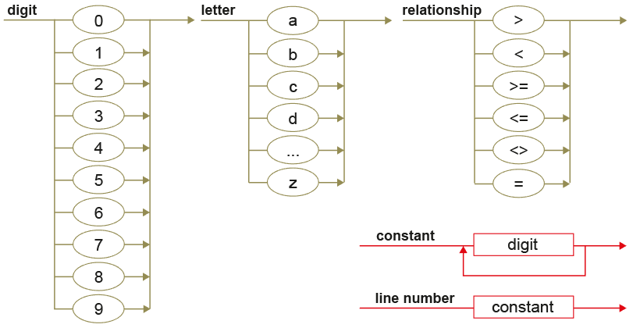

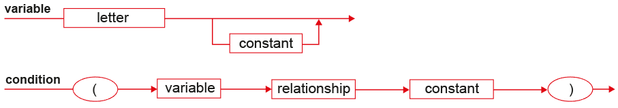

C:\Users\Rob\AppData\Roaming\PixelMetrics\CaptureWiz\Temp\13.png

1. Complete the parse tree for the IF statement: 102 IF (q5 > 8) THEN 32 [8]

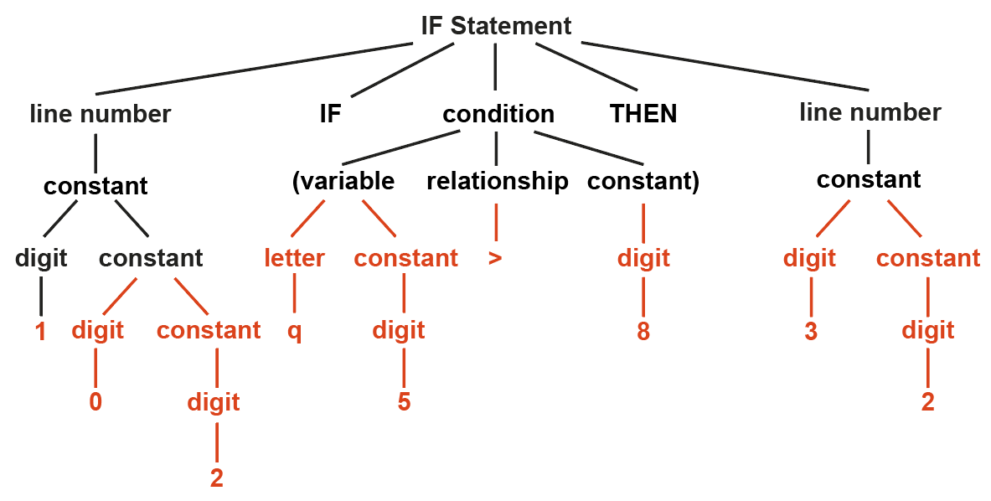

[Total 25 Marks]