# Homework 4 The Turing Machine Answers

1. Here is the set of transition functions for a Turing machine.

R indicates a movement to the right of the read-write head.

The notation used is:

δ (Current State, Input symbol) = (Next State, Output symbol, Movement).

|  |
| --- |
| δ (S0, 0) = (S1, 1, R) |
| δ (S0, 1) = (S1, 0, R) |
| δ (S0, ) = (S0, , R) |
| δ (S1, 0) = (S1, 1, R) |
| δ (S1, 1) = (S1, 0, R) |
| δ (S1, ) = (S2, , R) |

(a) Draw the state transition diagram for this Turing machine, given that the start state is S0 and the halt state is S2. [3]

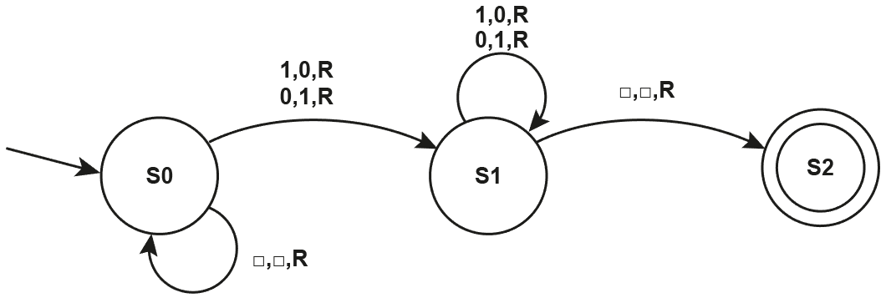

(b) Using this tape as input to the Turing machine, show the state of the same tape at each step in the execution of the program. [6]

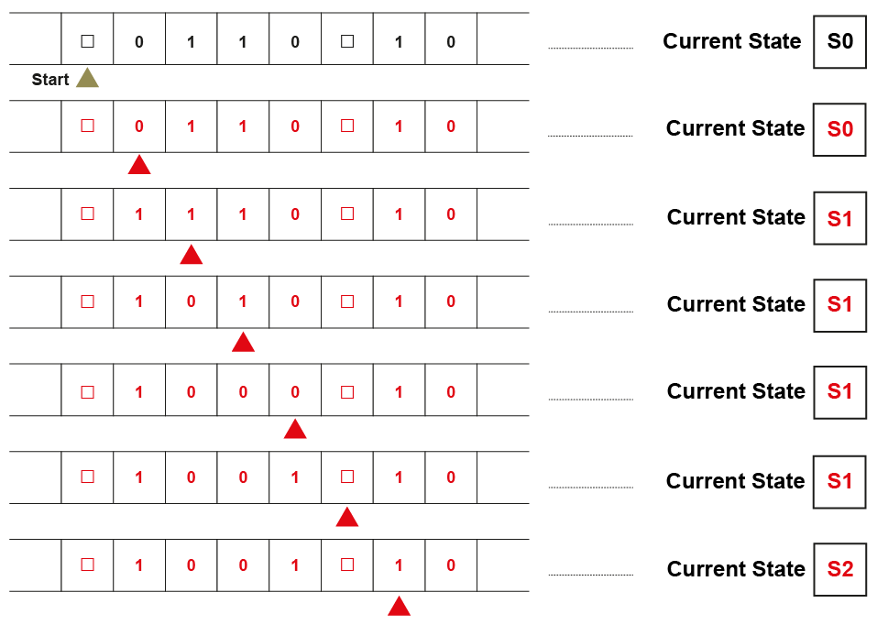

(c) Describe the function of this Turing machine. [1]

Inverter. It changes every 0 to 1 and every 1 to 0 and stops on the first symbol after a blank

2. A Turing machine has been designed to recognise binary strings with an equal number of 0s and 1s.

* The machine’s alphabet is 0, 1, ‘X’, , where indicates a blank cell on the tape.
* R and L are direction movements of the read-write head.
* The starting state is S0.
* S4 is the halting state.

Here is the transition function (δ) for this Turing machine.

δ (S0, 0) = (S1, X, R)

δ (S0, 1) = (S2, X, R)

δ (S0, X) = (S0, X, R)

δ (S0, ) = (S4, , L)

δ (S1, 0) = (S1, 0, R)

δ (S1, 1) = (S3, X, L)

δ (S1, X) = (S1, X, R)

δ (S1, ) = (S4, , L)

δ (S2, 0) = (S3, X, L)

δ (S2, 1) = (S2, 1, R)

δ (S2, X) = (S3, X, L)

δ (S2, ) = (S4, , L)

δ (S3, 0) = (S3, 0, L)

δ (S3, 1) = (S3, 1, L)

δ (S3, X) = (S3, X, L)

δ (S3, ) = (S0, , R)

(a) The image below shows the starting position of the tape. Fill in the empty rows of the trace table to show the behaviour of the Turing machine indicating the contents of the tape and the current state for each transition. [6]

Note that the read-write head in this table is indicated by the * symbol.

|  |  |  |  |  |  |  |  |  |  |
| --- | --- | --- | --- | --- | --- | --- | --- | --- | --- |
|  |  |  |  |  |  |  |  |  | **Current State** |
|  |  | 1* | 0 | 1 | 0 |  |  |  | S0 |
|  |  | X | 0* | 1 | 0 |  |  |  | S2 |
|  |  | X* | X | 1 | 0 |  |  |  | S3 |
|  | * | X | X | 1 | 0 |  |  |  | S3 |
|  |  | X* | X | 1 | 0 |  |  |  | S0 |
|  |  | X | X* | 1 | 0 |  |  |  | S0 |
|  |  | X | X | 1* | 0 |  |  |  | S0 |
|  |  | X | X | X | 0* |  |  |  | S2 |
|  |  | X | X | X* | X |  |  |  | S3 |
|  |  | X | X* | X | X |  |  |  | S3 |
|  |  | X* | X | X | X |  |  |  | S3 |
|  | * | X | X | X | X |  |  |  | S3 |
|  |  | X* | X | X | X |  |  |  | S0 |
|  |  | X | X* | X | X |  |  |  | S0 |
|  |  | X | X | X* | X |  |  |  | S0 |
|  |  | X | X | X | X* |  |  |  | S0 |
|  |  | X | X | X | X | * |  |  | S0 |
|  |  | X | X | X | X* |  |  |  | S4 |

1. Describe what happens on a single pass to the right of this Turing machine. (i.e. to line 4, current state S3). [2]

One 0 and one 1 are changed to X, then the machine goes all the way back to the left.

1. What are the contents of the tape when this Turing machine reaches the halting state? [2]

All the input cells have been overwritten with X.

[Total 20 Marks]