use of language for Equus

|  |  |  |  |
| --- | --- | --- | --- |
| Character | Key Lines | Meaning | Practical Application |
| DYSART  Focusing on his opening monologue (Scene 1) |  |  | I explored this monologue employing Cicely Berry’s Punctuation shift, and I learnt …..  When then utilised Lecoq’s La Rose des Efforts exploring Dysart’s dramatic territories and dramatic dimensions. This exercise allowed me to explore …… |
| ALAN  Focusing on his monologue (Scene 13) |  |  | Employing Lecoq’s Ten Attitudes allowed me to explore the ritual and grace of this monologue. Physically, The Attitudes allowed me to …… |

**SOME KEY WORDS I HOPE TO SEE YOU USING:**

**Paroxysmal = a sudden expression of strong feeling**

**Bathos = change from the beautiful to the ordinary | Pathos = Feelings of sympathy**

**Rhetorical = Statements / questions that require no answer**

**Tessiture = your natural range – I employed my own tessiture for this line**

**Non-sequitor = it does not follow – this is a non sequitor line showing his thoughts are dissipated**

**Lexis – the language you use – he has a developed lexis because of his education and profession**

**Caesura = a complete pause – I employed a caesura at this point to emphasis the word …**

**Staccato – broken up, disjointed**

**Legato = smoothly and connected**

characterisation

When we first played the characters of DYSART, DALTON AND DORA in a press conference, the initial choices I made were ….. but these changed as we read the text to …

We explored the character of Dysart through Stanislavski’s Inners and Outers and by building tension points. Through this practical work I learnt ……

A significant action I attributed to Dysart was ….. And when I explored this using Heathcote’s Layers of Meaning questions, I learnt ….

Through building a set of and exploring Dysart’s office, I learnt that …

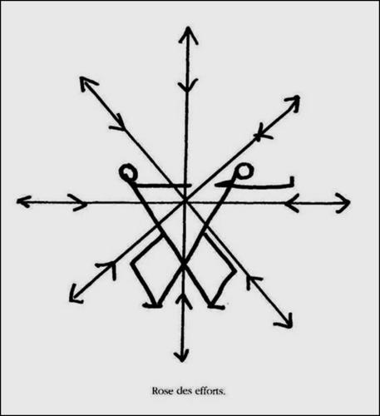

**Le Coq - Rose of Efforts (Rose des efforts) and The Attitudes**

**THE BODY KNOWS THINGS ABOUT WHICH THE MIND IS IGNORANT” Jacques Lecoq**

***You will not make discoveries through thinking, only through doing.***

**The Lecoq approach involves three key elements**

1. **Le Jeu (playfulness) throw yourself into work with the enthusiasm of a child**
2. **Disponsibilité (openness) always be willing to try**
3. **Complicité (togetherness) support, help and work with and for each other**

**“BE QUIET, PLAY AND THEATRE WILL BE BORN”**

**THE ATTITUDES**

**These series of movements aim to produce a series of attitudes that go beyond natural gestures.**

1. **One foot must remain constant and cannot move from a fixed spot (this aims to help you understand the breadth of your personal space)**
2. **Move through the sequence of movements pushing to the limit of the movement**
3. **Include statis (a moment of stillness which can be placed at the beginning, at the end or at a key point)**

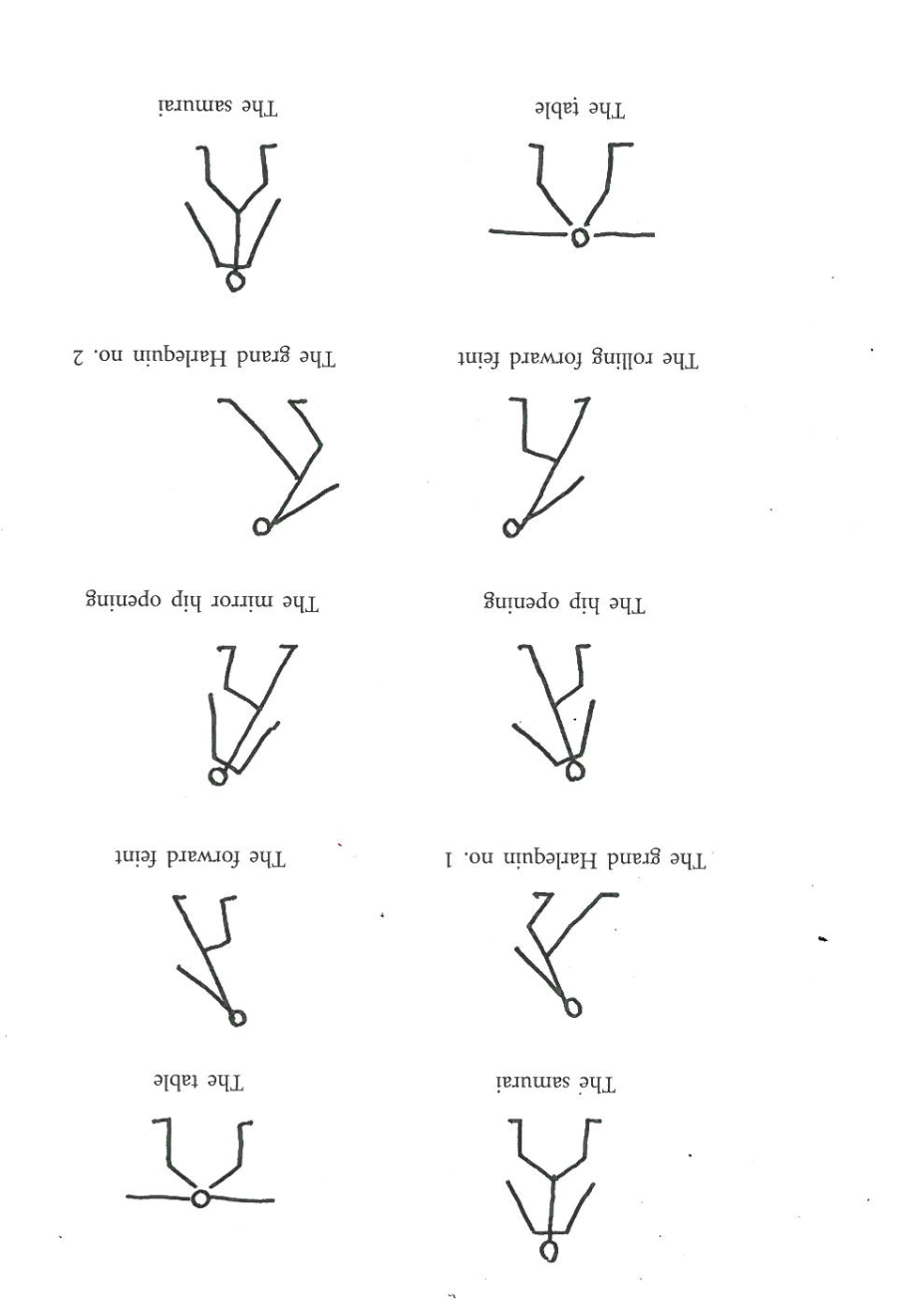

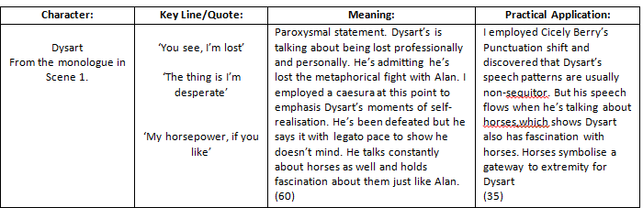

For characterisation put in a Laban Effort Graph for Dysart

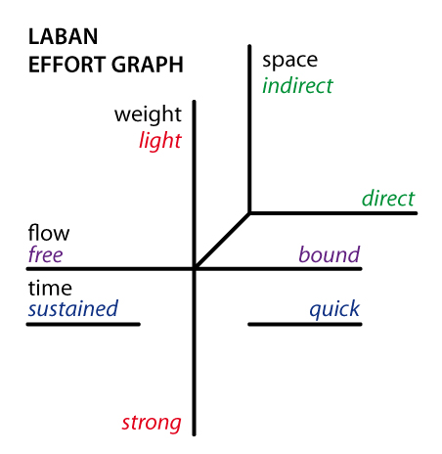**For Dysart**

EXAMPLE CHARACTERISATION

We explored Dysart’s character through Stanislavski’s inners and outer’s; outside he appears calm/interested inner=questioning/mid-life crisis. He speaks with chest resonance/calm tone to show that he is very sure of himself. His inner’s frustrated as he doesn’t understand Alan’s case. A significant action I attributed to Dysart was rubbing his thumb along his fingertips. Exploring Heathcote’s Layers of Meaning questions, I learnt that Dysart does this to try and relax him as he feels guilt for removing the passion he longs to have away from patients (link=Sc5). His animal link is an owl, wise yet not extreme. We built a set, exploring Dysart’s office. A window looking out on the world shows he envies the world, trapped in by his work. A dying plant shows his weakness and infertility.