During my preparation process I worked with Jacques Lecoq’s La Rose des Effort to establish my dramatic territories and dimensions. Understanding a person’s movements (physical and psychological) can be expressed by two essential actions - the movement of push and pull on different planes, I established my character’s space as …………. And my movement as ………………………. I intend to communicate this in performance by ……………….

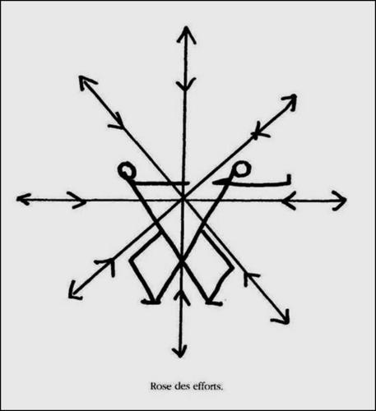

During my process work I explored Lecoq’s Attitudes to explore physicality in my movement and representation of character. Through employing the stance and gait of the …………. Attitude, I began to understand that my character ………….. and I intend to communicate this in performance by …

I also employ Lecoq’s idea of statis – stillness, the neutral space – during my performance, for example ………. to clearly communicate ………

Throughout my preparation work I worked with Lecoq’s guiding principal of Disponsibilité – Openness, trying new moves and developing the character through practical work.

You could then copy and paste an Attitude and place it within your text where your movement is inspired by that Attitude. (Repeat where appropriate)

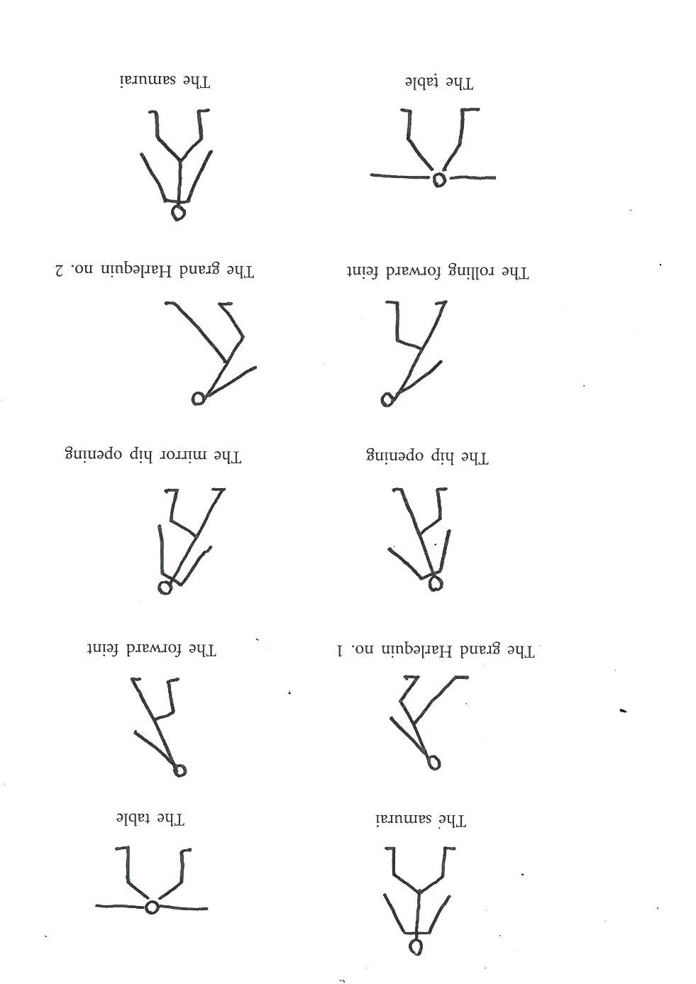

Use of Lecoq’s Bamboo stick exercise with my performance partner helped establish our spatial awareness and physical connection. Through this preparation exercise we learnt ……

I explored Berkoff’s Levels of the Grotesque understanding that the primary attitude of the character is physicalized, building in intensity from naturalistic to grotesque, this helped me create a strong, bold, extended physical portrayal. Developing from this, my playing level was (1=small/internal – 5=grotesque/externalised and over the top) and physically I ……………….

Michael Chekhov’s Psychological Gesture exercise clearly helped me establish my character ready for my first entrance, where I ………………….. to clearly sign to my audience that …………..

Cicely Berry’s Punctuation Shift helped me establish the floor-pattern of the speech directed by the punctuation. Through this I discovered that this is a …. (focused/dissipated) character with …. (clear/unclear) objectives. I intend to communicate this to my audience by …..

Laban’s Effort Graph helped me establish a physicality for my character who I discovered was ….

[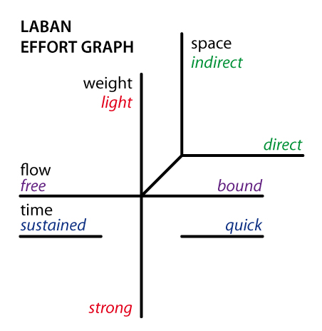](http://upload.wikimedia.org/wikipedia/commons/2/27/Laban-effort-graph.jpg)

And this influenced my character because …….. and I intend to communicate this to the audience by …..

Then include a completed Laban Effort Graph for your character and for yourself.