A TOP BAND EXAMPLE (not perfect–but yours should be!)

Godalming college,  AL 2 YEAR, 3000 words

C1 Portfolio

**5594**

**Centre Number: 64395**

**C1, AL Portfolio**

|  |  |
| --- | --- |
| 1 | Outline your initial response to the key extract and practitioner and track how it was developed throughout the devising process: |

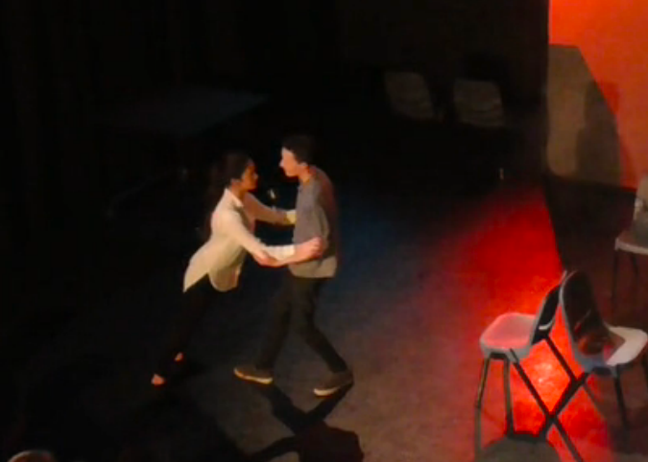After my first reading of ‘The Believers’[1] by Bryony Lavery[2], my initial reaction was that it was an interesting mix of genres, encompassing both comedy and tragedy. The most evident theme of the whole play is religion/belief[3] which intrigued me as I felt it’s a very current theme in the news today, questioning how far people are willing to go in the name of their beliefs[4]. Therefore, this became the central idea for our own performance. However, after deconstructing our chosen extract, I recognised the play is less about religion but more about the acquisition of truth. The shift in key theme of religion to a subtext of revealing truth inspired my choreography in the duologue between the parents, resembling Frantic Assembly’s ‘Round/By/Through’[5] transitions. This was a successful[6] moment in highlighting the truth within their relationship and how their beliefs were beginning to overpower their marriage.

Lavery is a lesbian[7] and feminist, with many feministic views placed within her plays[8]. This can be seen in The Believers with the strong female role of Marianne who is of an equal power status to her husband. She additionally spoke of her inspiration for writing the play[9] and its key themes of doubt and belief. This led to our group researching similar ideas of childhood demonic possession[10] and resultant parental neglect[11]. This fed our characterisation of the parents in our performance being very strict and including references in the dialogue[12] to the father being physically violent to his wife and children. Some negative reviews[13] of the first performance of Lavery’s play in 2014 gave us an urge to scrutinise the key theme of religion further and unearth what it truly means to individuals, allowing us to explore how this was going to affect our own characters.

I took particular interest in our practitioner, Frantic Assembly[14], as they use movement to unveil character’s real intentions and introduce subtext to the audience’s attention. Frantic’s choreography and movement makes the progression between scenes seamless whilst adding a sense of purpose to the transitions. As Frantic rarely utilise the device of multi-roling, we stayed true to this by each actor playing individually named characters, allowing the audience to form stronger connections to the characters through the episodic scenes (much like the majority of Frantic’s work[15]).

Our chosen extract was from scene 15 until the end of the play. We chose this extract as it is highly typical of the rest of the play in terms of style and genre. Also, we found the central idea of the cleansing to be exciting and inspirational for our own performance. This led to the denouement of the piece where the family cleanse and murder their youngest daughter, Grace. Our text extract was particularly interesting as it left questions unanswered, which we additionally wished to incorporate in our performance by allowing the audience to question whether the family got away with their crime.

|  |  |
| --- | --- |
| 2 | Connect your research materials to key stages in the development process and to performance outcomes: |

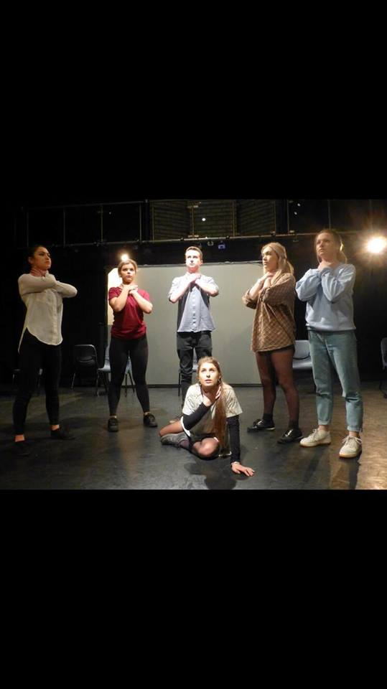During rehearsals, I researched into cult religions[16] and human sacrifice [17] [18] as we made a collective decision to focus on religion as a key theme to explore following the cleansing sacrifice in the play. From these sources I discovered it is common to use bloodless methods of killing for sacrifice (e.g. drowning) – linking nicely to the cleansing that takes place in The Believers and feeding into the final outcome of the cleansing of Grace. We wanted the audience to be shocked by the family’s brutality, and tangible feedback clearly demonstrated this was successful[19].

Further research was vital for my characterisation and, as I cannot personally empathise with being a mother, I decided to collect verbatim material[20] from mothers in my life to give my dialogue authenticity and avoid being either cliché or incorrect. From my research[21] (and drawing on personal experiences), I noticed the recurring mention of both high and low moments within a child – parent relationship which I wished to reflect through my dialogue. This influenced the contrast in scenes between a traditional happy family at the dining table to a growing heated argument about Hope dropping out of college.

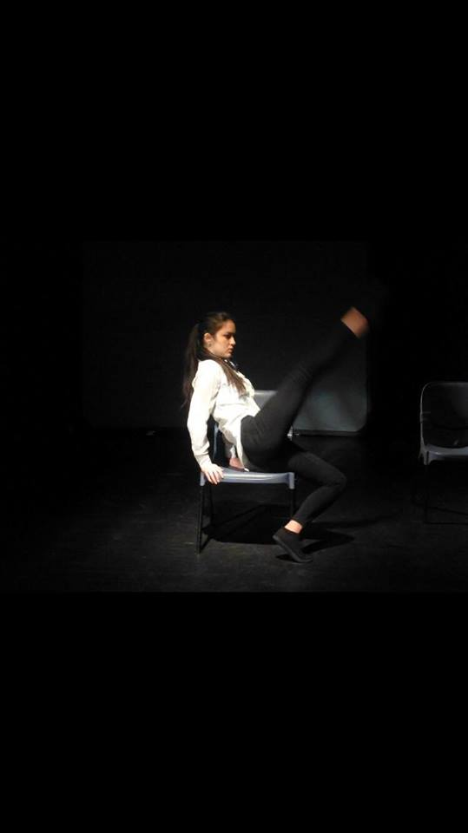As well as the works of Frantic Assembly[22], I decided to research into other physical theatre practitioners who have directly influenced Frantic- including DV8 [23]. I took significant inspiration from one of DV8’s videos[24] from a performance of ‘To Be Straight with You’[25]. The movement was highly polished and I wished to mirror a similar movement scene[26] using the same method of cannoning on chairs. I initially choreographed this scene with the idea of it being psychedelic/abstract as if the characters were hallucinating or ‘tripping’ from drugs due to the multiple drug references in the original play. Drugs[27] was one of the key themes from our extract that we began to explore but later scrapped as it was overcomplicating our plot and became irrelevant in developing our characters. Therefore, we changed our music from a psychedelic/electronic[28] song to a minimal/classical[29] piece paired with a voice over of the McCann’s press interview[30] to make this scene contemporarily relevant and allowing the audience to draw parallels between the McCann case and Grace’s disappearance in our performance. We concluded on this song as it charted a fine line between supporting as well as challenging the family unit through its minimalism and sorrowful tone. I took distinct interest in the music choice throughout our performance due to my research into Frantic Assembly’s strong ethos of music as a collaborator[31].

Watching Frantic Assembly’s performance of “Things I Know To Be True” [32] was one of the most influential methods of research for our development process as we witnessed first-hand how Frantic Assembly performed and incorporated their ethos into a performance. From this we decided to mimic a similar character structure with all the characters being part of the same family. Following this, I researched more into Frantic Assembly’s work and their Building Blocks for devising[33] [34] which stimulated many ideas of how we could incorporate their Building Blocks into our performance. I used practice as research to choreograph a Frantic Chair Duet[35] between the sisters, however this was later rejected as the movement reflected support and synchronicity which contrasted to the dialogue regarding their abusive relationship with their father (making the movement meaningless). Therefore, this was replaced by a Round, By, Through[36] sequence between the sisters whilst their father manipulated their movements – effectively[37] symbolising his power and control over them.

One of the key themes of the whole text is missing children, therefore we decided to collect verbatim material exploring this theme [38]. I had the idea to use this verbatim material as dialogue during a scene involving all the family at dinner and undertook further researched into the case of Madeleine McCann [39] [40]. From both my verbatim gathering and research, I discovered that many believe that the parents were involved in Madeleine’s disappearance which inspired the further development of filicide[41] within our performance and then the attempt to conceal the crime. Similarly, my research into the case of Shannon Matthews [42] partly inspired the police interrogation scene as it indicated the characters mocking their involvement in Grace’s disappearance. This was successfully[43] shown through my avoidance of eye contact, nervous scratching of my arm and my high pitched tone. I performed research into Shannon Matthews and Madeleine McCann as their cases were the focal inspiration for the character of Grace.

|  |  |
| --- | --- |
| 3 | Evaluate how your chosen role(s) emerged and developed from initial ideas through to the final performance: |

From the original source material, parenthood and family relationships were key themes we extrapolated, which guided our choice of all characters being a part of a single family. Due to the single-roling nature of our portrayal of characters, my personal role within the piece became the mother - based on the character of Maud in the original text. This was further confirmed after I undertook a Stanislavski Crossing the Space[44] workshop. I aimed to lose my own physicality and embrace her authoritative and strict role. My low shoulders, raised chest and fast direct walk conveyed my character’s view of her own power status as head of the family.

In the early rehearsal process, I wasn’t sure how I wanted my character to be portrayed, therefore, I used practise as research in improvisation with Harry to determine their husband-wife relationship which then became the basis for my character[45]. On further exploration of my character, I completed Stanislavski’s Hot Seating[46] – helping to develop her inners and outers[47]. This highlighted her inner emotion of fear of her husband contrasting with the outer physicality of power and strength as a deflection for her inner emotions she’s attempting to conceal. From this interaction I researched Laban[48] and plotted a Laban effort graph[49]:

[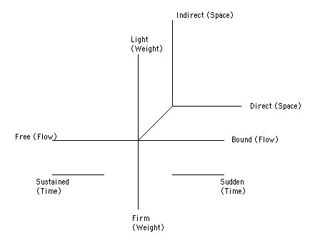](http://moodle2.coastlinelive.com/mml/topic/topicsSearch_detail.php?id=537)

My graph highlighted that she is a very powerful and strong character through her direct use of space and firm weight. I particularly showed her directness in the scene where the parents are questioning Hope leaving college and both parents are pacing, crossing the stage back and forth. The movements are quick paced with sudden, agile changes of direction paired with her firm weight to reflect the guilt she’s carrying. However, I additionally showed that her husband is still the power holder and she plays a more passive role through her sudden time, connoting a lack of control.

Initially, from creating a Role on the Wall[50], I determined that Eden would appear to be a very soft and passive character at first with a legato delivery and high pitch to reflect her desperation to get her child back (particularly seen in the interview scene). However, as the performance progresses and the audience discover the sinister truth that this was all an act, her voice and physicality changes. I showed this contrast through a change in pitch and slower pace to highlight a regain of control. My character was vital in representing the central, dictatorial, power figure of the family. Therefore, my role fed our overall question of “how far would you go in the name of religion?”[51] I reflected these attributes successfully[52] through a slow tempo-rhythm to suggest a lack of guilt, much more direct movement and plosive language to reflect her power within the family.

|  |  |
| --- | --- |
| 4 | Analyse how your contribution was influenced by the selected theatre practitioner and/or theatre makers, and the impact live theatre has had on your own practical work: |

Frantic Assembly[53] was our selected theatre practitioner and inspiration for our performance[54]. Their ethos focuses on inspiring, supporting and collaborating as a group which was influential to us as we all contributed ideas and amalgamated these ideas together. Their methods of devising they title ‘Building Blocks’[55] which I took most inspiration from and therefore led us to practice as research, trying some of their Building Blocks including Round, By, Throughs[56] and Chair Duets[57]. Through this we were able to establish the stylistic influence of their work on our own.

The company formed in 1994, during the context of angst and rebellion in the UK against the Tory government. Additionally, ‘In-Yer-Face’ Theatre[58] was popular at the time, reflecting the current political mood. Frantic Assembly took inspiration from this by questioning moral norms but in an alternative, fierce and intelligent way rather than angry or politicised. This led me to question what our performance could educate about or be a response to and fed to the decision about the final central question that our performance would focus on: “how far would you go in the name of your religion?”

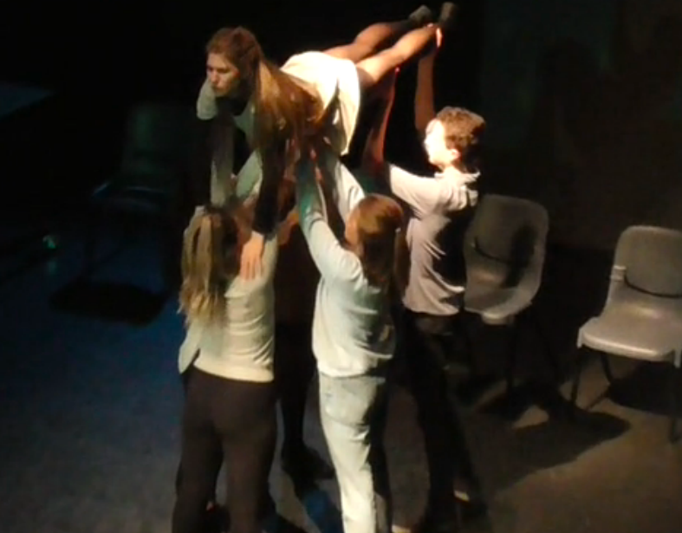Frantic Assembly’s performance of “Things I Know To Be True” [59] was one of the most influential methods of research for our development process as we could see first-hand how Frantic Assembly performed and combined their unique physical style of movement, design, music and dialogue. I took particular inspiration from their use of physical theatre and how subtly it was placed within the performance. One particular moment was when the mother was lifted using a quad lift by all the children which we chose to similarly use in our piece when Grace is lifted by the rest of the family – signifying that she’s the central member that holds the family together.

Additionally, I watched a verbatim performance about childhood[60] which was inspired by Frantic’s questionnaire methodology[61]. It was so thought provoking to watch the piece knowing that all the dialogue was verbatim and seeing how it was pieced together, therefore we decided to collect our own verbatim material[62] on our chosen themes of religion, drugs and missing children. I thought to use our verbatim words during the scene with the family at the dinner table as it provided a naturalistic element as the dialogue was real spoken words, allowing the audience to relate to the characters as the discourse wasn’t superficially written.

|  |  |
| --- | --- |
| 5 | Discuss how social, historical and cultural conventions impacted on your work: |

‘The Believers’, by Bryony Lavery, was first performed in 2014 – a year after The National Crime Agency released its Child Abduction Report[63] (which was a significant stimulus for Lavery). Our group took inspiration from this key theme in the text extract as child abductions/missing children is still a relevant topic to a contemporary audience as it is evident that child kidnappings are increasing[64]. This first performance was a motivating force for our use of symbolic, stylised and minimalistic set as well as creating multiple settings with the same set.

Due to the rise in technology, and the current generation’s attitude towards it, it’s a common widespread fear for parents to protect their children from strangers/child predators. However, from our research[65] I discovered that it’s much more common for a family member to kidnap a child than a stranger, further leading us to the development of the idea of filicide. This idea was then reflected in the staging: the police interrogation scene opened the performance in-media-res, with the family on a lower proxemic to the interrogator. This was further enhanced by a distorted shadow projection of the missing girl upstage centre, giving her centrality in this scene and symbolising their guilt through her ominous presence.

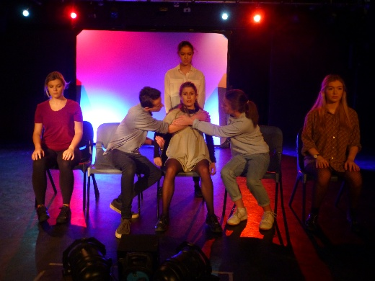

Our group’s key question: “how far would you go in the name of your religion?” was chosen as it’s very relevant today with the widespread fear of terrorism[66] and radical, extremist religious groups. Our performance reflected this with the family being blinded by their faith and thus twisting their morality. Additionally, people are leaning more and more against religion nowadays, partially due to extremism, and it has become increasingly ‘fashionable’ to be an atheist in today’s Western world[67].

Culturally, our audience were theatrically literate, white, middle-classed and aged 16-25. Therefore, our audience grew up surrounded by the case of Madeleine McCann[68]. However, whilst devising our piece the case came back into the press[69]. It is evident that there are still elements within both the police and public in the UK and Portugal who suspect the parent’s complicity in Madeleine’s disappearance. Additionally, the case of the McCann’s has maintained media fascination and it could be argued that this is because Madeleine is a white, blonde girl from a privileged background[70] whose parents have been skillful in ensuring continued public attention. We took these into consideration and based the character of Grace quite similarly to Madeleine McCann (Grace being the age Madeleine would be now) and the idea of her parents as being secretive and manipulative.

It was unsettling for me when researching historical abuse cases[71] that the majority of the victims were female. Therefore, we intended to support Lavery’s[72] self-definition as a ‘second wave feminist’[73] (a wave that brought greater social awareness of child sexual abuse in the 1960s) in our performance by rooting the play in gender politics[74] and exposing a clear divide between the female characters and the single dominant male. Having Harry as a singular male holding the highest status within the family clearly demonstrated the patriarchy that is still prevalent in today’s society but kept concealed within benign situations like everyday family life.

|  |  |
| --- | --- |
| 6 | Evaluate the creative choices you made and whether or not they were successful in performance. |

I believe our final performance was successful[75] in portraying our subject matter and raising cultural awareness of the contemporary issues of domestic abuse[76] and missing children[77]. To highlight Lavery’s strong relationship with the female response[78], we successfully[79] focused on the three daughter’s psychological struggles and poisonous relationship with their father in a need for healing, which ultimately led to the cleansing and murder of Grace.

Our key message was to question how far a family is willing to go in the name of their religion - the discourse at the centre of the original play-text. Therefore, I aimed to successfully communicate to the audience that we are a strong family unit – making it later shocking that we murder our daughter. I believe we achieved our aim[80] as one of our early scenes, when we’re in a police interview, is us talking as a family retrospectively about Grace’s missing case. This scene allowed us to play with the family dynamic as we begin expressing our love for Grace but hinting at the parents being more sinister through lines like *“they frighten us*.” I took inspiration from many cases in the news[81] of family members kidnapping or killing their own children but performing elaborate press interviews pleading for their child’s return. Similarly, we named our piece “Crocodile Tears”[82] to foreshadow to the audience that the family were involved but allowing them to question as to how far and why. Prior to the performance, I undertook research into how people behave when lying[83] and applied this to the scene with moments of touching my face, shaking my head and avoiding eye contact with the audience (as if they’re the interviewer).

My decision to have my character of the mother as the central, starting figure of the movement piece was successful[84] in showing her psychological battle concerning her family. Tangible evidence[85] proved that this scene beginning with one singular character on stage and later characters joining with synchronised movement meant we accomplished our aim in highlighting the family’s splintered relationship. I decided to enhance this scene with the use of a voice over of the McCann family’s police and press interviews[86], socially contextualising our piece and relating it to a contemporary audience. This allowed the audience to draw connections between the themes explored in our performance with current, relevant missing cases.

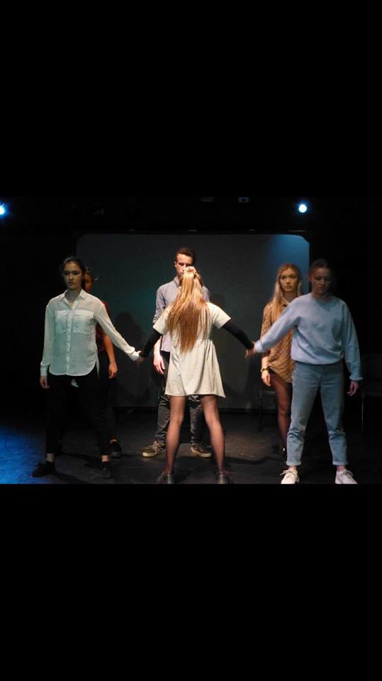I had the idea to use a leitmotif of blue light throughout the performance to subtly foreshadow the final scene of Grace’s murder where she’s drowned. The blue light was present during the scenes where Grace confesses her dreams as the blue light connoted water. I had the initial idea to incorporate a series of dreams within the piece as there are many instances within the Bible[87] [88] of God communicating through dreams. However, I accomplished my idea[89] to twist it to be as if Grace thought it was God speaking to her but it was ultimately a more demonic being and we showed this through an ensemble repetition of *“I didn’t believe it*”, signifying that these voices are in her head. On reflection, I think the blue light was too subtle as a foreshadowing device and we could have used something more pronounced like an exegetic sound of water.

1. The Believers by Bryony Lavery (Publisher: Faber & Faber) ISBN-13: 978-0571315758
2. <http://www.unitedagents.co.uk/bryony-lavery> (Date Accessed: 05/02/17) Lavery’s plays include A Wedding Story, Last Easter, Her Aching Heart [Pink Paper Play of The Year,1992] Smoke, Dirt and More Light.
3. <https://www.franticassembly.co.uk/productions/the-believers> (Date Accessed: 03/02/17)

   The Believers written by Bryony Lavery. Scott Graham (director) speaking of his intentions with the play: “I wanted this show to be about belief, how we construct our own and how we can crush or covet others”
4. <https://www.thereligionofpeace.com/attacks/attacks.aspx?Yr=2016> (Date Accessed: 17/12/16)
5. <http://www.ista.co.uk/downloads/DevisingandphysicalitywithFranticAssemblyLondonTaPSOctober2014.pdf> (Date Accessed: 04/01/17) Definition of Round/By/Through (page 2)
6. “I thought the parents really loved each other but then it showed that their religion and beliefs were more important to them than each other and their family” –Audience Member
7. <https://www.theguardian.com/stage/2006/apr/06/theatre3> (Date Accessed: 05/02/17)

   Lavery speaks of how she is an openly lesbian writer, which she realised after an early marriage ended in divorce
8. <https://365plays.wordpress.com/tag/bryony-lavery/> (Date Accessed: 28/12/16) Research shows that many of Lavery’s plays have a strong feminist message.
9. <http://www.whatsonstage.com/london-theatre/news/04-2014/bryony-lavery-on-the-believers-frantic-assembly-an_34206.html> (Date Accessed: 11/12/17) “[Scott Graham] had some newspaper cuttings of stories about children who died as a result of being demonised”
10. <http://www.dailymail.co.uk/news/article-3596516/Eighty-children-treated-hospital-outbreak-demonic-possession-Peruvian-school-pupils-say-visions-man-black-trying-kill-them.html> “Scores of children at a school in Peru have suffered seizures and described visions of a man in black trying to kill them in what locals say was a mass case of 'demonic possession'.” (Date Accessed: 27/12/16)
11. <http://www.mirror.co.uk/news/uk-news/hundreds-children-abused-being-possessed-9260792> (Date Accessed: 11/12/17) “Hundreds of children each year are [beaten, starved and reviled by their own families](http://www.mirror.co.uk/all-about/child-abuse) after being branded a witch or as possessed by evil spirits but only a fraction of the cases are identified”
12. *“He spits in our 5 and 7-year-old faces, our fragile bodies wounded on the ground, our*

    *dresses stained with red”* (Scene 6 – Sister Duologue)
13. <http://www.telegraph.co.uk/culture/theatre/theatre-reviews/10791232/The-Believers-Tricycle-Theatre-review-intriguing.html> (Date Accessed: 05/12/17) “The crucial questions about faith are skirted round [-] Lavery doesn’t push nearly deep enough into it.” –Dominic Cavendish
14. * The Frantic Assembly Book of Devising Theatre, Routledge; 2 edition (15 July 2014) ISBN: 1138777013

   
15. Episodic structure particularly seen in Andrew Bovell’s “Things I Know to Be True”, directed by Frantic Assembly
16. <http://www.therichest.com/rich-list/most-shocking/10-of-the-most-dangerous-religious-cults/> “many cults have sinister or extreme agendas that are so far outside they norm they become dangerous. This manifests in mass-suicides, brainwashing, extremist behavior, attacks, abductions, extortion and vandalism” (Date Accessed: 10/01/17)
17. <https://www.britannica.com/topic/human-sacrifice> (Date Accessed: 15/01/17)
18. <https://www.youtube.com/watch?v=Zc02G1rht7g&t=108s> (Date Accessed: 08/01/17)
19. “I thought the family were so nice and normal at first, I can’t believe they killed their own daughter and sister.” –Audience Member
20. “you just love your child unconditionally, like you made them. You’ll never understand that thought until you have children” Verbatim answer in response to the question ‘would you defend your child if they committed a crime?’
21. <http://www.medicalnewstoday.com/releases/149047.php> “The majority of parents and adult children experience some tension and aggravation with one another” (Date Accessed: 02/01/17)
22. <https://www.franticassembly.co.uk/productions> (Date Accessed: 12/12/16)
23. <https://www.dv8.co.uk> (Date Accessed: 12/12/16) ‘DV8 Physical Theatre's work is about taking risks, aesthetically and physically, about breaking down the barriers between dance and theatre’
24. <https://www.youtube.com/watch?v=PvctLx8H8xs> (Date Accessed: 02/01/17) DV8
25. Movement scene from ‘To Be Straight with You’ – written by Lloyd Newson, produced by DV8 and first performed in 2007.
26. Minutes 17:20 – 19:45 of our performance
27. <https://www.drugabuse.gov/publications/drugfacts/hallucinogens> (Date Accessed: 29/12/17) ‘Hallucinogens cause hallucinations, or sensations and images that seem real though they are not.
28. <https://www.youtube.com/watch?v=scQGXNjpbs0> (Date Accessed: 05/12/16) ‘Soul Shake’ by My Nu Leng & Flava D
29. <https://www.youtube.com/watch?v=I_x1rnaisuw> (Date Accessed: 11/01/17) ‘Fly’ written by Ludovico Einaudi
30. <https://www.youtube.com/watch?v=divprR1XZKM> (Date Accessed: 05/01/17)
31. <https://www.franticassembly.co.uk/resources/552/things-i-know-to-be-true-resource-pack.pdf> (Date Accessed: 03/02/17) Page 14: I believe that you have to find that one perfect connection between scene and music that then informs you how you can use the rest of the range.
32. “Things I Know to Be True” –Written by Andrew Bovell, produced by Frantic Assembly (performed at Chichester Festival Theatre, 23/11/16)
33. <https://www.youtube.com/watch?v=gUqZPfGIX6U&t=3s> (Date Accessed: 02/01/17)
34. <https://www.youtube.com/watch?v=PB-9LERsyY8> (Date Accessed: 02/01/17)
35. <https://www.youtube.com/watch?v=PB-9LERsyY8&feature=youtu.be> (Date Accessed: 20/12/16)
36. <https://www.youtube.com/watch?v=gUqZPfGIX6U> 1:05-5:46 (Date Accessed: 20/12/16)
37. Intangible evidence: gasp by an audience member when the father hits the daughter
38. Examples of the verbatim questions: How would you feel if your child went missing from your own negligence? What do you think happened to Madeleine McCann?
39. <http://www.huffingtonpost.co.uk/entry/madeleine-mccann-news-detectives-given-funds-to-probe-important-new-lead_uk_5843e80de4b061fb97e58743?utm_hp_ref=madeleine-mccann> (Date Accessed: 12/01/17)
40. <http://www.findmadeleine.com> (Date Accessed: 15/01/17)
41. Definition of ‘Filicide’: the killing of one's son or daughter.
42. <http://www.bbc.co.uk/news/10327470> (Date Accessed: 15/01/17) Karen Matthew’s faked her daughter Shannon’s disappearance.
43. “I never trusted the mum. Even in the first scene I knew she was hiding something, she seemed suspicious.” –Audience Member
44. Actors split into 5’s or 6’s and cross the space from one end to the other, followed by the next 5/6’s. They’re given specific scenarios/objectives e.g. crossing a beach with hot sand in bare feet.
45. I discovered in this workshop of the power imbalance between Eden and Eli. My character plays a much more passive role in comparison to her husband.
46. Hot Seating: a way of developing (or deepening) character. If you are in the hot-seat you answer questions from others in the group while you are 'in role'.
47. Inners = fear of her husband, questioning her beliefs, need for the truth and guilt for her involvement in killing Grace. Outers = confidence, strength and stability.
48. <https://www.trinitylaban.ac.uk/about-us/our-history/rudolf-laban> “He established choreology, the discipline of dance analysis, and invented a system of dance notation, now known as Labanotation” (Date Accessed: 25/01/17)
49. <https://www.theatrefolk.com/blog/the-eight-efforts-laban-movement/> (22/01/17)
50. <http://dramaresource.com/role-on-the-wall/> (date accessed: 22/01/17)
51. This question developed from the central idea in the original text of the cleansing and how it was allowed to happen.
52. “I was quite fearful of the mother, I thought she was very strict” –Audience Member
53. <https://www.franticassembly.co.uk/about>: “It is about the ethos of collaboration, of empowerment, of that constant desire to improve” (Date Accessed: 29/01/17)
54. Described as "vibrant and visceral" *-The Independent*
55. <https://www.youtube.com/watch?v=gUqZPfGIX6U> -showing Round/By/Throughs and Hymn Hands
56. <https://www.youtube.com/watch?v=gUqZPfGIX6U> (1:10) –Round/By/Throughs
57. <https://www.youtube.com/watch?v=PB-9LERsyY8&t=10s> -Chair Duets
58. <http://www.inyerfacetheatre.com/what.html> “something 'blatantly aggressive or provocative, impossible to ignore or avoid'” (Date Accessed: 29/01/17)
59. “Things I Know to Be True” –Written by Andrew Bovell, produced by Frantic Assembly (performed at Chichester Festival Theatre, 23/11/16)
60. Verbatim performance by ClassAction in Studio 816
61. <http://cchjvdrama2013.blogspot.co.uk/2013/10/frantic-assembly-and-questionnaires.html> “The Questionnaire seeks to indulge the cast in a bit of fun but also to unearth the darker side of our characters. It has some loaded questions directly related to the themes we want to explore” (Date Accessed: 03/02/17)
62. Questions included: “Do you believe in God?”, “What’s your opinion on drugs?” and “What do you believe happened to Madeleine McCann?”
63. <https://www.ceop.police.uk/Media-Centre/Press-releases/2013/CHILD-ABDUCTION-REPORT-REVEALS-NEED-FOR-A-REVAMPED-STRANGER-DANGER-ALERT/> (Date Accessed 06/02/17) “It also reveals that 17 per cent were abducted (or attempted) by a parent”
64. <http://www.independent.co.uk/news/uk/crime/child-kidnap-and-abduction-increase-as-crimes-come-under-greater-scrutiny-10062014.html> (Date Accessed: 06/02/17)

    “Child abductions and kidnappings are on the increase, with almost 900 reported cases in the past year alone”
65. <http://abcnews.go.com/US/story?id=91365> (Date Accessed: 12/02/17) “Stranger abductions make up the smallest percentage of children reported missing every year. The National Center for Missing and Exploited Children believes that stranger abductions are decreasing overall”
66. <http://uk.businessinsider.com/are-we-safer-now-than-on-911-2016-9> (Date Accessed: 07/02/17) Since September 11, 2001, "the global terror threat has compounded and cascaded,"
67. <http://news.nationalgeographic.com/2016/04/160422-atheism-agnostic-secular-nones-rising-religion/> (Date Accessed: 12/02/17) The religiously unaffiliated, called "nones," are growing significantly. They’re [the second largest religious group](http://www.pewresearch.org/fact-tank/2015/06/22/what-is-each-countrys-second-largest-religious-group/) in North America and most of Europe
68. <http://findmadeleine.com/about_madeleine/index.html> “It is only since Madeleine was taken from us, that Gerry and myself have become aware of just how many children go missing each year from all around the world” (Date Accessed: 20/12/16)
69. <http://www.telegraph.co.uk/news/worldnews/europe/portugal/6974917/Madeleine-McCanns-death-covered-up-by-parents-who-faked-kidnap-court-hears.html> (Date Accessed: 11/01/17)
70. <http://www.denverpost.com/2013/02/14/why-do-we-seldom-hear-about-missing-black-children/> (Date Accessed: 12/02/17) “They are other people’s children, but we worry for them, pray for them. In addition to being young and innocent, these well-known names have something else in common. All are white.”
71. <http://www.lwa.org.uk/understanding-abuse/statistics.htm> (Date Accessed: 08/12/16) “Leads to, on average, two women being murdered each week and 30 men per year”
72. “Until we break down the patriarchal hold created by our patrilineal society we will never be safe. We must not accept, we must speak out” –Bryony Lavery
73. <http://www.bbc.co.uk/archive/70sfeminism/> (Date Accessed: 09/12/16) “the 1970s saw the self-titled second wave feminists motivated to abolish sexism wherever they found it”
74. Definition of ‘Gender Politics’: [debate](https://www.collinsdictionary.com/dictionary/english/debate) about the [roles](https://www.collinsdictionary.com/dictionary/english/role) and relations of men and women
75. “I really enjoyed the performance and took interest on the sinister approach to the topic of religion” –Audience Member
76. http://safelives.org.uk/policy-evidence/about-domestic-abuse?gclid=CMG9_u-FiNMCFY8W0wodCiACGw#facts and stats (Date Accessed: 09/01/17) Research shows that 1.4 million women suffer from some form of domestic abuse a year
77. <http://edition.cnn.com/2013/10/22/us/missing-children-fast-facts/> (Date Accessed: 05/01/17) [The most recent study published by the Department of Justice, from 2002,](http://www.ncjrs.gov/pdffiles1/ojjdp/196465.pdf) reported that 203,900 children were abducted by family members
78. <https://365plays.wordpress.com/tag/bryony-lavery/> (Date Accessed: 28/12/16) Research shows that many of Lavery’s plays have a strong feminist message.
79. “I liked the development of the sisters because at first I was shocked and confused by their actions but by the end understood why they reacted in that way.” –Audience Member
80. “I felt awful for the family at the beginning, I imagined if I was in their situation and this made it even more shocking when I later discovered they were lying” –Audience Member
81. <http://www.dailymail.co.uk/news/article-4210912/Shannon-Matthews.html> (Date Accessed: 19/03/17)
82. “Crocodile tears”: tears or expressions of sorrow that are insincere
83. <http://www.independent.co.uk/news/science/how-to-tell-if-someone-is-lying-to-you-by-watching-their-face-a6846611.html> (Date Accessed: 05/02/17)
84. “I really felt for the mother in this scene, at first I didn’t like her but I felt really sorry for her at this point” –Audience Member
85. “The mum beginning the movement was really effective as it showed her as the rock of the family” –Audience Member
86. <https://www.youtube.com/watch?v=AZcfFTOti-s> - McCann’s interview with Sky News
87. Genesis 28:12-13 *“And he dreamed, and behold, there was a ladderset up on the earth, and the top of it reached to heaven.**And behold, the Lord stood above it and said, ‘I am the Lord, the God of Abraham your father and the God of Isaac.’”* 
88. Genesis 37:9 *“Then he dreamed another dream and told it to his brothers and said, ‘Behold, I have dreamed another dream. Behold, the sun, the moon, and eleven stars were bowing down to me.’”*
89. “The performance became much more sinister as I thought Grace was innocently talking to God but it then swapped to voices in her head” –Audience Member