

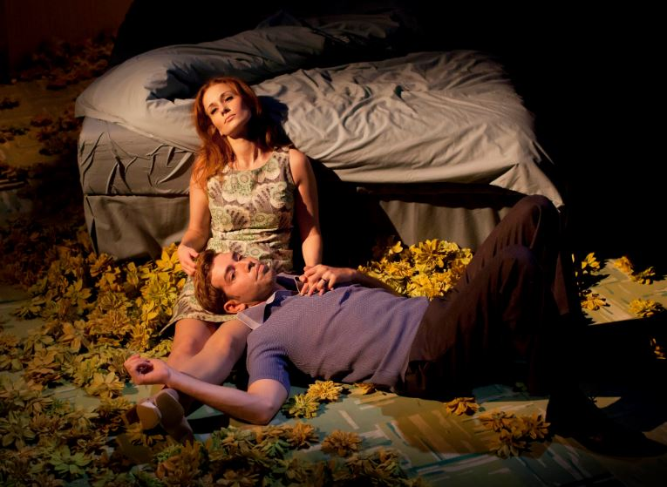

**UNIT 1**

**INVESTIGATING PRACTITIONERS’ WORK**

**WEEK TWO RESEARCH**

**LoveSong**

**Task 1.2:**

Basic Research: Biographical Information

<https://www.franticassembly.co.uk/productions/lovesong>

Have a look around the page and then ensure you download and look at The Resource Pack

|  |  |
| --- | --- |
| LOVE SONG | |
| Written by |  |
| What else do you know about this playwright |  |
| Date of production |  |
| Directed/Choreographed by |  |
| Old Billy played by |  |
| Young Billy played by |  |
| Old Maggie played by |  |
| Young Maggie played by |  |
| Set Design by |  |
| Lighting Design by |  |
| Projection by |  |
| Inspirations for production |  |

|  |
| --- |
| **NOTE YOUR SOURCES** |
|  |

**Task 2.2:**

Look at (and add to as much as possible) the SCENE ANALYSIS form for FRANTIC ASSEMBLY LOVE SONG – FIRST CONNECTION

**Task 3.2:**

Fill in with as much detail as you can giving reference to sections of the production / text ….

[**WHAT**](https://soundcloud.com/user-937115012/the-frantic-podcast-the-first-one) **IS LOVESONG ABOUT …**

|  |  |
| --- | --- |
| MARRIAGE |  |
| ROLE OF WOMEN |  |
| INABILITY TO CONCEIVE |  |
| LOVE |  |
| TIME |  |
| AGEING |  |
| DEATH |  |
| SUICIDE |  |
| THE ONE LEFT BEHIND |  |

|  |
| --- |
| **NOTE YOUR SOURCES** |
|  |

**Task 4.2:**

Look at (and add to as much as possible) the SCENE ANALYSIS form for FRANTIC ASSEMBLY LOVE SONG – THE OPENING

**Task 5.2:**

Have a look at the FRANTIC ASSEMBLY CLIPS on GOL > UNIT 1

* There is an interview with the two actors who play BILLY which needs to be watched
* You can now watch the whole production of LOVE SONG via the six section clips on GOL

**SOURCES**

<https://www.ayoungertheatre.com/review-love-song-frantic-assembly-abi-morgan-lyric-hammersmith/>

<http://matttrueman.co.uk/2012/01/review-lovesong-frantic-assembly.html>

<https://www.telegraph.co.uk/culture/theatre/theatre-reviews/8841719/Lovesong-Warwick-Arts-Centre-touring-review.html>

<https://variety.com/2012/legit/reviews/lovesong-1117946841/>

<https://www.whatsonstage.com/west-end-theatre/news/review-round-up-lovesong-at-the-lyric_5707.html>