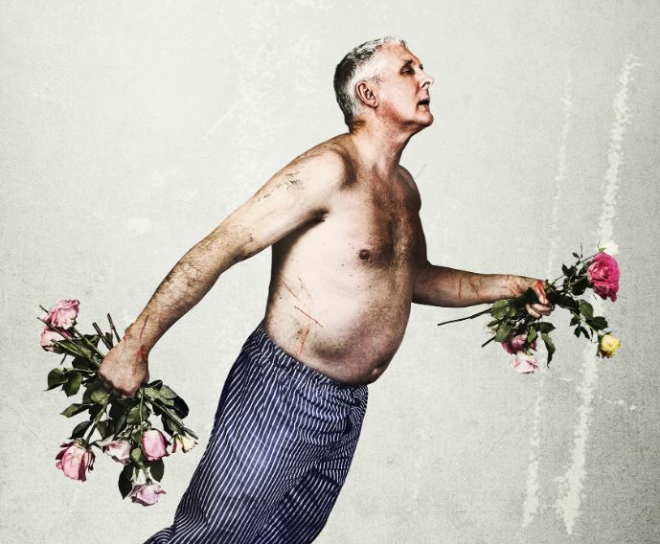

**UNIT 1**

**INVESTIGATING PRACTITIONERS’ WORK**

**WEEK FOUR RESEARCH**

**Things I Know To Be True**

**Task 1.4:**

|  |  |
| --- | --- |
| THINGS I KNOW TO BE TRUE – 2016-2017 | |
| Writer |  |
| Directors |  |
| Costume |  |
| Music/Sound Design |  |
| Set Design |  |
| Lighting |  |
| PERFORMERS |  |
|  |  |
|  |  |
|  |  |
|  |  |
|  |  |

|  |
| --- |
| **NOTE YOUR SOURCES** |
|  |

**Task 2.4:**

**Focus on the OPENING – Rosie’s Monologue**

**Complete a scene analysis sheet for this moment**

* **Clip on GoL**
* **Blank Scene Analaysis on GoL**