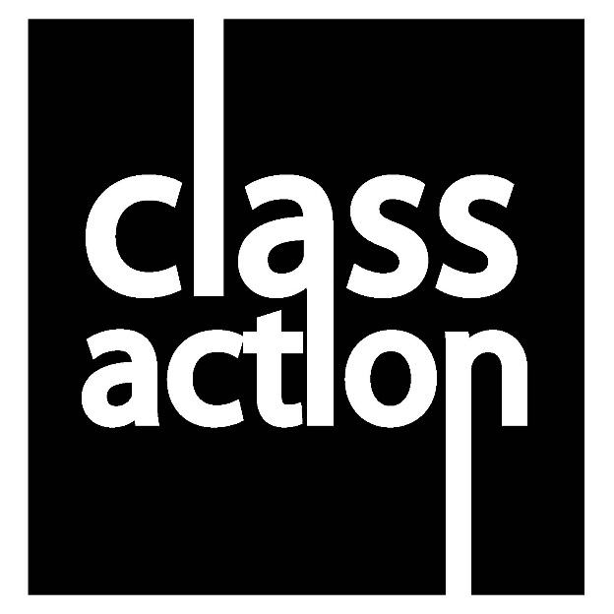
BTEC Level 3 Extended Certificate in Performing Arts
Unit 2:
Developing Skills and Techniques for Live Performance

HOW AM I ASSESSED?

HOW TO ACHIEVE
LEARNING AIM A
DISTINCTION | For distinction standard, learners must present a detailed and comprehensive account, showing a thorough and informed understanding of the role of the professional performer. They should evaluate the various technical, practical, employability and personal skills required, and how the performer may secure employment and achieve longevity through effective skills and professional development. Learners will evaluate training and qualification routes in terms of their appropriateness and viability and their work will draw conclusions about the impact of working patterns and lifestyle factors on the performer’s career. Learners’ conclusions will be well argued and supported by well-chosen examples. Their work will be presented to a high standard, with effective use of subject-specific terminology, relevant presentation techniques, for example practical demonstrations, and good use of grammar.
MERIT | For merit standard, learners must present a detailed account, showing understanding of the professional performer’s role. They will analyse the performer’s role, showing how the various technical, practical, employability and personal skills may contribute to the performer’s career development. Learners’ presentation will examine appropriate training and qualification routes, consider alternatives and explain typical working patterns and lifestyle. Their work will be detailed, using relevant presentation techniques, for example practical demonstrations, and accurate subject-specific terminology.
PASS | For pass standard, learners must present their understanding of the role of the professional performer and performance discipline with reference to the technical, practical, employability and personal skills the performer requires to succeed. Learners’ information will explain progression routes, including formal training and qualifications, as well as what characterises the performer’s role in terms of working patterns and lifestyle. Learners’ work may lack detail but will be presented to a satisfactory standard, with use of subject-specific terminology.

LEARNING AIM B & C
DISTINCTION | For distinction standard, learners will work at a high standard throughout workshops, technique classes, exercises, practice and performance. They will demonstrate professionalism and dedication in their willingness to acquire skills, explore, experiment and improve their performance practice. They will use feedback from teachers and peers actively and proactively, leading to independent development. Learners’ approach to interpreting and exploring existing performance material/ texts/repertoire will be methodical, highly detailed and comprehensive, leading to effective results in the development of roles and the imaginative application and refinement of relevant skills. Learners’ informal presentations of material developed through exercises and workshops will be confident and assured, communicating the stylistic features and qualities of the selected performance style effectively, expressively and with imagination.
MERIT | For merit standard, learners will carry out tasks in workshops, technique classes and exercises and practise independently and effectively. They will demonstrate focus, commitment and an ability to acquire, explore and develop performance skills. They will use feedback from teachers and peers to support development. Learners’ interpretation and exploration of existing performance material/texts/repertoire will be thoughtful and organised, and they will select appropriate research findings to inform their development of character/role, with effective results during the considered application of relevant performance skills. Learners’ informal performances of material developed will show attention to detail and a secure demonstration of performance skills, clearly communicating the stylistic features and qualities of the selected performance style.
PASS | For pass standard, learners will actively and positively participate in technique classes,  exercises and practice supporting the development of skills for a live performance. They will  respond to feedback from teachers and peers and attempt to improve their skills as a result.  Learners’ interpretation and exploration of existing performance material/texts/repertoire will show the ability to derive meaningful conclusions to support their development of character/role and be able to reach logical decisions on the application of relevant performance skills. Learners’ informal presentations of material developed will show appropriate application of performance skills and an attempt to convey the stylistic features and qualities of the selected performance style.

LEARNING AIM D
DISTINCTION | For distinction standard, learners must produce a performance log with clear reference to exercises and techniques in classes and workshops where they have acquired, developed  and applied performance and interpretative skills. Learners will reflect in detail on personal  management, discipline and safe working practices. Learners will evaluate their strengths and the development of performance skills and techniques, with clear reference to and an understanding of areas for improvement. Learners’ performance log will include setting of long- and short-term goals linked to professional practice. Learners will regularly monitor and review their targets through self-reflection and feedback from teachers and peers. Their work will be communicated in a well-structured and meaningful manner, showing accurate use of subject-specific vocabulary and grammar.
MERIT | For merit standard, learners must produce a performance log with reference to the development and application of performance and interpretative skills during classes and workshops. Learners will also reflect on their personal management, discipline and safe working practices. They will analyse their strengths and areas for improvement, referring to skills and techniques developed. They will set considered targets to support personal development and professional practice. Learners will use self-assessment, as well as feedback from teachers and peers, when reflecting on performance and target setting. Their target setting will be clear and will be used to develop performance skills.  Learners will present information coherently, with good use of grammar.
PASS | For pass standard, learners must produce a performance log with reference to the development and application of performance and interpretative skills, personal management, discipline and safe working practices. Learners will make reference to strengths and areas for improvement and include how personal development and professional practice can be achieved and maintained. They will refer to self-assessment, as well as feedback from teachers and peers, when explaining development needs and action planning. Learners’ journal may lack detail and there may be inconsistent use of grammar.

