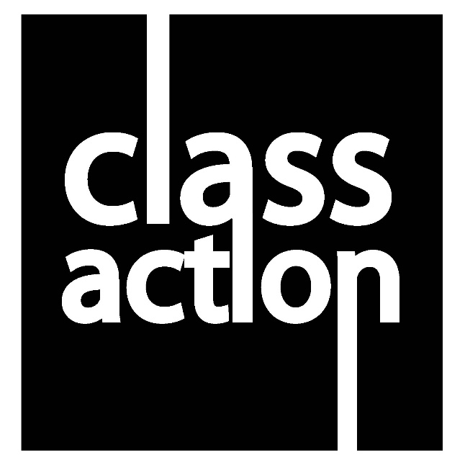

**UNIT 2**

**Developing Skills and Techniques for Live Performance**

|  |  |
| --- | --- |
| **STUDENT NAME:** |  |

**Learning Aim B**

|  |  |  |  |  |  |
| --- | --- | --- | --- | --- | --- |
| **Learning aim B: Develop performance skills and techniques for live performance** | | | | | |
| B.P2 Demonstrate the development of performance skills through exploration,  and workshops. |  | B.M2 Demonstrate effective  selection and development  of performance and interpretative skills through effective use of  exploration and workshops  for selected performance  discipline and style. |  | BC.D2 Demonstrate confident,  disciplined and highly effective use of exploration and workshops in the development and application of performance and interpretative skills for selected performance  material, discipline and style. |  |
| B.P3 Demonstrate the  development of interpretative skills with reference to selected  performance material, discipline and styles |  |

|  |
| --- |
| **LEARNING AIM B** |

|  |  |  |  |
| --- | --- | --- | --- |
| **Student name:** |  | | |
| **Qualification:** | **Pearson BTEC Level 3 National Diploma in Performing Arts** | | |
| **Unit number & title:** | **Unit 2: Developing Skills and Techniques for Live Performance** | | |
| **Description of activity undertaken** | | | |
| LEARNING AIM B: Develop performance skills and techniques for live performance.  Practitioners were observed over a number of rehearsals exploring and developing physical skills, performance disciplines and styles (Style: Naturalism or Jazz and then Physical Theatre or Contemporary). Exploring and developing vocal/interpretative skills and personal management skills for performance. At least one session was also filmed as further evidence for Learning Aim B. | | | |
| **Assessment & grading criteria** | | | |
| B1 Explore and develop physical skills, performance disciplines and styles  B2 Explore and develop vocal skills, performance disciplines and styles  B3 Develop interpretative skills, performance disciplines and styles  B4 Personal management and discipline skills for performance | | | |
| **How the activity meets the requirements of the criteria** | | | |
| The observation clearly allowed the assessor to accurately assess whether the unit content had been covered and which grade should be awarded. Filmed evidence also supports the grading. | | | |
| **Student signature:** |  | **Date:** |  |
| **Assessor signature:** |  | **Date:** |  |
| **Assessor name:** |  | | |

|  |  |  |  |  |  |
| --- | --- | --- | --- | --- | --- |
| **Learning aim B: Develop performance skills and techniques for live performance** | | | | | |
| B.P2 Demonstrate the development of performance skills through exploration,  and workshops. |  | B.M2 Demonstrate effective  selection and development  of performance and interpretative skills through effective use of  exploration and workshops  for selected performance  discipline and style. |  | BC.D2 Demonstrate confident,  disciplined and highly effective use of exploration and workshops in the development and application of performance and interpretative skills for selected performance  material, discipline and style. |  |
| B.P3 Demonstrate the  development of interpretative skills with reference to selected  performance material, discipline and styles |  |

|  |  |  |  |
| --- | --- | --- | --- |
| Witness name: |  | | |
| Witness job role: |  | | |
| Witness signature: |  | Date: |  |

**LEVEL 3 PERFORMING ARTS – Extended Certificate / Diploma**

**LEARNING AIM B**

**UNIT 2 Developing Skills and Techniques for Live Performance**

**I.V. AWP**

|  |  |  |  |
| --- | --- | --- | --- |
| **TITLE OF ASSIGNMENT/WORKSHOP** | Project ID  Induction Showcase | Group Piece | Two Minute Solo (Dance/Drama) | DATE ASSESSED | 29/09/16 |

|  |  |  |  |  |  |  |  |
| --- | --- | --- | --- | --- | --- | --- | --- |
|  |  |  | |  | **P** | **M** | **D** |
| **B1** | **Explore and develop physical skills, performance disciplines and styles** | Characterisation, facial expression, gesture, mannerism, posture, rhythm and tempo, weight placement, timing and pace, relationship, reaction and interaction with other characters/roles, audience, proxemics, use of space, use and manipulation of props and equipment. | physical skills appropriate to the dance style, physical characterisation and expression, timing and rhythmic accuracy, emphasis, musicality, phrasing, projection, , breathing, impetus, facial expression, bodily expression, relationship, reaction and interaction with other performers, stylistic quality of movement, use of space, spatial awareness. | |  |  |  |
| **B2** | **Explore and develop vocal skills, performance disciplines and styles** | Articulation, inflection, modulation, projection, register, pitch, timing, breathe control. use of pause, use of pace, dialect and accent, characterisation, projection | Rhythm, tempo, musicality, dynamics, characterisation, phrasing, expression | |  |  |  |
| **B3** | **Develop interpretative skills, performance disciplines and styles** | Choice of performance skills matched performance style.  Clear interpretation choices being made |  | |  |  |  |
| **B4** | **Personal management and discipline skills for performance, During classes, workshops** | attendance and punctuality, being ready to work, warming up and cooling down, wearing correct attire and presentation, e.g. footwear, dance wear, loose clothing, hair tied back, no jewellery, concentration and focus, learning dialogue and actions, listening and responding positively to direction, instruction and feedback, willingness to experiment and try things out, sensitivity and empathy towards others | | |  |  |  |



**Evidence to support   
Learning Aim B**

|  |
| --- |
| **Evidence of Professional Management Completed Form**  **Rehearsal Techniques Evaluation x 2** |

**Video evidence is also available of workshops, rehearsals**

**Learning Aim C**

|  |  |  |  |  |  |
| --- | --- | --- | --- | --- | --- |
| **Learning aim C: Apply performance skills and techniques in selected styles** | | | | | |
| C.P4 Demonstrate the  application of performance  skills and techniques for selected performance material, discipline and style. |  | C.M3 Demonstrate effective  selection and application  of performance and  interpretative skills for  selected performance  material, discipline and  style. |  | BC.D2 Demonstrate confident,  disciplined and highly effective use of exploration and workshops in the development and application of performance and interpretative skills for selected performance  material, discipline and style. |  |
| C.P5 Apply interpretative skills  for selected performance  materials, discipline and styles. |  |

**Recorded performance work is submitted as evidence for this learning aim**

|  |
| --- |
| **LEARNING AIM C** |

|  |  |  |  |
| --- | --- | --- | --- |
| **Student name:** |  | | |
| **Qualification:** | **Pearson BTEC Level 3 National Diploma in Performing Arts** | | |
| **Unit number & title:** | **Unit 2: Developing Skills and Techniques for Live Performance** | | |
| **Description of activity undertaken** | | | |
| LEARNING AIM C: Apply performance skills and techniques in selected styles  Practitioners were observed over a number of rehearsals exploring and developing physical skills and interpretative skills – practical exploration and development work. Practitioners applied performance skills during ‘Project ID’ (filmed evidence) and either naturalism or Dance Theatre work assessing performance skills. | | | |
| **Assessment & grading criteria** | | | |
| C1 Application of performance skills to performance material, disciplines and styles  C2 Application of interpretative skills to performance material, disciplines and styles | | | |
| **How the activity meets the requirements of the criteria** | | | |
| The observation clearly allowed the assessor to accurately assess whether the unit content had been covered and which grade should be awarded. Filmed evidence also supports the grading. | | | |
| **Student signature:** |  | **Date:** |  |
| **Assessor signature:** |  | **Date:** |  |
| **Assessor name:** |  | | |

|  |  |  |  |  |  |
| --- | --- | --- | --- | --- | --- |
| **Learning aim B: Develop performance skills and techniques for live performance** | | | | | |
| C.P4 Demonstrate the  application of performance  skills and techniques for selected performance material, discipline and style. |  | C.M3 Demonstrate effective  selection and application  of performance and  interpretative skills for  selected performance  material, discipline and  style. |  | BC.D2 Demonstrate confident,  disciplined and highly effective use of exploration and workshops in the development and application of performance and interpretative skills for selected performance  material, discipline and style. |  |
| C.P5 Apply interpretative skills  for selected performance  materials, discipline and styles. |  |

|  |  |  |  |
| --- | --- | --- | --- |
| Witness name: |  | | |
| Witness job role: |  | | |
| Witness signature: |  | Date: |  |



|  |
| --- |
| **UNIT 2**  **Learning Aim C(1&2)** |

**APPLYING PERFORMANCE SKILLS AND TECHNIQUES**

|  |  |
| --- | --- |
| PRACTITIONER’S NAME |  |
| ASSESSMENT | PHYSICAL THEATRE / CONTEMPORARY (INMOTION PERFORMANCE) |
| DATE | 13/01/17 |

**Applying relevant performance skills in informal presentations in class of existing material in a chosen style)**

|  |  |  |  |
| --- | --- | --- | --- |
| **✓** | **Demonstrate** the application of performance skills and techniques for selected performance material, discipline and style. Apply interpretative skills for selected performance materials, discipline and styles. | **Demonstrate effective** selection and application of performance and  interpretative skills for selected performance material, discipline and  style. | **Demonstrate confident, disciplined and highly effective** use of exploration and workshops in the development and application of  performance and interpretative skills for selected performance  material, discipline and style. |
| **C1 -** Application of physical and vocal skills to performance material, disciplines and styles |  |  |  |
| **C2 -** Application of interpretative skills to performance material, disciplines and styles |  |  |  |
|  | Learners’ informal presentations of material developed **will show appropriate application** of performance skills and **an attempt to convey the stylistic features** and qualities of the selected performance style. | Learners’ informal performances of material developed will **show attention to detail and a secure demonstration of performance** skills, **clearly communicating** the stylistic features and qualities of the selected performance style. | Learners’ informal presentations of material developed through exercises and workshops **will be confident and assured,** communicating the stylistic features and qualities of the selected performance style **effectively, expressively and with imagination** |

**Learning Aim D**

|  |  |  |  |  |  |
| --- | --- | --- | --- | --- | --- |
| **Learning aim D: Review and Reflect on development of skills and techniques for live performance** | | | | | |
| D.P6 Explain own development of performance skills,  strengths and areas for  improvement. |  | D.M4 Analyse own development of performance skills,  strengths and areas for  improvement, setting  targets to support future progress. |  | D.D3 Evaluate own strengths  and areas for improvement through consistent review of  and reflection on the development of performance skills, setting comprehensive  targets to support progression and practice. |  |



**Evidence to support   
Learning Aim D**

|  |
| --- |
| **Initial Skills Audit**  **Long Term Targets (Initial)**  **6 Performance Logs mapping development**  **Evaluation of Project ID**  **Evaluation of Khan solo so far** |