**DEVELOPING SKILLS AND TECHNIQUES FOR LIVE PERFORMANCE**

**A PERFORMER’S LIFE FOR ME**

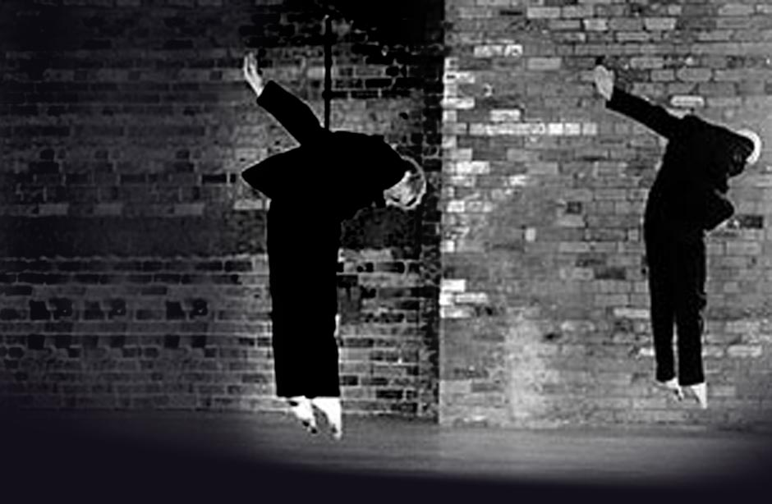

Learning Aim A: Understand the role and skills of a performer

|  |  |
| --- | --- |
| Name: |  |

|  |
| --- |
| **SECTION** **1 Exploring** **the** **roles** **and** **skills** **of** **a** **performer** |

**WHAT MAKES A GOOD PERFORMER? (P1/M1)**  
When you watch professional work, how do you know it is good?

|  |
| --- |
|  |

|  |  |
| --- | --- |
| **TO** **READ** | The work of the professional performer requires time and dedication to training, developing and improving the tools of the trade. For actors, dancers and singers, the ‘tools’ are the body, the voice and the creative and intellectual skills needed to interpret the performance material to communicate with and entertain an audience. Employment opportunities in performing arts often require the performer to demonstrate skills in more than one style, for example the ability to perform in classical texts or repertoire as well as contemporary works. Training, development and practice of skills are lifelong commitments, enabling the performer to respond to the demands of rehearsals and performances with commitment, imagination and accuracy |

**WHAT** **ARE** **THE** **KEY** **SKILLS** **OF** **A** **PROFESSIONAL** **ACTOR/DANCER** **(P1/M1)**

Here you are focusing on what you think are the essential skills and qualities required to be a professional performer.

|  |  |  |
| --- | --- | --- |
|  | **SKILL** | **EXPLAIN** – Why you think this skill is important - giving examples. |
| **1** |  |  |
| **2** |  |  |
| **3** |  |  |
| **4** |  |  |
| **5** |  |  |
| **6** |  |  |

|  |  |
| --- | --- |
| **D1** |  |
| **Looking** **at** **that** **skill-set,** **where** **would** **you** **identify** **your** **weakness?** **What** **might** **you** **do** **to** **improve** **your** **skill-set?** (3/4 side of A4) | |
|  | |

|  |
| --- |
| **What** **are** **their** **main** **duties** **and** **responsibilities?** (3/4 side of A4) |
|  |

|  |
| --- |
| **What** **qualifications** **do** **you** **need** **/** **could** **you** **acquire** **to** **work** **in** **this** **role?** (3/4 side of A4) |
|  |

2 |UNIT 2 LEARNING AIM A

|  |
| --- |
| **What** **is** **the** **salary** **like** **for** **this** **role** **and** **what** **are** **the** **usual** **terms** **and** **conditions** **of** **employment?**  (1 side of A4) |
|  |

|  |  |
| --- | --- |
| **D1** |  |
| **Does** **this** **research** **make** **you** **feel** **more** **or** **less** **inclined** **towards** **working** **professionally** **in** **this** **role?** **Why** **do** **you** **feel** **the** **way** **you** **do?**  (1 side of A4) | |
|  | |

**THE** **LIFE** **OF** **A** **PROFESSIONAL** **ACTOR** **/** **DANCER** **(P1/M1)** How does this job impact your lifestyle?

|  |
| --- |
| **What** **does** **a** **typical** **working** **day** **look** **like** **for** **a** **professional** **(working)** **actor** **or** **dancer?**  (3/4 side of A4) |
|  |

|  |
| --- |
| **How** **has** **that** **professional** **creative** **prepared** **for** **a** **day** **in** **a** **rehearsal** **room?**  (1/2 side of A4) |
|  |

|  |  |
| --- | --- |
| **D1** |  |
| **How** **will** **this** **job** **impact** **your** **life-style?** **Is** **this** **something** **you** **would** **want** **to** **do?** (3/4 side of A4) | |
|  | |

**DEVELOPING** **THE** **TOOLS** **OF** **YOUR** **TRADE** **(P1/M1/D1)**

|  |  |  |
| --- | --- | --- |
|  | **P1/M1**  Describe what this is and how you develop this? | **D1**  What is the importance of this tool for a professional creative? |
| **CV** |  |  |
| **HEAD** **SHOTS** |  |  |
| **SHOW** **REEL** |  |  |
| **AGENTS** |  |  |
| **AUDITIONS** |  |  |

**INTER-RELATIONSHIPS** **(P1/M1/D1)**

Working within this industry requires excellent team-work and collaboration. Who might you have to work with / alongside?

|  |  |  |
| --- | --- | --- |
|  | **Name** **another** **‘creative’** **you** **would** **be** **required** **to** **work** **with** | **EXPLAIN** **/** **EVALUATE**  How would you inter-relate to this creative? Why is this relationship important?  What might happen if this relationship was not effective? |
| **1** |  |  |
| **2** |  |  |
| **3** |  |  |
| **4** |  |  |

**SECTION** **2**

**Training** **and** **Qualifications**

|  |  |
| --- | --- |
| **D1** |  |
| **Evaluate:** **Why** **do** **you** **feel** **formal** **training** **in** **the** **performing** **arts** **is** **important?** **Why** **is** **understanding** **formal** **training** **routes** **important** **to** **you** **as** **a** **developing** **practitioner?**  (3/4 side of A4) | |
|  | |

**AUDITIONING** **AND** **INTERVIEWING** **(P1** **/** **M1)** Complete some research.

|  |
| --- |
| **What** **advice** **is** **given** **to** **a** **practitioner** **who** **is** **auditioning** **at** **vocational** **drama** **and** **dance** **schools?**  (at least 1 side of A4) |
|  |

**RESEARCH** **TASK.** **(P1** **/** **M1)**

Pick a professional actor or dancer that you find inspiring. (1 side of A4)

* Why have you picked them? Discuss their skill-set
* What initial experience did they have?
* Where did they train?
* What was their early professional work?

|  |
| --- |
|  |

|  |  |
| --- | --- |
| **D1** |  |
| **What** **can** **you** **be** **doing** **NOW** **to** **prepare** **for** **future** **auditions** **and** **interviews** **for** **vocational** **schools?** **What** **is** **your** **Action** **Plan?** (3/4 side of A4) | |
|  | |

**An** **analysis** **of** **training** **institutions**

|  |  |  |  |  |  |  |  |  |
| --- | --- | --- | --- | --- | --- | --- | --- | --- |
|  | **Name** **and** **type** **of** **institution** | **What** **is** **the** **course** **structure?** | **What** **Modules** **can** **be** **studied?** | **What** **facilities** **are** **offered?** | **What** **are** **the** **fees?** | **What** **is** **the** **audition** **process?** | **Alumni/career** **opportunities/** **What** **%** **of** **students** **went** **into** **the** **profession?** | **Opportunities** **to** **specialise** |
| **Drama** **School/** **Dance** **School** |  |  |  |  |  |  |  |  |
| **Drama** **School/** **Dance** **School** |  |  |  |  |  |  |  |  |
| **University** |  |  |  |  |  |  |  |  |
| **University** |  |  |  |  |  |  |  |  |

|  |  |
| --- | --- |
| **D1** |  |
| **From** **this** **research,** **what** **school** **would** **you** **like** **to** **attend?** **Why** **have** **you** **made** **this** **decision?** **What** **does** **this** **institution** **offer** **that** **no** **other** **does?**  (3/4 side of A4) | |
|  | |

**INTERVIEWS** **WITH** **INDUSTRY** **PROFESSIONALS:**

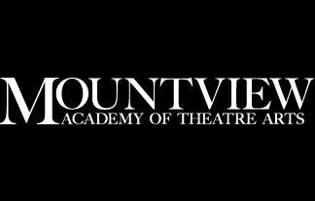

**Representatives** **from**

**MOUNTVIEW** **ACADEMY** **OF** **THEATRE** **ARTS** **(P1** **and** **M1** **ASSESSED)**

What did you learn from these sessions discussing with industry professionals?

|  |  |
| --- | --- |
| **D1** |  |
| **Evaluate** **your** **current** **practice.** **In** **response** **to** **the** **above** **interviews** **and** **masterclasses,** **what** **do** **you** **need** **to** **do** **now** **to** **prepare** **for** **vocational** **training** **in** **a** **years’** **time?** | |
|  | |

|  |
| --- |
| **Using** **the** **Harvard** **Reference** **System**  **List all** **your** **sources for this LEARNING AIM A**  **RESEARCH PROJECT.** |
|  |