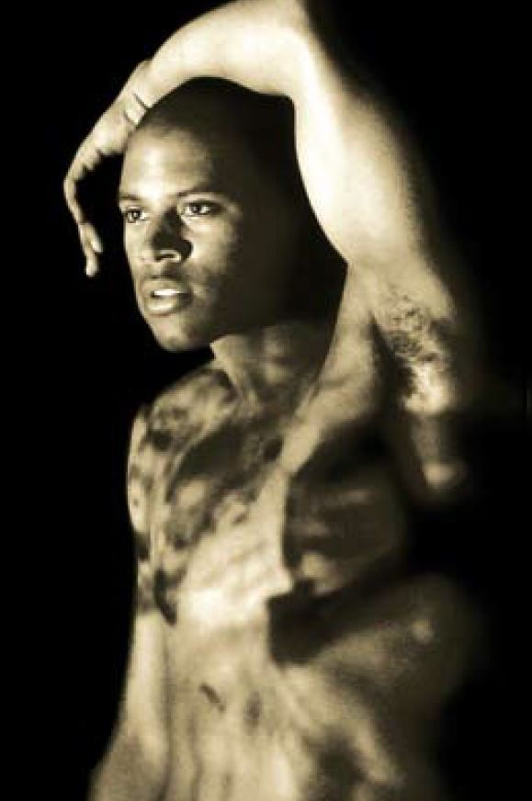

**UNIT 1**

**INVESTIGATING PRACTITIONERS’ WORK**

**WEEK THREE RESEARCH**

**To Be Straight …**

**Task 1.3:**

<https://www.dv8.co.uk/pages/interview-to-be-straight-with-you-qa>

Look at the interview with Lloyd Newson and discuss how each context can be seen within this work

|  |  |
| --- | --- |
| TO BE STRAIGHT WITH YOU | |
| Historical |  |
| Cultural |  |
| Political |  |
| Economic |  |
| Social |  |

|  |
| --- |
| **NOTE YOUR SOURCES** |
|  |

**Task 2.3:**

Look at these quotes from Newson ([www.DV8.co.uk](http://www.DV8.co.uk)) and say how you think this may shape his work – can you see it reflected in the work?

1. My physical work requires trained dancers, although many dancers have difficulty adapting to my approach because they've had the connection between meaning and movement trained out of them.
2. We find movement to express the meaning or idea we're presenting moment by moment, and if movement can't do it and words or song can, then we'll use those. Most dance companies, I feel, have restricted what they can speak about because they have accepted a limited definition of what movement constitutes 'dance'.
3. I left traditional dance because of its lack of specificity, its lack of questioning and its lack of rigour beyond technique. Psychology training has helped me to see patterns of behaviour and language and think of physical ways to interpret these.
4. We must encourage dancers to use more than just their bodies.

|  |  |
| --- | --- |
| TO BE STRAIGHT WITH YOU | |
| 1 |  |
| 2 |  |
| 3 |  |
| 4 |  |

**Task 3.3:**

|  |  |
| --- | --- |
| TO BE STRAIGHT WITH YOU | |
| Conceived and directed by |  |
| Toured |  |
| Choreography |  |
| Music/Sound Design |  |
| Set Design |  |
| Performers |  |

|  |
| --- |
| **NOTE YOUR SOURCES** |
|  |

**Task 4.3:**

Look at (and add to as much as possible) the SCENE ANALYSIS form for DV8’s TBSWY - STABBING IN HULL

**Articles to read:**

<https://www.theguardian.com/stage/2008/oct/27/dv8-straight-with-you>

<https://www.dv8.co.uk/projects/can-we-talk-about-this/foreword-by-lloyd-newson>

<https://www.theguardian.com/stage/2012/mar/13/dv8-can-we-talk-about-this>

<http://www.theargus.co.uk/magazine/interview/11742491.Lloyd_Newson_on_meaning_and_movement_in_physical_theatre/>

<http://www.officiallondontheatre.co.uk/news/backstage-pass/article/item137116/the-big-interview-lloyd-newson/>

<https://theatreanddance.britishcouncil.org/artists-and-companies/d/dv8-physical-theatre/>

<http://danceworks.net/inspiration/dance-companies/dv8/>

<http://www.bbc.co.uk/education/guides/ztfk6sg/revision/1>

**Clips to watch:**

Search YOU TUBE FOR DV8 “To Be Straight With You” and “Dead Dreams of Monochrome Men”

**Interviews:**

<https://www.dv8.co.uk/pages/interview-dance-now-lloyd-newson-on-dance>

<https://www.dv8.co.uk/media-portal/explore-our-work/can-we-talk-about-this/hear-from-the-performers>