**Pornography- Simon Stephens, unnamed character.**

Intimate

(1) And I get home and Jonathan’s not there (2). He should be there. He should be at home. I don’t have the slightest idea where he is. I try not to think about it (12). The house is quieter without him. (6)

Objective to find out where he’s been  
Obstacle his lies

Transitive verb =PULL

PRESS

Where were you? Where were you? Which shops? What were you doing? What were you doing there? What were you buying? What are you going to paint? (7) I want to know what you need paint for. I want to know what you want to paint (8). I want to know where you’ve been (9). Do you like my sandals? I bought some sandals, do you like them? I bought them for the beach. For the summer.

Social

EMBRACE

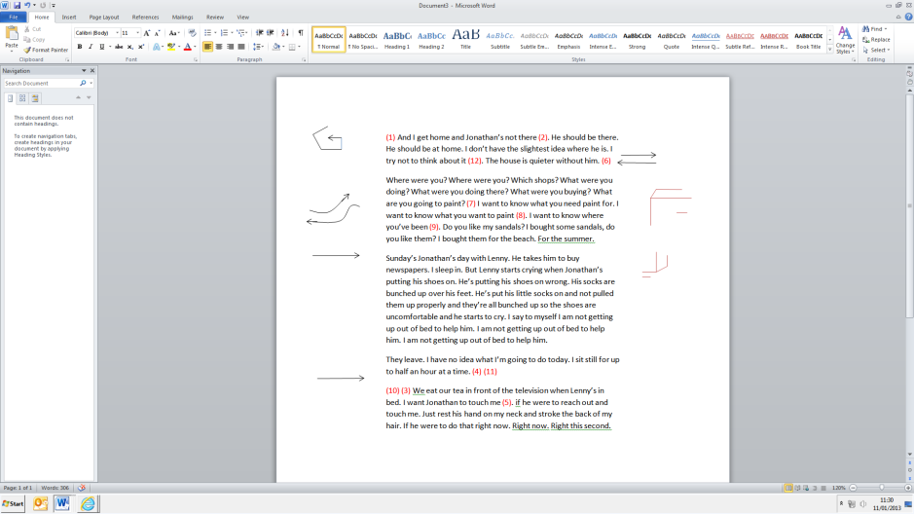Sunday’s Jonathan’s day with Lenny. He takes him to buy newspapers. I sleep in. But Lenny starts crying when Jonathan’s putting his shoes on. He’s putting his shoes on wrong. His socks are bunched up over his feet. He’s put his little socks on and not pulled them up properly and they’re all bunched up so the shoes are uncomfortable and he starts to cry. I say to myself I am not getting up out of bed to help him. I am not getting up out of bed to help him. I am not getting up out of bed to help him.

Objective to look after my son  
Obstacle wanting to make Jonathan deal with Lenny

WRESTLE

They leave. I have no idea what I’m going to do today. I sit still for up to half an hour at a time. (4) (11)

Intimate

MELT

Objective to feel physical love from my husband  
Obstacle his frigidity

(10) (3) We eat our tea in front of the television when Lenny’s in bed. I want Jonathan to touch me (5). if he were to reach out and touch me. Just rest his hand on my neck and stroke the back of my hair. If he were to do that right now. Right now. Right this second.

BUTTER

*My personal Laban Effort graph:*