**DEVELOPING SKILLS AND TECHNIQUES FOR LIVE PERFORMANCE**

**A PERFORMER’S LIFE FOR ME**

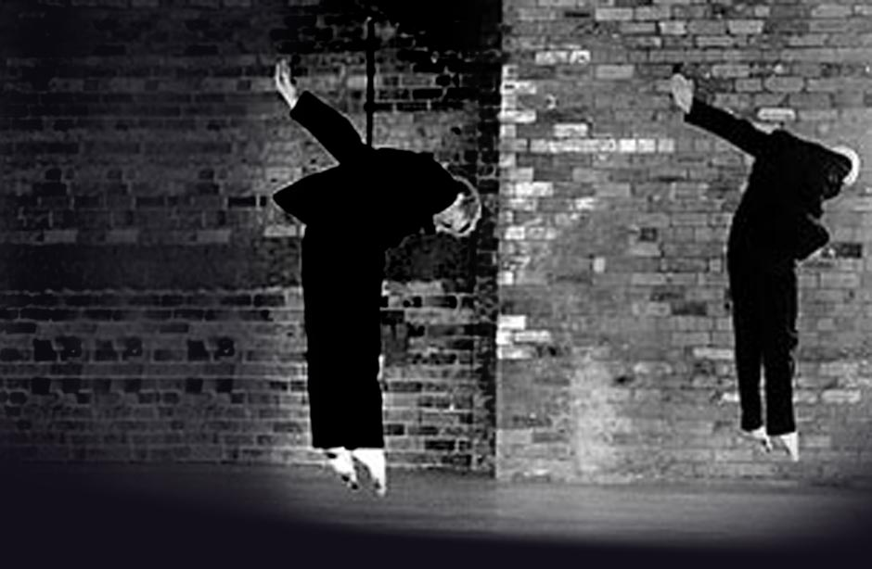

Learning Aim A: Understand the role and skills of a performer

|  |  |
| --- | --- |
| Name: |  |

**SECTION 1 (P1 and M1 ASSESSED)**

**WHAT MAKES A GOOD PERFORMER?**  
When you watch professional work, how do you know it is good?

|  |
| --- |
| **This needs to be developed … your personal feelings … how do you judge if someone is a good performer? Use as many subject key words as possible here**  <https://collegegrad.com/careers/actors> |

What are the key skills, qualities and attributes of a professional actor or dancer; explain in detail what these roles are and why they are key?

* Skills
* Qualities
* Attributes

|  |
| --- |
| <https://collegegrad.com/careers/actors>  <https://www.rsc.org.uk/search?q=how%20to%20be%20an%20actor>  <https://www.truity.com/career-profile/actor>  <https://nationalcareersservice.direct.gov.uk/job-profiles/dancer>  **This is your identifying what SKILLS (i.e. diplomacy, resilience, perseverance, organisation) are required personally to be a performer and then moving to identifying the technical skills for your pathway …. (i.e. Vocal, Movement, Accents etc)**  <http://learn.org/articles/What_Are_the_Skills_Needed_to_Work_in_Acting.html> |

What (and why) are the key features of the role of a professional performer?

* What is their work like (be specific about what role you are discussing)

|  |
| --- |
| <https://nationalcareersservice.direct.gov.uk/job-profiles/actor>  https://nationalcareersservice.direct.gov.uk/job-profiles/dancer  <https://www.allaboutcareers.com/careers/job-profile/actor>  <https://www.brightknowledge.org/knowledge-bank/arts-and-humanities/careers-and-courses/my-job-explained-actress>  **Simply – DO YOUR RESEARCH …. What sort of jobs would you expect to be getting in your pathway … Discuss also when they do when not in work (look for some percentages here – what percentage are out of work and for how long?)** |

* What are their main duties and responsibilities?

|  |
| --- |
| <https://nationalcareersservice.direct.gov.uk/job-profiles/actor>  <https://www.prospects.ac.uk/job-profiles/actor>  <https://www.prospects.ac.uk/job-profiles/dancer>  **This needs to be informed by research**  **What are they required to do when in work?**  **Have a look at some profiles and contracts**  <http://learn.org/articles/What_Is_the_Job_Description_of_an_Actress_or_Actor.html> |

* What qualifications do you need?

|  |
| --- |
| <http://www.theartcareerproject.com/build-a-dramatic-career-in-acting/221/>  **This needs to be informed by research** |

* What is the salary like for this role?

|  |
| --- |
| <http://www.theartcareerproject.com/build-a-dramatic-career-in-acting/221/>  <https://nationalcareersservice.direct.gov.uk/job-profiles/actor>  <http://www.equity.org.uk/resource-centre/rates-and-agreements/equity-rates/>  <https://www.theguardian.com/money/2002/aug/18/wageslaves.careers>  **UK rates not American rates please** |

* What are the terms and conditions?

|  |
| --- |
| <https://nationalcareersservice.direct.gov.uk/job-profiles/actor>  **This needs to be informed by research. Terms and conditions are the items on your contract of employment that dictate your job. (i.e. you only work ### hours per day, only do ### shows per week ETC)** |

* How does this job impact on your life-style?

|  |
| --- |
| <http://www.backstage.com/advice-for-actors/backstage-experts/how-acting-affects-your-self-esteem/>  <https://www.quora.com/Does-the-personal-life-of-an-actor-in-any-way-affect-his-or-her-career>  <http://www.telegraph.co.uk/culture/theatre/dance/8926160/The-life-of-a-Royal-Ballet-dancer.html>  <http://www.backstage.com/advice-for-actors/backstage-experts/10-sacrifices-actor-makes/>  <http://theportlandballet.org/15-truths-professional-dancer/>  **This needs to be informed by research** |

What is a typical working day for a professional actor/dancer?

|  |
| --- |
| <https://www.prospects.ac.uk/job-profiles/actor>  <https://www.theguardian.com/money/2011/feb/05/working-life-actor>  **This needs to be informed by research – I would cover, a day when not in work, and a day in work** |

How would a professional actor or dancer, ensure they are ready for a day of rehearsals?

|  |
| --- |
| https://www.theatrefolk.com/blog/preparing-first-day-rehearsal-guide-student-actors/  **This needs to be informed by research** |

How would a professional actor or dancer use their team working skills in their job role?

|  |
| --- |
| <http://learn.org/articles/What_Are_the_Skills_Needed_to_Work_in_Acting.html>  <https://www.theatrefolk.com/blog/collaboration-vs-teamwork-whats-the-difference/> |

Below is a list of application procedures that you could consider to become a professional actor.

|  |  |  |  |
| --- | --- | --- | --- |
|  | Describe what this is (P1) | How do you develop these? What must they include? (M1) | How does this sell a professional practitioner? What is their importance? (D1) |
| **CVs** | <https://www.kent.ac.uk/careers/cv/actorcv.htm> |  |  |
| **Personal statements** |  |  |  |
| **Auditions** | <http://www.backstage.com/advice-for-actors/backstage-experts/10-tips-winning-audition/>  <http://blog.stageagent.com/how-to-prepare-for-an-audition/>  http://www.wikihow.com/Prepare-for-an-Audition |  |  |
| **Portfolios of work** |  |  |  |
| **Agent** | https://actorsandperformers.com/actors/advice/2/securing-work/dealing-with-agents |  |  |
| **Head shots** | https://www.spotlight.com/news-and-advice/tips-and-advice/everything-you-need-to-know-about-photos/ |  |  |

**INTERRELATIONSHIPS**

Chose director or choreographer

|  |  |  |  |
| --- | --- | --- | --- |
|  | How does an actor/dancer interrelate to this person? | Why is this relationship important to the success of the performance? | Evaluate what might happen if this interrelationship was not effective |
| **Director/Choreographer** | <http://www.markwtravis.com/2012/06/the-actordirector-relationship/>  http://www.danceconsortium.com/features/interview/deborah-colker-the-choreographerdancer-relationship/ |  |  |

**(D1 ASSESSED)**

**Based on this research –evaluate what you have learnt, what has surprised you – has this researched changed your opinion about working in the performance industry? What can you be doing now to prepare for a career in the performing arts? (no more than one side of A4)**

|  |
| --- |
| **This should be reaching ONE SIDE OF A4 if it is developed enough** |

**REFERENCING / SOURCES**

Using the Havard Reference System – please list your sources that informed the work above

|  |
| --- |
|  |

**SECTION 2 (P1 and M1 ASSESSED)**

**TRAINING AND QUALIFICATION ROUTES**

Why do you feel formal training in the performing arts is important? Why is understanding formal training routes important to you as a developing practitioner?

|  |
| --- |
| <https://www.dramauk.co.uk/faqs>  <https://actorsandperformers.com/actors/advice/44/training-and-skills/drama-schools>  https://www.danceuk.org/resources/faqs/professional-dance-training-and-careers/ |

**DRAMA AND MUSICAL THEATRE TRAINING, WITH A FOCUS ON OUR LOCAL DRAMA SCHOOL – GUILDFORD SCHOOL OF ACTING.**

Complete a brief research analysis of GSA.

* What courses they run, what their audition procedure us like, their teaching hours etc

|  |
| --- |
| **This simply comes from answering all the questions about the video ….**  **There is a fair bit of writing to include here** |

How does this research make you feel about vocational training? (D1)

|  |
| --- |
| **PERSONAL THOUGHTS AND REFLECTION – more -= a better grade!** |

**AUDITIONING AND INTERVIEWING (The Council for Dance Education and Training and the National Council for Drama Training).**Complete a brief research analysis of advice on auditions and interviews

|  |
| --- |
|  |

**AWARENESS OF THE BREADTH OF THE PERFORMING ARTS INDUSTRY**delete the grid that does not apply to you

|  |  |  |  |  |
| --- | --- | --- | --- | --- |
|  | **Job Title & Outline of role/responsibilities** | **Example of Employer** | **Training Route** | **Skills Required** |
| **PERFORMER** | Principal dancer (Ballet/Contemporary) | **Needs to be a specific named company that would employ this job role ….** | **Really specific – everything they would do from (and including) A Level – to get this job** |  |
| West End performer (Musical Theatre) |  |  |  |
| Cruise ship performer |  |  |  |

|  |  |  |  |  |
| --- | --- | --- | --- | --- |
|  | **Job Title & Outline of role/responsibilities** | **Example of Employer** | **Training Route** | **Skills Required** |
| **PERFORMER** | Theatre Actor |  |  |  |
| Theatre Actor  Musical Theatre |  |  |  |
| Theatre Actor  Devising company |  |  |  |

<https://www.dramauk.co.uk/articles/student>

<https://ccskills.org.uk/careers/advice/any/theatre>

<https://ccskills.org.uk/careers/advice/any/theatre/performance?gclid=CKvftY3nq9ICFUKZGwodPMcNIA>

<https://ccskills.org.uk/careers/advice/job-profiles/theatre>

**(D1 ASSESSED)**

**Based on this research –evaluate what you have learnt, what has surprised you – has this researched changed your opinion about working in the performance industry? What can you be doing now to prepare for future auditions and interviews for vocational schools? (no more than one side of A4)**

|  |
| --- |
| **This should be reaching ONE SIDE OF A4 if it is developed enough** |

|  |  |  |  |  |  |  |  |  |  |
| --- | --- | --- | --- | --- | --- | --- | --- | --- | --- |
|  | **Name and type of institution** | **What is the course structure?** | **What Modules can be studied?** | **What facilities are offered?** | **What are the fees?** | **What is the audition process?** | **Alumni/career opportunities/What % of students went into the profession?** | **Opportunities to specialise** | **What are your personal feelings about this institution?** |
| **Drama School/**  **Dance School** |  |  |  |  |  |  |  |  |  |
| **Drama School/ Dance School** |  |  |  |  |  |  |  |  |  |
| **University** |  |  |  |  |  |  |  |  |  |
| **University** |  |  |  |  |  |  |  |  |  |

**An analysis of training institutions**

**INTERVIEWS WITH CURRENT PRACTITIONERS FROM:**

ARTS EDUCATIONAL  
DRAMA CENTRE

MOUNTVIEW

PERFORMANCE PREPARATION ACADEMY

URDANG

FALMOUTH UNIVERSITY

LEEDS UNIVERSITY

**(P1 and M1 ASSESSED)**

What did you learn from these interviews?

|  |
| --- |
|  |

**(D1 ASSESSED)**

Evaluate your current practice. In response to the above interviews, what do you need to do now to prepare for vocational training in a years’ time?

|  |
| --- |
|  |