**PERFORMING ARTS IN THE COMMUNITY (Unit 4)**

**Community performance, practice and practitioners**

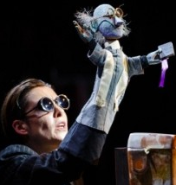

Learning Aim A: Understand community performance and practice

|  |  |
| --- | --- |
| Name: |  |

**A COMMUNITY PERFORMANCE I HAVE BEEN IN THE AUDIENCE FOR:**

**P1 | M1**

|  |  |
| --- | --- |
| Title of piece: |  |
| Purpose and focus of the performance: |  |
| Themes explored: |  |
| Type/Range: (i.e. T.I.E.) |  |
| Venue: |  |
| Client: |  |

|  |
| --- |
| EVALUATE the success of this community performance D1:  Did it meet it’s aims / did it connect with the target audience? |
|  |

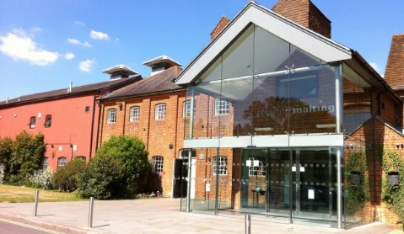**There are a range of venues for community performance in our local area including:**

**P1**

|  |  |
| --- | --- |
| 1. | 2. |
| 3. | 4. |
| 5. | 6. |
| 7. | 8. |

**In addition, there is a range of clients in our local area that we might perform to including: P1**

|  |  |
| --- | --- |
| 1. | 2. |
| 3. | 4. |
| 5. | 6. |

**HOW WOULD YOU DEFINE COMMUNITY THEATRE? P1 | M1**

|  |
| --- |
|  |

**WHAT IS THE PURPOSE OF COMMUNITY THEATRE? P1 | M1**

|  |
| --- |
|  |

**WHAT ARE THE CHARACTERISTICS OF COMMUNITY THEATRE? P1 | M1**

|  |
| --- |
|  |

**WHY DO IT? WHAT IS THE FOCUS OF COMMUNITY THEATRE? P1 | M1**

|  |
| --- |
|  |

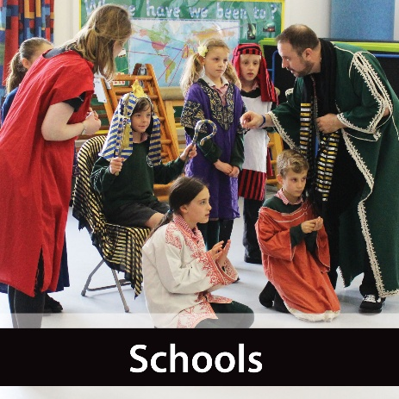**WHAT ARE YOUR PERSONAL VIEWS AND FEELINGS ON COMMUNITY THEATRE? IS IT AN IMPORTANT ART FORM?**

**D1 (500 words)**

|  |
| --- |
|  |

|  |  |
| --- | --- |
| **INTERVIEW WITH A PROFESSIONAL PRACTITIONER**  **TINA WILLIAMS (Pied Piper Theatre) and VICKY BARKLAMB (Theatre Exchange) P1 | M1 | D1**  500 words | See the source image |
| Discuss your findings from these primary source interviews, explain/analyse the work of each practitioner and company and then **evaluate** what you have learnt from these interviews | |
|  | |

Define the range of community performance. P1 | M1

|  |  |  |
| --- | --- | --- |
| **GENRE** | **DESCRIPTION** | **Local Venue where you may see this work** |
| **Community Plays** |  |  |
| **Street Performance** |  |  |
| **Open-Air Productions** |  |  |
| **Concert** |  |  |
| **Small-Scale Theatre** |  |  |
| **Touring Theatre** |  |  |
| **Theatre In Education** |  |  |

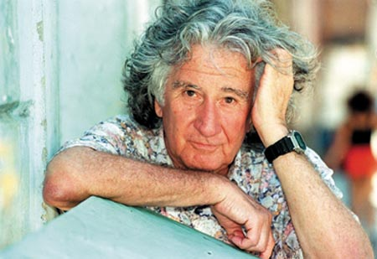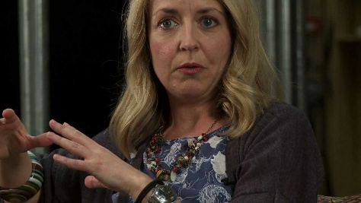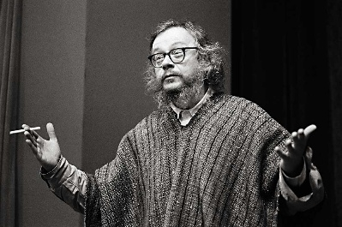

**PRACTITIONERS AND PERFORMANCES**

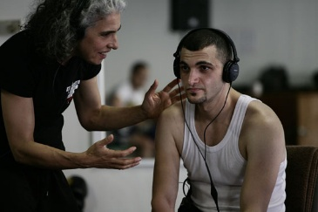

|  |
| --- |
| **VERBATIM THEATRE** |

|  |  |
| --- | --- |
| Purpose and focus of the work: |  |
| Venues it has been performed in: |  |
| Clients it could serve (and why): |  |
| How could the Verbatim style/genre be used to develop community theatre? |  |

**Explaining and Analysing VERBATIM THEATRE**

|  |
| --- |
|  |

**Evaluating VERBATIM THEATRE**

|  |
| --- |
|  |

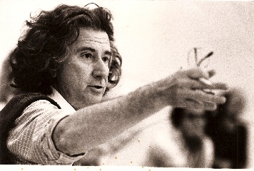

|  |
| --- |
| **AUGUSTO BOAL** |

|  |  |
| --- | --- |
| Purpose and focus of his work: |  |
| Venues the work is performed in: |  |
| Clients it could serve (and why): |  |
| How did Boal develop his work for ‘communities’ and engage communities? |  |

**Explaining and analysing the work/techniques of BOAL**

|  |
| --- |
|  |

**Evaluating the work/techniques of BOAL**

|  |
| --- |
|  |

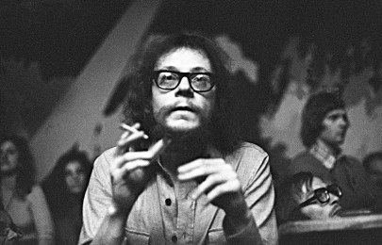

|  |
| --- |
| **JERZY GROTOWSKI** |

|  |  |
| --- | --- |
| Purpose and focus of his work: |  |
| Venues the work is performed in: |  |
| Clients it could serve (and why): |  |
| How is the work of this practitioner useful for community touring? |  |

**Explaining and analysing the work/techniques of GROTOWSKI**

|  |
| --- |
|  |

**Evaluating the work/techniques of GROTOWSKI**

|  |
| --- |
|  |

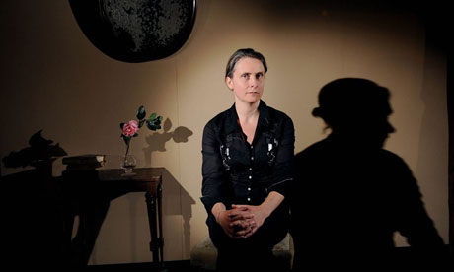

|  |
| --- |
| **KATIE MITCHELL** |

|  |  |
| --- | --- |
| Purpose and focus of her work: |  |
| Venues the work is performed in: |  |
| Clients it could serve (and why): |  |
| How does Mitchell engage communities in the creation of her work? |  |

**Explaining and analysing the work/techniques of KATIE MITCHELL**

|  |
| --- |
|  |

**Evaluating the work/techniques of KATIE MITCHELL**

|  |
| --- |
|  |

**PRACTITIONERS AND PERFORMANCE**

|  |  |
| --- | --- |
| Image result for JOAN LITTLEWOOD | **Joan**  **Littlewood** |

|  |
| --- |
| **Describe her work and her beliefs about community performance:** |
|  |
| **What themes / type of work did she explore – for what purpose?** |
|  |
| **What venues did she work in / for what clients?** |
|  |

|  |  |
| --- | --- |
| **An Evaluation of her work including a critique of “Oh What A Lovely War”** |  |

|  |  |
| --- | --- |
| Image result for john mcgrath theatre | **John**  **McGrath** |

|  |
| --- |
| **Describe his work and his beliefs about community performance:** |
|  |
| **What themes / type of work did he explore – for what purpose?** |
|  |
| **What venues did he work in / for what clients?** |
|  |

|  |  |
| --- | --- |
| **An Evaluation of his work** |  |

|  |  |
| --- | --- |
| Image result for Elizabeth MacLennan | **Elizabeth  MacLennan** |

|  |
| --- |
| **Describe her work and her beliefs about community performance:** |
|  |
| **What themes / type of work did she explore – for what purpose?** |
|  |
| **What venues did she work in / for what clients?** |
|  |

|  |  |
| --- | --- |
| **An Evaluation of her work including a critique of “Wild Raspberries”** |  |

|  |  |
| --- | --- |
| Image result for Ann Jellicoe | **Ann**  **Jellicoe** |

|  |
| --- |
| **Describe her work and her beliefs about community performance:** |
|  |
| **What themes / type of work did she explore – for what purpose?** |
|  |
| **What venues did she work in / for what clients?** |
|  |

|  |  |
| --- | --- |
| **An Evaluation of her work** |  |

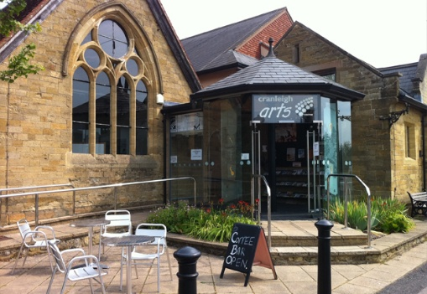**OUR BOROUGH COUNCIL – WAVERLEY –**

**A RESPONSE TO THEIR COMMUNITY ARTS STRATEGY**

|  |  |
| --- | --- |
| The community development Arts Officer at Waverley Borough Council is: |  |

|  |  |
| --- | --- |
| How does she see her role in the Borough: |  |
| Findings from her Spending Survey: | (Can just be bullet points) |
| How does she support the arts, and how does she see the creative milieu in the borough: |  |

**LOCAL COMMUNITY THEATRE COMPANIES P1 | M1**

|  |  |  |  |  |
| --- | --- | --- | --- | --- |
|  | **The purpose and focus of their work is:** | **The themes and issues they explore include:** | **The venues they perform in locally include:** | **Their client base / their target audience is:** |
| **THEATRE EXCHANGE** |  |  |  |  |
| **ALTEREGO** |  |  |  |  |
| **SYNERGY THEATRE PROJECT** |  |  |  |  |
| **PIED PIPER THEATRE** |  |  |  |  |
| **AJTC** |  |  |  |  |
| **GEESE THEATRE COMPANY** |  |  |  |  |
| **SCENE PRODUCTIONS** |  |  |  |  |
| **DANTE OR DIE** |  |  |  |  |
| **PEER PRODUCTIONS** |  |  |  |  |

“We can’t afford not to fund the arts”

Sir Peter Bazalgette, Chair, Arts Council

Until January 2017

**Evaluating the above quote D1**

|  |
| --- |
|  |

|  |
| --- |
| **Using the Harvard Reference System, give all your sources for: Learning Aim A** |
|  |