|  |  |
| --- | --- |
| **UNIT 4 AGENDA** | |
| Date of Meeting: | 15/03/2022 |
| Room: | 842 |
| Time: | 11.00am |
| Agenda Author: | AWP |

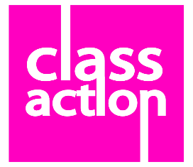

The initial agenda items will be led by AWP until a Production Manager is in place:

1. Election of Minute Taker
2. Meeting started at:
3. Present / Apologies for absence
4. Agreeing last meetings minutes (NA)
5. **The Assignment Brief:**

*Working with local schools for Years 9 and/or 10.*

*Producing a ‘technique rich’ production*

*Working to support the schools in their teaching*

**ClassAction Response:**

*Our 4 feeder schools = Broadwater, Glebelands, Rodborough, Woolmer Hill*

*50% = Support for ‘literacy’ through the staging of a ‘classic text’ (Shakespeare, a popular children’s book)*

*50% = Support for/with anxiety focusing on mental health*

1. Discussion in response to Item 3

Including input about a proposed way forward

1. Election of a Production Manager who will then take over the rest of the meeting

Proposal on the table: Emma

Proposed way forward

1. Election of ClassAction Diploma Production Team

On the table:

Production Manager – Emma

Marketing Manager – Nil

Social Media – Monica

Education Manager – Fred

Stage Manager – Charlotte

Assistant Stage Manager with responsibility for overseeing set – Red

Costume – Ethan

Set – Atlas

Props – Sam

1. A.O.B.
2. Meeting closed at: