|  |  |
| --- | --- |
| **UNIT 4 AGENDA** | |
| Date of Meeting: | 10/05/22 |
| Room: |  |
| Time: |  |
| Agenda Author: | AWP / EC |

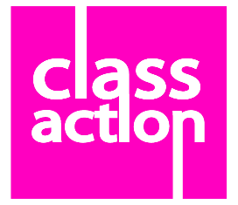**ROMEO AND JULIET**

**This is not a love story**

1. Allocation of Minute Taking
2. Present / Apologies for absence
3. Agreeing last meetings minutes
4. Checking actions from last week’s minutes
5. Pre-production paperwork:
   * 1. SWOT – Complete
     2. Company Structure - Complete
     3. Project Plan – Uploaded.
6. Marketing
   * 1. Social Media Update.
     2. Social Media report back from meeting with NAOMI EARNSHAW
     3. Press Release – has now been sent to college to circulate
     4. AP has contacted schools – no response yet – will chase at the end of this week we are now behind on this
     5. Headshots – schedule and organisation of this?
     6. Rehearsal photos? Have any been taken? These need sharing with AP
7. Initial Props Collection
   * 1. Where is the prop box, and what is already in there?
     2. What props are we struggling with and maybe we can help with?
     3. Viewing props list on TEAMS to see if there is anything more to add
8. Other Production Schedule Updates
   * 1. Update on rehearsals / facilitator / the book.
     2. Do we need to update the schedule?
     3. Costume update? We should have started sourcing by now
     4. Set update?
     5. Music – Is there a centralised ‘playlist’ for the music that everyone has access to?
9. Company Member of The Week
10. Company Baker for next week
11. A.O.B.

Please see admin schedule that you have been sent on TEAMS

**The SCRATCH of practical work so far**