|  |  |
| --- | --- |
| **UNIT 4 AGENDA** | |
| Date of Meeting: | 24/05/22 |
| Room: |  |
| Time: |  |
| Agenda Author: | AWP / EC |

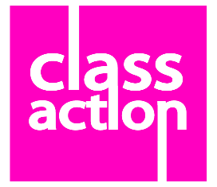**ROMEO AND JULIET - This is not a love story**

1. Allocation of Minute Taking
2. Present / Apologies for absence
3. Company Baker moment – not invisible cakes again!!
4. Agreeing last meetings minutes
   * 1. Thank you for having this completed so early last week!
5. Checking actions from last week’s minutes
6. INDIVIDUAL CHECK UP
   * 1. Each member of the Diploma Company to share “where they are going this week / what are they working towards …?”
        1. As an actor
        2. In your production role
7. Touring
   * 1. Tuesday 14th June = Broadwater
     2. Wednesday 15th = STUDIO816
     3. Glebelands, Woolmer Hill, Rodborough have all expressed interest, just now negotiating dates
8. Education
   * 1. We will need to see a DRAFT education pack at our Friday rehearsal over half term to agree. Can AP be presented with an initial draft during your Monday half term rehearsal
9. Marketing
   * 1. Social Media report back from meeting with NAOMI EARNSHAW
     2. Rehearsal photos? Can more be shared with AP please
10. Other Production Schedule Updates
    * 1. Set
      2. Costume
      3. Props
11. Rehearsal Schedule moving forwards
    * 1. Talk through what will be achieved over the coming week
      2. What will happen after this meeting?
      3. Reminder of what is happening over Half Term and outcomes?
12. Company Member of The Week
13. Company Baker for next week
14. A.O.B.

Please see admin schedule that you have been sent on TEAMS

**CHECK – WHAT TECHNIQUES HAVE NOT YET BEEN UTILISED WELL?**

