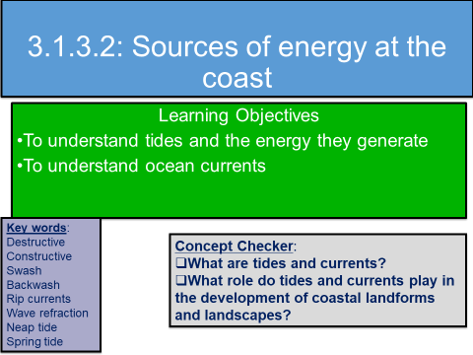

What are tides and what causes them?

Watch the following clip and complete the paragraphs below https://www.youtube.com/watch?v=6IyRE9azhwQ
As the moon orbits the Earth, the high tide follows it. ____________in a lunar month (28 days), when the moon, sun and ____________are in a straight line, the tide-raising force is ___________. This produces the ___________monthly tidal range or ______________tide.

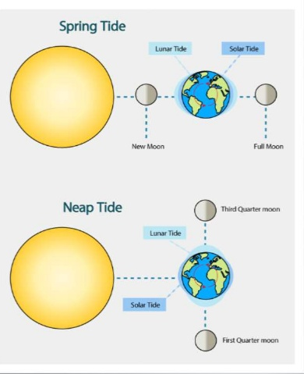
Also twice a month, the moon and sun are positioned at __________ (perpendicular) to each other in relation to the ___________. This alignment gives the lowest monthly tidal range, or ___________tides. At this time high and low tides are between 10 to 30% ____________than the average.

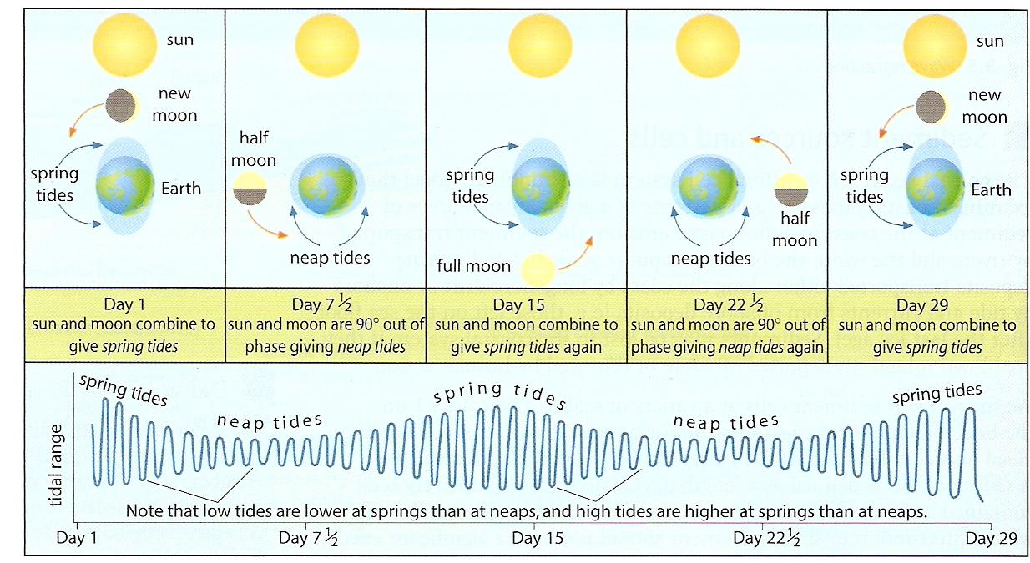

Tidal ranges
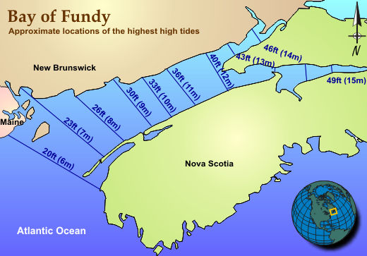
.
The Bay of Fundy, Nova Scotia has the highest tidal range in the world.
Watch this video clip and explain why this is the case.
https://www.youtube.com/watch?v=l85Dk9LpIEs

Some coasts have a larger tidal range than others.

Micro-tidal ranges are under 2 metres
Meso-tidal ranges are 2–4 metres
Macro-tidal ranges are over 4 metres.

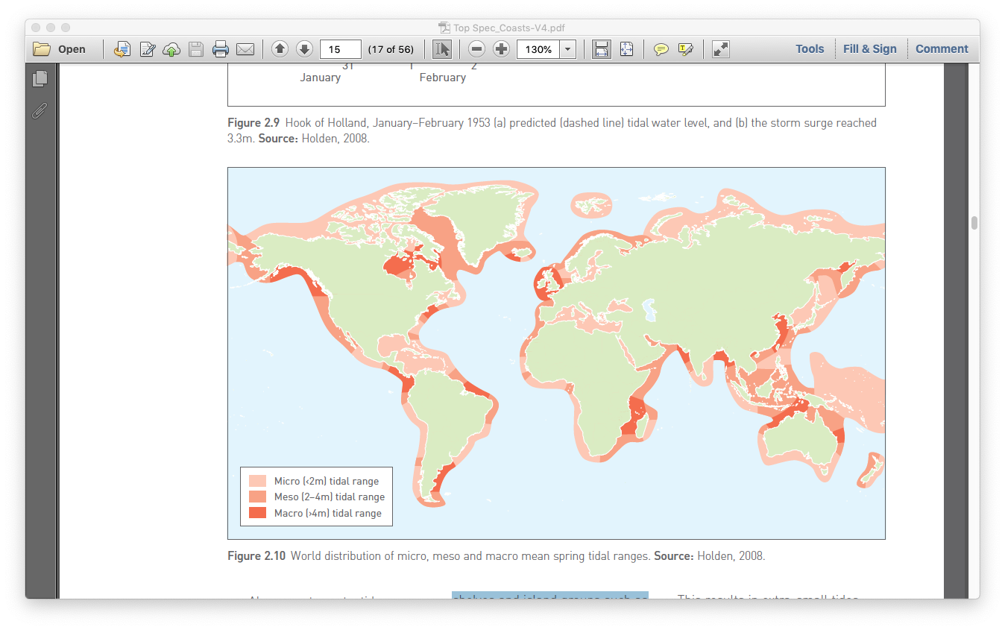

Describe the location of macro-tidal ranges on this map

Estimate the percentage of coastlines that are macro-tidal

Annotate the diagram below to show how the tide and wave influences coastal processes

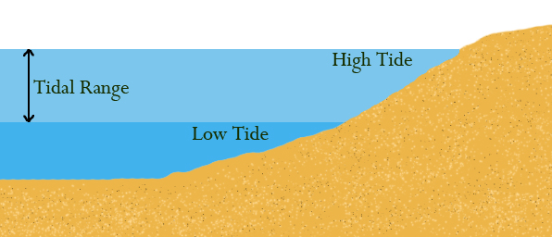

EWhar

What 3 things modifies the pattern of tides?

Whjhg

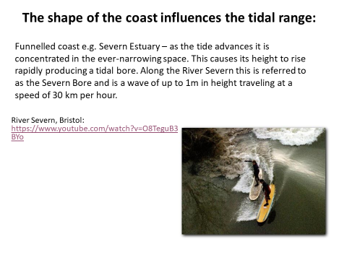
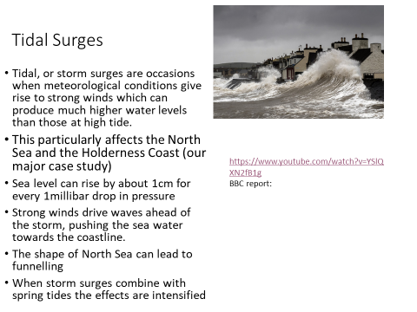

Using this synoptic chart – what evidence is there to suggest the likely occurrence of a tidal or storm surge in eastern Britain?
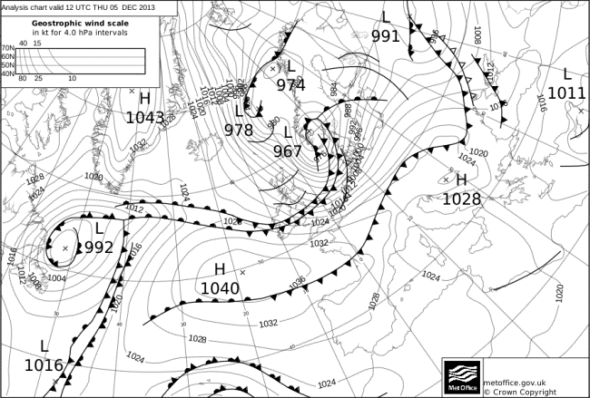
Give an example of a tidal surge and describe its impacts.
Currents

The term current refers to the permanent or seasonal movement of surface water in the seas and oceans. There are 4 currents you need to know about:-
Small currents have less energy, so they only move finer sediments.
Large currents have more energy: they can move bigger materials.
- Tidal currents
- Longshore currents (also referred to as littoral drift)
- Rip currents
- Upwelling

Tidal Currents
Ebb currents: currents that move away from the land.
Flow (or flood) currents: currents that move towards the land.

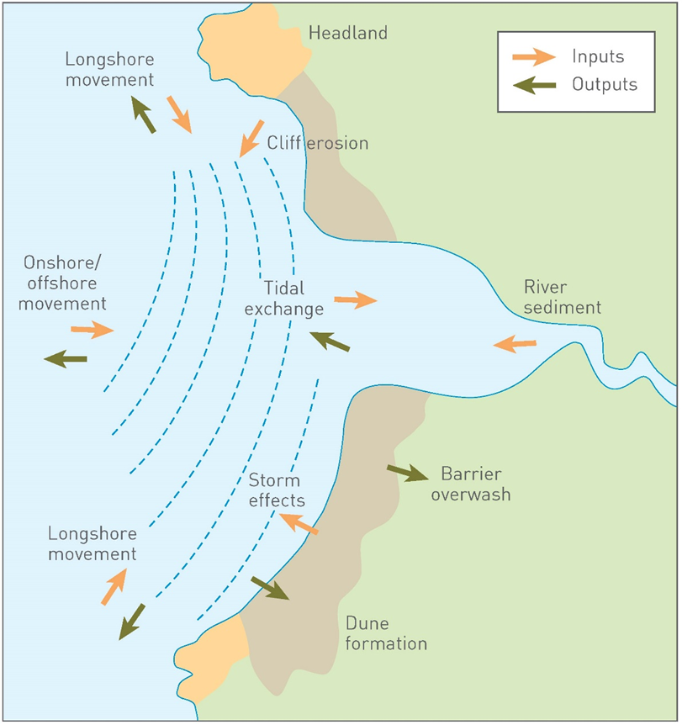
- What influence do you think the ebb and flow of currents will have on sediment transfer?

- How might tidal exchange be influenced by spring and neap tides?

Longshore drift diagram

How important a role do you think that longshore drift has on the formation of coastal landscapes?

Rip currents
These are strong currents moving away from the shoreline.

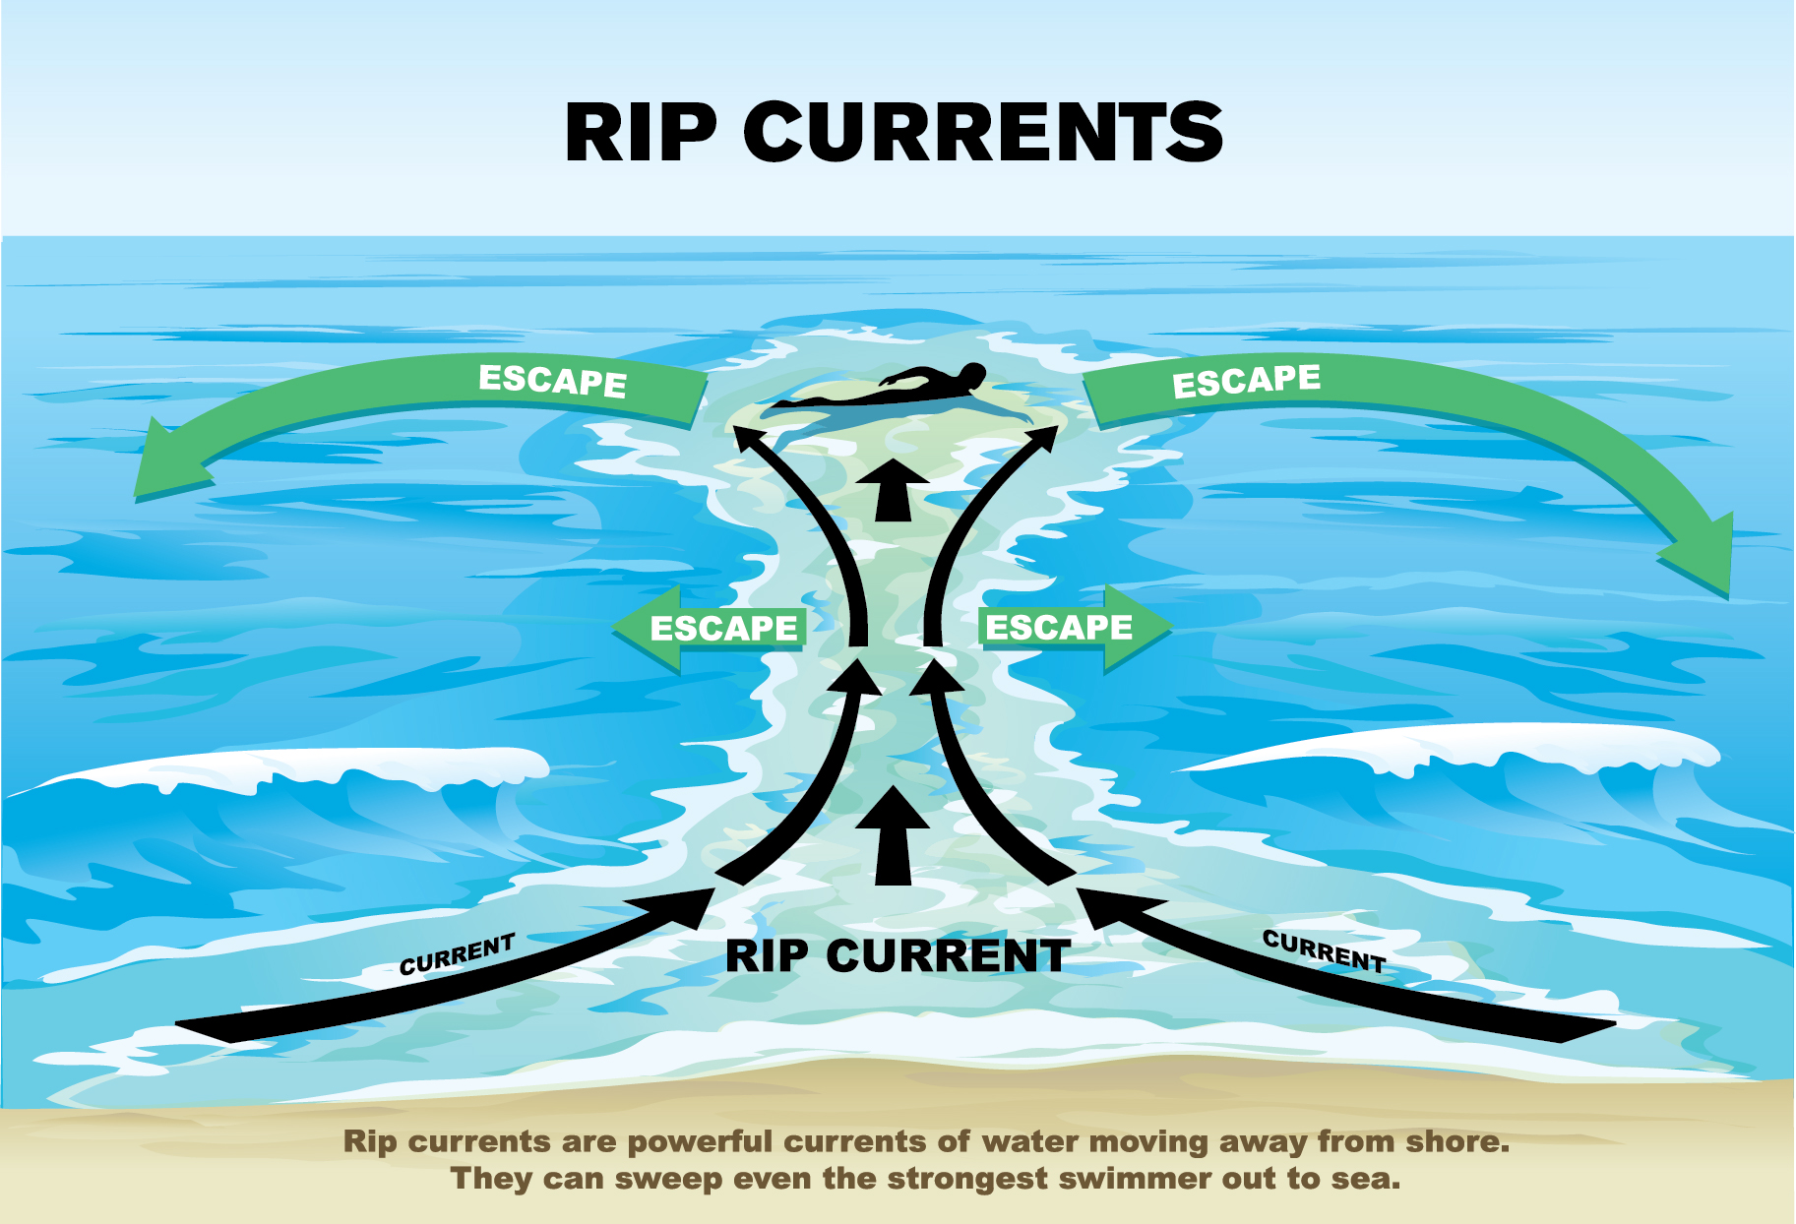

What impact do you think rip currents will have on the sea bed?

Upwelling is the movement of cold water from deep in the ocean towards the surface. The more dense cold water replaces the warmer surface water. These currents form part of the pattern of global ocean circulation currents.

What do you notice about the pattern of ocean currents? What do you think causes this?

The 3 sources of energy that we have studied are:-
- Wind
- Waves
- Tides and currents
In pairs/groups you need to rank their importance as factors shaping the coastline. Justify your rankings.

Evaluate the role of tides and currents in the development of coastal landforms and landscapes (9 marks)
Evaluate is a key command word and requires you to give some kind of measure/worth as to the role that it has. You also need to consider whether there are other factors which are more important.

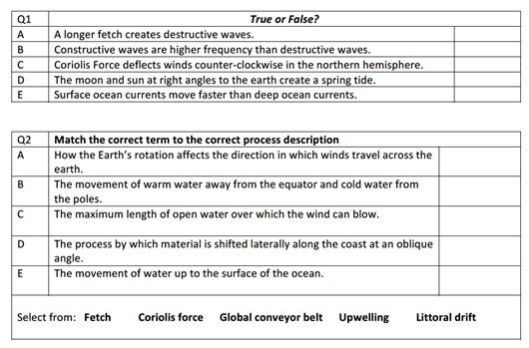
Further reading/research

P94-95 Hodder textbook

https://www.youtube.com/watch?v=l1WF8b6HZLM Learn about tides and currents

