COASTAL MANAGEMENT – PART 2:SUSTAINABLE APPROACHES
Figure (a). Landuse at the coast
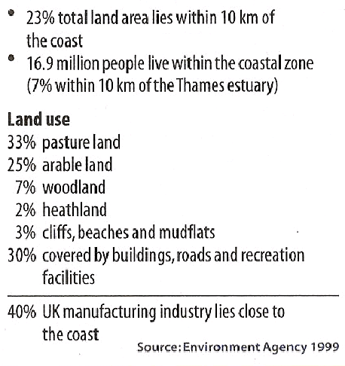
Using the information from Figure (a) explain why we need to protect the coastline.

Introduction - Sustainable approaches to coastal flood and erosion management
Some soft engineering schemes adopt sustainable principles, but they tend to be focused a particular stretch of coastline. Increasingly management authorities are looking at holistic management plans for significant stretches of coastline.
Policies have been adapted by the UK Government to make coastal management more sustainable and policies have developed at a global level to create a common and integrated approach around the world.
- Shoreline Management Plans
Introduced in 1995, 22 SMPs around England and Wales. An SMP works with the concept of littoral cells, or sediment cells along the coast. Each cell is managed either as a whole unit or a sub-unit. The SMP does not take account of other activities beyond the shoreline, so ICZM has now been adopted by many coastlines around the world
- Integrated Coastal Zone Management (Coast AND activities)
Originated from the UN Earth Summit of Rio De Janeiro in 1992 (Agenda 21). The European Commission have developed a framework to promote ICZM to manage the fine balance between people, economy and environment. In 2013, the EC launched the maritime spatial planning (MSP) framework to support ICZM.

- Shoreline Management Plans

What is the aim of the SMP?
To provide the basis for sustainable coastal defence policies within a sediment cell (specified lengths of coast) and to set objectives for the future management of the coastline.
Their aim is to identify the most sustainable approach to managing the different sections of coastline in the short term (0-20 years), medium term (20-50 years) and the long term (50-100 years)
They are funded mostly by the national government agency – DEFRA, along with the Environment Agency and local councils.
Using the images below and the textbook, describe each of the four strategy options and outlines what types of coastal defence might be used for each:

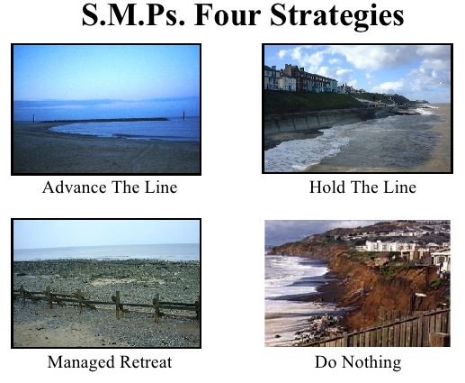

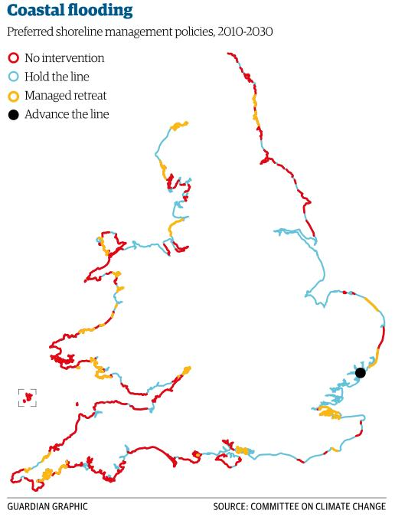

What factors will determine which of the above strategies is designated along the coast?

What issues might arise if different sections of coastline are designated different strategies?

- Tables 1 and 2 show different ways of looking at costs and benefits at the coast.
Table 1. A simple view of costs and benefits:
 | CONSIDERATIONS | BENEFITS | COSTS
£ | Economic considerations |  | e.g. Building and maintaining the coastal defences
 | Social considerations | e.g. Security and peace of mind | e.g. Increased problems of access to beaches
e | Environmental considerations | e.g. Rarely beneficial unless ‘soft’ engineering

Table 2. A simple cost-benefit calculation for three coastal defence options:
Options | Benefits | Damage | Costs | Benefit/  Cost Ratio
1. Do nothing | X | £650, 000 | X | X
2. ‘Holding the line’ along the whole section of the coast. | £650, 000 | £0 | £1, 000, 000 | 0.65
3. Protect some places but not others along the coast | £600, 000 | £50, 000 | £350, 000 | 1.5

i. Complete Table 1 by filling in the missing examples (2 marks)
ii. Explain why decision makers might choose option 3 in Table 2.
.......................................................................................................................................................
.......................................................................................................................................................
.......................................................................................................................................................
.......................................................................................................................................................
(2marks)
iii. Identify the circumstances in which ‘do nothing’ (Option 1) would be the preferred option.
.......................................................................................................................................................
.......................................................................................................................................................
.......................................................................................................................................................
.......................................................................................................................................................
(2 marks)
iv. Explain why it may be difficult to put value on some costs or benefits.
.......................................................................................................................................................
.......................................................................................................................................................
.......................................................................................................................................................
.......................................................................................................................................................
- marks)
- Holderness Coastal Flood Risk and Erosion Management
Defending Holderness – the challenges of sustainable management?
Watch part 3 & 4 of the video: Defending the coast (11.49 min +): http://estream.godalming.ac.uk/View.aspx?ID=4586~4x~8zS48MtV
- Mappleton – give the two main reasons why coastal protection is present here?

- Who has benefitted from coastal defences and how long is this guaranteed?

- Name other justifiable reasons for defending the coast

- Summarise the impacts on the rest of the coastline

- How much does East Riding Council spend on maintenance of defences?

- Why is building and maintaining coastal defences not a sustainable long-term strategy?

Sustainable approaches to coastal flood risk and coastal erosion management along the Holderness Coast
The Flamborough Head to Gibraltor Point SMP is a plan for managing coastal flood and erosion risk for stretches of coastline in the short term (up to 2025), the medium term (2026 – 2055) and the long term (up to 2105). The main aim of the SMP is to develop a sustainable management approach (actions that do not cause problems elsewhere – see 4 main options below) for the shoreline that takes account of the key issues and achieves the best possible balance of all the values and features that occur around the shoreline over the next 100 years. This needs to recognise the strong relationship with social, economic and environmental activities around the shoreline.
Four options are outlined:
- No active intervention (monitor and review) – There is no planned investment in defending against flooding or erosion, whether or not an artificial defence has existed previously. Let nature take its course.
- Managed realignment / retreat – Allowing the shoreline to move naturally, but managing the process to direct it in certain areas. This is usually done in low-lying areas, but may occasionally apply to cliffs.
- Hold the (existing defence) line – An aspiration to build or maintain artificial defences so that the position of the shoreline remains (often using hard engineering methods).
- Advance the line – New defences are built on the seaward side. Extending the coastline out to sea, e.g. encouraging the growth of beaches.

Shoreline management plans try to decide the most appropriate scheme in discussion with all interested parties:
Decisions can be taken using various types of assessments:
- Cost-benefit analysis considers the social and economic aspects of a strategy. The benefits of a scheme (new businesses or jobs and savings in lives and property) are divided by the costs of building and maintaining it.
- Environmental impact assessments try to assess the effects upon an area.
- Feasibility studies look at the technical merits of a particular scheme and site. Is the engineering planned suited to the local geology or coastal processes?
- Risk assessment involves taking decisions in the light of the likely recurrence interval and what is at risk.

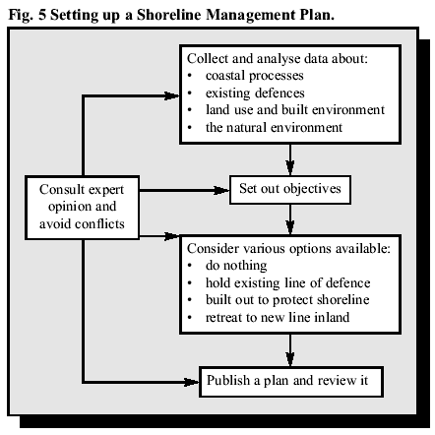
What might the challenges of a sustainable approach, such as a SMP, to coastal management be? Find out by completing the decision-making exercise!
Holderness Sustainable Coastal Management: DECISION MAKING EXERCISE
The Holderness Coast is threatened by the process of erosion and in addition the beach areas, which are important for tourism around some locations, are being depleted at an alarming rate. Land has been reclaimed in the Humber estuary and this is now being used for industry; a key location as it will boost the local economy and also marks the edge of the river and the beginning of the coastline.
The aim of this exercise is for you to develop ideas for a Shoreline Management Plan for whole of the Holderness Coast whilst considering:
- existing coastal defence and the use of the land being protected
- coastal processes in operation along the whole of the coast
- current research into sediment movement along Holderness

You have been allocated one of the seven sites along the Holderness coast, where coastal management is taking place. You have to choose the best option for the future. You need to put forward your recommendation for managing the coastline in the future to the council at the next meeting choosing from one of the four management options. You will do this after completing the following 3 activities:

- Information Sorting – get the information together for your allocated section of coastline. Classify into: social, economic, environmental considerations and summarise them for your bit of coastline
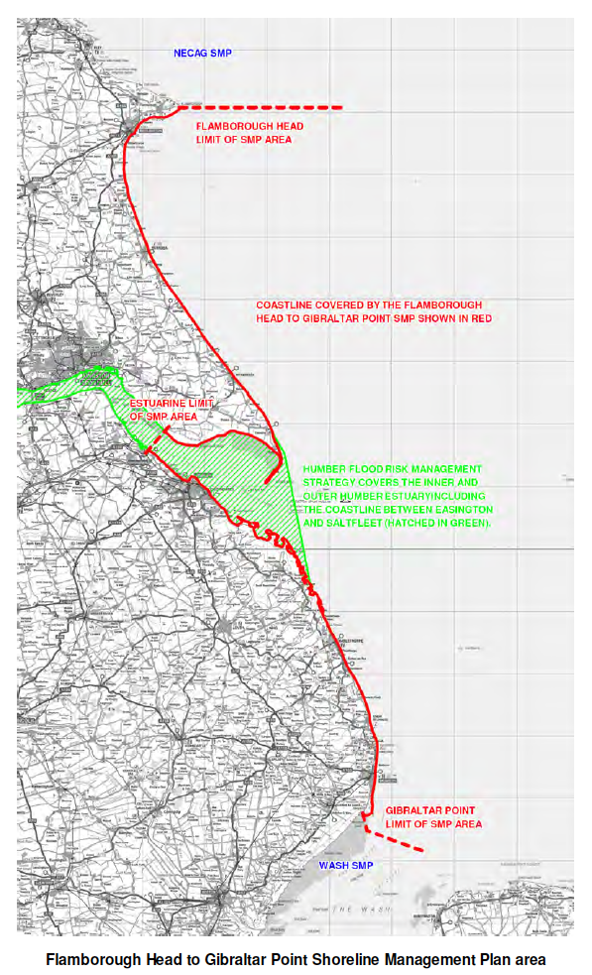
Factors | Summary sentence of key points for your coastline
Social / Socio-economic
Economic
Environmental

- For each of the 4 main management options, carry out a cost-benefit assessment using the key points below to complete your matrix. Use the key or devise your own.
MAIN points to consider: | KEY:
Technically possible – is it practically possible to put the defence plan into operation? E.g. will it interfere with existing operations like ship navigation or access? | Y or N
Costs – Is it financially viable? How much does it cost – cheap or expensive solution? Is the land cost worth protecting? | £= cheap, ££ = expensive
Built environment – impact on local economy – will it affect tourism, land use or industry? | +, - or neutral (+/-)
Natural environment – damage to natural environment or conservation? | +, - or neutral (+/-)
Coastal processes – impact on sediment flow and erosion rates – does it work with nature? | +, - or neutral (+/-)
Other sites – where erosion is prevented, there is a lack of sediment from the cliffs that may be transported along the coast to protect other sites? | +, - or neutral (+/-)
Sustainable – economically sustainable or will it deplete financial resources elsewhere? Environmentally sustainable – can it protect whilst enabling nature to have its way? | +, - or neutral (+/-)

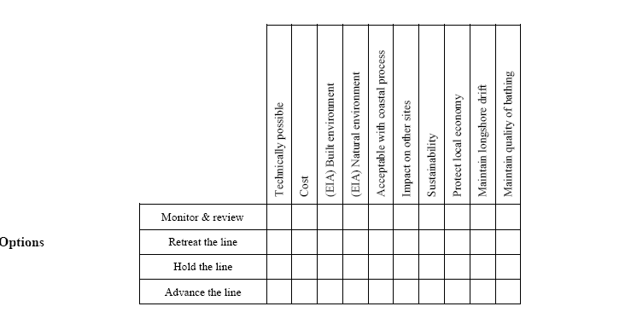
Note: The 3 extra points in the matrix above may or may not be relevant to your site…
- Group Presentation: Final Recommendation

You will need to discuss your allocated section of coastline and state which of the 4 management options (or a combination) you would recommend for your area based the evidence and your cost-benefit assessment.
Which one approach or a combination of options? Why? What costs are involved? Why not other options?
STATEMENT:

HOLDERNESS – the challenges represented in sustainable management of the Holderness Coast
The table of aims in The Holderness SMP – score the importance of each one out of 5. Pick 5 of these aims from the table below to memorise for the exam and be prepared to discuss their relative importance.
Holderness Case Study – challenges for sustainable management

Answer the following questions in full and ADD THEM to your case study on the Holderness Coast:

- Referring to named examples (along the Holderness Coast), suggest what factors influence the choice of coastal defence strategy. For example, why might traditional approaches to coastal management, such as some of the hard management strategies, be important in management of the coast? Use your example for the decision making exercise to help you.
- What do you understand by the term ‘sustainable approaches’ to coastal management?
- With the greatest challenge of climate change - what are the most important approaches to coastal management and why?
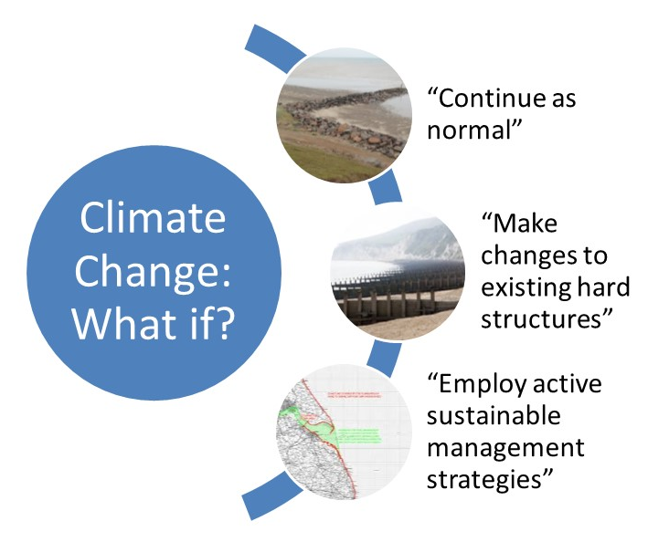
Exam-style Question

‘Sustainable approaches to coastal management will become more important than traditional approaches in dealing with the impacts of climate change.’ To what extent do you agree with this view? [20 marks]

- BUG the question (Box the command word, Underline the Geography, Glance back at the question)
- How would you answer the question…….make a plan:

- Integrated Coastal Zone Management
A systems perspective recognises that an action in one location is likely to have an impact elsewhere. The development of ICZM plans takes this as a basis for holistic (all components taken into account) planning.
The coastal zone is not only a place for natural marine processes and habitats but shoreline activities, inshore and offshore operations and inland activities that output at the coast through drainage systems that flow into the coastal zone.
The key aim of ICZM planning is to co-ordinate all the potential pressures and conflicts of interest at the coast and manage them fairly, responsibly and sustainably. Specifically:
  - Monitoring, information-gathering and recording of what is taking place at the coast
  - Identifying and involving all stakeholders (who may change with time)
  - Agreeing co-ordinated plans that allow key objectives for stakeholders to be met
  - Following sustainable strategies
  - Managing the natural and human systems responsibly
  - Considering changes to coastal systems and anticipating likely impacts
  - Adapting plans accordingly

ICZM Holderness
It is important to involve all stakeholders across the different sectors

- Why is an integrated coastal management is needed? (use the link:
http://www.coastalwiki.org/wiki/The_Integrated_approach_to_Coastal_Zone_Management_(ICZM))

- How can people and economic activity put pressure on coastal environments? (use the link: http://www.coastalwiki.org/wiki/The_Integrated_approach_to_Coastal_Zone_Management_(ICZM))

- What are the origins of ICZM? (Use the European Commission on AGENDA 21 link: http://ec.europa.eu/environment/iczm/index_en.htm )

- What are the specific issues facing coastal environments in the future?

- Who are the stakeholders, who should be considered when thinking about coastal management?

- How can ICZM be viewed as a cyclical process? (http://ec.europa.eu/environment/iczm/index_en.htm )

Exam Style Question
Read Oxford textbook pages 142-143, Hodder textbook pages 122-124, and use the information to answer the question below.
- Assess the advantages of integrated management plans such as Shoreline Management Plans (SMPs) and Integrated Coastal Zone Management (ICZM) [9 marks]

Other important links on ICZM:
- 20min interview with Dr. Burbridge from Newcastle University on ICZM: https://www.youtube.com/watch?v=g3uD-m6DPcc

