**3.1.5.1 The concept of hazard in a geographical context**

***This is what the exam board says you should know:***

* **Nature, forms and potential impacts of natural hazards (geophysical, atmospheric and hydrological).**
* **Hazard perception and the factors that determine a person’s perception.**

**Key terms:**

**Hazard Natural hazard Disaster Risk Vulnerability**

**Write down all the words and different events you can think of associated with this term:**

Hazards

**Types of natural hazard**

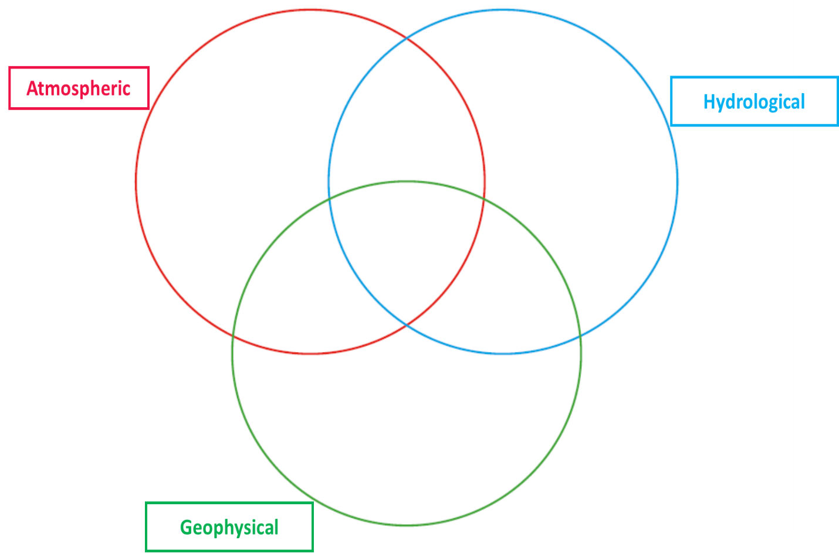Classify the examples of natural hazards that you have into the following categories:

Add in other hazards from the list on the board.

**What is a hazard?**

How would you define a hazard? Work on a definition with, no more than **20 words.**

**KEY TERMS**

|  |  |
| --- | --- |
| HAZARD |  |
| NATURAL HAZARD | An event perceived to be a threat to people, the built environment and the natural environment. They occur in the physical environments of the atmosphere, lithosphere and hydrosphere. |
| DISASTER | A hazard event that causes widespread disruption, destruction of property and loss of life on a significant scale. |

**The United Nations (UN) classifies a hazard as a disaster when:**

* A report of ten or more people are killed.
* A report of 100 or more people are affected.
* A declaration of a state of emergency by the relevant government is made.
* There is a request by the national government for international assistance.

**Common characteristics of natural hazards:**

* Clear origins and distinctive effects, e.g. earthquakes causing buildings to collapse;
* Only a short warning time before the event;
* The scale and intensity require an emergency response;
* Exposure to the risk is involuntary, particularly in less well developed countries.
* Most loss of life and damage occurs shortly after event; Effects can be felt long after.

**What are the potential impacts of natural hazards?**

Watch the clip and make notes on the different ways people can be affected:

What is the difference between a natural hazard and risk?

* Natural hazard = Natural phenomenon with the potential to harm;
* Risk = the probability of a hazard occurring and creating loss.

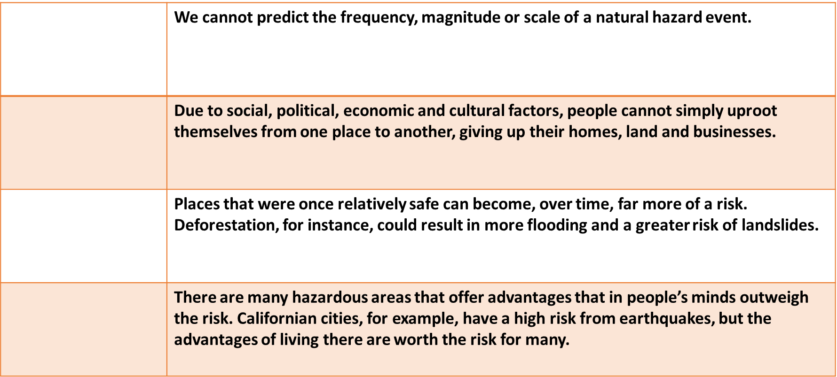**Why do some people put themselves at risk?**

Lack of alternatives - Cost/benefit - Hazard events are unpredictable - Changing the level of risk

**Perception of hazards**

Perception = the way in which an individual or a group views the threat of a hazard event. This will ultimately determine the course of action taken by people, governments and other organisations.

*Read the section under ‘Perception of hazards’ on page 213, Oxford.*

Try to come up with 3 or more factors that influence people’s perception of natural hazards:



*Take one factor and explain its role in influencing perceptions of hazards:*

**Risk and vulnerability**

Vulnerability = risk + ability to cope with potential loss.

When ability to cope is lower a community is more vulnerable.

***Discuss***: *Why are some populations vulnerable to natural hazards and exposed to risk?*

1) Suggest reasons why poorer people often more vulnerable to a natural hazard event:

2) Why are urban areas, particularly large ones, considered to be very vulnerable to natural hazard events?