**3.1.5.1 The concept of hazard in a geographical context**

***This is what the exam board says you should know:***

* **Characteristic human responses – fatalism, prediction, adjustment/adaptation, mitigation, management, risk sharing;**
* **Their relationship to hazard incidence, intensity, and level of development.**
* **The Park model of human response to hazards. The Hazard Management Cycle.**
* **Hazard perception and its economic and cultural determinants.**

**Key terms:**

**Fatalism adaptation primary effects secondary effects mitigation**

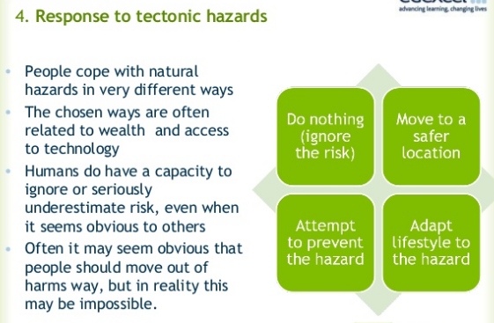

**What is the difference between primary and secondary hazard impacts?**

* Primary =
* Secondary =

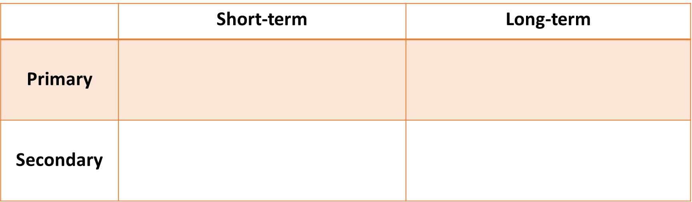

*Some may fit into more than one category!*

TSUNAMI COLLAPSED HOMES FOOD SHORTAGES

CRACKS IN GROUND DISRUPTED WATER SUPPLY PEOPLE HOMELESS

SHAKING BUILDINGS BREAKDOWN IN LAW AND ORDER LAVA FLOW

**How do people respond to natural hazards?**

There are three key responses to natural hazards:

**Fatalism:** Acceptance that hazard events are natural and there is little or nothing we can do to prevent them. Few, if any, preventative measures are put in place. Some may believe that taking action could harm existing ecosystems.

**Fear:** The perception of the hazard is such that people feel so vulnerable that they are no longer able to face living in the area and move away to regions perceived as safer.

**Adaptation:** People see it is possible to prepare for, and therefore survive, the event by prediction, prevention, and/or protection, depending upon the economic and technological circumstances of the area.

**The park model of human responses**

When a hazard event occurs, it disrupts economic and social life often immediately and totally. The **Park model** describes a sequence of phases following such an event.

It refers to the strategies and approaches taken to get ‘back to normal’ after a disaster. These methods span from immediate ‘relief’ to providing temporary housing to reconstructing after the damage.

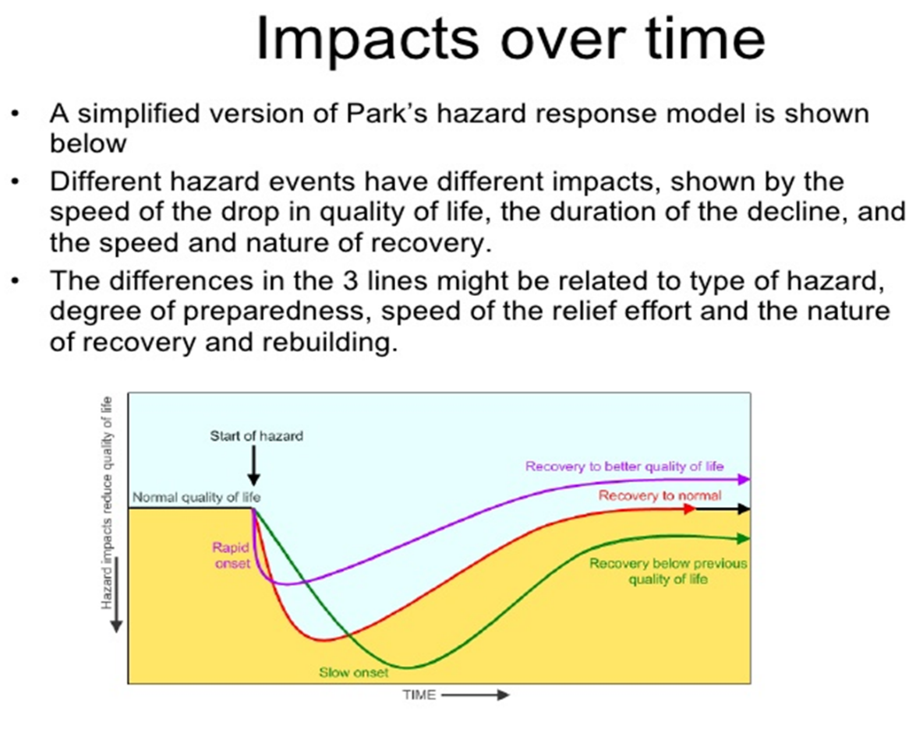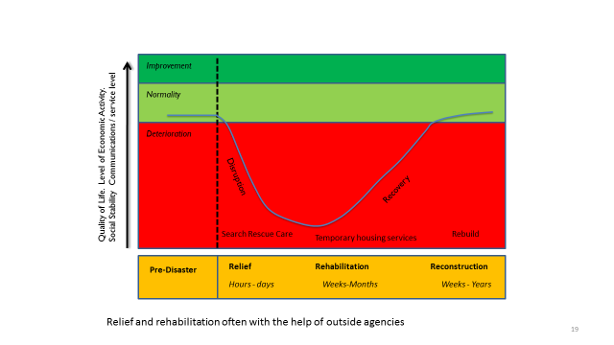

Different hazard events have different impacts, shown by the speed of the drop in quality of life, the duration of the decline, and the nature of recovery.

The difference in the line might relate to the type of hazard, degree of preparedness, speed of relief effort and the nature of reconstruction.

|  |
| --- |
| Stage 1:  Normality, attempts made to modify the event before it happens. |
| Stage 2:  The event |
| Stage 3:  Emergency search and rescue |
| Stage 4:  Relief and Rehabilitation including national and international help. |
| Stage 5:  Nature of recovery related to the need to reduce vulnerability and the need to restore normality ASAP. |

1) On your copy of Park’s response model, draw two different curves for:

1. A powerful earthquake in a LEDC with high population density;
2. Flooding after prolonged rain in a MEDC.

*Use two different colours.*

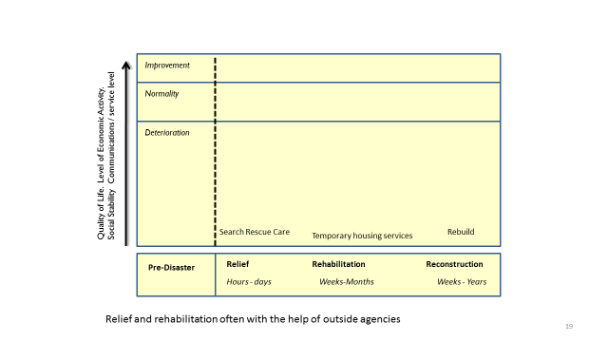

2) Write a paragraph explaining the different shapes of the curves.

3) Suggest two ways in which Park’s model shows that hazards can have different impacts over time.

4) Brainstorm the ways people cope before, during and after a hazard.

**The Hazard Management cycle.**

Both before and after a disaster strategies can be used to reduce the damage of the current and future hazards.

The Risk Management cycle outlines the strategies that can be taken at each stage:

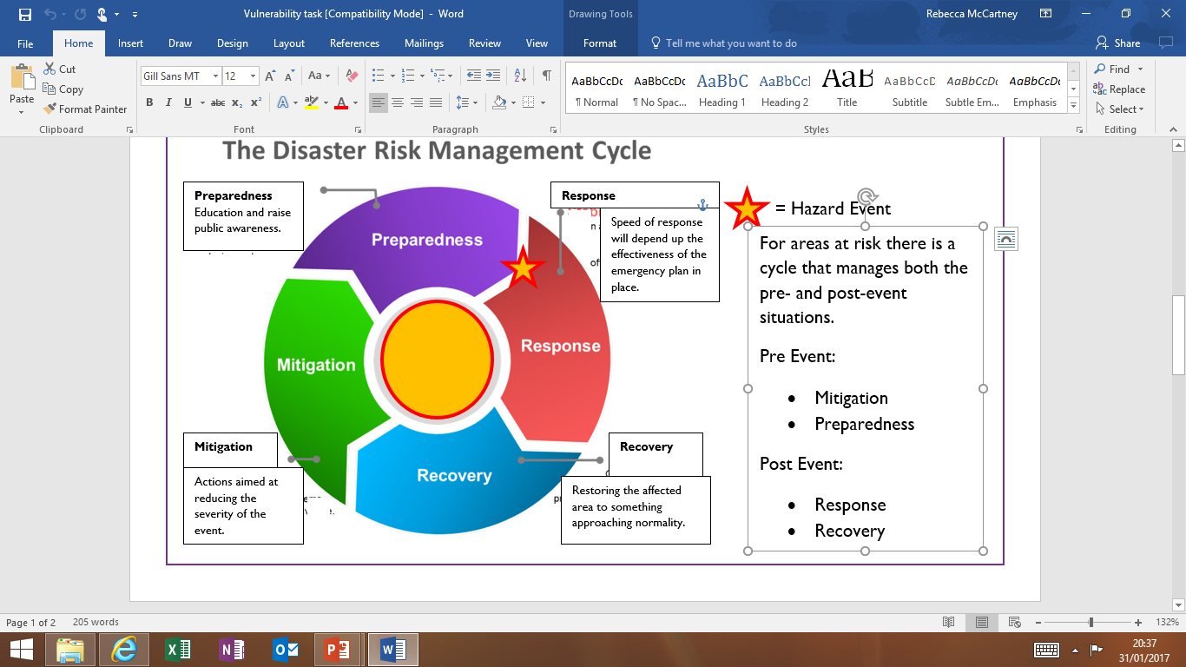



*Add the following labels onto your copy of the Hazard Management Cycle:*

*Hazard risk assessments, Hazard maps produced, Warning, Evacuation, Saving people, Emergency aid, Assessing damage, On-going aid, Restoration of Infrastructure, Economic & Social recovery, Education and Public awareness, Building codes put in place, Defences built, Long term aid, Land use planning, evacuation plans put in place, temporary shelters put in place, Counselling for the bereaved.*

**Exam-style question:** Evaluate the usefulness of Parks Model in responding to natural hazards in comparison to the Hazard Management Cycle (9) *Use separate paper.*

TED talk: managing hazard response (10 mins) <https://www.ted.com/talks/caitria_and_morgan_o_neill_how_to_step_up_in_the_face_of_disaster>

*Watch and make notes on how communities can improve their preparedness and response.*

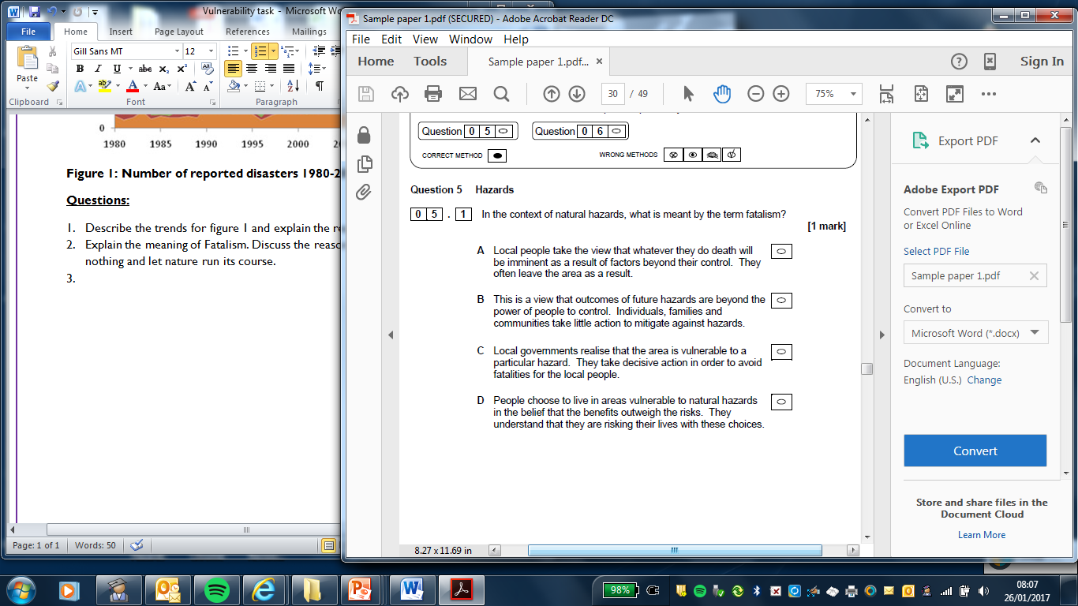

**Multiple choice hazards questions**

**Tick the correct answer in each case. Each multiple choice question is worth one mark.**

1. The following definition applies to which key term? (1 mark)

“a perceived natural/geophysical event that has the potential to threaten both life and property”

1. Risk
2. Natural hazard
3. Disaster
4. Vulnerability
5. Which of the following **cannot** be defined as a natural hazard? (1 mark)
   1. Hurricanes
   2. Landslides
   3. Wildfires
   4. Oil spills

3. Which stage of the Hazard Management Cycle would involve ‘restoration of infrastructure’?

1. Preparedness
2. Response
3. Recovery
4. Mitigation

4. Which response to hazards is described as the “view that hazard is natural and part of life in the area and so losses are accepted as inevitable” (1 mark)

1. Fatalism
2. Fear
3. Adaptation
4. The timescale of the **relief** **stage** of the Park Model of Human Response is:
   1. Hours-days
   2. Days-weeks
   3. Weeks-years

**Homework:**

Read through the Tutor2u study notes *Hazard types, perception, response & models* and highlight any new information.