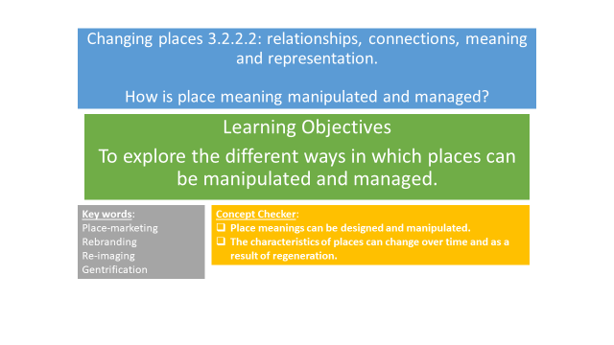

**Agents of change/Placemakers** –

**Examples would include** –

.

**Stakeholders -**

|  |  |  |  |
| --- | --- | --- | --- |
|  |  |  |  |
| To change negative stereotypes | To attract inward investment | To improve the quality of the built environment by removing derelict buildings, redeveloping wasteland, etc. | To raise the status of a place which can in turn give political gain. |
| To encourage people to move, live and work in an area | To improve job opportunities | To clean up neglected waterways and open space, making way for recreation. | To rebrand, make more attractive, possibly attract inward investment, and improve lived experience of people. |

Why is change needed? Why might the perception of place need to be managed and manipulated?

Political, social, economic or environmental?

**KEY TERMS**

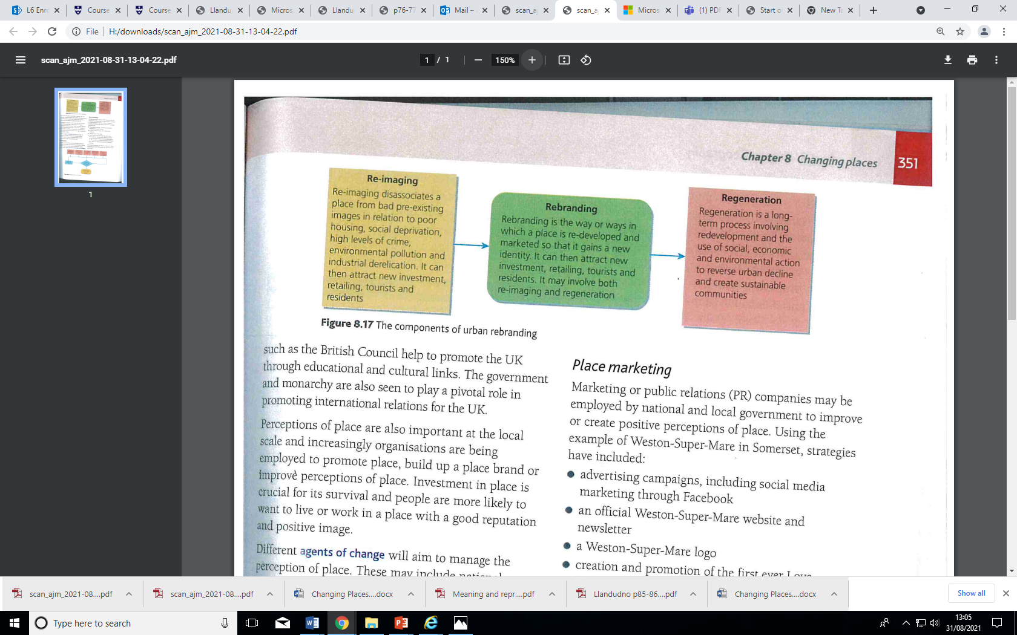

**RE-IMAGING**

Where have we already studied an example of re-imaging?

What did they do?

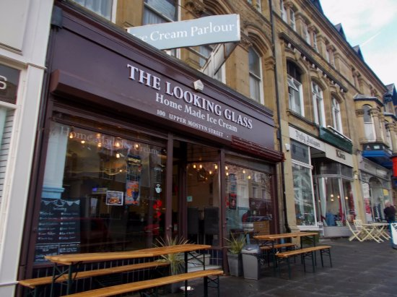

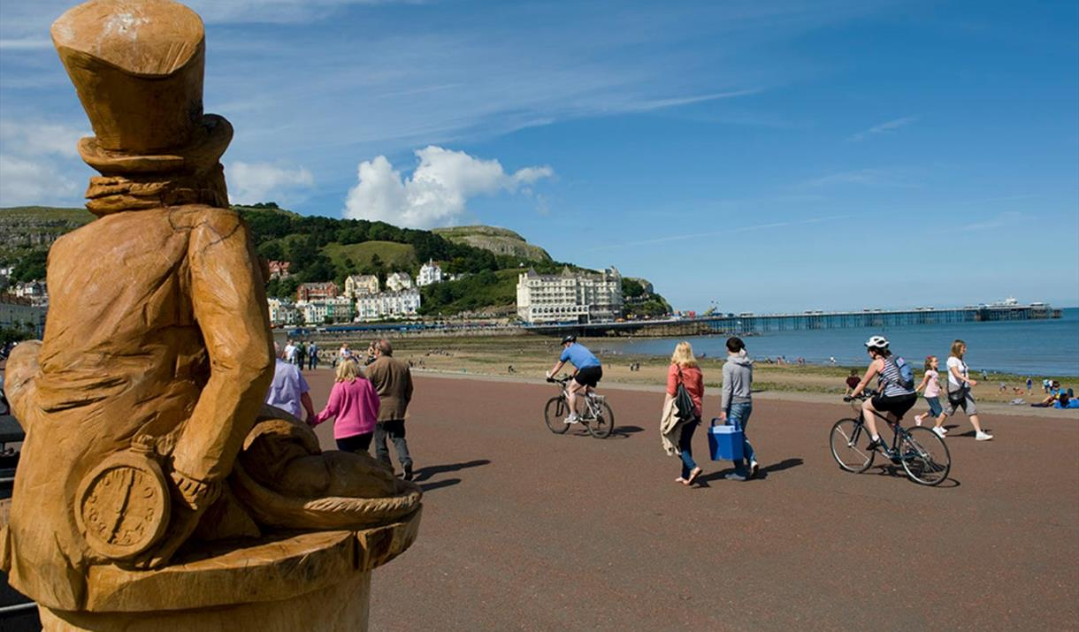

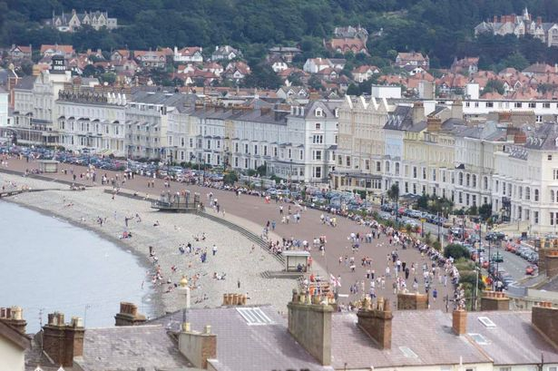

**REBRANDING**

**Case study Llandudno, North Wales – Alice Town**

<https://youtu.be/kC2IMt4_okI>

<https://www.dailypost.co.uk/news/north-wales-news/llandudno-alice-wonderland-tourist-trail-6647112>

Oxford pages p85 &86

Why do you think rebranding was needed?

Who were the Agents of Change? (also known as Placemakers)

What various things have they done?

Assess the success of the rebranding? (include both positives and negatives and come to an overall judgement)

**Features of regeneration**

**REGENERATION**

We will be covering a number of regeneration/redevelopment case studies during the Changing Places topic. Our main case study will be Stratford in London.

What examples of regeneration have you studied at GCSE? What were the social, economic and environmental changes that took place?

This is a photo of an area in Birmingham city centre.

*Annotate the photo with features that show evidence of redevelopment.*

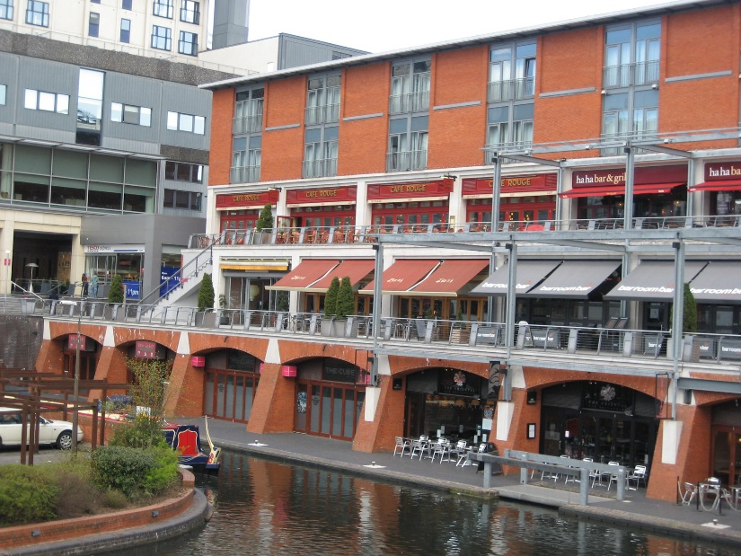

*High end housing and luxury apartments.*

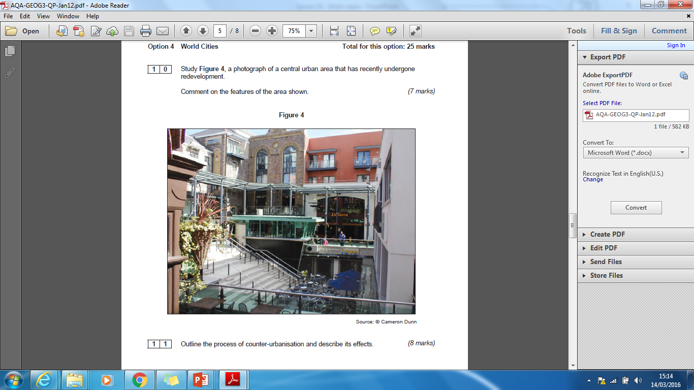

Study Figure 4, a photograph of a central urban area that has recently undergone redevelopment.

Comment on how representation of place may have changed in this area. (6 marks)

**P**

**PLACE MARKETING**

Marketing or public relations (PR) companies may be employed by national and local governments to improve or create positive perceptions of place.

What strategies do you think they may include?

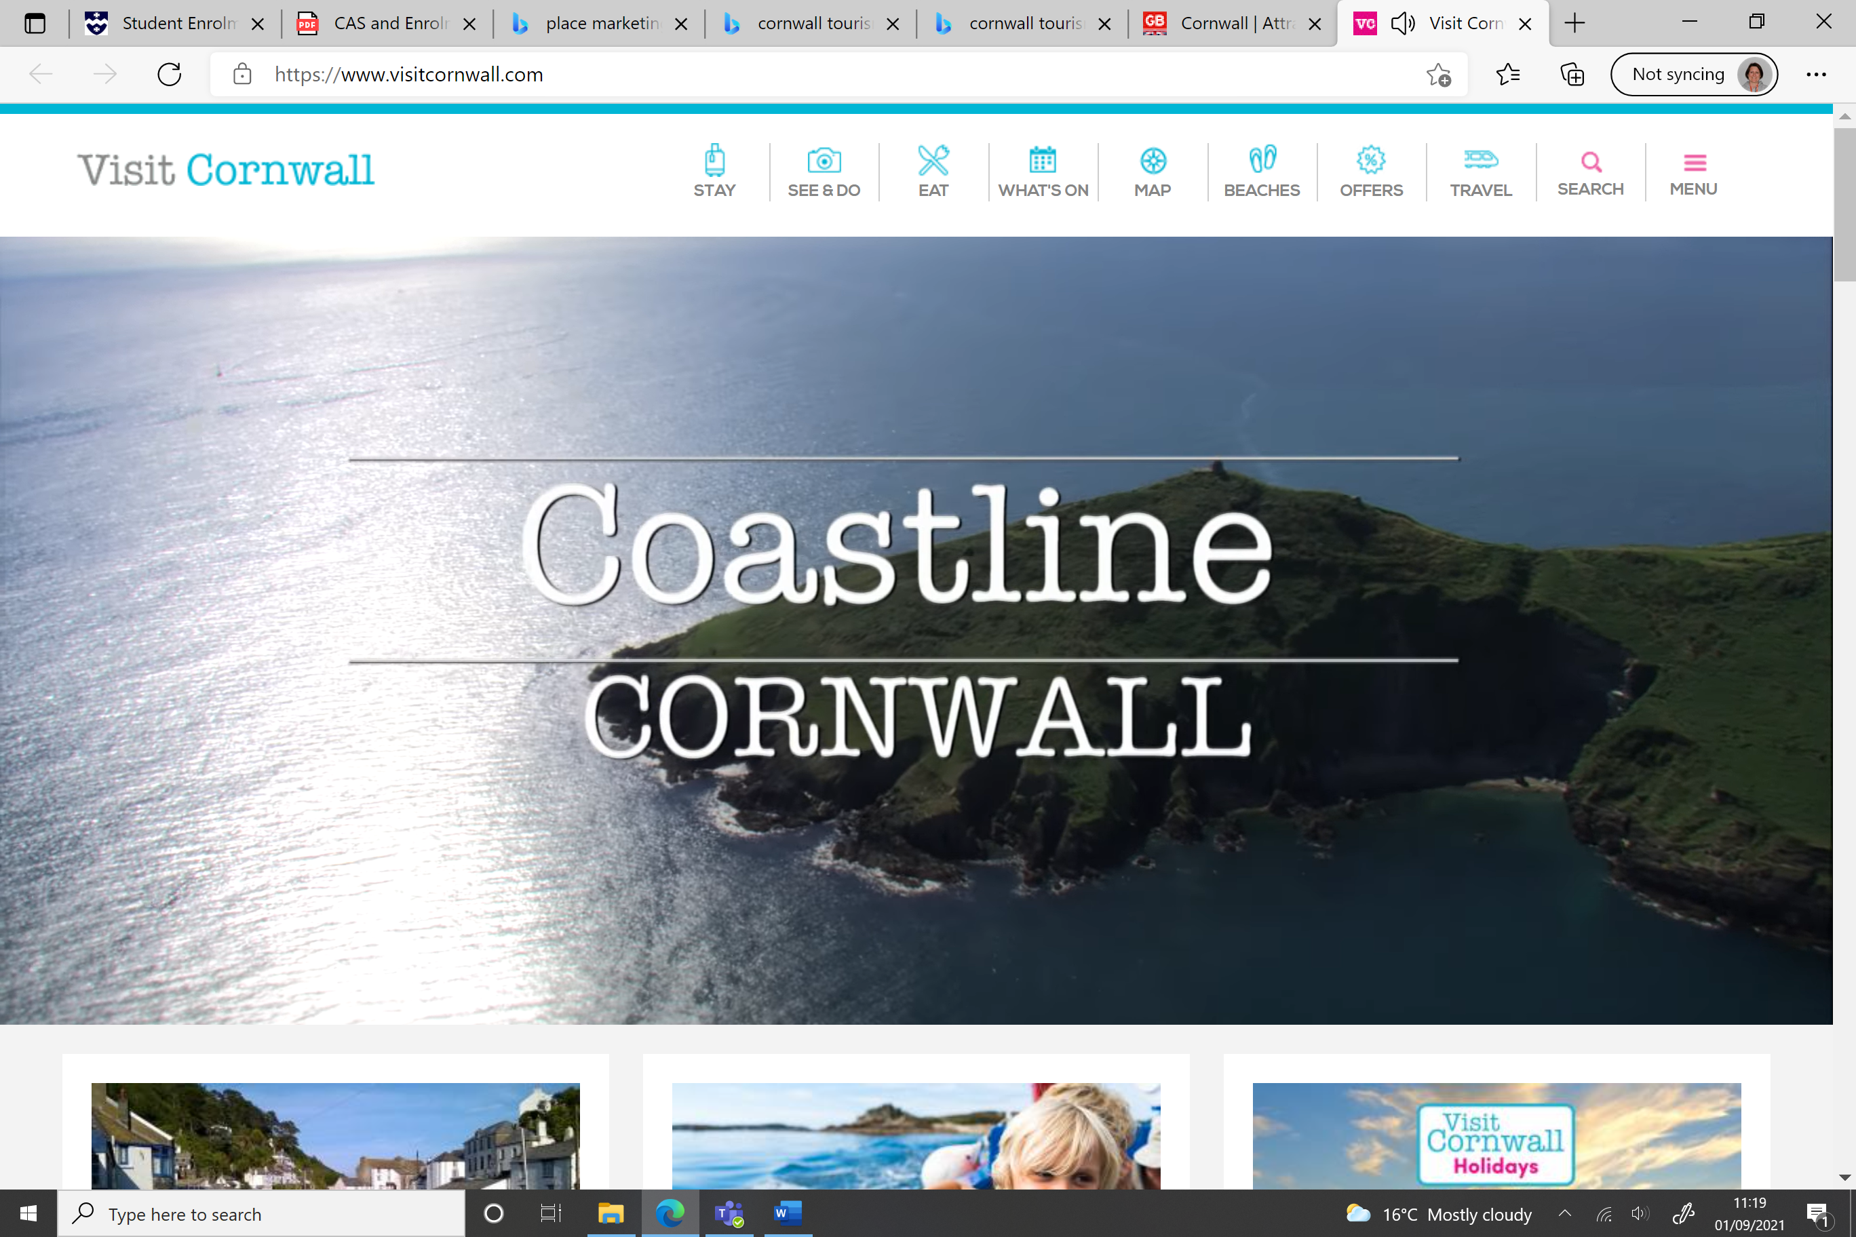

**CORPORATE BODIES**

A corporate body is an organisation or group of persons that is identified by a particular name.

Examples of corporate bodies include institutions, businesses, non-profit enterprises and government agencies.

Many corporate bodies will have an interest in place but some will want to manipulate perceptions of place.

What examples of corporate bodies are there?

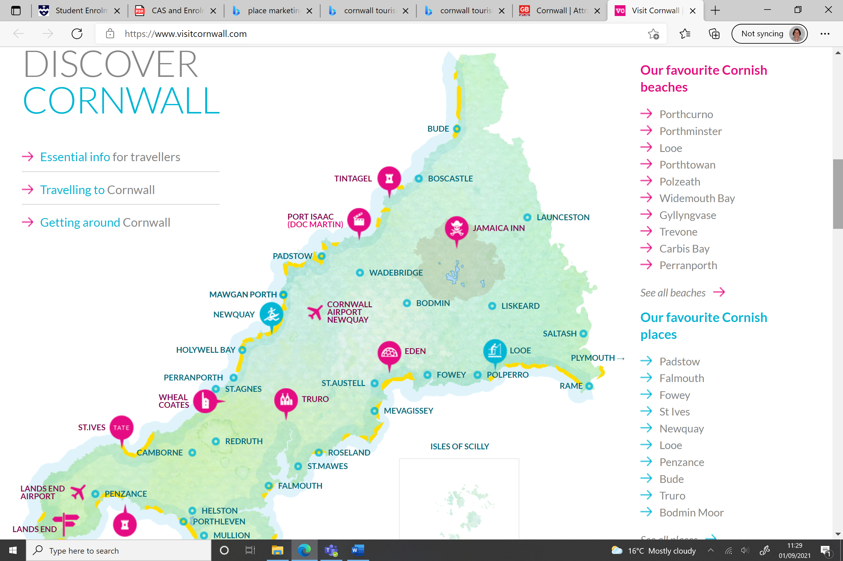

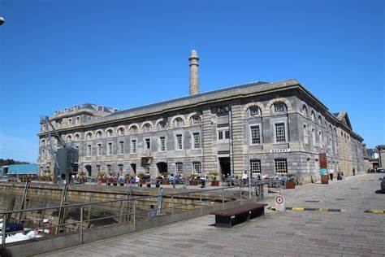

**GENTRIFICATION**

This is the buying and renovating of properties often in more run-down areas by wealthier individuals.

Royal William Yard apartments in Plymouth.

Is this gentrification?

Why?

Portland Road, London

Is this gentrification?

Why?

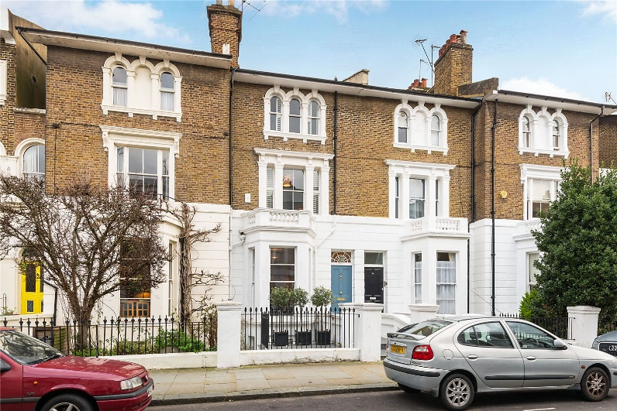

**TASK – Managing place**

Read the hand-out *‘The tricks stores use to make you spend more’:*

1. How do shopping centre designers attempt to manage the movement of customers?
2. Describe two ways shopping centres now encourage people to stay for longer and spend money in the high-end shops

**FLAGSHIP DEVELOMENTS**

**Significant,** **high-profile and prestigious land and property**. **developments which play an influential and catalytic** **role in urban regeneration**

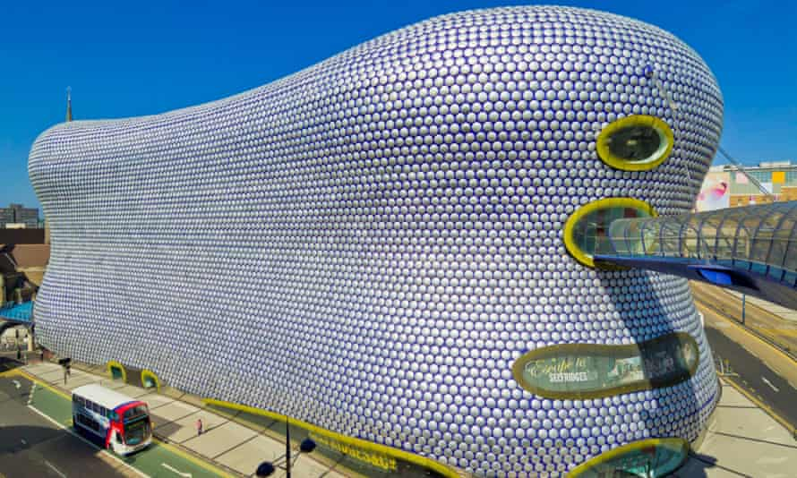

The Bullring - Birmingham

Why do you think that it was built?

It cost £500 million to build. Based on the information on the PPT, do you think that it was good value for money? Why?

The different people and groups involved in regeneration are known as **stakeholders.** They may influence the process of regeneration or be affected by it. Stakeholders may include:

* Local council;
* Central government;

What is the difference between a stakeholder and a placemaker?

* Town planners;
* Developers/construction companies;
* Local residents;
* Community and local charity groups;
* Conservationists;
* Heritage organisations;
* Retail companies.

Additional reading:-

Hodder p349-353