UIC - Mumbai, social and economic opportunities

People have moved to Mumbai because large cities like Mumbai offer more opportunities to people than rural areas can.  Cities benefit from ECONOMIES of SCALE – it easier and cheaper to provide the services people desire when there are lots of people.

**Social Opportunities**  
These are opportunities that help people in some way or other, Mumbai offers many opportunities to people via access to various public and private services;  
Health care – we often take health care for granted in the UK, with our free at the point of use NHS, but access to quality healthcare matters to many people.  In cities like Mumbai people have easier access to a wider range of medical services including doctors, hospitals and nurses. Even the poor have access to basic medical services that they either would not have in the rural areas or would have to travel very long distances for.  
**Education** – this is another free at the point of use service in the UK, but education is truly life changing and often taken for granted. Not in poor countries, migrants often move to cities to have access to schools for their children, so that their children have a much better chance in life than themselves.  
**Water supply**– This is variable in Mumbai, and in Dharavi slum the water pipes are only in use 2 hours a day and there are queues for this water.  However, this is clean drinking water, which often not available in poorer rural areas or involves a time consuming labour intensive walk for (mainly) women to the local well.   Having access to clean water that does not transmit parasites or cause cholera is another opportunity provided by living in an urban megacity like Mumbai.  
**Energy** – some remote parts of India still have no electricity, whilst living in a large city like Mumbai allows people to live with all of the benefits of energy and electricity. This is another opportunity or pull factor, think of all of the opportunities that having regular energy supply offers to people.

**Economic opportunities**

The major pull factor of a city like Mumbai, like cities in LICs and NEEs across the globe, is the opportunity for employment.  Most people around the globe want the chance to work, earn a living and provide a decent life for themselves and their families.  Mumbai offers a huge range of job opportunities from the hugely attractive and often unobtainable like working for a major financial institution like a bank or in the Bollywood film industry, to the most basic such as rag pickers (people who sift through rubbish to find items of any worth).

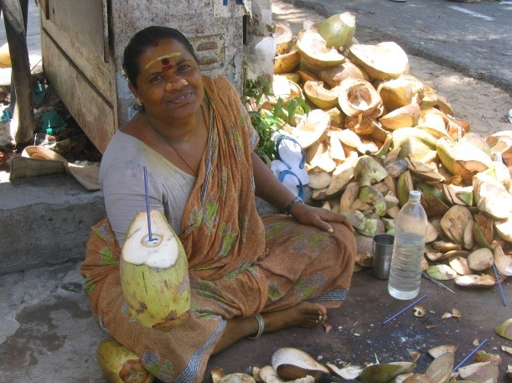

Mumbai has many job opportunities because it alone accounts for 6% of India's GDP and 40% of its foreign trade.  It is also a manufacturing hub which creates a lot of jobs, 25% of India’s industrial production is in Mumbai. The port area also creates a lot of valuable jobs.   
It also has the headquarters of a number of Indian financial institutions such as the Bombay Stock Exchange and the Reserve Bank of India, and numerous Indian companies such as the Tata Group. Most of these offices are located in downtown South Mumbai which is the nerve center of the Indian economy.

**The formal and informal economy**  
Many of the jobs in Mumbai are in the formal economy.  These jobs are registered jobs where the workers’ pay taxes to the government and the companies have a legal obligation to protect their workers, offer holidays and pay regular wages.  
However, many of the jobs in Mumbai are also found in the informal economy.  Here there is no minimum wage, the workers are unlikely to pay taxes, have no holiday rights and often work in dangerous or hazardous conditions. Jobs include rag picking, breaking up and recycling old electronic products, recycling waste, making pottery, selling items on the street etc.  The key to many these jobs is that they cost little to set up, use simple tools and are labour intensive (involve lots of human work).

Despite the difficulties of the informal industry, these industries offer poor often uneducated people a foothold in the city.  They can earn money and start to improve their quality of life from that point. Dharavi slum has the following positives for people  
1. Informal shopping areas exist where it is possible to buy anything you might need.  
2. There are also mosques catering for people's religious needs.  
3. There is a pottery area of Dharavi slum which has a community centre.  
4. Rooms within houses have multiple functions, including living, working and sleeping. Many daily chores are done in social spheres because people live close to one another. This helps to generate a sense of community.  
5. The buildings in the pottery part of the slum are all of different heights and colours, adding interest and diversity. This is despite the enormous environmental problems with air and land pollution.  
6. 85% of people have a job in the slum and work LOCALLY, and some have even managed to become millionaires.

# UIC - Mumbai, location & Importance

### **Mumbai – a case study of a major city in a  LIC or NEE**

### **The location and importance of the city, both nationally and internationally**

**Key words**  
Economic opportunities - Chances for people to improve their standard of living through employment.  
Formal economy - This refers to the type of employment where people work to receive a regular wage and are assured certain rights e.g. paid holidays, sickness leave. Wages are taxed.  
Informal economy  - This type of employment comprises work done without the official knowledge of the government and therefore without paying taxes. It is common in many LICs.  
Social opportunities - Chances for people to improve their quality of life, for instance access to education and health care.  
Squatter settlement - An area of poor-quality housing, lacking in amenities such as water supply, sewerage and electricity, which often develops spontaneously and illegally in a city in an LIC.

Mumbai can be found in Maharashtra state in the West of India.  It is not the most populous of Indian cities but it is one of the most important economically and culturally.  Mumbai is a MEGACITY, with a population of over 12 million people!

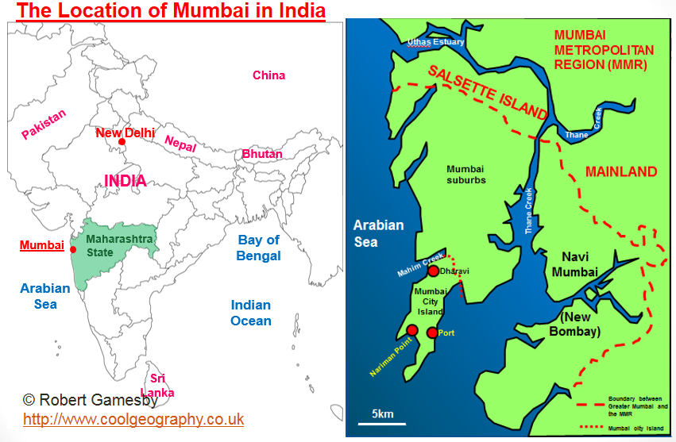  
Its Geographic location (see map) is very significant, as it is on a major shipping route through the Mediterranean Sea via the Suez Canal, along with other shipping routes.  It also has a major airport and is connected to other Indian cities via railway and road links.  
Its location  attracted fishermen initially, then British Colonisers and was the ideal place for a port, as Mumbai is built on an island with a river estuary to the East, protecting the ships from waves in the Indian Ocean when in dock.

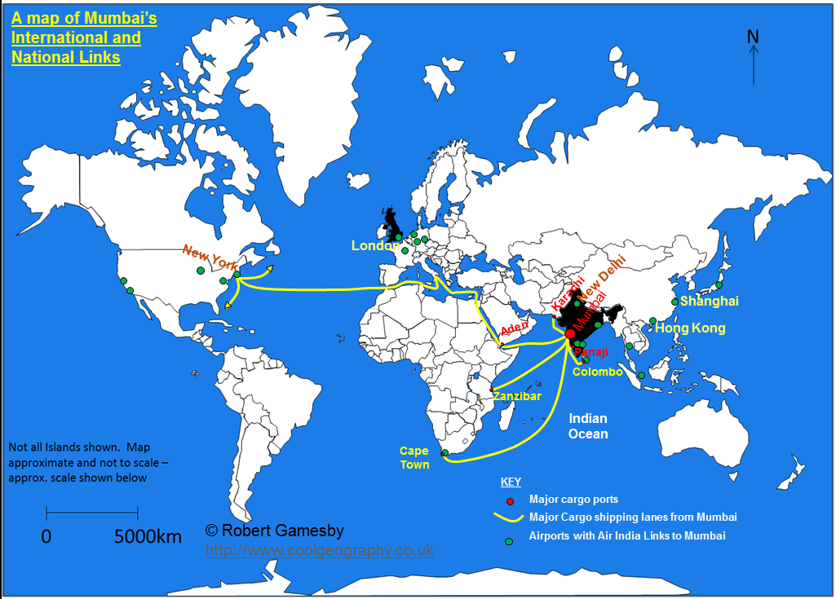  
Mumbai's international links

Mumbai is a city of contrasts, being one of the richest cities in Asia but also home to some of the world’s poorest people.  It accounts for 6% of India's GDP, 40 % of foreign trade, and 25% of industrial production. In total, the city creates US$10 billion in corporate taxes and its per-capita income is higher than the national average.   
It is also the entertainment, fashion and commercial centre of India. It is also one of the world's top 10 centres of commerce in terms of global financial flow.  It also has the headquarters of a number of Indian financial institutions such as the Bombay Stock Exchange and the Reserve Bank of India, and numerous Indian companies such as the Tata Group. Most of these offices are located in downtown South Mumbai which is the nerve centre of the Indian economy.  
Many foreign companies also have their branches in the South Bombay area. Mumbai is the world's 29th largest city by GDP.

UIC - Mumbai, causes of growth

Mumbai is IN Maharashtra state, but there are differences between the 2 as is evident in the table below.  
Contrasts between Mumbai and Maharashtra state

|  |  |  |
| --- | --- | --- |
|  | Maharashtra State | Mumbai |
| GDP per head (US $) | 1,660 | 2,845 |
| Life expectancy | 68.4 | 52.6 (men) and 58.1 (women) |
| Infant Mortality | 28 | 26 |
| Literacy rate | 82.9% | 90.81% |
| Birth rate | 17.6 | 20.1 |
| Death rate | 6.7 | 6.0 |

**POPULATION GROWTH**

The population of the city has increased incredibly, as can be seen on the graph below.  The issue that Mumbai has is that despite its incredible wealth by Indian standards, it still has a huge number of people living in shanty towns or slums, together with all of the associated environmental and social problems these areas have.

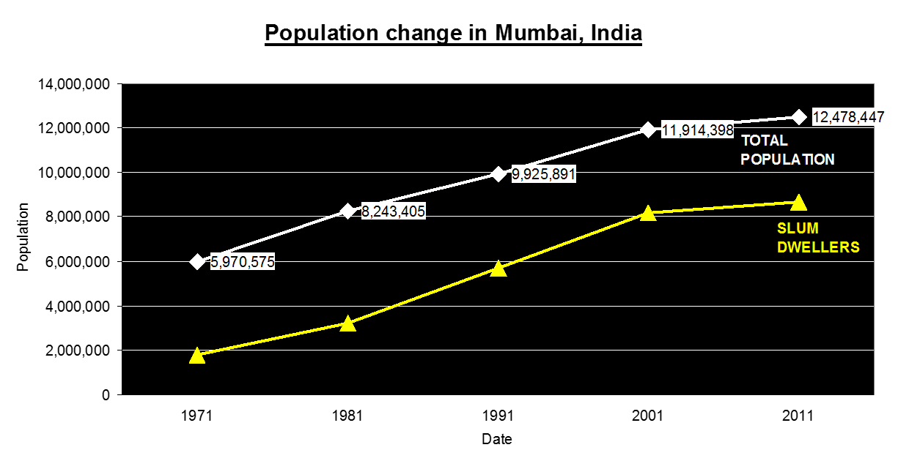

**CAUSES OF GROWTH**  
1. **Migration** - 38% of migrants to Mumbai come from Maharashtra state together with many others from other poor regions.  Maharashtra state is more rural than Mumbai and half of the population works in farming.

Farming has undergone massive changes in India in recent decades.  Increased use of machinery has forced people out of work, and changes to farming have forced people with small farms to sell up to larger land owners.  Small scale farmers are also vulnerable to bad harvests and poor weather as they are totally dependent on their crops.  In bad years, they can end up forced to sell up and have to migrate. In Mumbai there are job opportunities in service industries and the manufacturing industries which pay higher wages. There are also more schools, health care facilities and entertainments in Mumbai than other parts of Maharashtra state.

2. **Natural increase**– although less significant than migration in Mumbai’s case (see graph below), the population of Mumbai is also increasing naturally, with significantly more births than deaths (due to high birth rates) every year.

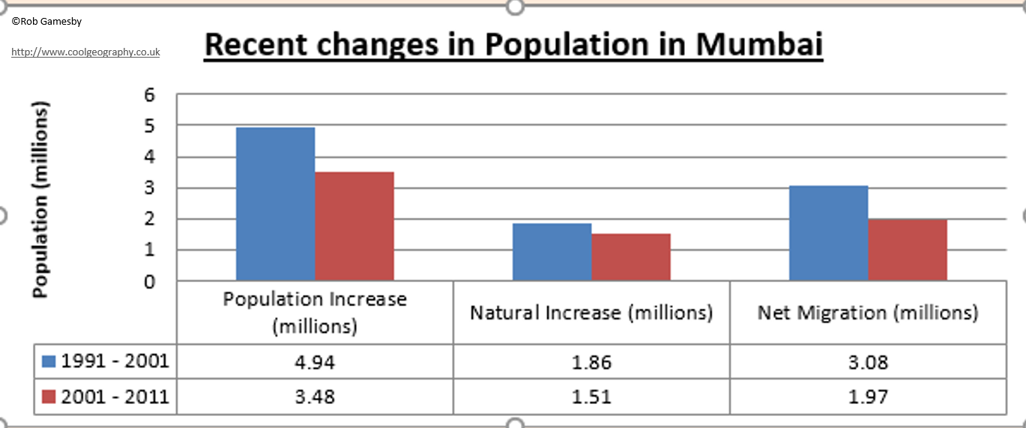

# UIC - Mumbai - SEE Challenges

**Key words**  
**Inequalities**- Differences between poverty and wealth, as well as in peoples' wellbeing and access to things like jobs, housing and education. Inequalities may occur in housing provision, access to services, access to open land, safety and security.  
**Pollution**- The presence of chemicals, noise, dirt or other substances which have harmful or poisonous effects on an environment.  
**Sanitation** - Measures designed to protect public health, including the provision of clean water and the disposal of sewage and waste.  
**Traffic congestion** - Occurs when there is too great a volume of traffic for roads to cope with, so traffic jams form and traffic slows to a crawl.

**SOCIAL AND ECONOMIC CHALLENGES**  
Mumbai is a city that faces many challenges and those challenges are large because of its immense size and rapid growth.  Physical Geography also plays a role, as Mumbai has been limited in where it can grow because it originally grew at the southern end of an island surrounded by the Arabian Sea and 2 rivers.  
The major problem in Mumbai is the growth of squatter settlements known in India as SLUMS. These slums come with many issues for people including the lack of planned access to clean water and sanitation systems, poor health, lack of education, unemployment and the prospect of crime.  
One of the world’s most infamous slums is Dharavi slum, which is the largest squatter settlement located in Mumbai (formally Bombay) in India. There are a million people crammed into one square mile in Dharavi. At the edge of Dharavi the newest arrivals come to make their homes on waste land next to water pipes in slum areas. They set up home illegally amongst waste on land that is not suitable for habitation. In the wet monsoon season these people have huge problems living on this low lying marginal land.

**Challenging Conditions in the slums**  
In the slum people have to live with many problems;  
1. **Lack of sanitation is the MAJOR ISSUE**- people have to go to the toilet in the street and there are open sewers because 500 people share one public latrine. Children play amongst sewage waste and doctors deal with 4,000 cases a day of diphtheria and typhoid.

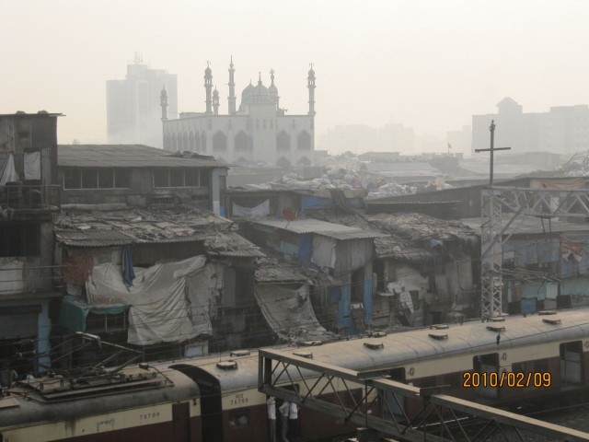

[Dharavi Slum By Leonora Enking via Wikimedia Commons](https://commons.wikimedia.org/wiki/File%3ADharavi_Slum_Mosque_Mumbai_India_February_2010.jpg)

2. **Lack of access to clean water**– there are few water pipes in the slum and those that exist only have the supply switched on for 2 hours a day by the city authorities.  This means people have to queue for water and have LIMITED SUPPLY.  In addition, next to the open sewers are water pipes, which can crack and take in sewage.  Dharavi slum is based around this water pipe built on an old rubbish tip.

3. **Lack of legal rights** - The people have not planned this settlement and have no legal rights to the land.  In addition, the slum houses have little in the way of security.  Mumbai as a whole has a problem with crime, such as pick pockets and organised begging.  
4. **POOR HEALTH**– life expectancies in the squatter settlements are low because of these conditions, poor quality water, mosquitoes which thrive in nearby mangrove swamps and dangerous jobs (There are toxic wastes in the slum including hugely dangerous heavy metals) all serve to impact on people’s health.  
5. **UNEMPLOYMENT and POOR QUALITY WORK -** Many people have poor jobs, such as those who work to sift the rubbish in the tips where children and women sift through the rubbish for valuable waste. They have to work under the hot sun in appalling conditions. They earn around a £1 a day for their work.  
Many architects and planners claim this slum could hold the solution for many of the problems of the world’s largest cities.

**ENVIRONMENTAL CHALLENGES:**  
Mumbai has challenges to deal with protecting the natural environment and providing people with a clean environment to live in.   
1. **Water pollution is a major problem in Mumba**i.  A major study revealed that 77% of households suffer from poor water quality in the city.  This poor water quality is leading to water borne diseases occurring in people and levels of things like total dissolved solids (TDS) and nitrates are higher than safe limits.  Toxic chemicals such as arsenic and lead and disease-causing bacteria are also contributing to the alarming increase in the water contamination. Deadly waterborne diseases like cholera, jaundice, typhoid, diarrhoea are affecting people as a result.

2. **Air pollution** – Mumbai has some very dirty air including dangerous levels of Nitrous Oxides and small dust particles called particulate matter.  These are both hazardous to human health and can cause things like asthma. The causes of this pollution are industry, ever increasing numbers of cars and construction dust.

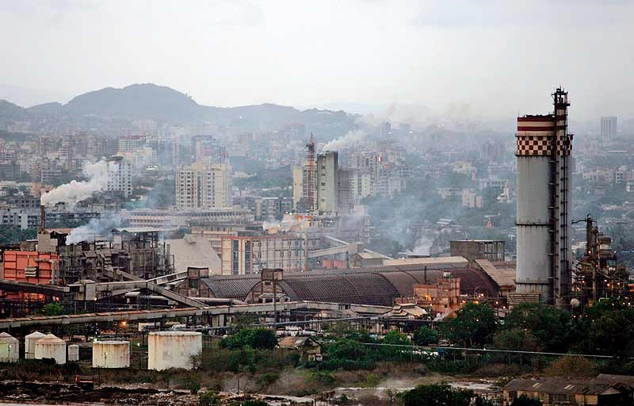

3. **Waste**– Mumbai produces 7,500 metric tonnes of waste every day, a huge amount.  There is no comprehensive city based system of collection and this waste poses a hazard to human health.  The slum of Dharavi has a recycling zone. It is claimed that Dharavi’s recycling zone could be the way forward to a sustainable future. Everything is recycled from cosmetics and plastics to computer keyboards. 23% of plastic waste gets recycled in the UK, in Dharavi it is 80%. Despite this Mumbai still has major problems getting rid of its waste.

4. **Traffic congestion** – there are more than 22 million vehicles registered in Mumbai and these contribute to both noise and air pollution, as well as lots of lost hours as people sit in traffic jams.  This is despite Mumbai’s renowned train system.

# UIC - Mumbai, Improving Urban areas

The city authorities of Mumbai want to improve the quality of life of the people who live there.  This includes the slum or squatter settlement dwellers.  Current approaches across Mumbai are for whole sale DEMOLITION of the slums which are replaced by high rise tower blocks for people to live in. The positives and negatives of these are shown below;

[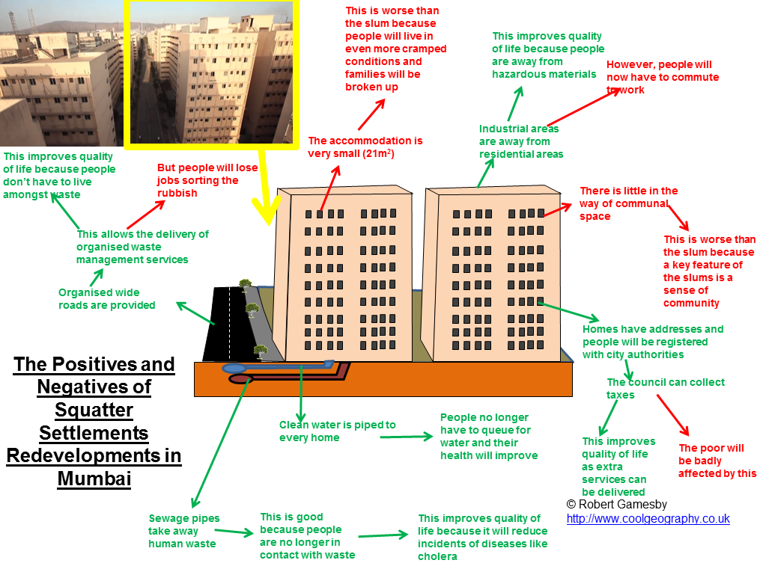](http://www.coolgeography.co.uk/_cmslibrary/images/GCSE/Urban/Improving_housing_Mumbai.png)  
  
**Above - High rise dwelling approach to improving the lives of squatter settlement residents**

These types of redevelopment are planned for Dharavi by the[Slum Rehabilitation Authority](http://www.sra.gov.in/)(SRA).  They have proposed a $2billion development project. This threatens the recycling district and part of Dharavi. The land upon which Dharavi is built is next to Mumbai’s financial district. This makes it a prime target for redevelopment. The people who are relocated will be put into smaller housing in apartment blocks. An ancient fishing village is also threatened. These areas have strong safe neighbourhoods that have low crime and communal areas. Also at risk are the local shops and markets and the community spirit which has taken generations to develop. The locals would prefer small improvements to the existing slum such as improvements in drainage. The value of land is so high that redevelopment is now a real threat. The alternative accommodation is very small, only 21m squared.  
The slum dwellers face 14 story apartments as accommodation as proposed by the cities Slum Rehabilitation Authority. This will separate communities and make people work away from where they live. Only people who have lived in the slum since 1995 will be relocated. Current redevelopment projects are densely populated and house lots of people. They are not good for the community.

**Local Based Improvements**  
There is an alternative to large scale redevelopment and that is to allow LOCAL people design the improvements to the slum.  
The [Society for the Promotion of Area Resource Centres, better known as SPARC](http://www.sparcindia.org/index.php), is an NGO that supports the efforts of local people to get better housing for their many members. Ideas generated from local people supported by this charity include adding an extra floor to buildings so that all family members can be accommodated in the same building. These flats also had 14-foot high ceilings and a single tall window so are well ventilated, bright, and less dependent on electric fans for cooling. Their loft spaces add extra room without seeming crowded, and include small spaces for bathing. Toilets are placed at the end of each of the building’s four floors, and kept clean by the two or three families who use each one. These ideas only work when water is running in Dharavi.  
As the National Slum Dwellers Federation has repeatedly proven, housing the poor works best, costs less and is better for the environment, when the poor themselves have a say in what is being built.