**Name:**

**Spatial Patterns: Case Study - London**

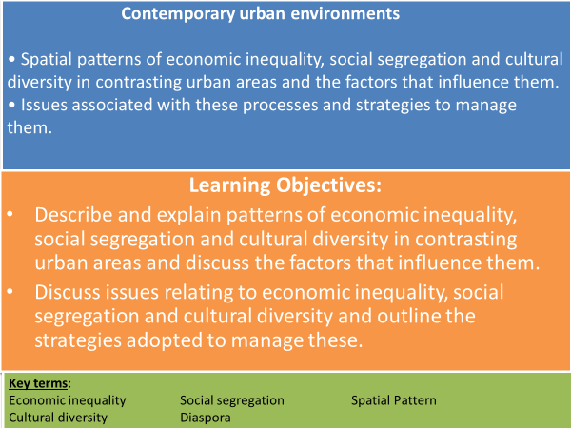

**Social and Economic Issues Associated with Urbanisation**

**TASK: What are the social and economic issues associated with urbanisation in the UK? Make a list below.**

**How is inequality measured in the UK?**

**Measuring poverty and inequality**

* The Index of Multiple Deprivation – a UK government study measuring deprivation at small-area level across England. This can be viewed at [The Consumer Data Research Centre](http://maps.cdrc.ac.uk/) or [IMD explorer](http://dclgapps.communities.gov.uk/imd/idmap.html)
* 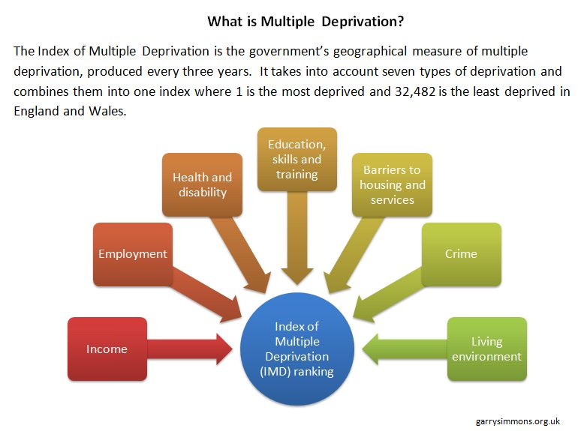The 7 dimensions of deprivation are:

The 2010 IMD data found 98% of most deprived areas in England were in cities.

Some London Boroughs that have experienced more recent gentrification have become less deprived for example: Hackney, Tower Hamlets and Newham.

**Case-Study – London**

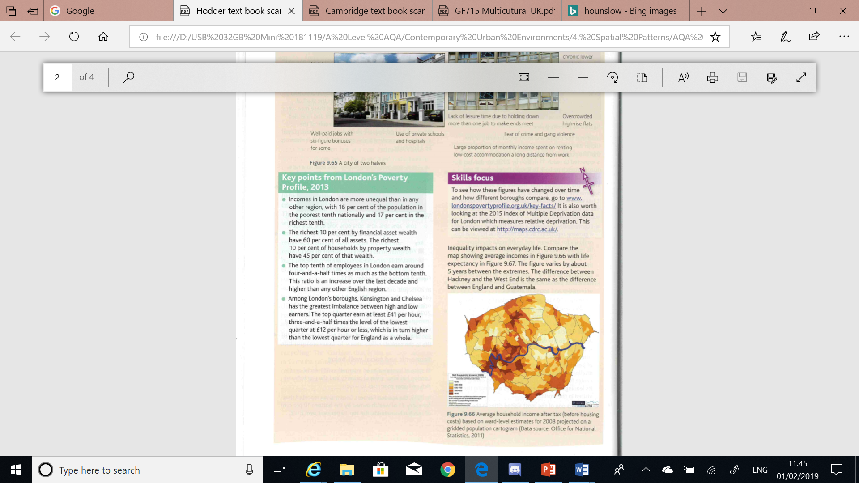

**TASK: Watch the clip and answer the following questions on inequality in London.** [**https://www.youtube.com/watch?v=8uZ64re-Zos**](https://www.youtube.com/watch?v=8uZ64re-Zos)

How does London rank in terms of unequal cities in the developed world?

What is youth unemployment like in Poplar, East London?

What is the wealth inequality between Canary Wharf and Poplar?

How does it divide lives? How much longer can life expectancy be?

What impacts did the recession have on inequality?

How have property prices changed in expensive and cheaper areas?

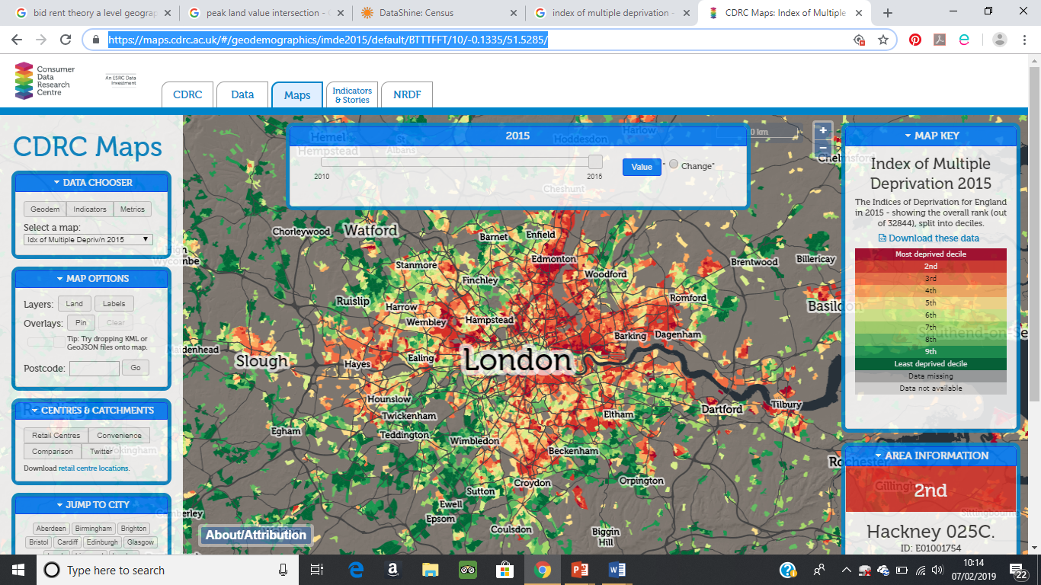

**TASK: Describe the spatial pattern of deprivation across London. What is the general pattern? Name some of the most deprived and least deprived areas.**

**Social and Economic Issues in London**

**TASK: Use the words below to fill the gaps.**

**Hate crime poverty differ widely**

**isolated gentrified widened**

* London is home to some of the **richest** and **poorest** people in the UK – this gap **has ________________** since the 1980s.
* The average annual income in Kensington and Chelsea is more than **£130,000**, but in Newham it’s less than **£35,000**. Low wages and few job opportunities in some areas mean that more than **25%** of people in London live in **_______________**.
* Many inner city areas, e.g. Notting Hill, have been **______________** – this has **forced poorer residents** out of the area.
* London is culturally diverse – more than 50% of the population is **not white British**. Proportions of ethnic minorities **___________________** between boroughs – e.g. in **Brent** over **60%** of people are not white British, whereas in **Havering** the proportion is only around **16%**, suggesting that ethnic segregation is an issue.
* **________________** based on race and religion is a problem in London, e.g. in the twelve months before July 2015, there were over 800 **anti-Muslim** incidents (including verbal abuse and violence) in the city.
* Social segregation based on **age** and **class** is also an issue – London residents have less interaction with people of different age groups and classes than people elsewhere in the UK. This could lead some residents to feel **______________**.

**Changes in Socio-Economic Status in London**

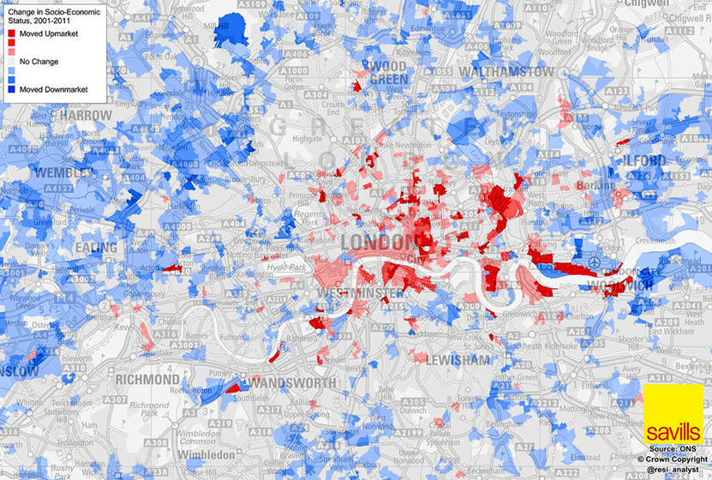

**TASK: Describe the changes in socio- economic status in London between 2001 and 2011. Make particular reference to areas studied e.g. Stratford, Canary Wharf, Notting Hill & Hounslow (to be studied) and label these on the map.**

**What may have contributed to the changes in socio-economic status in Stratford and Canary Wharf?**

**Cultural Diversity**

**Key term: Diaspora – a group of people with a similar heritage or homeland who have settled elsewhere in the world.**

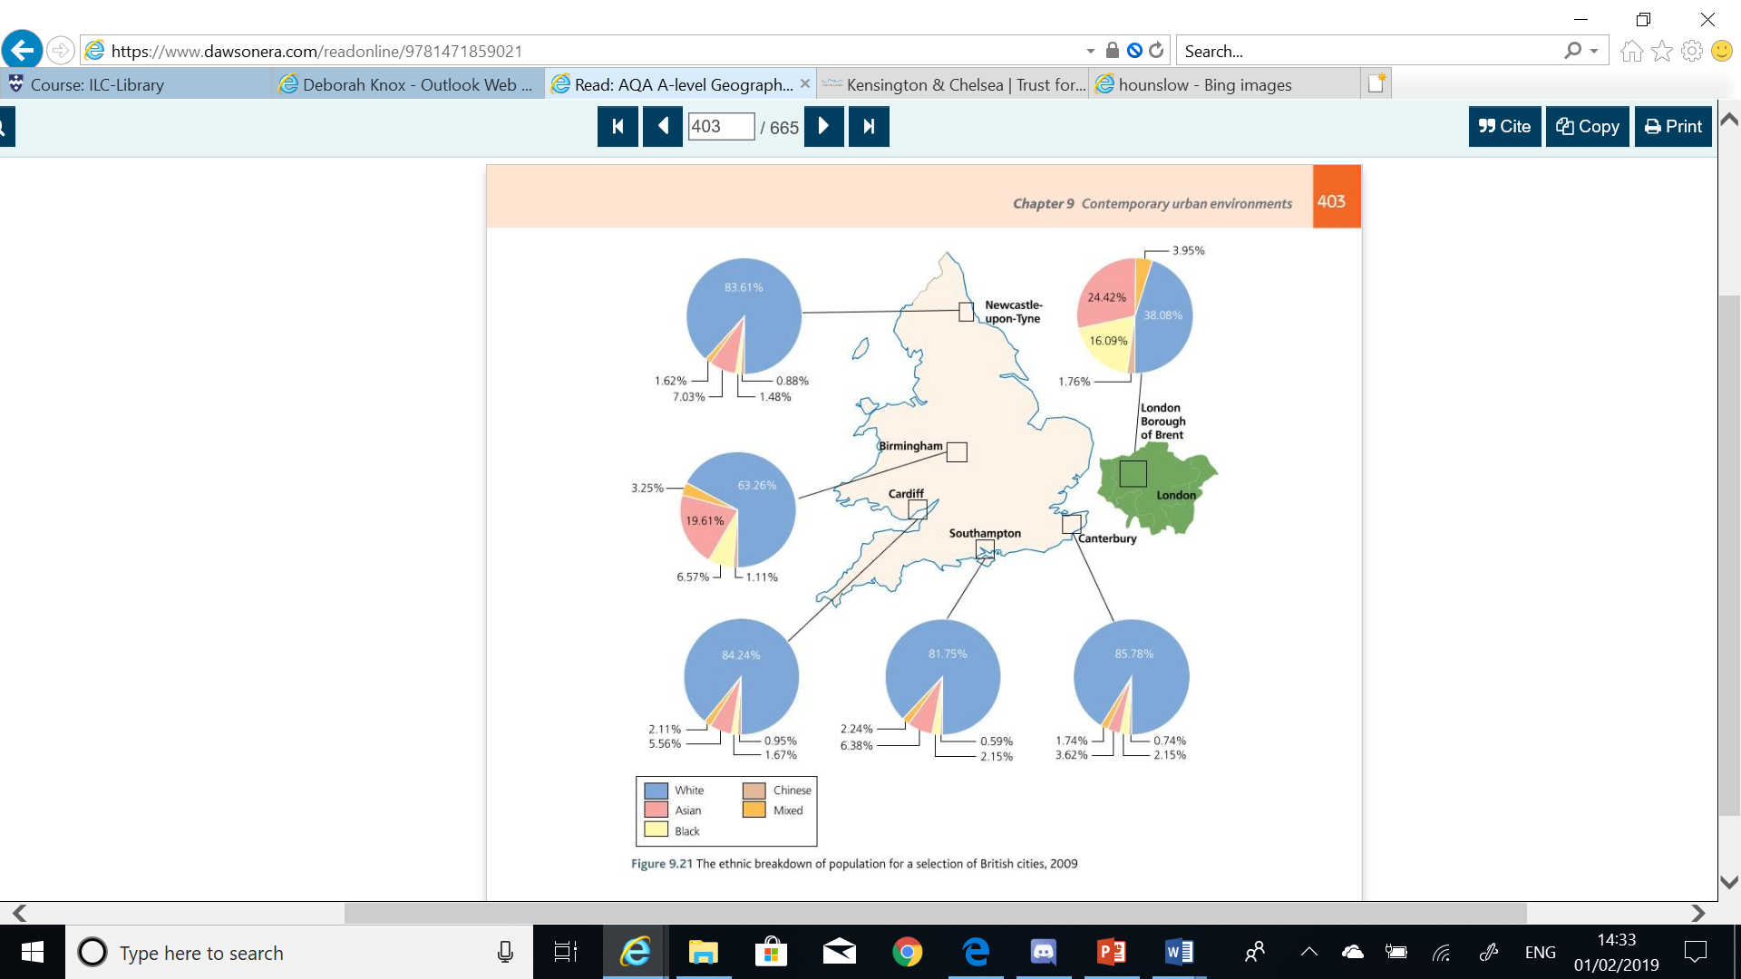**TASK: Which 2 cities have the greatest cultural diversity? Quote evidence to support your answer.**

**Why do you think some cities are more culturally diverse than others?**

**Economic Inequality and Cultural Diversity**

**TASK: Watch the clip on income disparities and answer the questions.**

[**http://www.aljazeera.com/news/2017/08/uk-minorities-lag-white-counterparts-income-170807080047883.**](http://www.aljazeera.com/news/2017/08/uk-minorities-lag-white-counterparts-income-170807080047883.)[**html**](http://www.aljazeera.com/news/2017/08/uk-minorities-lag-white-counterparts-income-170807080047883.html)

How does the median disposable income vary for Bangladeshi, Pakistani and Black African groups compared to White British?

How do these figures change when housing is considered?

What impacts this disparity?

What has happened to the gap recently?

What reason is given for this?

**Cultural Diversity in London**

**TASK: Analyse the distribution of the White British and Pakistani population of London in the maps. (2011 Census)**

**P – Pattern A – Anomaly D – Data L - Links**

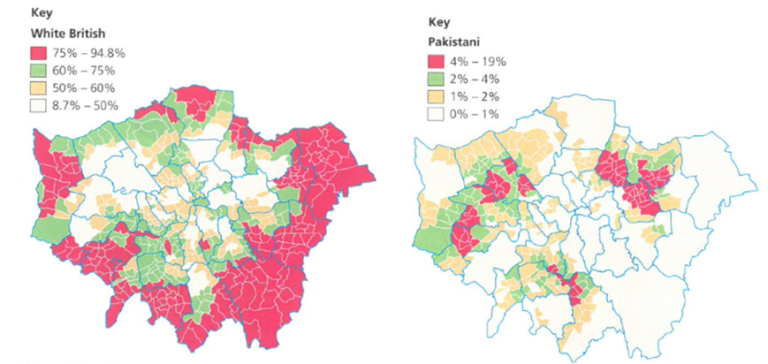

**London Borough of Kensington and Chelsea**

**TASK: Annotate the graphs to show how the 2011 Census data for ethnic classifications in the Royal Borough of Kensington & Chelsea compares to London and England & Wales.**

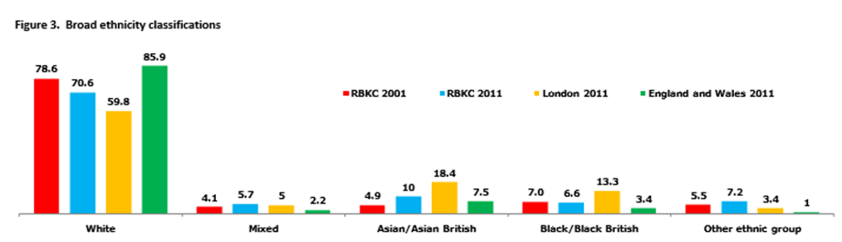

**TASK: Annotate the graphs to show how the 2011 Census data for occupation groups in the Royal Borough of Kensington & Chelsea compares to London and England & Wales. How will this affect income?**

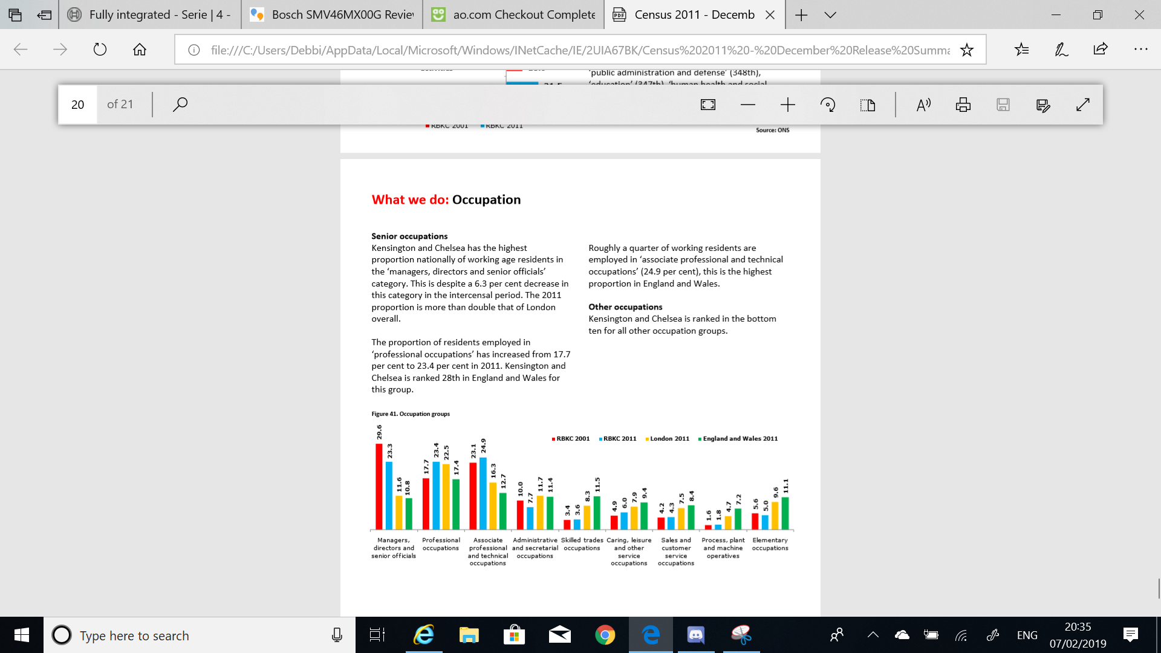

**London Borough of Hounslow**

**TASK: Read and highlight/underline key points about Hounslow’s ethnicity, reasons for ethnic enclaves, employment and income.**

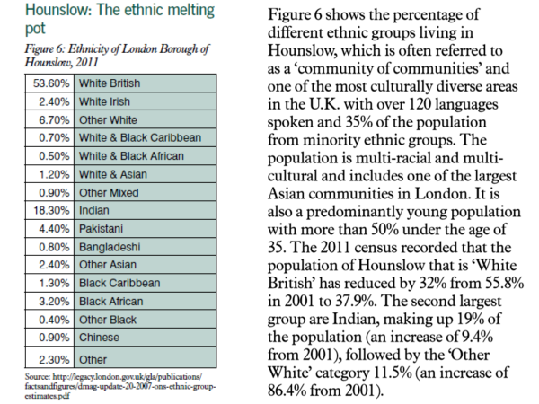

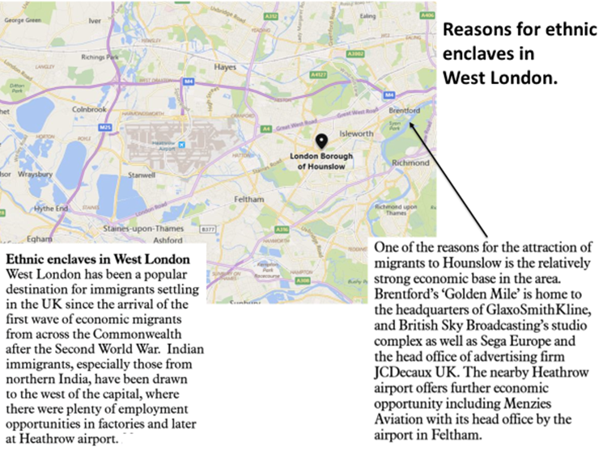

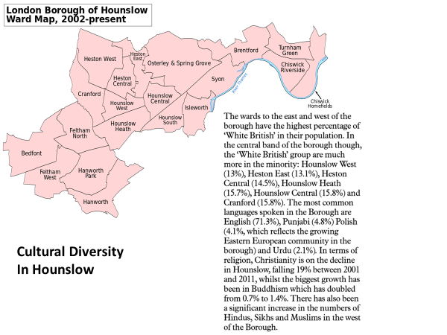

**Employment and Income in Hounslow**

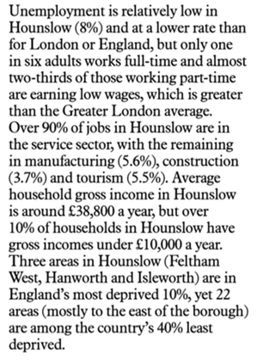

**TASK: Produce an A3 poster or word document answering the following questions to complete the Case Study on London.**

**Resources: Your booklet, PowerPoint slides on GOL.**

* What are some of the social and economic issues associated with urbanisation?
* What is the IMD and how is it measured?
* To what extent is there economic inequality in London? Quote data and include specific places in your answer.
* How is London socially segregated? Where are the more deprived and less deprived areas? Quote data and include specific places in your answer.
* What are the social and economic issues in London?
* How has socio-economic status changed in London? What are the reasons for the changes?
* What is a diaspora? Why is London culturally diverse? What are the positives and negatives of this?
* What is the link between economic inequality and cultural diversity?
* What is the spatial distribution of Pakistanis in London? What might the reasons be for this social segregation?
* Mini case studies of Kensington and Chelsea and Hounslow. Describe and explain the economic inequality and cultural diversity for both places.

Use the slides in the PowerPoint on GOL to answer:

* What are the strategies in London to:
  + reduce poverty and economic inequality?
  + encourage social and cultural integration?

**Extension Task – Fieldwork considerations**

**What are the ethical and socio-political implications of collecting, studying and representing geographical data about human communities?**

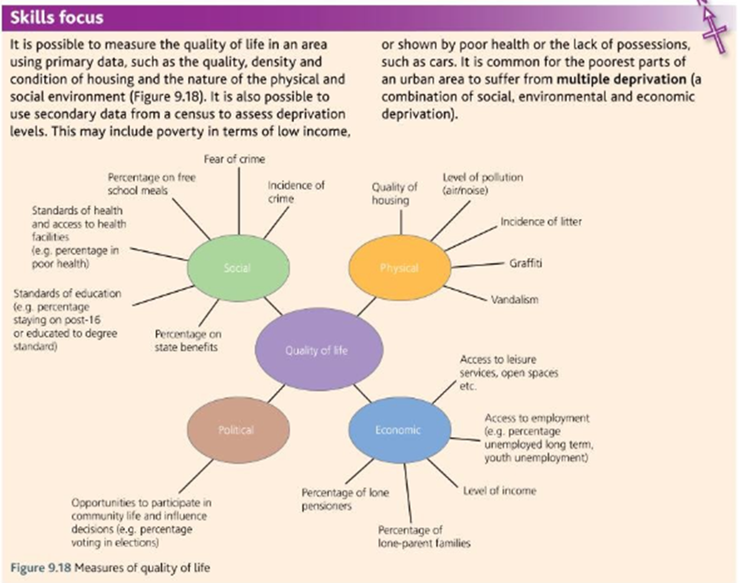

**Pre-work/flipped learning**

Using Hodder p406 – 408 produce a mind map/make notes on the following:

* + Reasons why cities are warmer than rural areas.
  + The eight reasons why the urban heat island a matter of concern.