Name:

Urban Climate

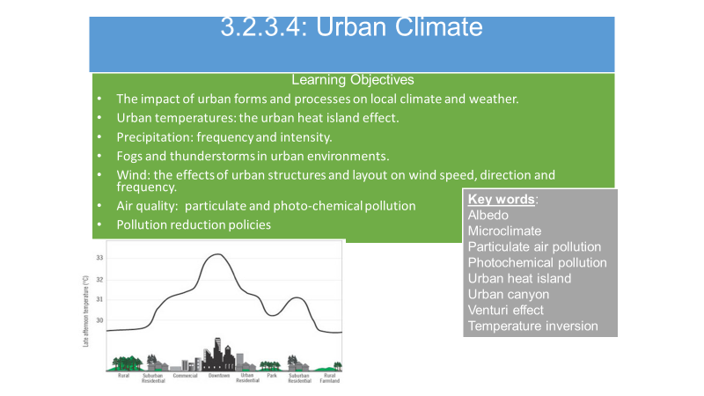

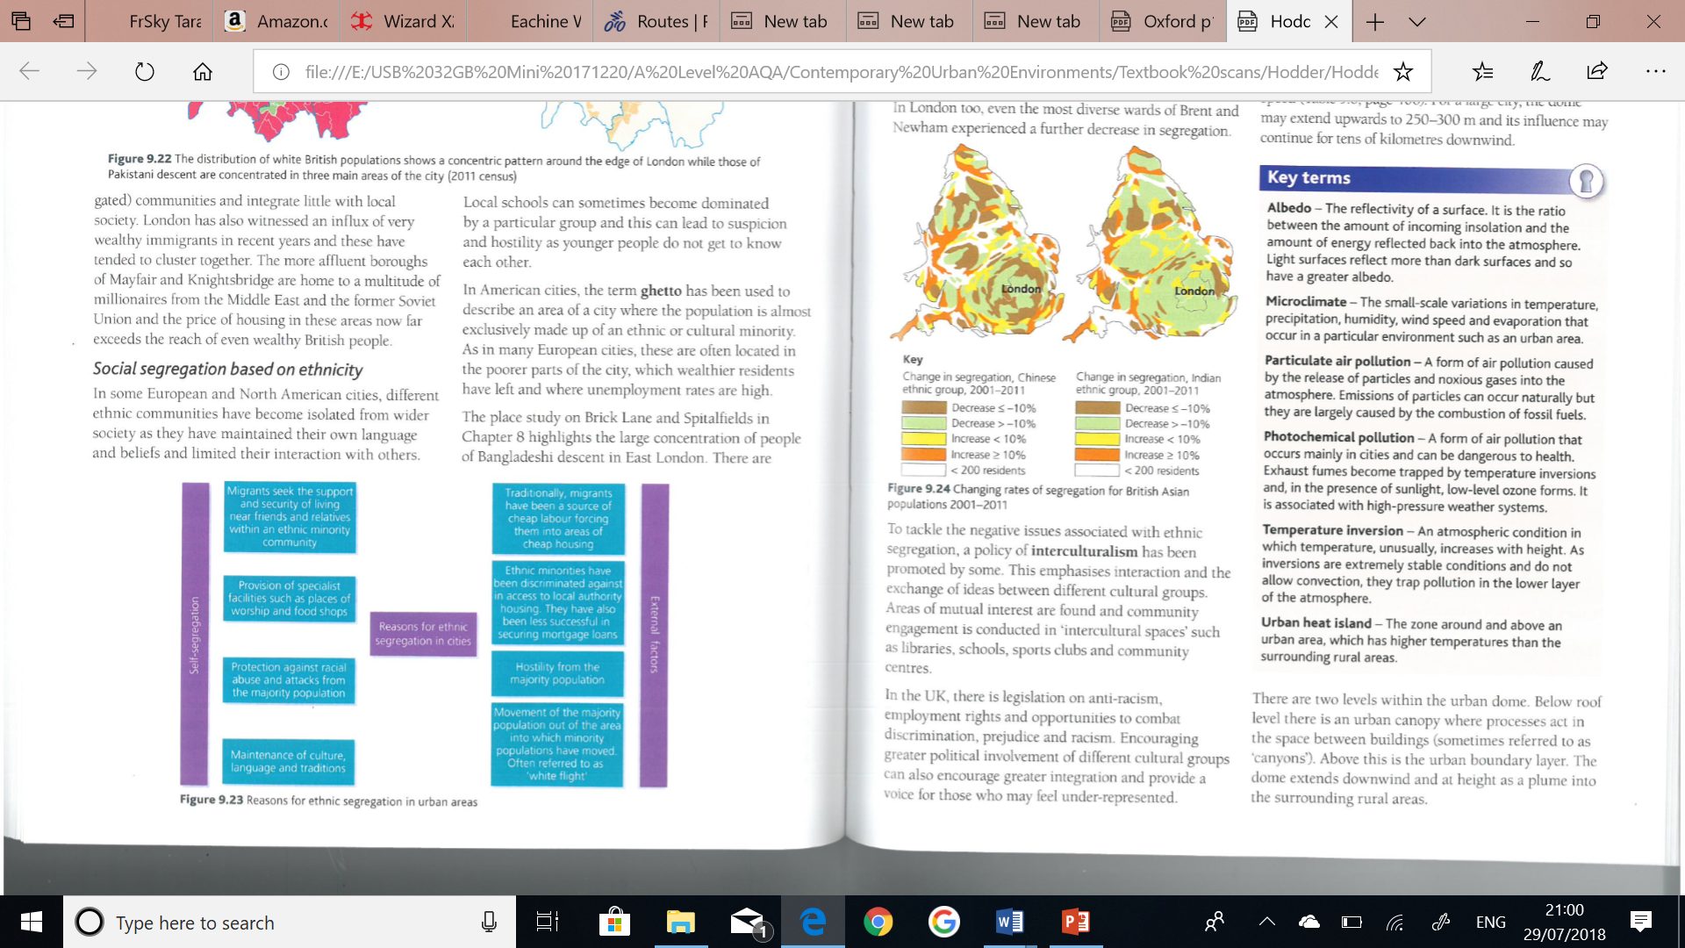

**TASK: Use your pre-work to answer the following:**

How would you expect weather to be different in a city such as London in comparison to the countryside around it?

Why would you expect these differences?

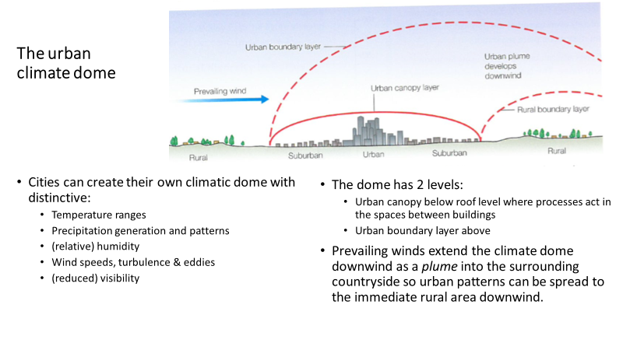

**TASK: Watch the clip make notes on the Urban Heat Island, how to manage it and answer the questions below.**

[**https://www.youtube.com/watch?v=t-sXHl3l-rM&version=3**](https://www.youtube.com/watch?v=t-sXHl3l-rM&version=3)

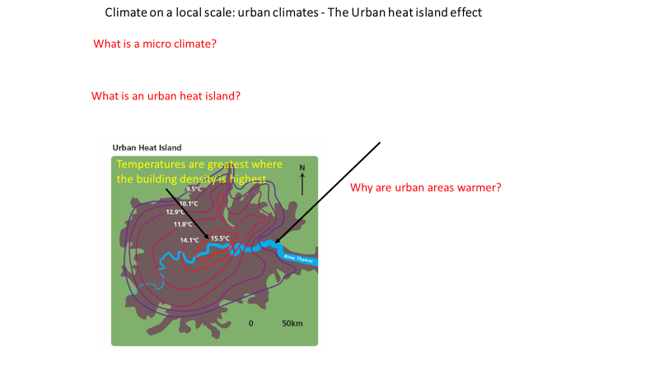

**TASK: In your own words use the PowerPoint slide to summarise how the urban heat island varies *seasonally* and *diurnally* (between day & night). Quote facts and figures.**

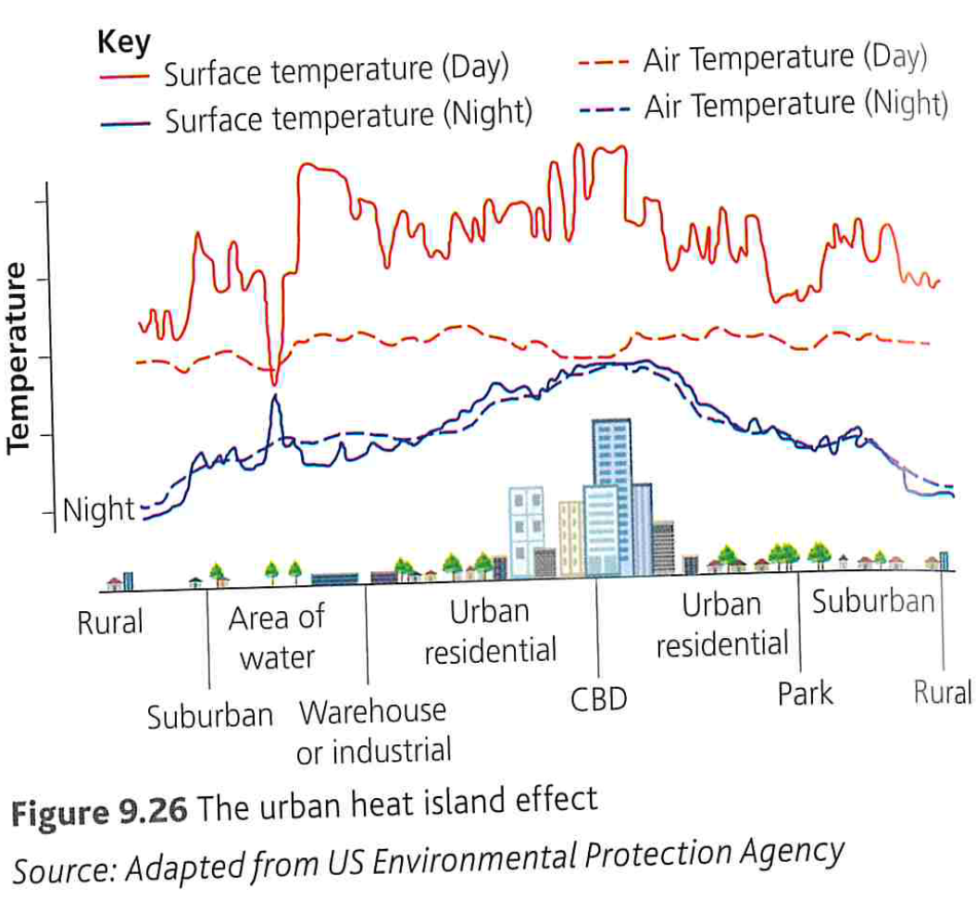

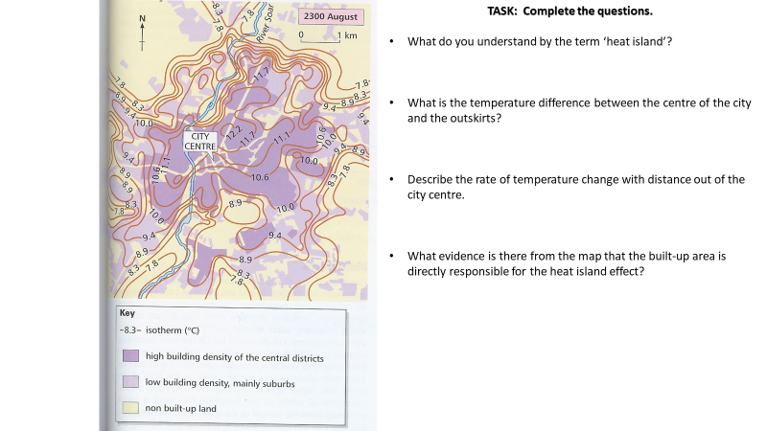

**Albedo**

**Albedo** is a measure of the reflectivity of a surface. The albedo effect when applied to the Earth is a measure of how much of the Sun's energy is reflected back into space.

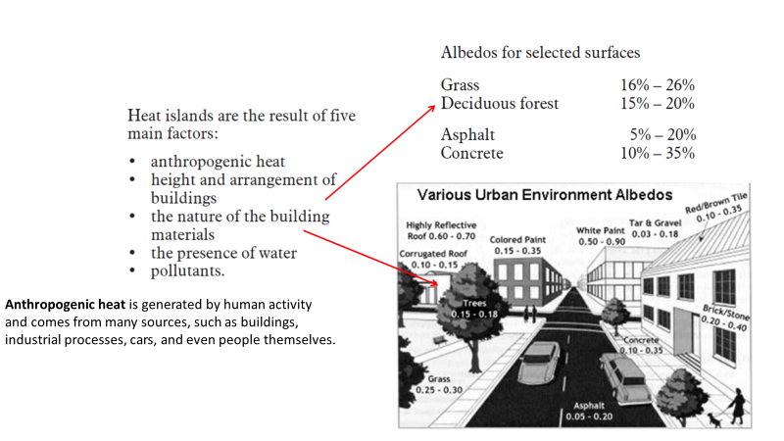

**TASK:** **Complete activities 1a & b p149 Oxford text book. Use Tutor2u case study sheet ‘Urban climate issues and management London’ to help answer the questions 1b.**

**Why is the urban heat island a matter of concern?**

**TASK: Use your pre-work to answer the following questions.**

* As temperatures rise in the summer months what health risks may occur? Which groups of people are most likely to be affected?
* Hot and still, anticyclonic weather conditions causes what to happen to air pollution and why?
* Why does excessive heat put an increased strain on energy?
* Why is there extra strain on the water supply in warmer periods?
* What impact will earlier flowering times of plants and trees in cities and prolonged growing season have for residents?
* How are some animal and insect pests affected by rising temperatures?
* How might historical monuments and buildings be affected by increased temperatures?
* What impact could climate change have on the urban heat island effect?

**Strategies for managing the urban heat island**

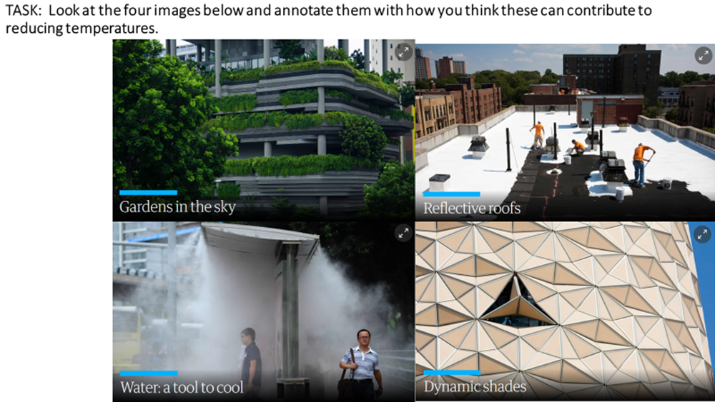

**TASK: Using Hodder text book p408 – 409 complete the table on strategies for managing the urban heat island.**

|  |  |
| --- | --- |
| **Strategy** | **How it manages the urban heat island** |
| **Cool surfaces** |  |
| **Green roofs** |  |
| **Urban greening** |  |
| **Sky view factor** |  |
| **Cool cars** |  |

**Urban Precipitation and Wind**

**TASK: Watch the video clip** [**https://www.youtube.com/watch?v=U_WfkRuY7rk&version=3**](https://www.youtube.com/watch?v=U_WfkRuY7rk&version=3)

* **Use the PowerPoint slide to complete the figure below.**

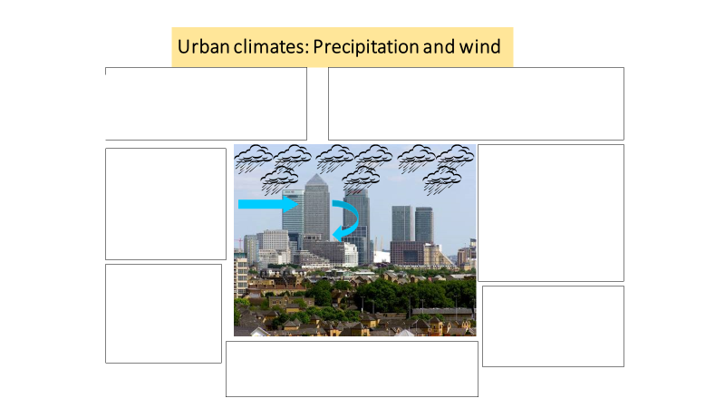

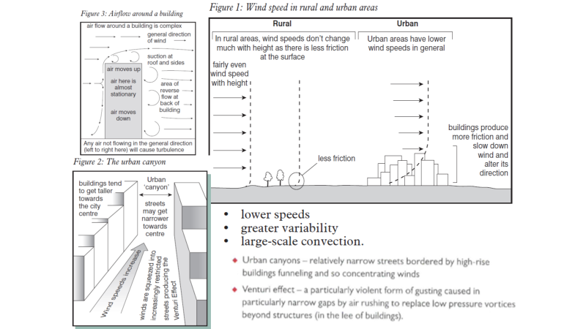

**TASK: Complete the table below to summarise microclimatic contrasts between urban and rural areas quote facts and figures in your answers.**

**Include detail on any impacts on people’s ‘lived experience’ in *urban areas*.**

**Resources: Hodder text book p409 -412 and p148 – 151 Oxford text book**

|  |  |
| --- | --- |
| **Microclimatic contrast** | **Urban compared to rural** |
| **Annual mean temperatures**  **p406 Hodder** |  |
| **Precipitation amount and frequency** |  |
| **Fog** |  |
| **Thunderstorms** |  |
| **Wind** |  |

**Urban Air Quality**

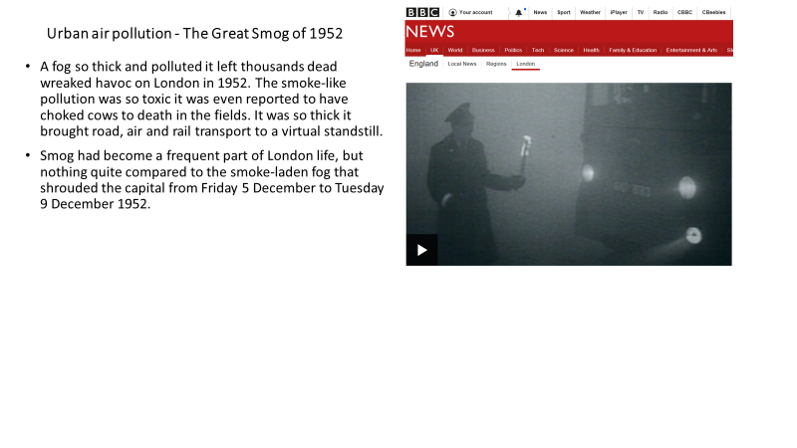

**TASK: Watch the clip on The Great Smog of 1952**

[**https://www.bbc.co.uk/news/av/uk-england-london-20615186/the-great-smog-of-london-remembered-60-years-on**](https://www.bbc.co.uk/news/av/uk-england-london-20615186/the-great-smog-of-london-remembered-60-years-on)

**Impacts of the smog**

* The fog finally cleared on December 9, but it had already taken a heavy toll.
* About 4,000 people were known to have died as a result of the fog, but it could be many more.
* Many people suffered from breathing problems
* Press reports claimed cattle at Smithfield had been asphyxiated by the smog.
* Travel was disrupted for days

**Response to the smog**

* A series of laws were brought in to avoid a repeat of the situation.
* This included the Clean Air Acts of 1956 and 1968.
* These acts banned emissions of black smoke and decreed residents of urban areas and operators of factories must convert to smokeless fuels.

**TASK: Use pages 152-153 Oxford text to answer the questions below.**

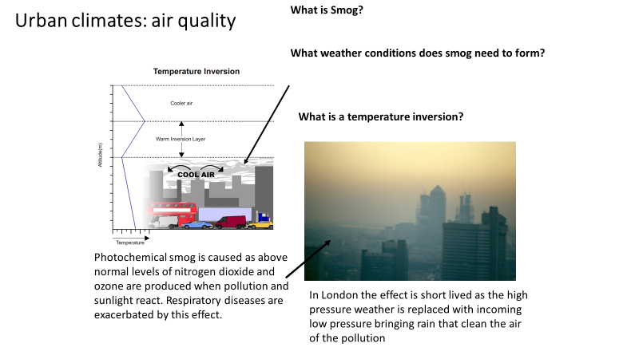

**TASK: Complete the questions below using p153 Oxford text book.**

* What are the main sources and types of urban pollution?
* What is the difference between smog and photochemical smog?

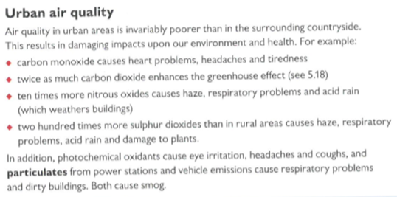**TASK: Read the section titled ‘Urban Air Quality’ and highlight/underline the impacts poor air quality has on the environment and health.**

**Pollution Reduction Policies**

**TASK: Using p414 – 415 Hodder textbook and p153 Oxford textbook add notes to produce a mind map on pollution reduction policies.**

**Air Quality in London**

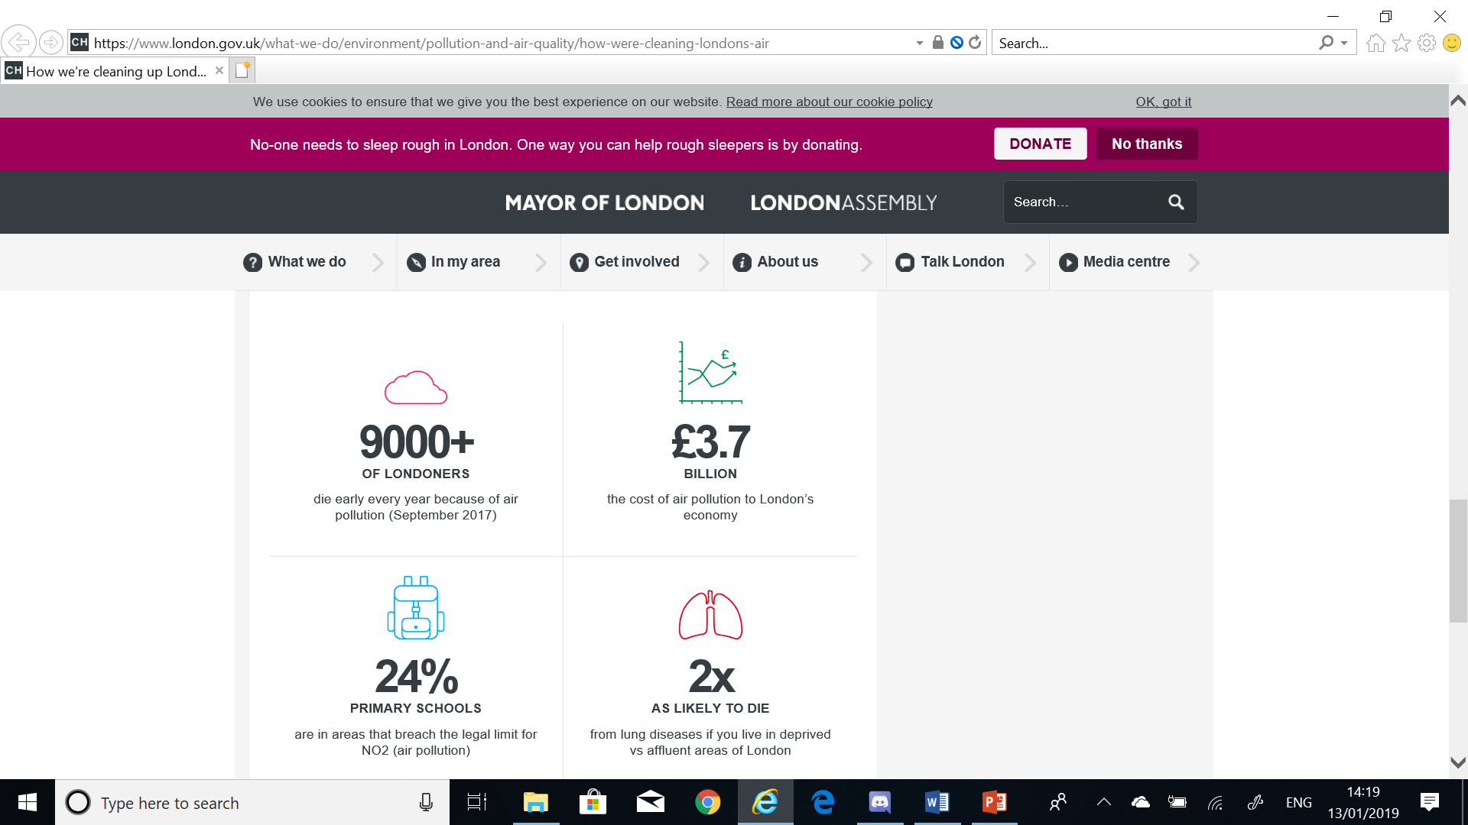

**TASK: Using the ‘London Air Quality Case study’ link below summarise how London is cleaning up its air.**

<https://www.london.gov.uk/what-we-do/environment/pollution-and-air-quality>

**EXTENSION TASK:** New Delhi plans to introduce congestion charging, but New York rejected similar plans for Manhattan. Outline the environmental, economic, social and political arguments for and against managing urban traffic in this way

**Exam Style Questions**

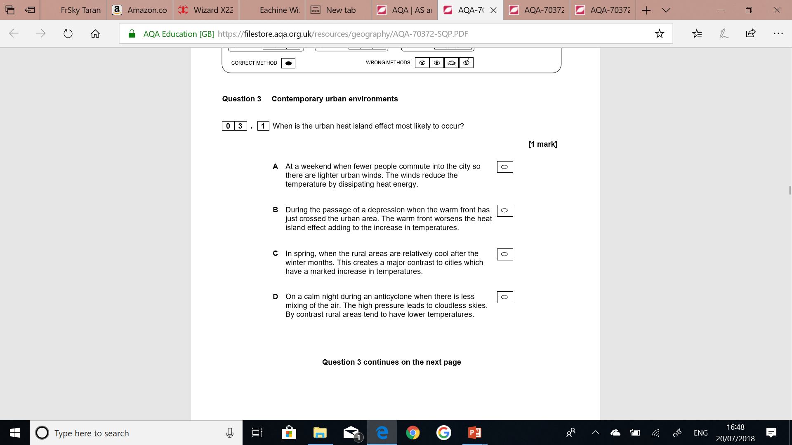

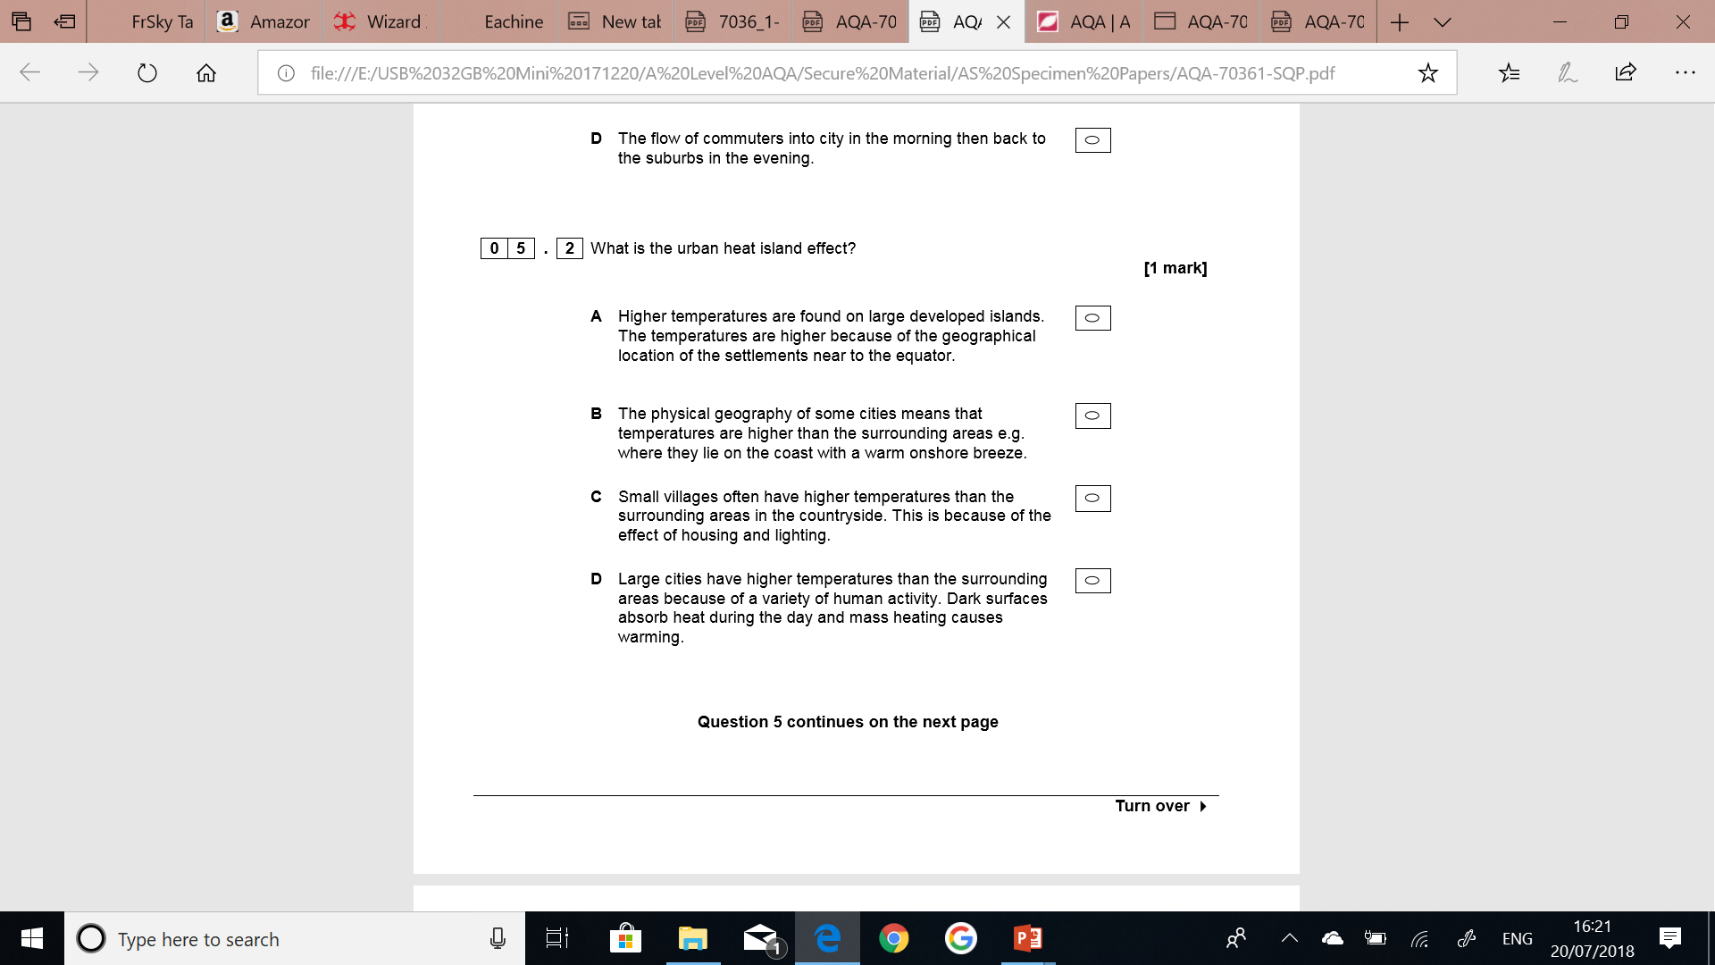

* **Using your own knowledge and** **the figure assess the extent of the urban heat island shown. (6 marks)**

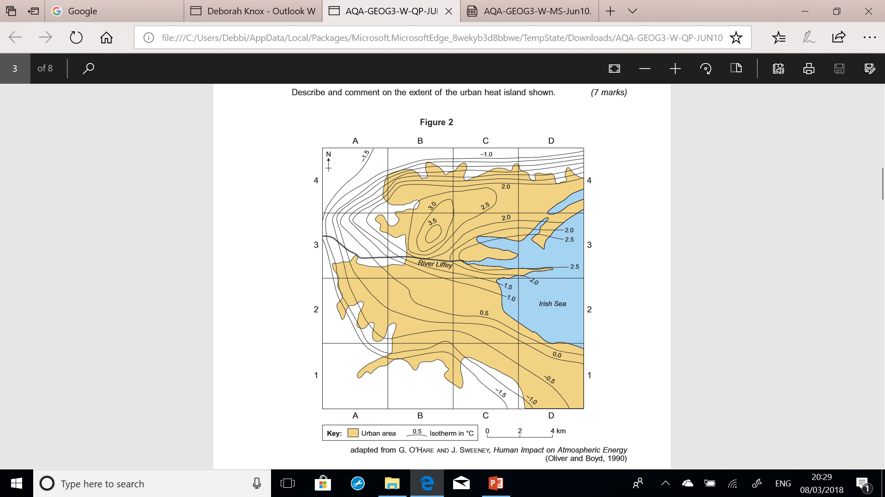

--------------------------------------------------------------------------------------------------------------------------------------------------------------------------------------------------------------------------------------------------------------------------------------------------------------------------------------------------------------------------------------------------------------------------------------------------------------------------------------------------------------------------------------------------------------------------------------------------------------------------------------------------------------------------------------------------------------------------------------------------------------------------------------------------------------------------------------------------------------------------------------------------------------------------------------------------------------------------------------------------------------------------------------------------------------------------------------------------------------------------------------------------------------------------------------------------------------------------------------------------------------------------------------------------------------------------------------------------------------------------------------------------------------------------------------------------------------------------------------------------------------------------------------------------------------------------------------------------------------------------------------------------------------------------------------------------------------------------------------------------------------------------------------------------------------------------------------------------------------------------------------------------------------------------------------------------------------------------------------------------------------------------------------------------------------------

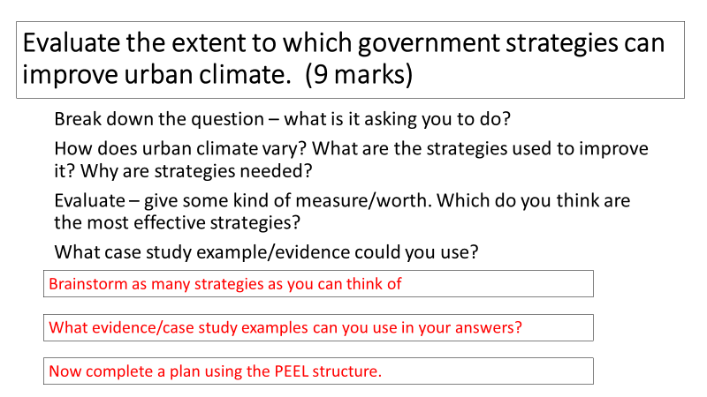

**Pre-work/flipped learning**

Read Hodder textbook p415 on urban drainage and urban hydrology and make notes/a mind map on:

* Urban precipitation
* Water movement through urban catchments