**Name:**

**Other Contemporary Urban Environmental Issues**

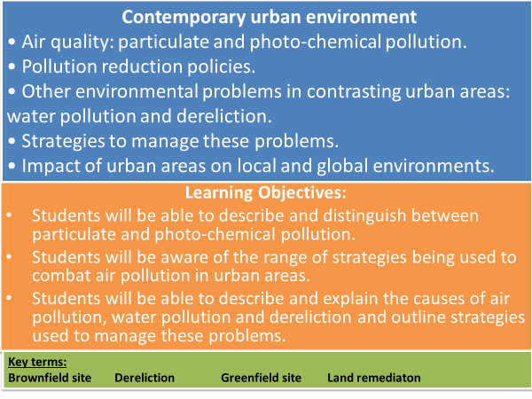

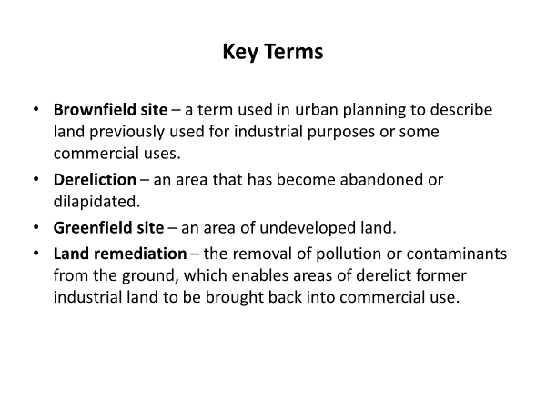

**Other contemporary urban environmental issues**

* Create a list of five environmental problems facing urban areas today. Rank them from the most to the least pressing and justify your decisions.

**Atmospheric Pollution**

**TASK: Use the words below to fill the gaps.**

**low harmful urban health negative pollutants gases prematurely**

* Atmospheric pollution is caused by the release of particles and noxious ___________ into the atmosphere.
* This can have a _____________ effect on human health.
* In 2014 the WHO found that urban air pollution was 2.5 times higher than the recommended levels in about half the __________ populations being monitored.
* This puts urban dwellers at risk of serious long-term __________ problems e.g. heart disease, stroke, respiratory illnesses and cancers.
* An estimated 9,400 Londoners died _______________ from air pollutants in 2010, principally from exposure to nitrogen dioxide and fine PM2.5 particles.
* Human activity produces the _______________ and the weather determines what happens once released into the air.
* During wet or windy conditions pollution concentrations remain _______, either blown or washed away.
* During periods of still, hot weather, pollution is able to build up to ___________ amounts – pollution episodes.

**TASK: Annotate the map to describe and comment on the concentration of particulate matter in urban areas.**

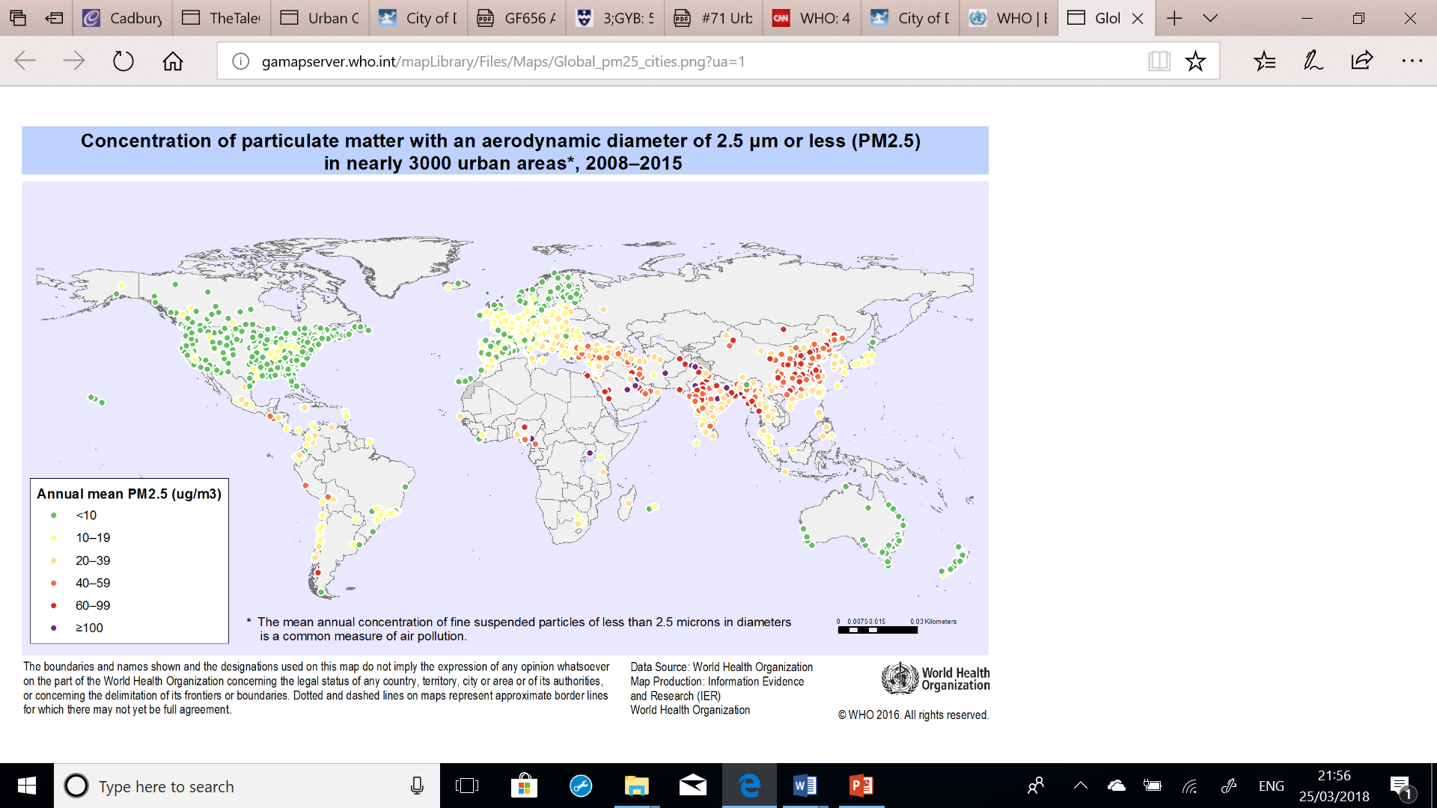

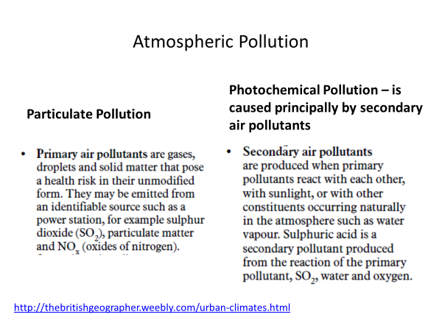

**TASK: Watch the clips on the urban air quality of London and Beijing.**

<https://www.theguardian.com/environment/2014/apr/03/smog-alert-very-high-air-pollution-levels-spread-across-england-live-updates>

<https://www.theguardian.com/environment/2014/oct/10/china-pollution-levels-hit-20-times-safe-levels>

**TASK: Open the link to see the Current urban air quality for London.**

<http://www.londonair.org.uk/london/asp/nowcast.asp>

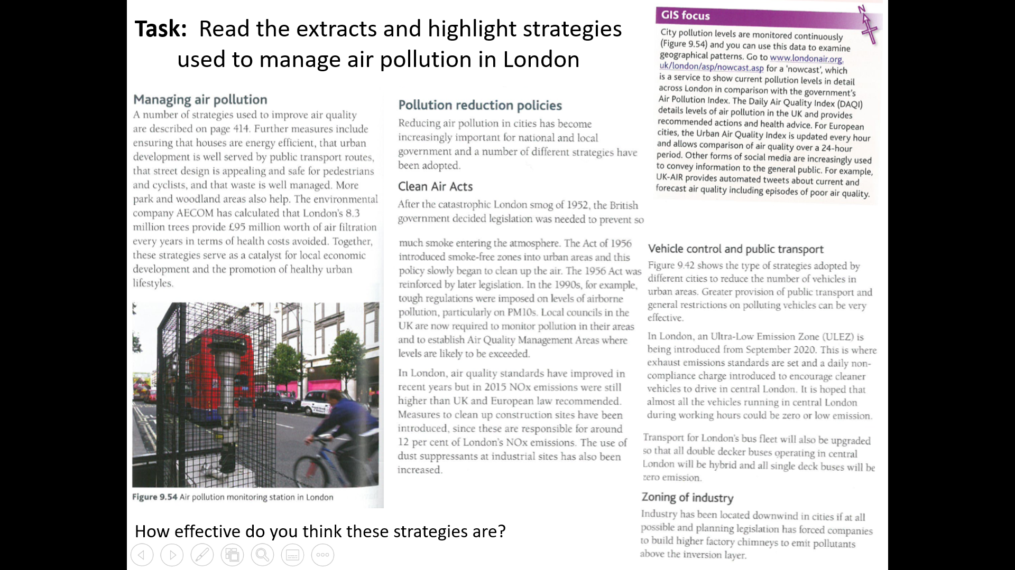

* There is greater concern about air pollution in low and middle income countries which lack the finances and legislation to adequately tackle the problem.
* Over 90% of air pollution in these countries is attributed to vehicle emission due to the high number of older vehicles, poor vehicle maintenance and low fuel quality.
* Recent schemes such as the UN partnership for Clean Fuels and Vehicles aim to improve air quality – improve road quality and commitments have been made to promote non-motorised journeys.

**Case Study: Beijing, China**



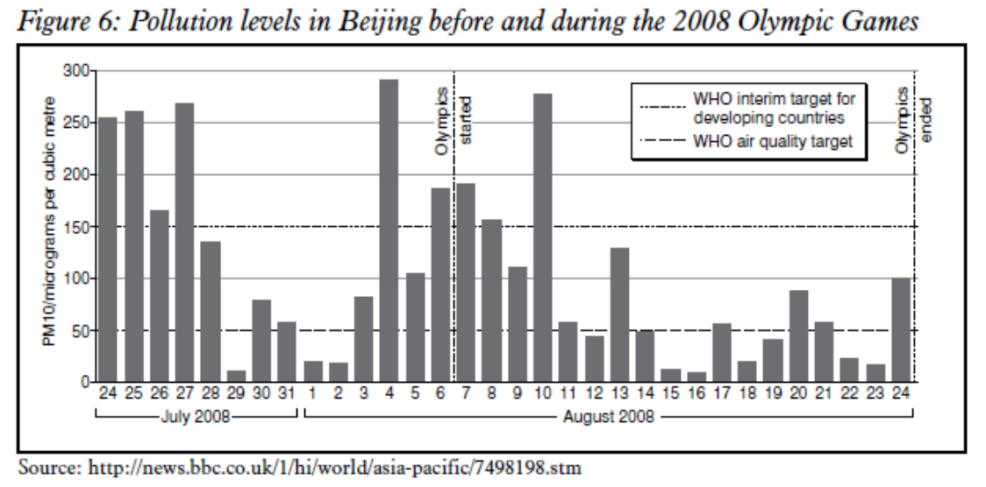

**Complete the following task on separate pieces of paper.**

**TASK: Use Read the tutor2u ‘Environmental Issues - Beijing’ article (GOL) and for *each* of the four urban problems; poor air quality, waste, acid rain and water pollution, summarise:**

* **Causes of the issue.**
* **Strategies to improve the issues.**
* **Identify any further concerns the solutions may result in**

**Water Pollution**

Water Pollution is the contamination of water sources including rivers, lakes, oceans aquifers and goundwater.

**TASK: On separate pieces of paper. Using pages 427-429 in the Hodder textbook produce a mind map identifying causes, consequences and strategies to manage water pollution.**

**TASK: Watch the first 4 minutes of the clip on The Thames Tideway Tunnel and answer the following:** [**https://www.youtube.com/watch?v=hVZGsfAfEPg**](https://www.youtube.com/watch?v=hVZGsfAfEPg)

* What is the Thames Tideway project and what is it designed to do?
* How many people was the Victorian sewage system designed for and how many people live in London now?
* How does a ‘combined’ sewage system work?
* How much sewage goes into the River Thames in a typical year?
* What are the impacts of the sewage entering the River Thames?
* Summarise the 3 stages to upgrade the system.
* How much is the Thames Tideway Tunnel costing?
* Where does the Thames Tideway Tunnel start and go to?

**TASK: Read the extracts on ‘Water problems in India’ and ‘The Thames Tideway Tunnel’. Produce a key and highlight/underline water pollution issues and management strategies.**

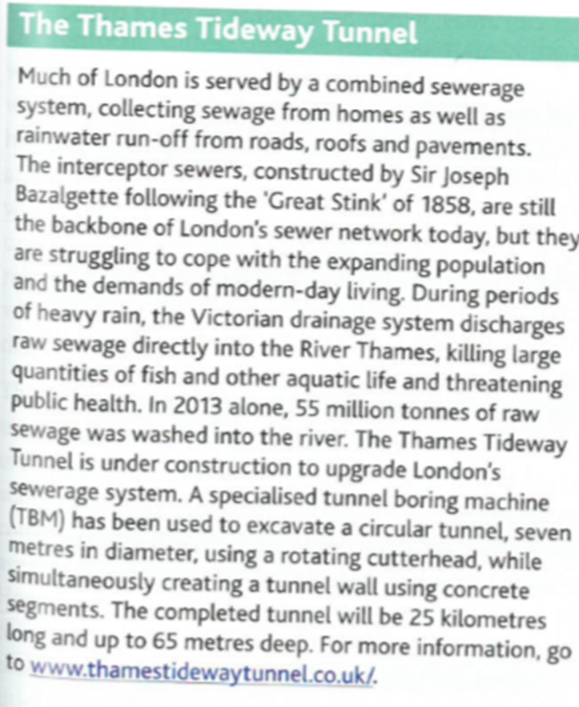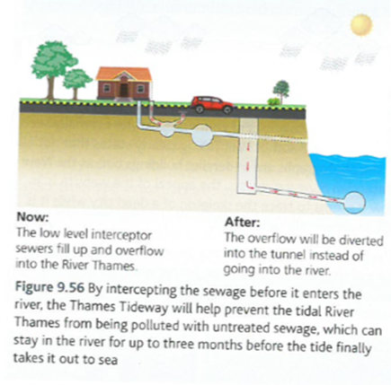

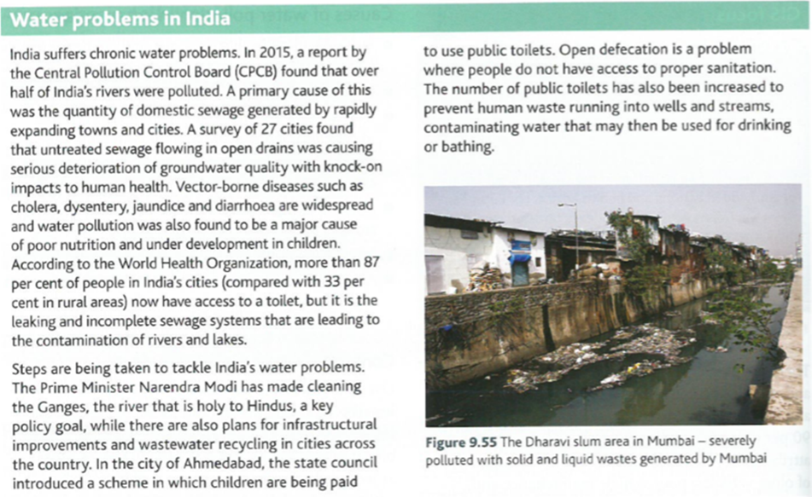

* **Briefly evaluate these management strategies.**

**Dereliction**

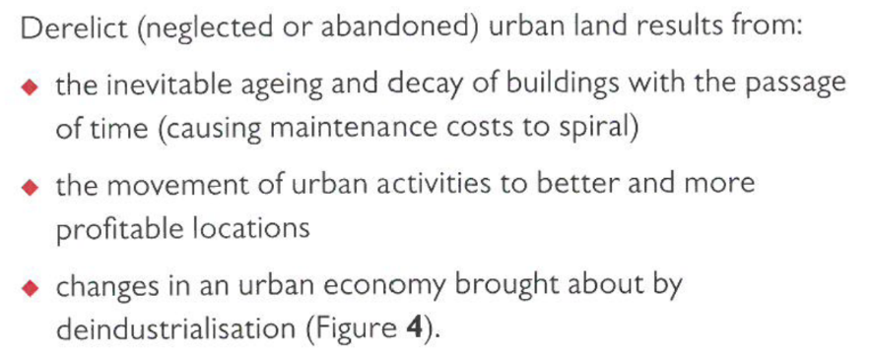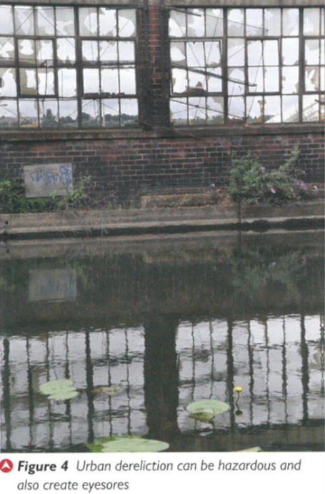

**TASK: Read p429-430 Hodder textbook and answer the following questions.**

* How does dereliction have a negative impact on the surrounding area?
* How does derelict land pose a risk to human health?
* What strategies are implemented to deal with derelict urban sites?
* What are the advantages and disadvantages of using brownfield sites in urban areas?
* What is land remediation and summarise its use for the 2012 Olympic Games?

**Strategies to manage dereliction in Detroit, USA**

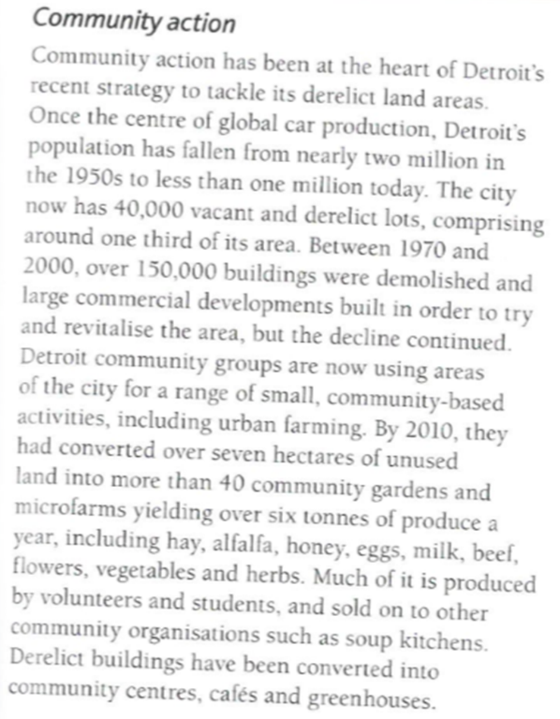

**The Guardian: ‘Detroit gets growing’**

Detroit was once the engine of America's automotive industry. Today it is a symbol of urban decay. But a daring bid to return the land to farming is sowing seeds of recovery – and could be a template for cities across the world.

**TASK: Watch the clip, Read the extract, Guardian article (GOL) and review your Detroit case study from Changing Places to identify how community action is helping tackle derelict land.**

**What else is Detroit doing to regenerate? Review your Changing places notes and see Detroit website – link below.** [**https://www.theguardian.com/environment/2010/jul/11/detroit-urban-renewal-city-farms-paul-harris**](https://www.theguardian.com/environment/2010/jul/11/detroit-urban-renewal-city-farms-paul-harris)

[**http://www.detroitmi.gov/**](http://www.detroitmi.gov/)

**Extension Task : Weigh up the pros and cons of different strategies to manage problems of dereliction and pollution.**

**Exam Style Questions**

* Evaluate the extent to which government strategies can improve the urban environment. (9 marks)
* ‘There are more challenges than opportunities associated with improving the environment in urban areas.’ To what extent do you agree with this view? (20 marks)

**Pre-work/flipped learning**

* Read Hodder p431 and make notes/mind map on Sustainable urban developments & dimensions of sustainability.
* Use the link to work out your households ecological footprint and print out the results. <http://www.myfootprint.org>[/](http://www.myfootprint.org/)