# **Godalming Fieldwork Follow-Up Task**

# Choose one of the following investigation titles:

What is a hypothesis? An idea or explanation that you can then test through study and experimentation e.g. people in Godalming think it is like any other town in the UK.

# To what extent is Godalming a ‘Placeless Town’?

# How globally connected is Godalming town centre?

# How does the microclmate of Godalming change?

# **Complete an introduction and method for your chosen title. You will need to come up with some sub-questions/hypotheses that you want to ask/test. You will also need to complete a bibliography listing the books/websites/articles you have used in your introduction and reference in the text where you have used direct quotes.**

|  |
| --- |
| **Area 1. Introduction and preliminary research - 10 marks (Approx 600 words)** |
| A research question(s) is effectively identified and is completely referenced to the specification with a suitable comment as to how it is relevant. |
| You have broken your key question down into specific key questions or hypothesis |
| Your introduction is well-supported by thorough use of relevant literature sources and fully referenced within the text and a bibliography. |
| You have included clear maps to show where your study area is located. Maps should be labelled/annotated or referred to in your text. |
| Your maps each have a source, title, scale and north arrow. |
| You have linked your question to geographical theory (i.e. the type of information you would find in a text book and online sources). This may be a model, concept, idea or geographical theory. |
| You have referenced any data/information you have gained from secondary sources. |

Link to the specification:-

<https://filestore.aqa.org.uk/resources/geography/specifications/AQA-7037-SP-2016.PDF>

Or simply type in Geography AQA A level specification

Example on powerpoint slide.

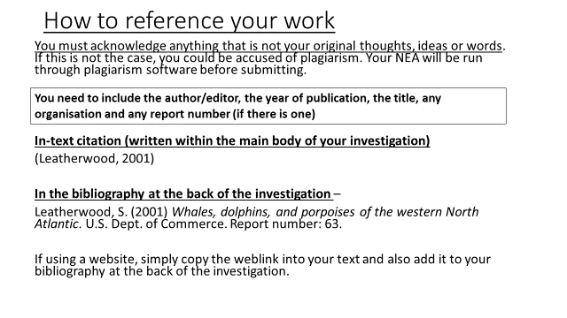

How to use the referencing tool in Word

1. Open a Word document
2. Type something that you have copied from a book/article/website
3. Click on the reference tab and insert citation and then click on new source.
4. Complete as many of the fields as you can (some may not be relevant) and click OK.

When you have completed all the citations you can click on the bibliography tab and it will automatically create a bibliography at the end of your document.

|  |
| --- |
| **Area 2. Methods of field investigation - 15 marks**  **(Approx 500 words)** |
| You have included methods of primary data collection. |
| You have included sources of secondary data collection. |
| Every type of data collection links very closely to your coursework question. If it doesn’t, change the method! |
| You have explained in detail exactly how you will collect each type of data. |
| You have said whether each type of data collection is stratified, systematic, random or pragmatic and why you selected this method. |
| You have said how much data you will collect (frequency and repetition), when you will collect it and referred to any collection methods requiring timing. |
| You have been specific on the timing of your data collection (time of day, date, season etc.) |
| You have justified your choice of study sites, making clear reference to your question. |
| You have a detailed paragraph referring to the ethics of collecting accurate and fair data. |
| You have identified problems, limitations and improvements for your data collections methods. |
| You have made a clear point to explain why you think your data is as accurate as it can be (evaluation will come in later). |
| You have mapped and labelled individual data collection sites |

Some students like to use a table to help them structure their method section, others prefer to write it in paragraphs.

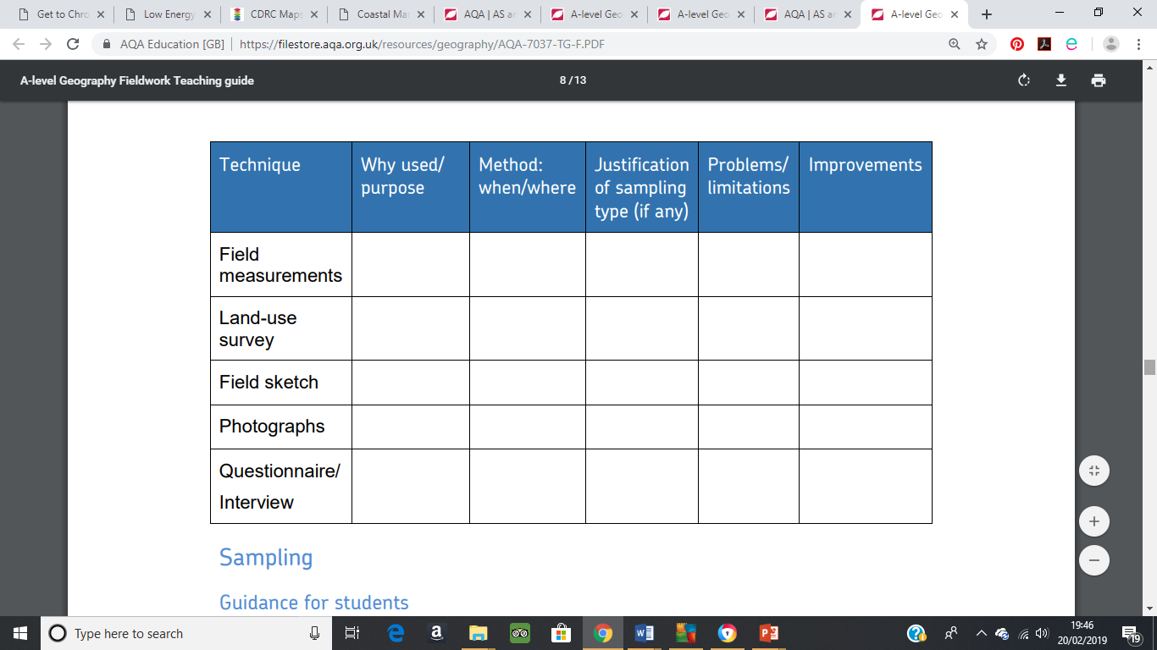

**To be completed for your first lesson back after Christmas.**

