**Physical Education A Level Information for Students and Parents**

**Resources**

Godalming Online gives you access to the most up to date text books currently available for AQA A Level PE, AQA A-Level PE Book 1 and Book 2, both by Carl Atherton et al. If possible, it could be beneficial to purchase your own hard copy so you can annotate them (scribble) in them. This has been proved in studies to help retain information in long term memory more effectively than looking at neat text. However, the online versions give you access to the same information and they are free (to you).

There are some websites with additional information, <http://www.mypeexam.org> is produced by an ex Head of PE of a large sixth form college similar to Godalming and closely mirrors the specification. Subject specific websites on Psychology and Biology can also be useful.

**Homework**

Specific, time bonded

General & ongoing

Homework will take different forms throughout the course. Godalming suggests that 50% of a students work will occur outside of the classroom. In Physical Education, this could be answering exam style questions that, depending on their nature, will be assessed in class or collected in and assessed by the teacher. It could be preparing for “pub quiz” style testing in the next lesson or preparation work on a new topic yet to be covered. We will also ask students to create their own text book as they progress through the course. This will be a vital resource for revising the early topics towards the end of the course. Other homework tasks could involve creating revision resources for completed topics such as mind maps, flash cards and other revision summaries.

If a student says “I have nothing to do in PE” they are being economical with the truth!

**Assessment during the year**

Each half term, you will have a benchmark assessment from both Danny and Kevin. These will be made up of short answer and extended answer questions to mirror the final papers. You should treat each one of these benchmarks as a final examination and prepare accordingly because they:

In June of the first year, the final benchmark will be a vital aspect of measuring performance and helping us assess how you might respond to high stakes exams at the end of two years. Performance on these exams, your benchmarks throughout the year, practical performance and coursework drafts will all play a part in helping us create an accurate predicted grade. This grade will be used for UCAS applications in the following September and it is unlikely that there will be any further opportunities to provide evidence to improve this grade. Your predicted grade is at least as important as your achieved grade as, for those you considering university, they make offers based on predictions, not achieved grades. (Unless you take a gap year and apply with grades later)

**External Examinations & Assessments**

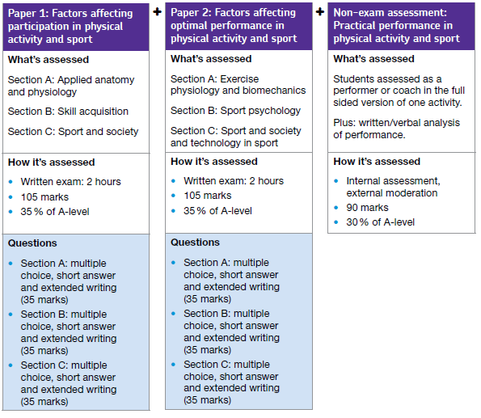



See section on what parents can do to help



**Reporting on Performance**

The Physical Education Department, like the rest of college, will always communicate with the student first when discussing issues regarding performance and behaviour. Twice during each academic year, we provide a review for both student and parent where we will reflect on relevant benchmark scores, general performance to date and set some targets for future development. There will also be a parents evening in each year to allow for face to face meetings and a targeted parents evening if there are specific areas of concern that we feel a meeting between staff and parents could address.

|  |  |  |
| --- | --- | --- |
|  | Lower 6th Year | Upper 6th Year |
| Parents Evening | November | October |
| 1st Student Review | January | November |
| 2nd Student Review | June | March |
| Targeted Parents Evening | March | |

If performance drops between the reporting periods or the staff feel that student behaviour is falling short of the Student Contract, a student will be placed on an action plan and parents will be informed of the specific action required by the student. Fail to complete the action plan will lead to the involvement of the Senior Tutor and possible disciplinary warnings.

**What can parents do to help?**

Although we usually communicate with the student first and believe that students are responsible for their own performance, there are times of the year when parental involvement is either required or desirable. During the first year, help is often required in helping the student collect evidence for their practical performances. Many students are assessed through our own sports teams but, where this is not possible, e.g. equestrian events, help is required to film students in the fully competitive context of their sport. Continuous filming of a number of performances will be required, especially if they believe the standard they can perform at is higher outside of the college provision e.g. county / international matches vs college matches. Cameras and tripods are available from the department and further information will be provided.

Other important assessment points will be October half term of the second year when the final version of the first part of the coursework is due and again at February half term when the second part is handed in. Students will receive feedback on their first draft during September and will then be expected to produce the final pieces without further written feedback. Support and help will be provided in class but a gentle nudge from parents to make sure deadlines are met and a reminder that no further opportunities to improve will be available would be very useful.

Otherwise, we believe a general interest in what they are doing in college and asking them how their PE text book is coming along should be all that is required. This will usually be met with a teenage grunt or two (if they haven’t done it) or a showing off moment that all can enjoy.