3.1.2.5.2 Efficiency of information processing

Reaction Time

Task 1 Simple Reaction Time Test – The Ruler Drop test

1, Complete the ruler drop test as described in the lesson.
2, Repeat test 10 times and record distances in table below.
3, Work out the mean distance from your ten trials.

Trial Number | Distance (cm)
1
2
3
4
5
6
7
8
9
10
Mean

4, Using the mean distance and some standard algebra, we can approximate our simple reaction time.
$$d=\text{ut}+\frac{1}{2}{\text{at}}^{2}$$

d = distance ruler travelled (cm)
u = initial velocity of ruler (cms⁻¹)
a = acceleration due to gravity (981cm⁻²)
t = response time

Because the intial velocity of the ruler is 0cms⁻¹ we can simply the equation to

$$d=\frac{1}{2}{\text{at}}^{2}$$

To work out the value of t, we rearrange the equation to:

$$t=\sqrt{\frac{2d}{a}}$$

We can now work out you simple reaction time:
SRT = seconds

Task 2 Choice Reaction Time – Card Shuffling Test

1, Holding a pack of shuffled cards face down, turn the cards over and separate into red and black (2 groups). Your partner times how long it takes and records in table below.
2, As before, but separate into suits. (4 groups)
3, As before but separate into suits of picture cards and suits of number cards (8 groups)
4, Plot the number of choices against your response time on the graph below.

2 groups
4 groups
8 groups

The results should back up Hick’s Law. Hick’s Law states that as the number of choices increases, response time also increases ie. we get slower as a performer.
Can you think of why this is useful to know in sport?
Definitions

Simple Reaction Time

Choice Reaction Time

Reaction Time

+
Movement Time

=
Response Time

Hick’s Law
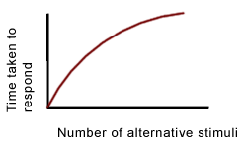

Psychological Refractory Period (PRP)
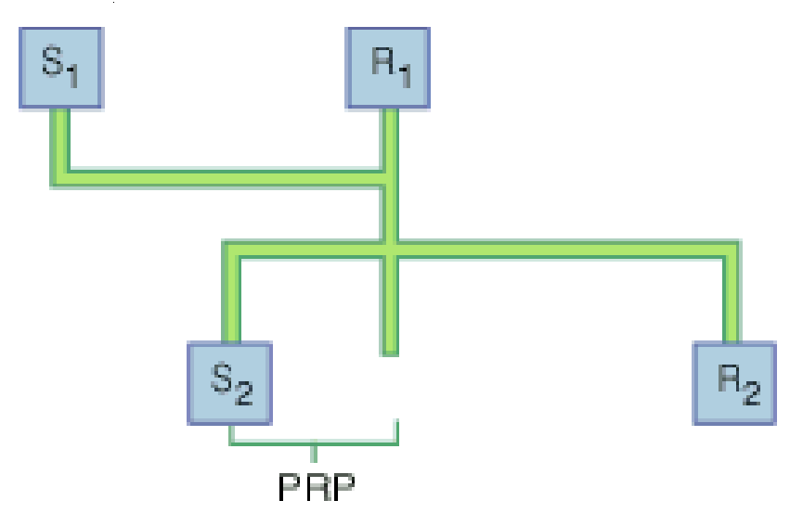

Anticipation (Spatial & Temporal)

Factors affecting Response Time

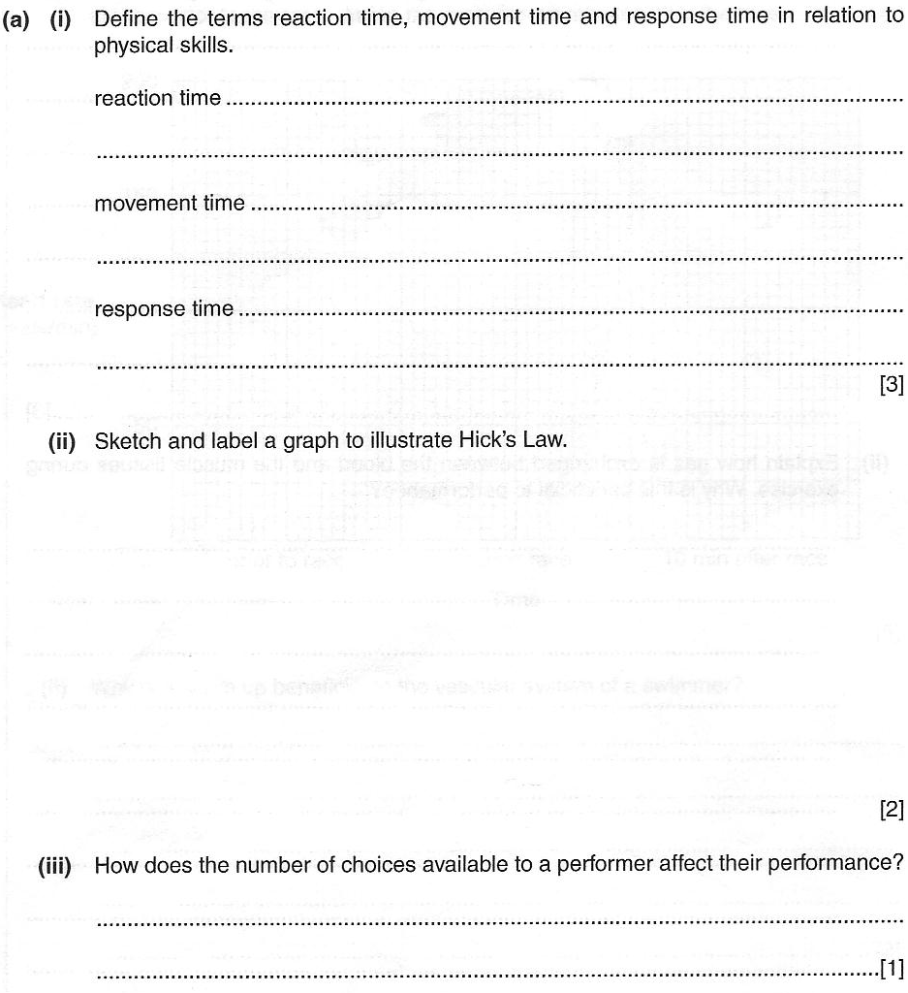
May 2002

