Information Processing

Task One

Consider hitting a shuttlecock in badminton. Complete the four boxes below by listing everything you do when hitting a shuttle.

Input

Output

Decision Making

Feedback

Lots going on in this box – split it into different processes?

Task Two

Using the headings above and some flow lines, complete the following diagram:

Our simple diagrams explain everything we need to know about information processing but we must now look at some other people’s interpretation of the same situation.

You need to know and understand Whiting’s model of information processing.

Task 3 Using the models provided, place practical examples next to each part of the information processing model.
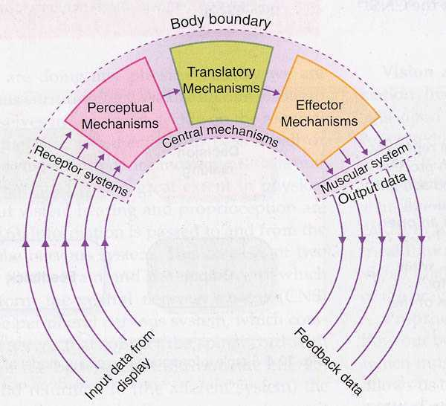
Whiting’s Model

Task 4 We should now be able to define the following terms:

Display
Stimuli
Sensory Organs and Receptor System
Perceptual Mechanism
Selective Attention
Proprioception
Translatory Mechanism
Effector Mechanism
Muscular System
Response
Intrinsic Feedback
Extrinsic Feedback
Senses

Perception and the DCR Process

May 2009

