**Working Memory Model**

For many years, PE students had to learn about the Multistore Model of Memory. You can see many of the processes overlap with what we have seen on Whiting’s Model of Information Processing.



In the last thirty years however, this model has failed to explain how we can maybe do two tasks at the same time if they are different in their nature and was considered too simplistic in that the one “box” of STM couldn’t possibly receive selectively attended information from the sensory memory and encode it to long term memory whilst at the same time retrieving different information / motor programmes from long term memory.

A number of psychologists split in up into different active processes, rather than just another store. Baddeley was probably the most famous and his Working Memory Model is an adaptation of the multistore model seen above.

[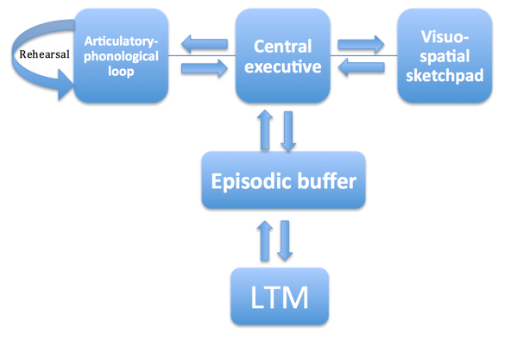](https://www.google.co.uk/url?sa=i&rct=j&q=&esrc=s&source=images&cd=&cad=rja&uact=8&ved=2ahUKEwiH45qxh4ngAhXL8uAKHVSaBuYQjRx6BAgBEAU&url=https://www.tutor2u.net/psychology/reference/working-memory-model&psig=AOvVaw2FKCfQew1sIUVdB5GsnEGV&ust=1548509951081323)

|  |  |
| --- | --- |
| **Central Executive** | 1. The most important component of the model 2. It controls attention, makes decisions and allocates resources/tasks to other components/slave-systems 3. It has a **limited storage capacity** so can only attend to a limited number of things at one time. |
| **Visuo-spatial sketchpad** | 1. Stores visual and spatial information, such as position of other players. 2. Is responsible for setting up and manipulating mental images 3. Has a **limited capacity** – maybe **3 - 4 objects.** 4. Later this was subdivided into: 5. The ***visual cache*** which stores visual data 6. The ***inner scribe*** which records the visual arrangement of objects in the visual field |
| **Phonological loop** | 1. Deals with auditory**.** 2. It has two components: 3. The***phonological store*** (inner ear) which stores the words you hear 4. The ***articulatory process*** (inner voice) allows maintenance rehearsal (repeating sounds in a loop to keep them in working memory while they are needed).   The **capacity** of this loop is argued to be approx. **2 seconds** **worth of what you can say** |
| **Episodic Buffer** | 1. Temporary store for information, combining visual, spatial & verbal information. 2. It is the storage component of the central executive and has a **limited capacity of approx. 4 chunks.** 3. The episodic buffer links WM to LTM |

This model explains how we can run with a ball and “fix” a rugby defender whilst listening to a call from our team mate shouting “short right” to receive a pass. This is because the player is using both the sketchpad and the phonological loop. It also explains why we might struggle to dribble a basketball and look for someone to pass to at the same time as both are using the sketchpad. (We can explain how the elite can do this if the first skill of dribbling is so well learnt that it requires very little conscious thought and placed in what some psychologists call procedural memory.)

**Typical questions**

Explain the key processes in the Working Memory Model. [4 marks] (AO1 & 2)

Analyse how the working memory model could be used to explain sports performance. [8 marks]

**Improving information processing**

We can train our processes to be more efficient.

**Selective attention** can be improved by:

1. Cue identification/direct attention to one aspect of performance/highlight cues/ direct focus;
2. Increase intensity of the stimulus/allow egs such as brighter ball;
3. Increase arousal of the performer;
4. Referring to past experiences/ transfer of skill from one situation to another;
5. Learn to ignore irrelevant stimulus/ practice with distractions;
6. Make stimulus meaningful or unique;

**Decision making process** can be improved by:

1. Chunking – adding items together to create larger chunks of information
2. Chaining – linking pieces of information together – like progressive part practice!

Both of these methods work by reducing the amount of information being processed by working memory and will speed up recall from long term memory.

**Response time** can be improved by:

1. Using anticipation
2. Increasing intensity of stimulus – brighter ball, louder call etc
3. Improving selective attention / concentration
4. Increase fitness levels
5. Reduce the number of choices – see Hick’s Law
6. Increase arousal levels of performer
7. Warm up
8. Make sure stimulus – response compatibility is high