Classifications of Skill
Remember “because…..”

Classify each of the following skills on the six continua. Make sure you explain your decision.

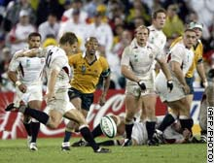
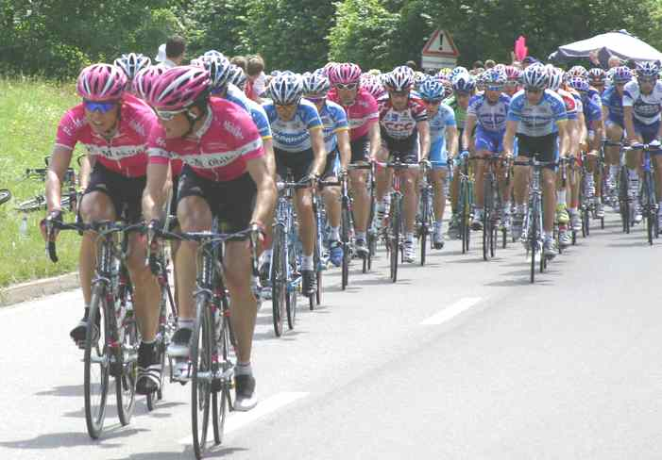
Open
Closed
Externally Paced
Self Paced
Simple
Complex
High in organisation
Low in organisation
Gross
Fine
Discrete
Continuous
Serial
Open
Closed
Externally Paced
Self Paced
Simple
Complex
High in organisation
Low in organisation
Gross
Fine
Discrete
Continuous
Serial
Open
Closed
Externally Paced
Self Paced
Simple
Complex
High in organisation
Low in organisation
Gross
Fine
Discrete
Continuous
Serial
Open
Closed
Externally Paced
Self Paced
Simple
Complex
High in organisation
Low in organisation
Gross
Fine
Discrete
Continuous
Serial
Open
Closed
Externally Paced
Self Paced
Simple
Complex
High in organisation
Low in organisation
Gross
Fine
Discrete
Continuous
Serial
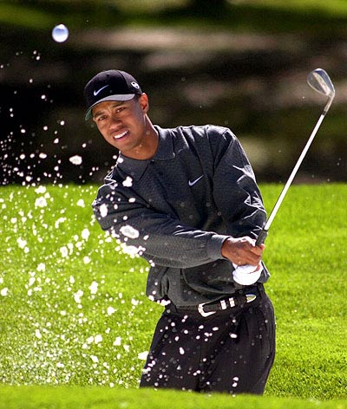
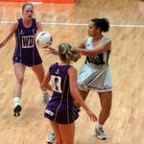
Open
Closed
Externally Paced
Self Paced
Simple
Complex
High in organisation
Low in organisation
Gross
Fine
Discrete
Continuous
Serial
Bunker shot in golf
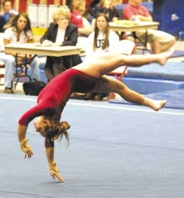
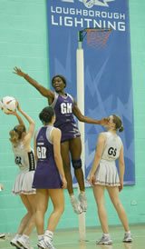
Drop goal in rugby
Cycle racing
Pass in netball
Floor routine in gymnastics
Shooting in netball

