Learning Curves and Plateaus

We all know that the speed of learning motor skills varies between people and at different stages of learning. Have a look at each curve and see if you can relate to the speed of learning occurring.
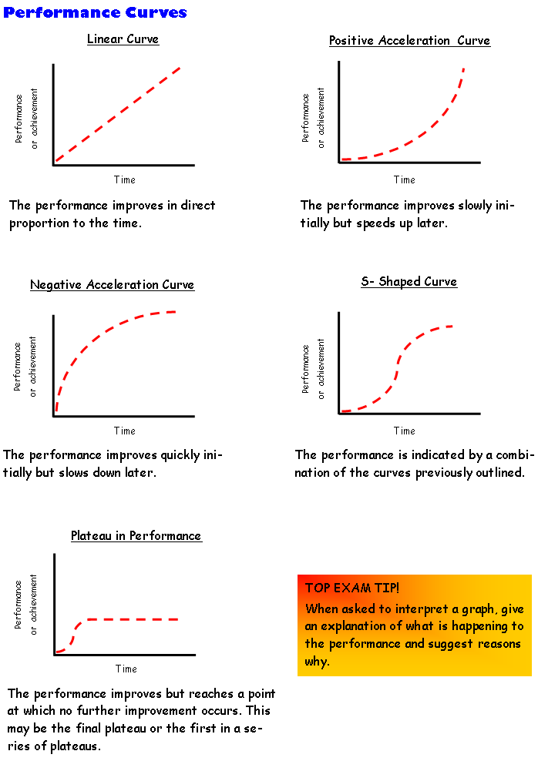

Describe possible causes of the plateau in performance

How could you stop the plateau occurring?

2013

