**4. Social Development Theory**

Vygotsky's theories stress the fundamental role of social interaction in the development of cognition (Vygotsky, 1978), as he believed strongly that community plays a central role in the process of "making meaning."

**Key Terms**

**More Knowledgeable Other**

The more knowledgeable other (MKO) is somewhat self-explanatory; it refers to someone who has a better understanding or a higher ability level than the learner, with respect to a particular task, process, or concept. Although the implication is that the MKO is a teacher or an older adult, this is not necessarily the case. Many times, a child's peers or an adult's children may be the individuals with more knowledge or experience. For example, who is more likely to know more about the newest teenage music groups, how to win at the most recent PlayStation game, or how to correctly perform the newest dance craze - a child or their parents?

In fact, the MKO need not be a person at all. Some companies, to support employees in their learning process, are now using electronic performance support systems. Electronic tutors have also been used in educational settings to facilitate and guide students through the learning process. The key to MKOs is that they must have (or be programmed with) more knowledge about the topic being learned than the learner does.

**Zone of Proximal Development**

The concept of the More Knowledgeable Other is integrally related to the second important principle of Vygotsky's work, the Zone of Proximal Development. This is an important concept that relates to the difference between what a child can achieve independently and what a child can achieve with guidance and encouragement from a skilled partner.

**Inter-psychological learning** using the more knowledgeable other (MKO)

**Intra-psychological learning o**ccurs within the performer where they **construct** responses based upon what they have gained from others and their own experiences.

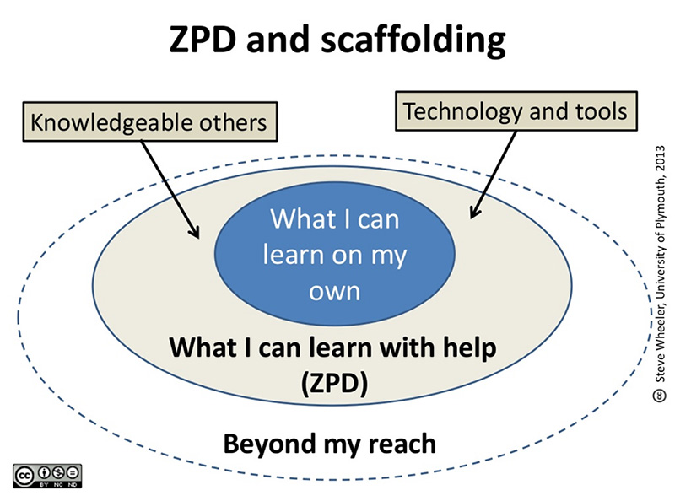

What are the three stages of development from the diagram above?

1.

2.

3.

