A-level PE:
NAME:
Exercise Physiology
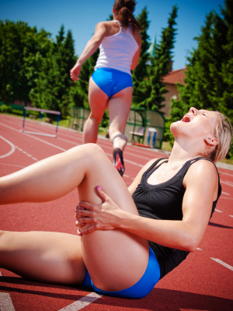
Sports Injuries & Recovery from exercise

What you need to know:

Types of injury: Acute (fractures, dislocations, strains, sprains), Chronic (achilles tendonitis, stress fracture,‘tennis elbow’).
Injury prevention methods: Screening, Protective equipment. Warm up, flexibility training
(active, passive, static and ballistic), taping and bracing.
Injury rehabilitation methods (proprioceptive training, strength training, hyperbaric chambers, cryotheraphy, hydrotherapy).
Methods of recovery from exercise: (compression garments, massage/foam rollers, cold therapy, ice bath,cryotheraphy).
Physiological reasons for use of hyperbaric chambers and cryotherapy in injury rehabilitation
Importance of sleep and nutrition for improved recovery.

1
Sports Injuries
Types of injury

- Acute | A sudden injury that is usually associated with a traumatic event such as clashing into another player during sports or a fall from a bike.
Fracture  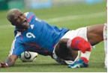 |  | Dislocation  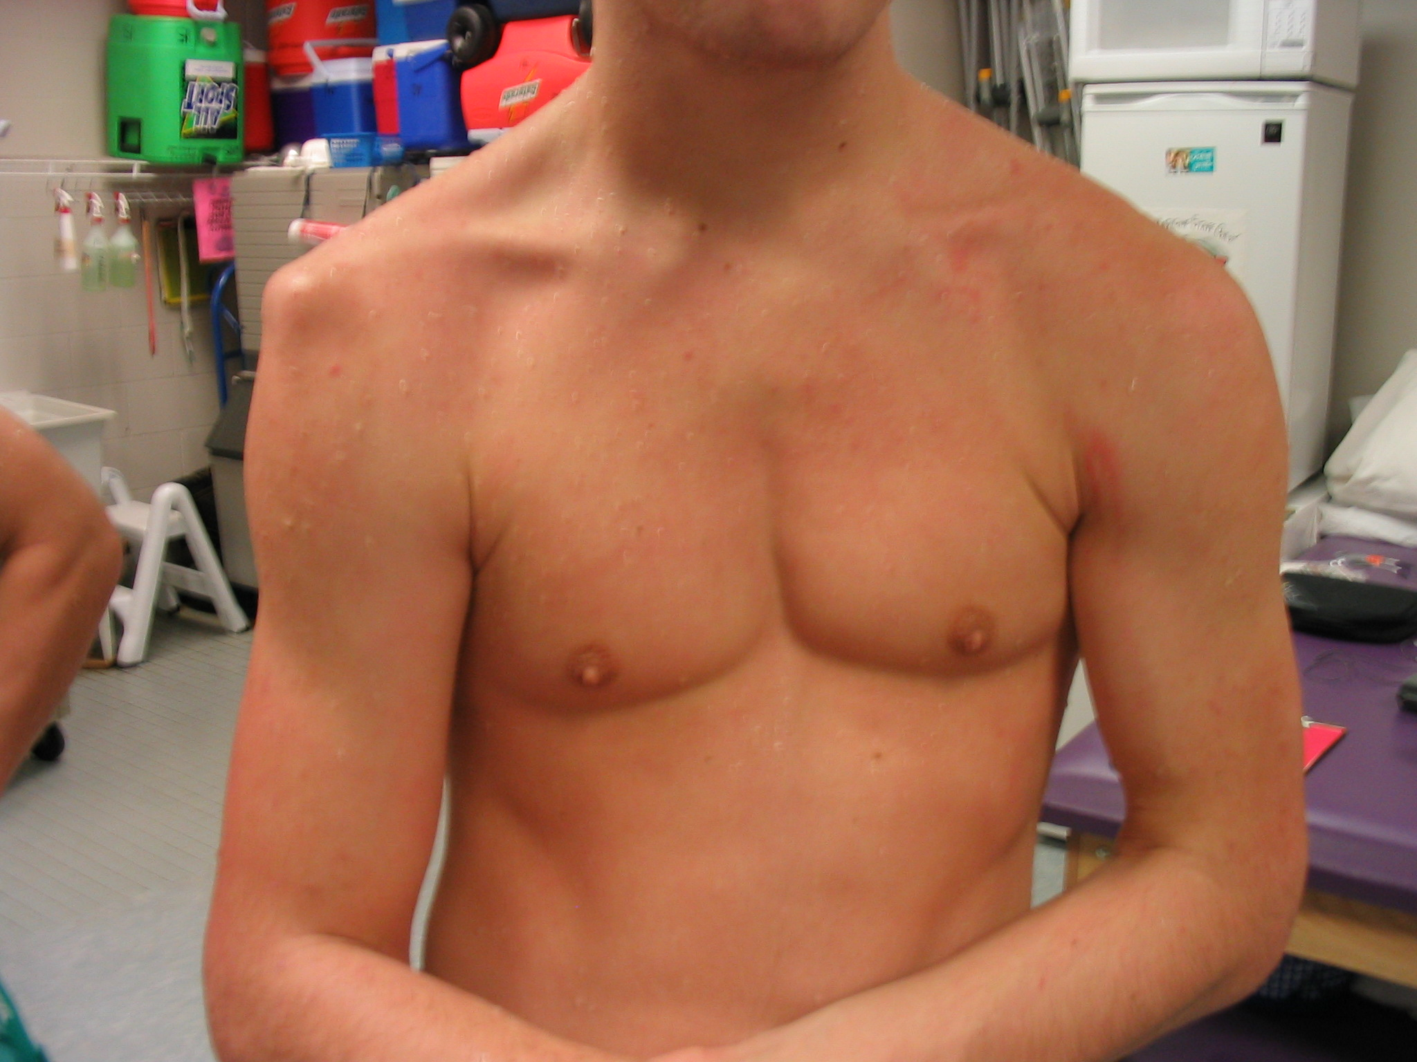 | Strain  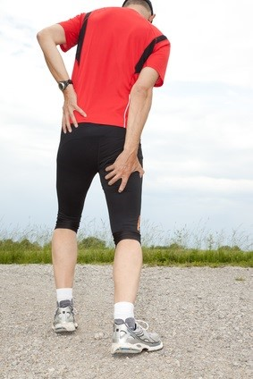 | Sprain  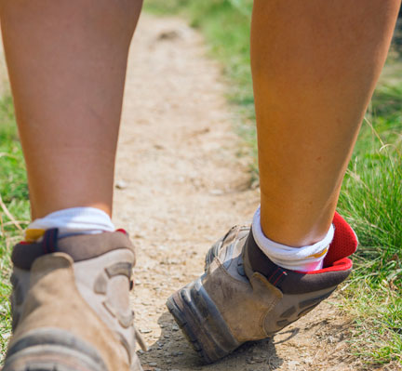

- Chronic | Over-use injury that develops slowly and is persistent and long-lasting, or constantly recurring over time. Caused by excessive wear and tear on the muscles and joints.
Achilles tendonitis  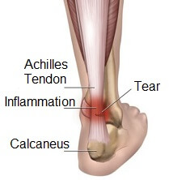 |  | Stress fracture  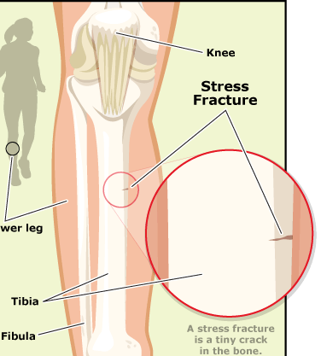 | Tennis elbow  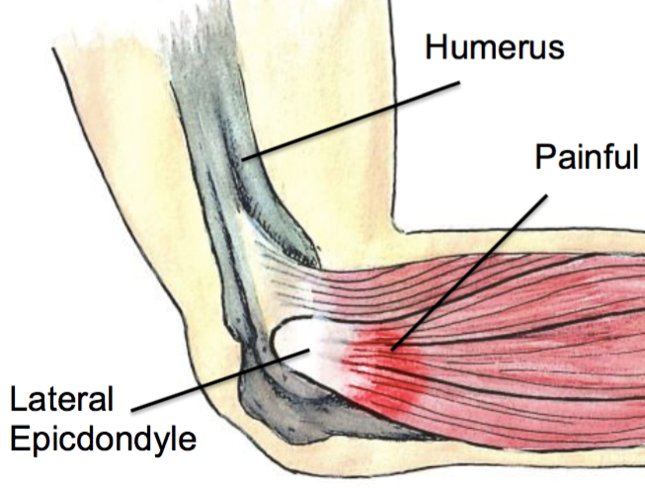

Prevent these acute and chronic injuries by….
1
Sports Injuries

Screening

Using protective equipment

Warming-up

Flexibility training

Taping and bracing

Types of stretches used in flexibility training
1
Sports Injuries

1 | Static  Stretches  E.g.  PNF | Can be done both actively (the agonist muscles create force to stretch the antagonist muscle) and passively (joints are moved by an external agent- usually a partner, device or gravity)  PNF stands for Proprioceptive Neuromuscular Facilitation.  If a stretching muscle is made to contract briefly, this inhibits the stretch reflex to that muscle and it is therefore allowed to relax and stretch further. | Active hamstring stretch    Passive Triceps Stretch  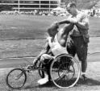  Hamstring PNF Stretch  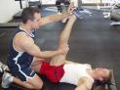  By pushing against the partner, the athlete briefly contracts his hamstrings. This switches off the stretch reflex, allowing the muscle to be stretched further.
2 | Ballistic  Stretches | These are a kind of dynamic stretching which involve rapid movements such as arm or leg swings. The benefit of these is that they mimic movements actually used in sport. Must be done carefully. | Ballistic leg swing stretch  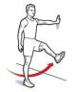

Essay Question:

Explain the use of PNF stretching to improve performance and prevent injuries. [8]

Revision – task to tackle!
1
Sports injuries
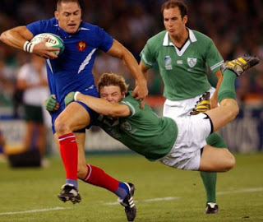

Steps | Description of stage | Explanation / physiological effects
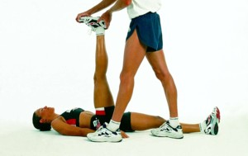  Step 1 | the muscle is  p_ _ _ _ _ ely stretched | ................................................  ..............................................  ................................................  ................................................. ................................................  ..............................................  ................................................  .................................................
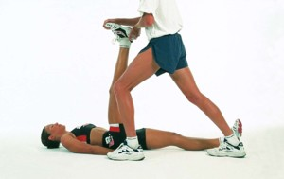  Step 2 | then it contracts iso_ _ _ _ _ _ ally against a resistance while in a stretched position for at least _ _ seconds | ................................................  ..............................................  ................................................  ................................................. ................................................  ..............................................  ................................................  .................................................
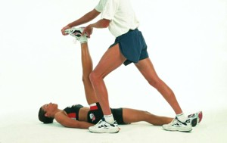  Step 3 | when passively stretched again there is an increase in the range of motion | ................................................  ..............................................  ................................................  ................................................. ................................................  ..............................................  ................................................  .................................................

2
Sports Injuries
Injury rehabilitation methods

Case study:

Rehabilitation for Ankle Sprains using proprioceptive training

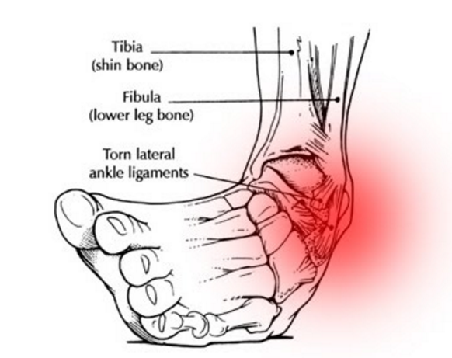

Proprioceptive training
How/why do we train it?
What is proprioception?

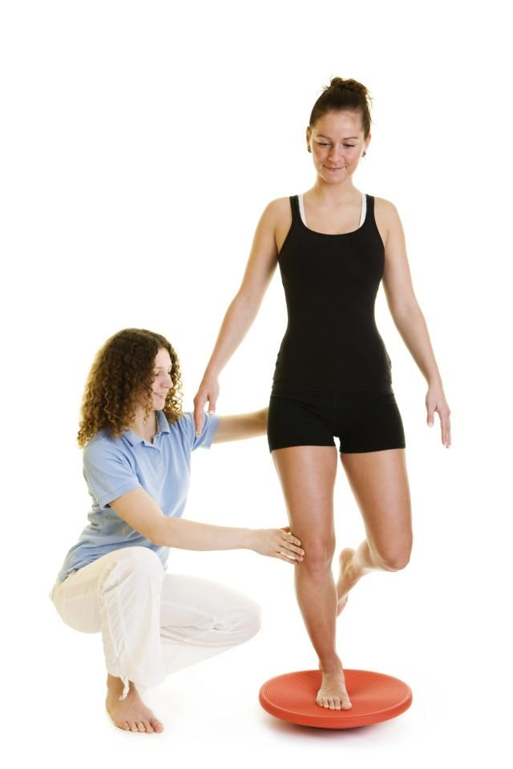

Proprioceptive exercises for ankle sprain rehabilitation
2
Sports Injuries

Phase 1 | 3 x daily stand on only injured ankle and attempt to balance for 5 seconds. When proficient try with eyes closed.
Phase 2 | Complete daily tasks e.g. brushing teeth on one leg. Now try with eyes closed.
Phase 3 | Perform star balance test twice daily. 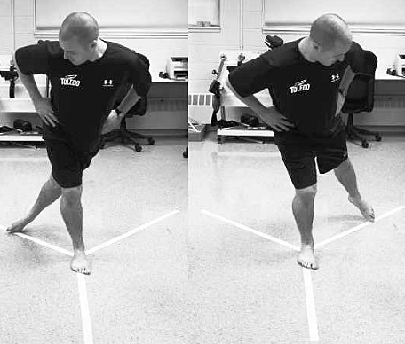
Phase 4 | Stand on wobble board and complete star test mobility three times daily.
Phase 5 | - Two legged jump onto bosu ball  3 sets of 10 reps landing on injured foot  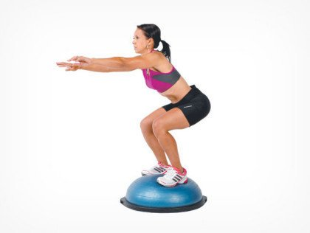  (Extend distance of jump when you can hold successfully)  - Dumbbell single leg calf-raises  3 sets of 10 reps landing on injured foot  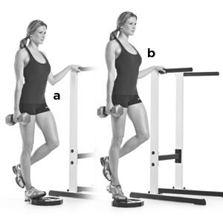

An athlete has suffered a sprained ankle. Explain the use of rehabilitation methods for the injury and the ways in which an ankle sprain can be prevented in the future. [8]

Injury rehabilitation methods
3
Sports Injuries

Case study:

Rehabilitation for hamstring strains using strength training.

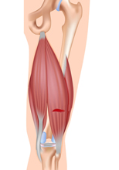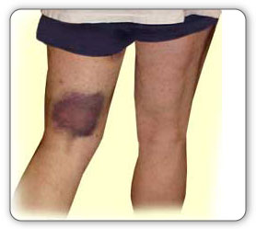

A hamstring strain is an over-stretch or tear to the tendons and/or large muscles at the back of the thigh.
It can occur in different severities. The 3 grades of hamstring injury are:
- grade 1 – a mild muscle pull or strain
- grade 2 – a partial muscle tear
- grade 3 – a complete muscle tear

Strength training = the use of resistance (bodyweight, therabands, free weights or machines) to prepare the body for exercise.

Sample strength training session for rehabilitation from hamstring strain.
3
Sports Injuries

 | Body weight exercise | Instructions
1 | 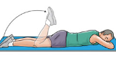  Prone knee flexion | Lie face down on the floor  Bend the knee before slowly lowering back down to the floor.  Reps 8 - 12
2 | 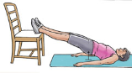  Single leg bridge holds  (straight leg) | Hold a straight, 2-leg bridge on a chair.  Raise one foot off the chair about 3 – 6 inches and hold for 2 seconds.  Return the foot the chair and raise the other leg.  5 reps on each leg.  3 sets.
3 | 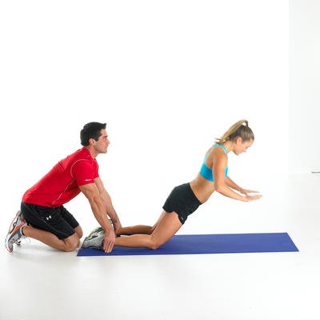  Nordic eccentric exercise | Have a partner secure your ankles to the floor.  With feet shoulder-width apart, face away from your partner.  Maintain a the body in a rigid plank position from knee to shoulder as you lower to the ground (eccentric lengthening by hamstrings)  Maintain the plank on the way back up as the hamstrings shorten concentrically.  8 reps.  3 sets.
4 | 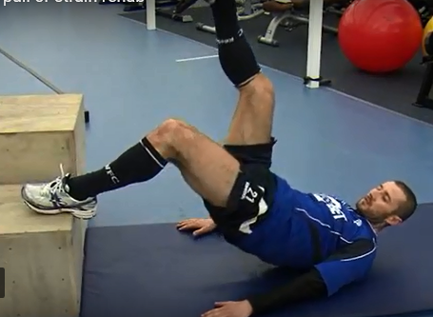  Single-leg raised bridge extensions | Place the injured leg up on a chair/ raised ledge.  Keep the foot flat on the chair.  Raise into a one-legged bridge and then lower the hips back to the ground.  Repeat 10 times on each leg.
5 | 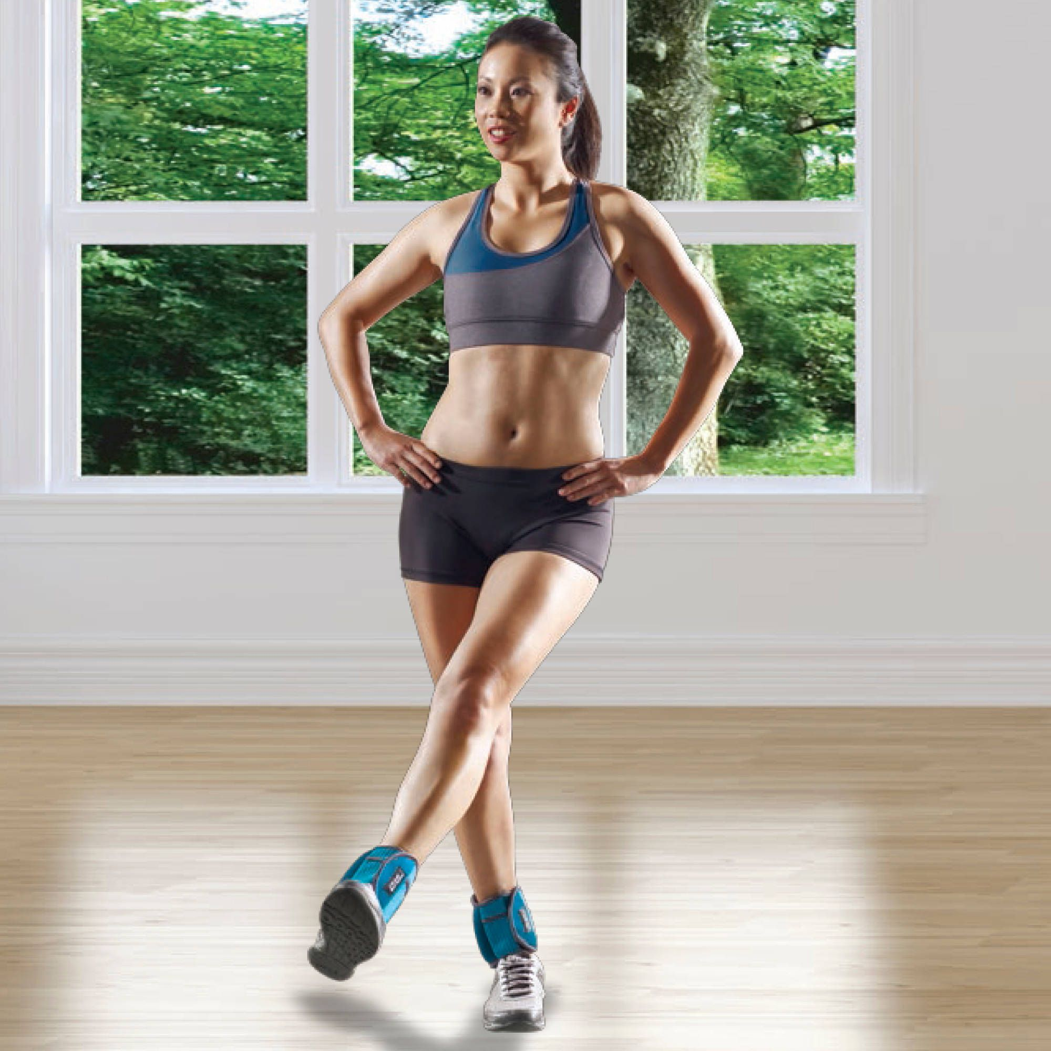  Weighted leg-kicks | Attach ankle weights / cable to injured ankle  Perform 7 repetitions of fast ballistic kicks  Perform 3 sets.

Hyperbaric Chambers
How does it work?

………………………………………………………………………………………………………………………………………………………….......
…………………….......
…………………….......
3
Sports Injuries

What effect does it have?

……………………………………………………………………………………………………………………………………………………………………………………………………………………………….
……………………................

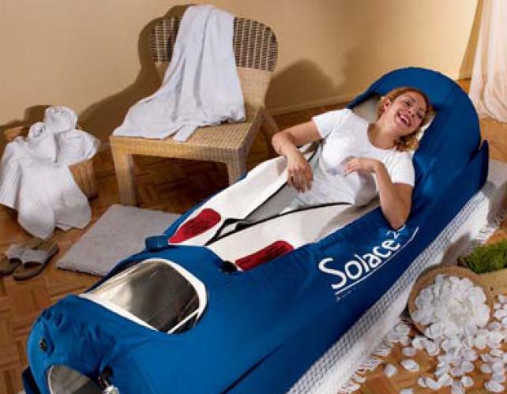

Cryotherapy

Cryotherapy = | Use in injury rehabilitation | Method | Benefits
The use of cold temperatures to treat an injury or aid recovery from exercise. |   Ice packs applied to muscle strains. | Applying ice decreases blood flow to the injured area.  R – Rest  I – Ice  C – Compression  E - Elevation | Pain relief  (analgesic effect)  Also reduced swelling.
 | 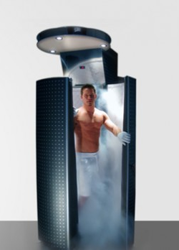  Whole Body Cryotherapy | 1.Chamber cooled by liquid nitrogen to – 100 degrees  2.Patient wears protective socks, gloves and swimming costume  3.Remains in chamber for 3 mins  4.Blood flows from arms and legs toward the core in an attempt to protect vital organs from cold  5. On leaving the chamber blood returns to arms and legs full of oxygen | Increased delivery of oxygen helps heal injured cells
Hydrotherapy
3
Sports Injuries
How does it work?
……………………………………………………………………………………………………………………………………………………………………………………………………………………………….

What effect does it have?
……………………………………………………………………………………………………………………………………………………………………………………………………………………………….

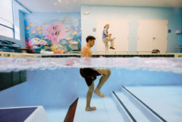

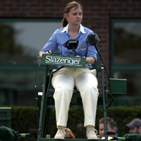
Be the umpire! Use the mark scheme below to award a mark out of 3

How may hyperbaric chambers aid injury rehabilitation? (3 marks)
Student answer:
Hyperbaric chambers enable injured performers to come back from their injury at faster speeds. This is because it provides the injured cells with more oxygen so that they repair quickly. On the down side they are very expensive.

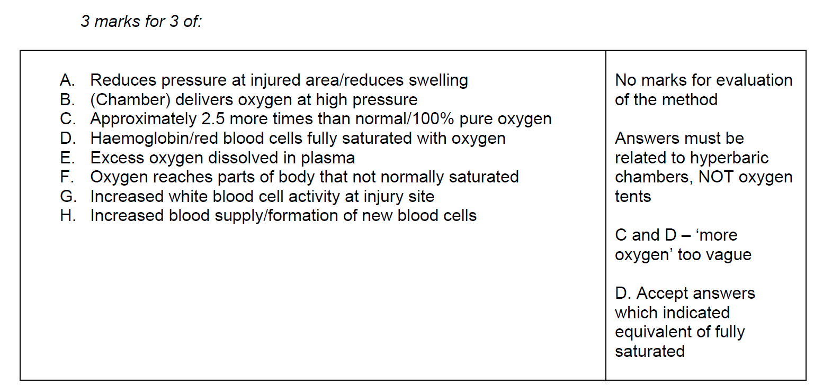
Methods of recovery from exercise
3
Sports Injuries

Ice baths (a type of cryotherapy)

How does it work?
……………………………………………………………………………………………………………………………………………………………………………………………………………………………….

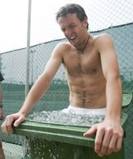
What effect does it have?
……………………………………………………………………………………………………………………………………………………………………………………………………………………………….

Compression garments

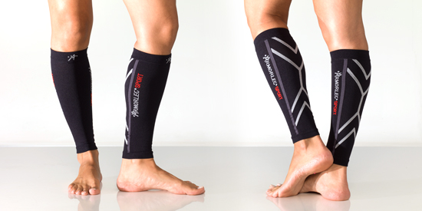
How does it work?
……………………………………………………………………………………………………………………………………………………………………………………………………………………………….

What effect does it have?
……………………………………………………………………………………………………………………………………………………………………………………………………………………………….

3
Sports Injuries
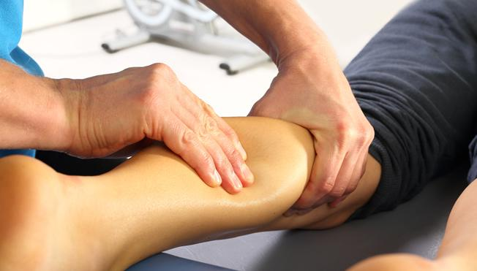MASSAGE

Benefits to recovery from exercise:

1……………………………………………………………………………………………………………….

2……………………………………………………………………………………………………………….

3………………………………………………………………………………………………………………..

4………………………………………………………………………………………………………………..

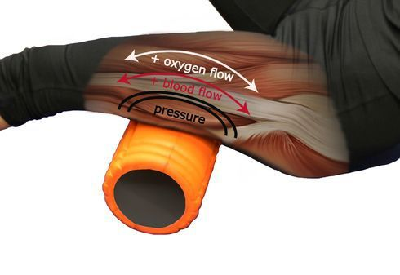
FOAM ROLLERS

3
Sports Injuries
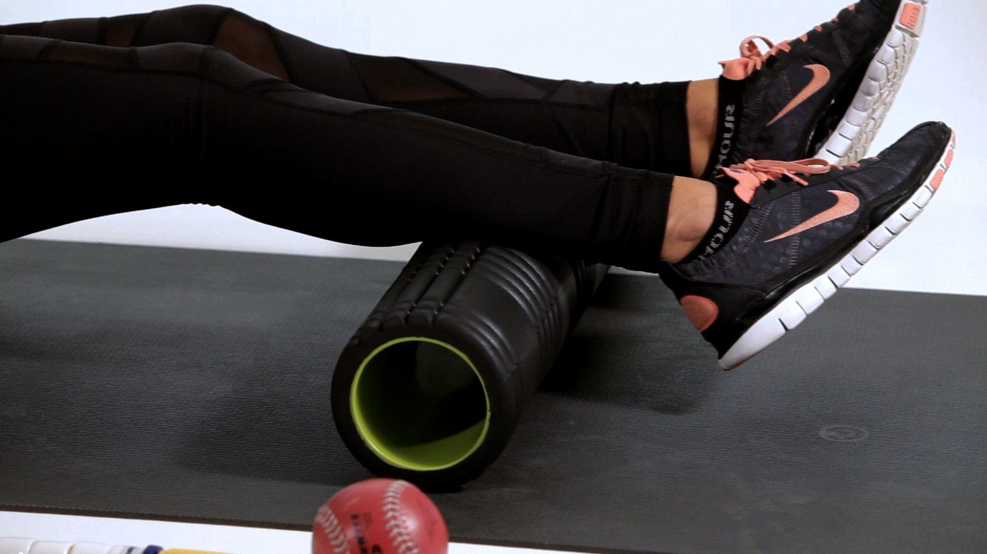

Foam rolling practical:

Foam rolling uses a technique called self-myofascial release by manipulating and releasing fascial tension caused by trauma and inflammation, which can be particularly beneficial to tight aching calves.
Follow these steps:
- Sit on the floor and place the foam roller underneath your calves, starting just above the ankle.
- Place both hands by your sides and lift off as though you were performing a reverse plank, which places your bodyweight onto the calf muscles.
- Slowly push your body forwards so the foam roller rolls up to the knee. NEVER FOAM ROLL AWAY FROM THE HEART as this works against the pocket valves in the veins.
- As you roll you should feel trigger points, these are the places where there is the most tension in the calves and they will feel like painful knots as you roll over them. As you reach a knot, this is where you need to apply more pressure in order to release the tension. Slow down and use little pulses over the knot until you feel it reduce.
- To add increased pressure, isolate each calf one at a time, so now your upper body weight is focused over one leg.
- To intensify this further still, cross the legs one over the other, now your entire bodyweight is focused over one calf.
- As you roll your calf rotate it slightly to make sure pressure is applied to the entire muscle. Try rolling with your feet facing inwards and outwards to combat the internal and external sides of the muscles

DOMS
3
Sports injuries
One aim of training is to improve fitness levels. An individual who wishes to improve strength may often work at higher intensities to overload the muscle in order to stimulate muscle hypertrophy. When this occurs the individual may experience tender and painful muscles some 24-48 hours after exercise. This is called DOMS or the delayed onset of muscle soreness.
1.

2.

3.

4.

5.

6.

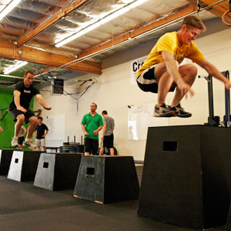
DOMS
FACTS

Be the umpire! Use the mark schemes below to award a mark out of 3

How can a performer reduce the effects of ‘delayed onset of muscle soreness’ (DOMS)?
(3 marks)
Student answer: A performer might limit DOMS by cooling down at the end of the game by doing low level, aerobic exercises that mimic the activity and the muscles used. You could take the pain away by using ice or go for a sports massage. Basically by being fitter this might also mean that DOMS do not occur in the first place.

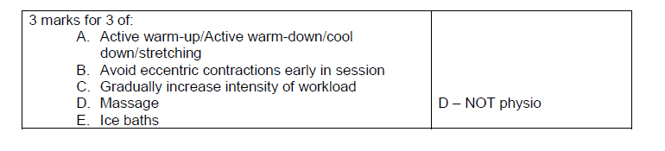

The importance of sleep for recovery
3
Sports Injuries
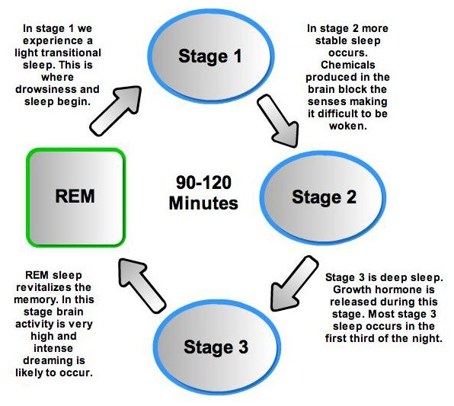
……………………………………………………………………………………………………………………………………………………………………………………………………………………………………………………………………………………………………………………………………………………………………………………………………………….
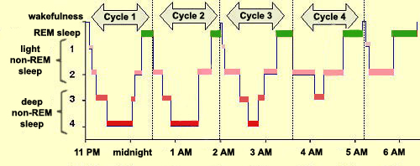

Be the coach! Imagine you run a youth sports team.
What action would you take in the following situations?

One of your players has a swollen ankle after colliding with an opponent and falling over. They are in a lot of pain and the ankle has swollen to twice the size. | You have just put your squad trough a gruelling bleep test followed by 40 minutes of sprint interval work. Many of the players are exhausted.
The importance of nutrition to aid recovery
3
Sports Injuries

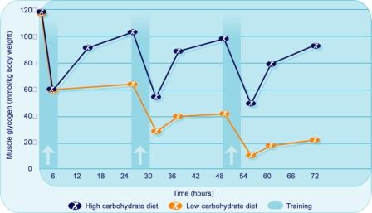

Task to tackle: Plan your answer to the Essay title below:

Analyse the use of hyperbaric chambers and cryotherapy in injury rehabilitation [8]
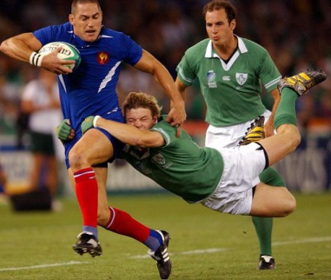

Practice makes perfect Exam Questions:

- What do you understand by the term DOMS (3 marks)

………………………………………………………………………………………………….……………………………………………………………………………………………………………………………………………………………………………………………

- How do hyperbaric chambers help in the rehabilitation of sports injuries (3 marks)

………………………………………………………………………………………………….……………………………………………………………………………………………………………………………………………………………………………………………

- Ice baths are increasingly used by sports performers as a recovery aid. How does an ice bath help a performer to recover? (3 marks)

………………………………………………………………………………………………….……………………………………………………………………………………………………………………………………………………………………………………………

Re-Cap Test
Q1

…………………………………………………………………………………………………………………………………………………………………………………………………….……………………………………………………………………………………………………………………………………………………………………………………………………
Q2

……………………………….…………………………………………………………………………………………………………………………………………………………………………………………………….……………………………………………………………………………………………………………………………………………………………………..
Q3

……………………………………………………………….………………………………………………………………………………………………….…………………………………………………………………………………………………………………………………….
Q4

………………………………………………………………………………………………….
……………………………………………………………………………………………………………………………………………………………………………………………………………………………………………………………………………………………………….

Exam Questions answers:

- DOMS – 3 marks for 3 from:
- Caused by Muscle tissue damage/ microscopic tears to muscle fibre
- Occurs 24-28 hours after exercise
- Caused by high intensity/ eccentric contractions/plyometrics
- Reduced by warm-up/cool-down/ massage/ ice bath

- Hyperbaric chambers explained:
3 marks for three of:
- High pressure of oxygen in chamber
- Means more Haemoglobin saturated with oxygen
- And formation of new blood cells
- Increases white blood cell activity at the injury site
- Helps to reduce swelling (faster)

- Ice baths impact on faster recovery
3 marks for 3 of:
- Constriction of veins/capillaries
- Improves blood flow/ reduces blood pooling
- Speeds up/ increases removal of waste products e.g. LA, CO2
- Reduction of DOMS/ pain

