# 3.1.1 Applied anatomy and physiology

**3.1.1.2 Cardiovascular system**

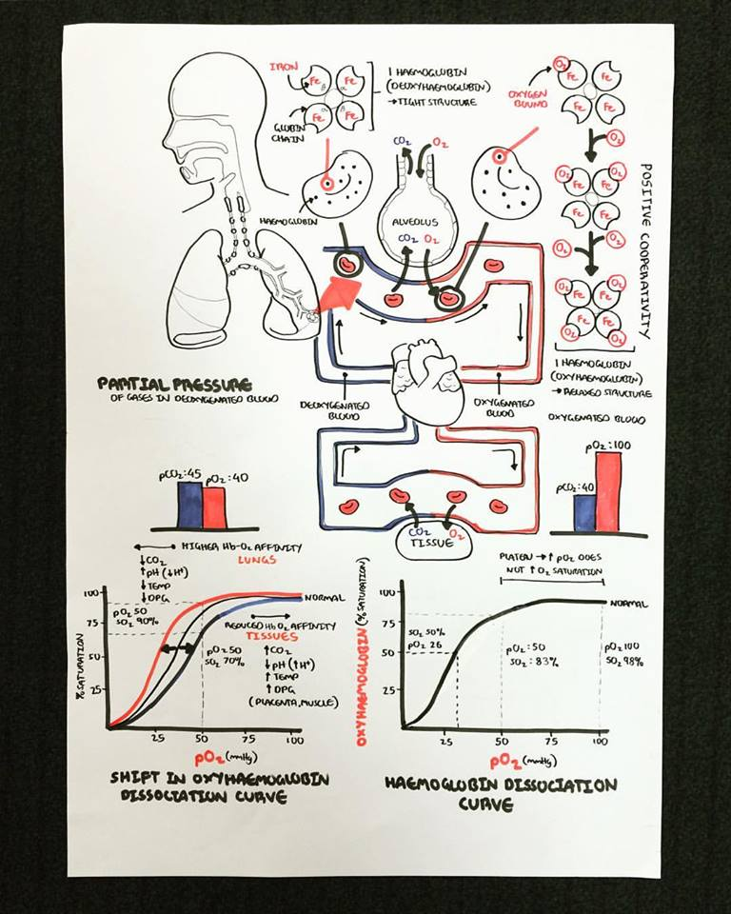**Bohr Shift** [**https://youtu.be/BYGPkRFvzOc**](https://youtu.be/BYGPkRFvzOc)

**Your notes on Bohr Shift and Oxyhaemoglobin Dissociation Curve**